NAME: MADHURI IYER
USN: 1BF25CS142
SECTION: C
LAB PROGRAM: PARKING CHARGE
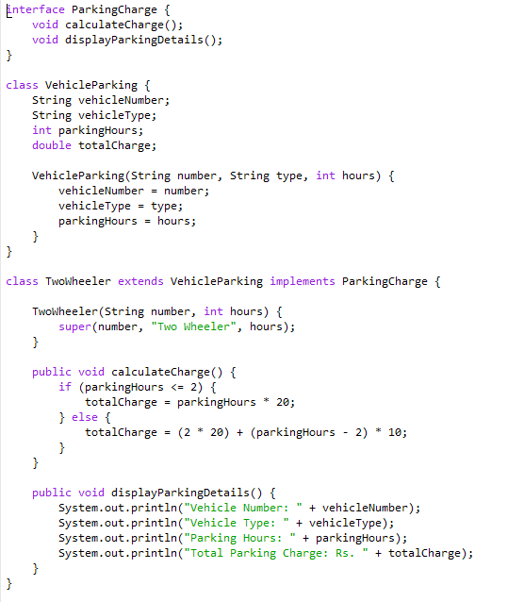
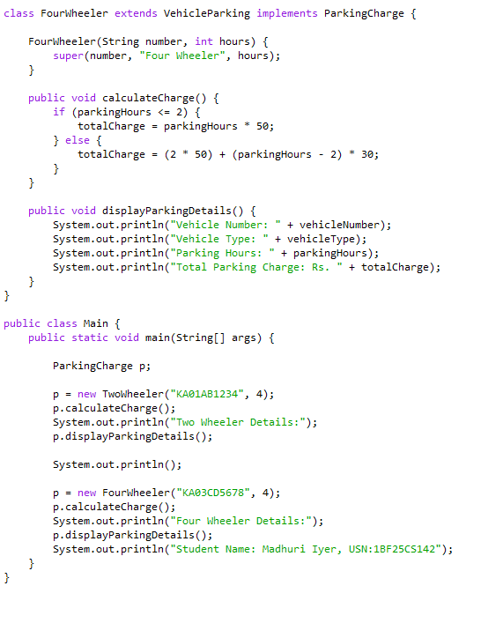

OUTPUT:
