PROJECT REPORT

Ramanujan's
Magic Square
An Interactive Puzzle and Learning Web Application
8 | 1 | 6
3 | 5 | 7
4 | 9 | 2
Submitted by
[Student Name]
[Register Number / Student ID]
[Course and Department]
[College / University]
[Project Guide]
[Academic Year]
A project report submitted in partial fulfilment of the requirements for [Degree / Course Name].

Certificate
This is to certify that the project report entitled “Ramanujan's Magic Square” is a record of the project work carried out by [Student Name], [Register Number], under the guidance of [Guide Name] during the academic year [Academic Year]. The work is submitted in partial fulfilment of the requirements for [Degree / Course Name] at [College / University].
The project has been reviewed for academic submission. The student and guide details, institutional wording, signatures, and dates must be completed by the institution.
Project Guide: ______________________________
Head of Department: ________________________
External Examiner: __________________________
Date: ______________ Place: ______________

Declaration
I, [Student Name], declare that the project report entitled “Ramanujan's Magic Square” is prepared as part of my academic project work. The implementation description in this report is based on the project code available for review. Any external material used in the final submission should be cited according to my institution's rules.
Student signature: __________________________ Date: ______________

Acknowledgement
I thank [Project Guide Name] for guidance and feedback during the development of this project. I also thank the faculty members of [Department / Institution] and the people who reviewed the application and suggested improvements. Their feedback helped shape the game interface, account features, and project documentation.
I acknowledge the open-source tools and libraries used in the project, including Python, Flask, SQLite, bcrypt, HTML, CSS, and JavaScript.

Abstract
Ramanujan's Magic Square is a browser-based puzzle application that introduces normal magic squares through interactive play. Users can solve boards of orders 3×3 through 10×10. The game provides Swap and Fill modes, Manual practice, a Daily Challenge, a formula and date-square page, player dashboards, achievements, leaderboards, account tools, and selectable visual themes.
The application uses HTML, CSS, and JavaScript in the browser and a Python Flask backend. SQLite stores users, game sessions, attempts, achievements, and chatbot messages. The backend constructs valid squares using methods appropriate to each order class and validates submitted solutions. The in-app companion currently returns curated rule-based answers, supports English and Kannada reply settings, and can use browser speech features when the device supports them. It is not currently connected to a large language model.
The report explains the mathematical foundation, requirements, architecture, data design, implementation, and validation approach. It also describes current deployment and security considerations and recommends a staged path for future AI features such as a board-aware coach and a guide-grounded tutor.
Keywords: magic square, puzzle game, Flask, SQLite, web application, chatbot, Kannada

Contents
Section | Coverage
Preliminary pages | Certificate, Declaration, Acknowledgement, Abstract
Chapter 1 | Introduction, problem statement, objectives, scope
Chapter 2 | Background, existing approach, proposed system, feasibility
Chapter 3 | Requirements, users, functional and quality requirements
Chapter 4 | Architecture, use cases, data flow, database design
Chapter 5 | Implementation, mathematical methods, game modules, chatbot
Chapter 6 | Testing strategy and representative test cases
Chapter 7 | Security, deployment, operation, and maintenance
Chapter 8 | Conclusion and future enhancements
References | Project files and technical documentation
Appendices | Local setup, environment configuration, viva summary

CHAPTER 1
INTRODUCTION
This chapter introduces the project, the problem it addresses, and the features included in the implemented application.

1.1 Background
Magic squares have been studied as mathematical arrangements with equal line sums. Their construction connects arithmetic, patterns, and spatial reasoning. A user who only reads a formula may not see how individual cell choices affect the rows, columns, and diagonals. An interactive board makes those relationships visible while the user solves a puzzle.

1.2 Problem Statement
The project addresses the need for an accessible way to practice magic squares and understand their constraints. A useful learning application should explain the target sum, make puzzle progress visible, validate solutions reliably, and provide reasons to return through saved progress and daily activities.

1.3 Objectives
- Present the rules and magic constant for normal magic squares.
- Generate playable squares from order 3 through order 10 and explain why order 2 is not playable.
- Provide Swap, Fill, and Manual ways to interact with a board.
- Validate submitted results on the server and associate completed attempts with user accounts.
- Provide daily puzzles, streaks, achievements, dashboards, and leaderboards.
- Offer curated chatbot help and selectable English or Kannada replies.
- Provide responsive pages and persistent visual theme selection.

1.4 Scope
The application focuses on one puzzle family, normal magic squares, and the features built around it. It includes public account entry, authenticated game pages, player profile and progress views, and administrator functions. The chatbot is restricted to MagicSquare and related site topics. The current release does not perform live multiplayer matchmaking or use a generative AI model.

1.5 Project Outcomes
The resulting system turns the magic-square rules into a playable web experience. Its server creates and checks puzzle data, while the browser presents controls, feedback, navigation, and progress views. The separation gives the project a clear foundation for future improvements without making AI necessary for basic game operation.

CHAPTER 2
BACKGROUND AND SYSTEM ANALYSIS

2.1 Mathematical Background
For a normal n×n magic square, the values 1 through n² are used once. Their total is n²(n²+1)/2. Dividing this total equally among n rows gives the magic constant M(n)=n(n²+1)/2. The same target applies to each column and each main diagonal.
Odd-order squares can be constructed with the Siamese method. Orders divisible by four use a doubly-even complement pattern. Orders that are even but not divisible by four use a singly-even construction, implemented here with a Strachey/LUX-style method. A normal 2×2 square is impossible under the distinct-value and diagonal constraints.

2.2 Existing Approach
A paper puzzle or a static explanation does not automatically track a player's time, attempts, hints, or streak. It also cannot validate progress across sessions without an application and storage layer. These limits motivated the addition of authenticated play, server-side checks, and a dashboard.

2.3 Proposed System
The proposed system provides an interactive browser interface backed by Flask API routes and SQLite persistence. The server generates the target square, tracks active game sessions, enforces mode rules, validates results, and stores eligible attempts. The player can then review outcomes through the dashboard and leaderboard.

2.4 Feasibility
Area | Assessment
Technical | The project uses widely available Python, Flask, browser technologies, and SQLite. A Dockerfile and hosting blueprint are included.
Operational | Players use a standard web browser. Account and game pages are organized around a shared navigation system.
Economic | The core application uses open-source dependencies. Hosting, email delivery, persistent storage, and any future AI provider may have costs depending on the chosen service.
Schedule | The project is divided into modules that can be implemented and reviewed independently: game logic, accounts, progress, and assistance.

2.5 Limitations of Current Release
- The chatbot is curated and rule-based; it does not generate answers with a language model.
- Voice features depend on browser speech-recognition support and voices installed or available on the device.
- SQLite is suitable for a small deployment, but a larger concurrent service may need a server database.
- Production deployment needs persistent storage for the SQLite file and careful secret configuration.
- Theme choice is browser-local and may not follow the same user across devices.

CHAPTER 3
REQUIREMENTS SPECIFICATION

3.1 Intended Users
The primary user is a player who wants to solve puzzles and monitor personal progress. An administrator can access separate review and management functions when the account has the required role.
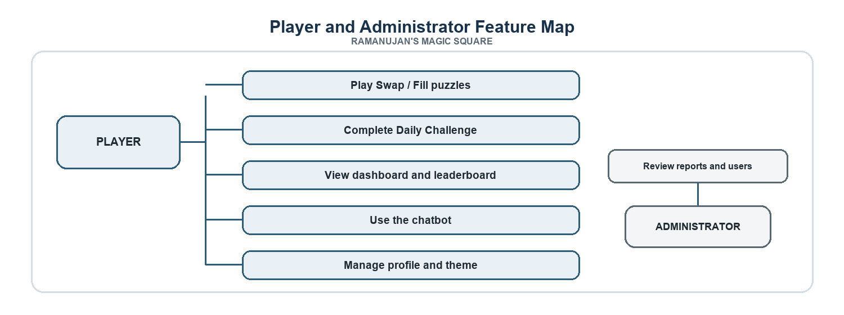
Figure 3.1: Player and administrator feature map

3.2 Functional Requirements
ID | Requirement
FR-01 | Allow a user to register, log in, log out, and manage account details.
FR-02 | Start a supported puzzle order and selected play mode.
FR-03 | Generate a valid target grid and provide a scrambled puzzle for Swap play.
FR-04 | Allow a player to enter a candidate grid in Fill mode and receive constraint feedback.
FR-05 | Support Manual practice without treating it as a competitive result.
FR-06 | Enforce the Daily Challenge order and record daily completion and streaks.
FR-07 | Save attempts, compute achievements, and show player records and rankings.
FR-08 | Provide theme selection and save the selection in browser storage.
FR-09 | Provide curated chatbot answers, language selection, and optional browser voice interaction.
FR-10 | Allow users to export account and activity data as CSV and delete their account.

3.3 Quality Requirements
- Correctness: validate order, number use, line sums, and saved results on the server.
- Usability: use clear controls, visible sum feedback, and a responsive layout.
- Maintainability: separate static frontend scripts, Flask routes, math functions, and chatbot rules.
- Privacy: protect account data behind authentication and avoid exposing server secrets in client files.
- Reliability: preserve saved data using a persistent database location in deployment.

3.4 Hardware and Software
Category | Requirement
Client | Current desktop or mobile browser with JavaScript enabled.
Server | Python 3 environment capable of running Flask and the packages listed in requirements.txt.
Database | SQLite database file in the configured DATA_DIR.
Deployment | Docker-compatible host; configure PORT and SESSION_SECRET, and persistent storage for DATA_DIR.

3.5 Assumptions and Constraints
The project assumes that a player has a modern browser and a working connection to the Flask service. An account is needed for saved competitive progress. Voice input depends on browser permission and support. The current deployment model uses one SQLite database file, so a hosted instance must preserve the configured data directory. The first release supports one puzzle family and two chatbot reply languages.

CHAPTER 4
SYSTEM DESIGN

4.1 Architecture
The application follows a browser-to-server architecture. The browser renders static HTML, CSS, and JavaScript. JavaScript sends same-origin HTTP requests to Flask endpoints and receives JSON. Flask applies authentication and validation rules, reads or writes SQLite data, and returns a response for the interface to display.
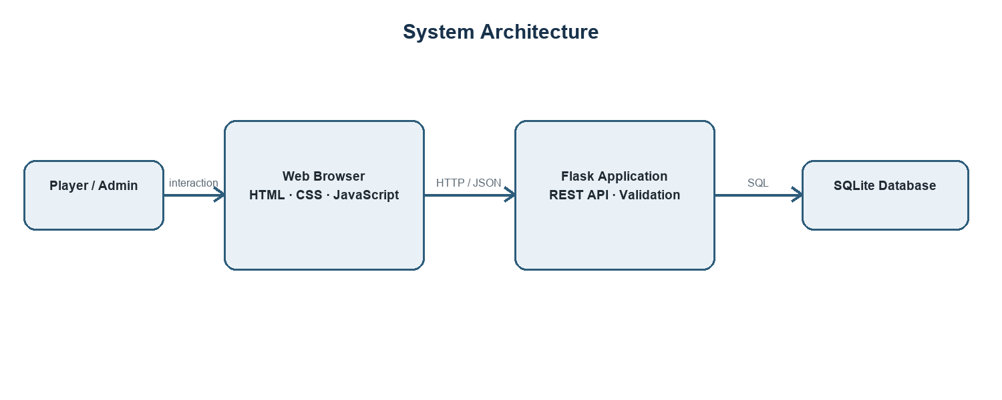
Figure 4.1: High-level system architecture

4.2 Module Design
Module | Responsibility
Authentication and Profile | Registration, login, session state, email, password changes, export, and account deletion.
Game Engine | Generate target grids, scramble puzzles, calculate targets, and validate submitted values.
Daily Challenge | Provide the shared daily puzzle sequence and track completion streaks.
Progress and Achievements | Save attempts, calculate best times, award badges, and populate dashboard views.
Leaderboard | Return ranked eligible results for global and daily views.
Theme Manager | Apply a palette through CSS variables and store the selected theme in local storage.
Gaming Companion | Match questions to curated rules, apply reply-language handling, and save signed-in conversation history.
Administration | Provide role-protected user, attempt, and chatbot feedback/report review routes.

4.3 Game Session Flow
A signed-in player requests a game by order and mode. Flask checks the order and mode, applies daily-order restrictions when needed, generates a valid square, and stores a game session. The browser presents the puzzle. When the player submits a candidate, the server validates it and records the result only when the applicable conditions are met.
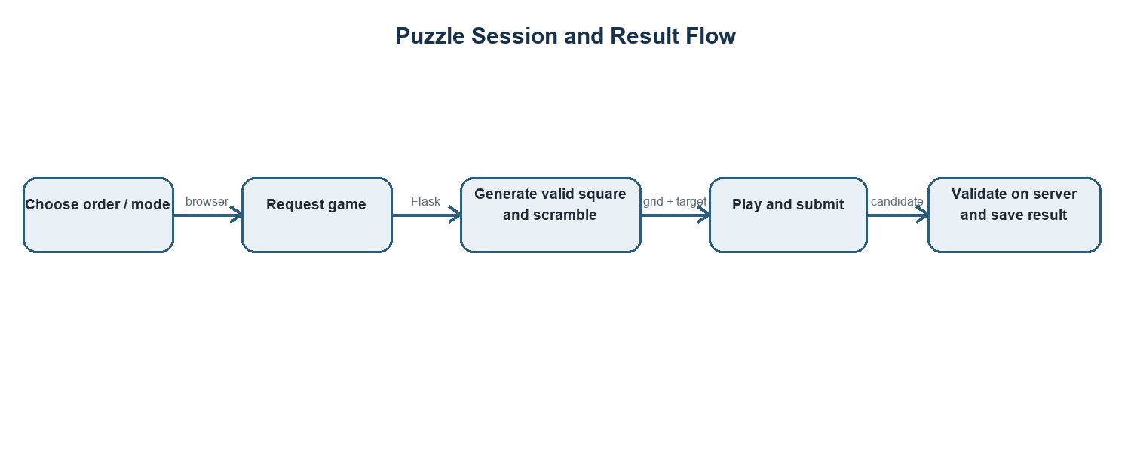
Figure 4.2: Puzzle session and result flow

4.4 Database Design
The SQLite schema separates account information from gameplay records. Foreign keys associate sessions, attempts, achievements, and chatbot messages with users. A configured DATA_DIR determines where the database file is created.
Entity | Purpose | Representative fields
users | Account and preference data | id, username, password_hash, is_admin, email, daily_streak, chatbot_language
game_sessions | Active or completed game state | id, user_id, square_order, solved_grid, mode, started_at, attempts_used
attempts | Completed puzzle records | user_id, square_order, moves_made, time_taken, hints_used, is_daily, mode
user_achievements | Awarded badge records | user_id, achievement_key, earned_at
chatbot_messages | Saved user and assistant messages | user_id, request_id, role, game_title, content, context_json

4.5 API Responsibilities
Flask routes are grouped by feature. Authentication routes manage sessions and account actions. Game routes create sessions and return puzzle data. Attempt routes update progress and save validated results. Daily, leaderboard, achievement, profile, chatbot, and admin routes provide their respective data services. Authenticated routes use a session check before accessing user-specific data.

CHAPTER 5
IMPLEMENTATION

5.1 Magic Constant
The application calculates the target using M(n)=n(n²+1)/2. It uses this value to label the board and evaluate lines. The formula works for every positive order as a target calculation, but it does not imply every order has a valid square; order 2 is the notable impossible case for a normal square.

5.2 Construction Algorithms
Order class | Construction method | Core idea
Odd orders: 3, 5, 7, 9 | Siamese method | Begin at the middle of the top row; move up and right with wraparound. If occupied, move down from the previous cell.
Doubly-even: 4, 8 | Complement method | Fill sequentially, then replace selected diagonal-pattern cells with n²+1 minus the original value.
Singly-even: 6, 10 | Strachey / LUX-style method | Build four offset odd-order quadrants and exchange selected columns to balance line sums.

5.3 Validation
The backend computes row sums, column sums, and both main diagonal sums. Fill mode also checks that values are within 1 through n², identifies duplicates and missing values, and reports line totals that differ from the target. Swap mode compares the submitted candidate with the stored target grid and validates the magic constraints before saving an attempt.

5.4 User Modes

5.4.1 Swap Puzzle
A valid square is created and shuffled for the user. The player selects tiles and swaps them until the target arrangement is restored. The interface provides move count, elapsed time, line-sum feedback, Undo, Hint, and a Next control that becomes available after solving and saving the current order. Each hint adds 15 seconds.

5.4.2 Fill the Square
Fill mode begins with empty cells. The user enters each number and submits a complete grid for checking. An incomplete grid is rejected without consuming a check. A round permits three completed checks and can be resumed for a limited interval. A successful solution is stored as a Fill attempt.

5.4.3 Manual Practice
Manual mode is intended for unscored practice. It lets the user enter a grid and inspect its mathematical constraints without submitting a competitive attempt.

5.5 Daily Challenge and Progress
Daily Challenge uses a shared date-based puzzle and requires completion in order by size. Successful daily play updates the streak. The dashboard reads attempt and achievement data to show records and badges. The leaderboard is based on eligible completed results, with server-side validation before saving.

5.6 Account and Data Features
Registration validates usernames and minimum password length. Passwords are hashed with bcrypt. The profile page supports password change, email management, CSV export, account deletion, and logout. Account-specific routes check the current session before reading or changing data.

5.7 Theme Selection
The theme script defines multiple palettes as CSS variable values. When the player selects a theme, the script updates variables such as page background, surface, border, accent, and text colors. It stores the palette key in local storage so later page visits in the same browser can reapply the selection.

5.8 Gaming Companion
The companion uses ordered phrase rules and curated text to answer known MagicSquare and website questions. It can return Kannada-script answers when Kannada is selected and stores signed-in chat history. Browser SpeechRecognition handles voice input and SpeechSynthesis reads answers aloud where supported. The current Flask status endpoint reports AI disabled; therefore the implementation should be described as rule-based rather than LLM-powered.
The knowledge guide in knowledge/magic-square-guide.md documents rules, modes, construction methods, progress, and troubleshooting. Curated rules make common answers repeatable, but questions outside the covered patterns may receive a generic response.

5.9 Portfolio and Navigation
The portfolio page introduces the application and offers account entry. Authenticated pages share navigation and a hamburger menu. The menu exposes Play, Daily Challenge, Manual, Dashboard, Leaderboard, Formula, and Change Theme. The profile area contains account actions and logout.

CHAPTER 6
TESTING AND VALIDATION
Testing should cover mathematical correctness, server-side authorization, persistence, browser interaction, and responsive layout. The table below defines representative checks and the expected behavior; it is a test plan and does not claim that every item has been executed in a formal test suite.

6.1 Representative Test Cases
Case | Action | Expected result
TC-01 | Request each playable order from 3 through 10 | A valid grid is generated and each required line totals M(n).
TC-02 | Request order 2 | The application explains that a normal 2×2 square is impossible.
TC-03 | Submit an incorrect Swap candidate | The server rejects it and does not save it as a successful attempt.
TC-04 | Submit an incomplete Fill grid | The server reports missing cells and does not consume a check.
TC-05 | Submit a complete incorrect Fill grid | The server returns value and line feedback and updates the check count.
TC-06 | Submit a valid solution | The backend records the attempt and evaluates achievements.
TC-07 | Call a protected route without a session | The request is denied or redirected according to the route and client behavior.
TC-08 | Select Kannada and ask in English | The chatbot returns Kannada-script content for supported topics.
TC-09 | Choose a theme and reload another page | The saved browser theme is applied again.
TC-10 | Export account data | The response is a CSV with headers and available account/activity data.
TC-11 | Complete daily orders out of sequence | The server blocks the next order until the expected daily order is completed.
TC-12 | Open the site on a narrow viewport | Navigation and game controls remain usable without horizontal overflow.

6.2 Validation Approach
The math engine can be checked by generating each supported order and verifying the number range, uniqueness, rows, columns, and diagonals. API behavior can be checked with authenticated and unauthenticated requests. Browser checks should include navigation, theme persistence, mobile layout, and speech support on target devices. A production release should automate repeatable checks and preserve test results with the release record.

CHAPTER 7
SECURITY AND DEPLOYMENT

7.1 Security Measures in the Code
- Passwords are stored as bcrypt hashes.
- Flask sessions use an HTTP-only cookie and SameSite=Lax setting.
- User-specific routes use an authentication decorator and retrieve records by the signed-in user ID.
- Game submissions are checked by the server against stored session data.
- SQLite queries generally use parameter placeholders for user-supplied values.
- Chatbot context is sanitized before it is used to explain a current board.

7.2 Production Hardening
The code contains a development fallback for SESSION_SECRET, so deployment must set a strong random value. Production should use HTTPS, enable secure cookies for HTTPS traffic, restrict secrets to the host environment, use persistent database storage, apply rate limiting to sensitive routes, review CSRF protection, and maintain backups. Security depends on the deployed configuration as well as the source code.

7.3 Deployment Configuration
The repository includes a Dockerfile that installs requirements.txt and starts app.py. The Render blueprint selects a Docker web service and generates SESSION_SECRET. DATA_DIR can point to a persistent storage location. The host must provide a persistent disk or external database if users' SQLite data must survive instance replacement.

7.4 Local Execution
1. Install Python dependencies from requirements.txt.
2. Set SESSION_SECRET to a long random value for a non-development environment.
3. Run python app.py.
4. Open http://localhost:3000 in a browser.
The project is a web application. The browser-based interface may be used on mobile devices, but browser voice APIs and available speech voices vary by device and browser.

CHAPTER 8
CONCLUSION AND FUTURE WORK

8.1 Conclusion
Ramanujan's Magic Square provides an interactive way to learn and play normal magic-square puzzles. The project combines construction algorithms and server-side validation with account-based progress, daily challenges, badges, leaderboards, themes, and curated chatbot assistance. Its browser frontend and Flask API keep presentation and trusted game validation in separate layers, while SQLite provides persistent application data.
The chatbot currently uses curated rules rather than a generative AI model. This distinction is important when presenting the project. The system is ready for future AI additions, but AI features should be added with clear scope controls and should not replace deterministic mathematical validation.

8.2 Future Enhancements
Enhancement | Proposed approach | Value
Board-aware coach | Analyze the live grid with deterministic line and swap scoring; explain the best candidate move. | Personalized help tied to the current puzzle.
Guide-grounded AI tutor | Retrieve relevant passages from reviewed project guides and pass them to a server-side language model. | More flexible explanations while keeping answers tied to project material.
Adaptive difficulty | Use solve time, move count, hint use, and success history to recommend a next order or mode. | A learning path that responds to player progress.
Screenshot assistance | Add an image upload path and a vision model, with consent and privacy limits. | Help identify visible puzzle state or interface problems.
Expanded language support | Add tested Hindi and Kannada answer content and transliteration handling. | Wider access for players who prefer local languages.
Production data platform | Move to PostgreSQL and add migrations, backups, and monitoring as usage grows. | Improved operations for a larger public service.

8.3 AI Integration Principles
- Keep model API keys on the server and outside source control.
- Restrict chatbot requests to game and website topics.
- Retrieve from reviewed knowledge documents and show when the answer is uncertain.
- Keep solution checking and scoring in deterministic backend code.
- Collect only the data required for coaching and explain how it is used.

References
1. Project source: app.py, Flask API routes, SQLite schema, authentication, game generation, validation, and chatbot endpoints.
2. Project source: public/js/magicSquare.js, client-side magic-square constants and construction methods.
3. Project source: public/js/companion.js, chatbot interface and browser voice interaction.
4. Project source: public/js/theme.js and public/css/style.css, theme palettes and shared presentation styles.
5. Project knowledge guide: knowledge/magic-square-guide.md.
6. Project configuration: requirements.txt, Dockerfile, render.yaml, and README.md.
7. Python Software Foundation, Python documentation, https://docs.python.org/.
8. Pallets Projects, Flask documentation, https://flask.palletsprojects.com/.
9. SQLite Consortium, SQLite documentation, https://www.sqlite.org/docs.html.
10. MDN Web Docs, Web Speech API, https://developer.mozilla.org/docs/Web/API/Web_Speech_API.

Appendix A Local Setup
The following steps describe a local development run from the project directory. Production hosting also needs HTTPS, persistent storage, and secure environment configuration.
1. Install a supported Python version.
2. Install dependencies with python -m pip install -r requirements.txt.
3. Set a development SESSION_SECRET in the environment.
4. Optionally set ADMIN_USERNAME before registering the intended administrator account.
5. Run python app.py and open http://localhost:3000.
6. For deployment, set DATA_DIR to durable storage and keep all secrets out of the repository.

Appendix B Important Environment Variables
Variable | Purpose | Notes
SESSION_SECRET | Signs Flask session data. | Set a long random secret in deployment; never rely on the development default.
DATA_DIR | Selects the directory for the SQLite database. | Use persistent storage in a deployed service.
ADMIN_USERNAME | Identifies the username granted the administrator role at registration. | Set before registering that account; protect administrator access.

Appendix C Submission Details to Complete
Before academic submission, replace the bracketed cover and certificate fields with the student's name, register number, course, department, institution, project guide, academic year, and any required institutional declaration. Confirm the required citation format and attach institution-approved screenshots if requested.

