Sentiment Classification of IMDB dataset using Long-Short-Term-Memory (LSTM) neural networks

Lalitha Madhuri Putchala (1), Ravi Teja(2)
CS Department
University of Central Missouri
(1) lxp76310@ucmo.edu
(2) rxm85860@ucmo.edu

Abstract

With the advent of social media, the Sentiment Analysis or Emotion AI has become one of the major research areas in the recent times. This research primarily focusses on determine the attitude of the writer, speaker or the overall context of the content. The main applications of the sentiment analysis can be seen in Twitter’s sentiment classification, companies making decisions based on customer review ratings, movie review ratings and so on. Predominantly, researchers follow Lexicon Based approach or Machine Learning approach to perform the sentiment analysis experiments. The rapid pace of development of Machine Learning and Deep Learning sciences are obtained better results for Emotional AI when compared to traditional lexicon-based approach. Among the Machine Learning algorithms, the neural networks when used with deep learning concepts we believe would obtain better accuracy over large datasets.

In this research, we apply a deep learning approach on IMDB movie review dataset for classifying the reviews to positive and negative. We build a Long-Term-Short-Memory (LSTM) recurrent neural networks algorithm using Tensorflow Libraries in Python. Our experiment evaluations indicate that our proposed approach has obtained better accuracy than the existing methodologies.

1. Introduction

Social-media has become a powerful communication tool among the people. The internet users share a million of messages on daily basis in the microblogging websites like Facebook, Twitter and Tumbler. This publicly available data can be used efficiently for social studies or marketing. The influence of the 2016 US elections is one such prime example. Other than lexicon based methods for Opinion Mining, Machine Learning and Deep Learning sciences have a great influence on analyzing the datasets in different ways and can be applied to Sentiment Analysis. In a real-time, the end to end flow of the Sentiment Analysis can be seen in Figure 1:

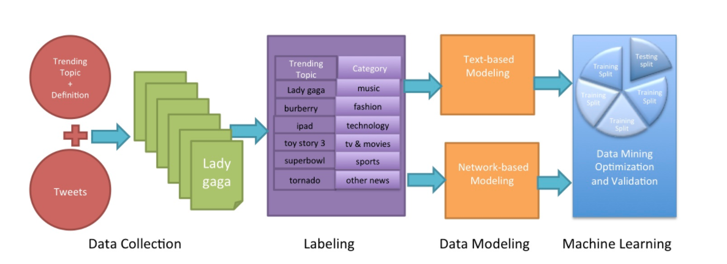

Figure 1: Architectural Representation of Data Flow in a Sentiment Analysis Model

1.1 LSTM Recurrent Neural Network:

The architecture of the Long-Short-Term-Memory neural network is suitable for sentimental analysis task which involves the learning from previous time steps of textual data. The data is passed in the steps of sequences in to the LSTM network. As seen in the below structure Figure 2, the LSTM cell obtains the previous cell output and the current cell input as combined input. This gives an oppurtunity for a LSTM cell to use the previous data and learn from it. One can define the back propogation to a limited time-steps to prevent over-fitting of the network to the data. The below Figure 2 shows a sequnce of LSTM units in a neural network layer

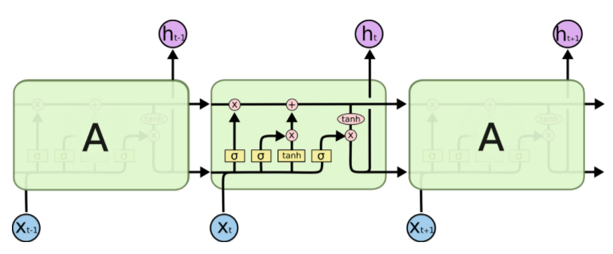
Figure 2: Long-Short-Term-Memory Recurrent Neural Network Structure
2. Background

A vast amount of research has been performed in Sentiment Analysis with various approaches. In the research paper by (Vinodhini G & Chandrasekaran R.M, 2012), the authors presented a brief survey on the Opinion Mining and Sentiment Analysis. (Pak A & Paroubek P, 2010) performed linguistic analysis on the Twitter data as a corpus to discover the phenomena and built a sentiment classifier based on the method TreeTagger for POS tagging. A broad overview of classification of Web forum opinions in multiple languages is addressed by (Abbasi, A Chen H & Salem A, 2008). The utility of the syntactic features and stylish features is measured for the sentiment classification of Arabic and English content. The research paper by (Taboada, M., Brooke, J., Tofiloski, M., Voll, K., & Stede, M. (2011).) presents an approach based on lexicon-based extraction of sentiment from a text. He uses the Sentiment Orientation Calculator to incorporate negation and intensification by using dictionaries of words annotated with their semantic orientation like strength and polarity. The paper further applies this calculator method to classify polarity and to assign a negative or a positive label to the text which captures the text’s opinion. In this research paper, the author is successful in proving the performance of SO-CAL is consistent on completely unseen data as well as across domains. The paper also describes the process of creation of the dictionary and evaluate its consistency and reliability by using the Mechanical Turk.

In the research paper by (Morency, L. P., Mihalcea, R., & Doshi, P. (2011, November)), the author highlights the fact of existence of data in various modes like videos, texts and images and the challenge in obtaining the information from across various modes of the data. The author comes with a concept of multimodal sentiment analysis and provides a proof of concept with experiments that builds a joint model that integrates the audio, visual and text features and identifies the relevant sentiment web videos. In the research paper (Tan, C., Lee, L., Tang, J., Jiang, L., Zhou, M., & Li, P. (2011, August)), the author tries to show that the information derived from social relationships can be used to improve user-level analysis. This research idea was developed on a motive that the users who are “connected” someway would share a significant amount of common opinions which will form a viewpoint of the user from their utterances. The research has made use of twitter data and applied a semi-supervised approach which can be said as transductive learning. The results of this paper show that the use of social network information is helpful in obtaining better results than a SVM based approach which has only to textual features. In the research paper by (Tang D, Qin B and Tang Liu, 2015), the authors addressed the application of deep learning algorithms on IMDB datasets. The accuracy results of LSTM network are only 45% which needs to be improved. However, none of this research provided reliable results and hence a deep learning network would be a solution for the best accuracy.
3. Motivation

Opinion Mining or Sentiment Analysis has a great impact on today’s world in framing marketing strategies, determining the behavior of the users, influencing the social problem and so on. The research in Sentiment Analysis needs to be extensive and accurate which will have a greater impact. Machine Learning and Deep Learning can become handful to obtain the optimum design and accuracy for Sentiment Classification. Among all the algorithms, the recurrent neural networks can learn from vast amount of data and from past experiences which would obtain satisfactory results. The available deep learning libraries like Keras, Pytorch, mxnet and Tensorflow made it easy for researchers to developers to build robust models. The application of tflearn library in building a sentiment classifier has been not explored. The wide range of functionalities provided by this high-level API of Tensorflow will be a great help in building a sentiment classifier model.

4. Research Hypothesis

This research will answer the following hypothetical questions:
- Whether a detailed analysis is performed on the current literature on Sentiment Analysis
- Whether the proposed Deep Learning approach using LSTM has better accuracy than the existing methods.
- Whether using Tensorflow and tflearn libraries has provided robust graphical results to interpret

5. Design

We have followed the traditional machine learning data flow. In the initial stages, we have downloaded the first 10,000 samples IMBD dataset and modified the data with respect to the algorithm. We performed the Sequence Padding and converted labels into binary vectors in the data pre-processing stage. We have designed the neural network using LSTM layers. The network design involved the building of the base layer, embedded layer, LSTM layer and fully connected layer. The design flow can be seen in Figure 3:

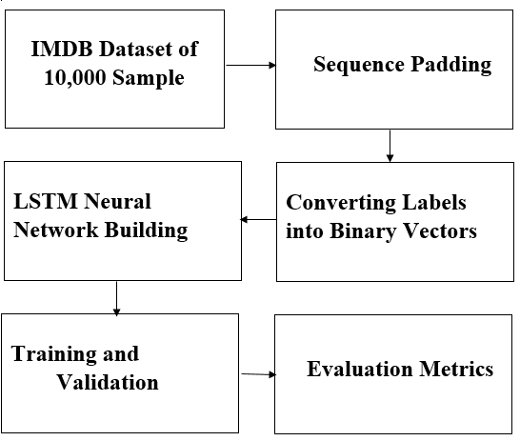

Figure 3: Flow diagram of the LSTM Sentiment Analysis model

6. Implementation:

The algorithm is implemented in Python with the help of tflearn library. We have imported built-in functions of tflearn : “to_categorical” for converting the labels to binary vectors and “pad_sequneces” to perform the sequence padding up to the length “100”. We then built the base layer of the network with size “100” and then the following layers. It has to be noted that each layer’s output is provided as input to the following layer. We then trained the network with the help of “tf.learn
and “model.fit” functions with the corresponding parameters required for the network.

6.1 Algorithm:

#Importing the required modules
from __future__ import division, print_function, absolute_import

import tensorflow as tf
tf.reset_default_graph ()

import tflearn

from tflearn.data_utils import to_categorical, pad_sequences
from tflearn.datasets import imdb

# Data Set Loading

# IMDB Dataset loading
train, test, _ = imdb. load_data (path='imdb.pkl', n_words=10000, valid_portion=0.1)

trainX, trainY = train
testX, testY = test

# Data preprocessing
# Sequence padding
trainX = pad_sequences (trainX, maxlen=100, value=0.)
testX = pad_sequences (testX, maxlen=100, value=0.)
# Converting labels to binary vectors
trainY = to_categorical (trainY, nb_classes=2)
testY = to_categorical (testY, nb_classes=2)

# Building the network

# Network building
net = tflearn. input_data ([None, 100])
net = tflearn. embedding (net, input dim=10000, output dim=128)
net = tflearn. Lstm (net, 128, dropout=0.8)
net = tflearn. fully_connected (net, 2, activation='softmax')
net = tflearn. Regression (net, optimizer='adam', learning_rate=0.001,loss='categorical_entropy')

#Training the Model
# Training
model = tflearn.DNN (net, tensorboard_verbose=3, tensorboard_dir = "C:/Users/manp/Documents/lal")
model. Fit (trainX, trainY, n_epoch =10, validation_set=(testX, testY), show_metric=True,
batch_size=32)

7. Experimental Results:

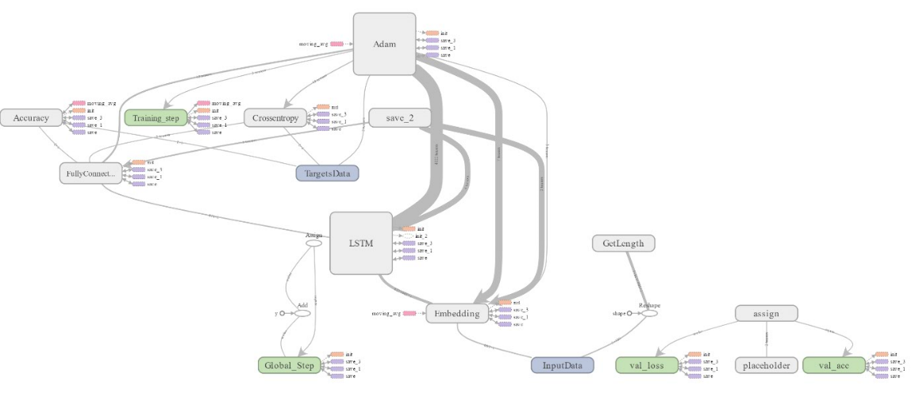
Figure 4: The network structure extracted from the tensorboard view

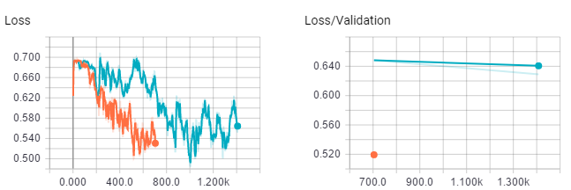

Figure 5: Variations of Cross Entropy loss during the training (across epochs)

5. Conclusions

Summary:

In this research. we have proposed a deep learning approach for Sentiment Analysis on IMDB movie dataset using LSTM recurrent neural network. The evaluation results show that our approach has outperformed all the existing methods with a classification accuracy of 98.3%.

Future Work:

The future research work would be applying on larger review datasets along with the gated recurrent neural networks for lightweight applications.

References

- Vinodhini, G., & Chandrasekaran, R. M. (2012). Sentiment analysis and opinion mining: a survey. International Journal, 2(6), 282-292
- Pak, A., & Paroubek, P. (2010, May). Twitter as a Corpus for Sentiment Analysis and Opinion Mining. In LREc (Vol. 10, No. 2010).
- Abbasi, A., Chen, H., & Salem, A. (2008). Sentiment analysis in multiple languages: Feature selection for opinion classification in web forums. ACM Transactions on Information Systems (TOIS), 26(3), 12
- Tang, D., Qin, B., & Liu, T. (2015, September). Document Modeling with Gated Recurrent Neural Network for Sentiment Classification. In EMNLP (pp. 1422-1432).
- Morency, L. P., Mihalcea, R., & Doshi, P. (2011, November). Towards multimodal sentiment analysis: Harvesting opinions from the web. In Proceedings of the 13th international conference on multimodal interfaces (pp. 169-176). ACM.
- Tan, C., Lee, L., Tang, J., Jiang, L., Zhou, M., & Li, P. (2011, August). User-level sentiment analysis incorporating social networks. In Proceedings of the 17th ACM SIGKDD international conference on Knowledge discovery and data mining (pp. 1397-1405). ACM.
- Taboada, M., Brooke, J., Tofiloski, M., Voll, K., & Stede, M. (2011). Lexicon-based methods for sentiment analysis. Computational linguistics, 37(2), 267-307.

