# **Pre-requisite of the set-up**

**Below are the details which are used for coding:**

Test Run Tool: Eclipse

Automation Tool: Selenium Webdriver

Code Language: java

Browser: Firefox

OS: Windows10

Package Name: com.Gurukula.Pack

Class Name: GurukulaTest

**Pre-requisite to run the test:**

1. Install java 1.8 (Both jdk and jre).
2. Install Eclipse neon.
3. Set up Selenium Webdriver with Eclipse neon.
4. Download ““selenium-server-standalone-3.0.0.jar” file:

* Navigate to <http://docs.seleniumhq.org/download/> page.
* Click on link and Download version [3.0.1](https://goo.gl/Lyo36k).

1. Download Geckodriver.exe:

* Navigate to <https://github.com/mozilla/geckodriver/releases> page.
* Install “[**geckodriver-v0.11.1-win32.zip**](https://github.com/mozilla/geckodriver/releases/download/v0.11.1/geckodriver-v0.11.1-win32.zip)”.
* Unzip geckodriver.exe.

1. Download “gurukula-0.0.1-SNAPSHOT.war” file from github.

**Set up Project:**

1. Open Eclipse.
2. Click on New->java Project.
3. Enter Project name, GurukulaProj. Click on Finish button.
4. Project name will appear to the left hand side of Eclipse under ‘Package Explorer’.
5. Two folders will be automatically created in the Project, “src” and “JRE System Library”.
6. Right click on “src” folder, click on New->Class.
7. Enter package name as “com.Gurukula.Pack”.
8. Enter class name as “GurukulaTest”.
9. Select check box ‘public static void main (String[] args).
10. Click on “Finish Button.
11. Right click on Project name, GurukulaProj and click properties.
12. Click Java build path and navigate to Library.
13. Click “Add Extenal JARS..” and add “selenium-server-standalone-3.0.0.jar”. Hit “Ok”.
14. Copy Geckodriver.exe and paste it in GurukulaProj.

**Below is the image of Project set-up:**

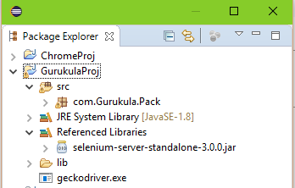

**Run the Command prompt:**

1. Open the command prompt from start.
2. Go to the directory where “gurukula-0.0.1-SNAPSHOT.war” file is kept through cd prompt.
3. Run Java – jar gurukula-0.0.1-SNAPSHOT.war
4. Wait until it generates external host.

**Below is the image of external link:**

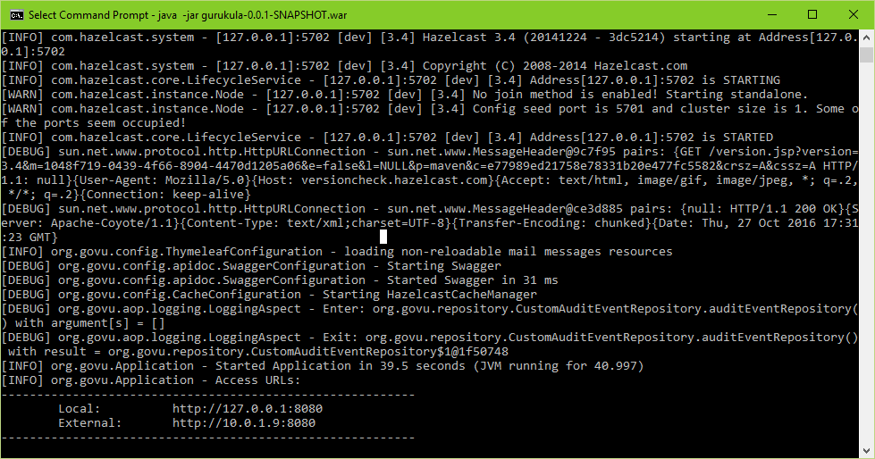

**Below is the package and class details:**

**package** com.Gurukula.Pack;

**import** **static** org.junit.Assert.*;

**import** java.util.List;

**import** java.util.Random;

**import** java.util.concurrent.TimeUnit;

**import** java.util.stream.DoubleStream;

**import** org.junit.Test;

**import** org.openqa.selenium.By;

**import** org.openqa.selenium.NoSuchElementException;

**import** org.openqa.selenium.WebDriver;

**import** org.openqa.selenium.WebElement;

**import** org.openqa.selenium.firefox.FirefoxDriver;

**import** org.openqa.selenium.support.ui.Select;

**public** **class** GurukulaTest {

@Test

**public** **void** test() **throws** InterruptedException

{

/*** Code has to copied here ***/

}

}