# **Defects – Description & Screenshot**

**1.Defect ID:** Defect-01

**Summary:** Staff search result is not working properly.

**Steps to reproduce:**

1. Navigate to Staff screen.
2. Create few staffs,
3. Search with created Staff name/ Branch name.

**Expected Result:** Search result page should be displayed for the queried Staff/Branch Name.

**Actual Result:** Search result page is not getting displayed value for “Branch”. It is showing null on Branch.

**Screenshots:**

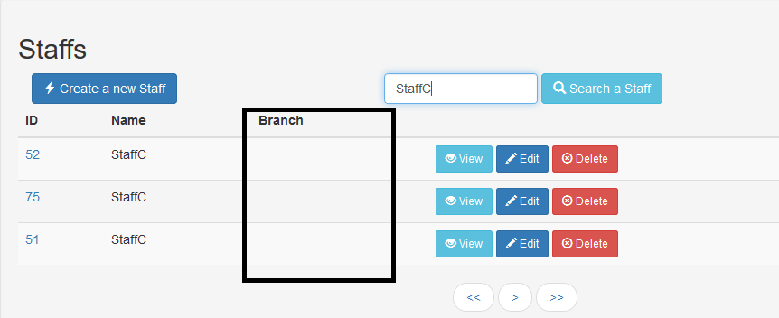

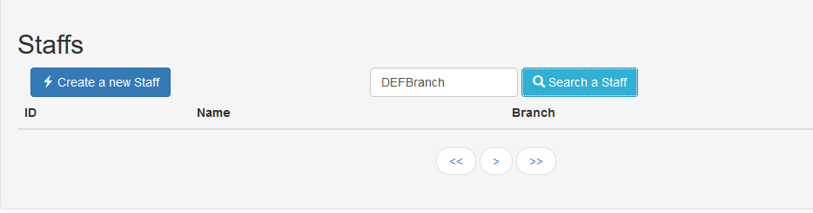

**2.Defect ID:** Defect-02

**Summary:** Not able to register a new account.

**Steps to reproduce:**

1. Open Gurukula Home page.
2. Click on “[Register a new account](http://10.0.1.9:8080/#/register)”.
3. Enter required fields.
4. Click on “Register” button.to Staff screen.

**Expected Result:** New account should be registered.

**Actual Result:** Registration failed! Please try again later.

**Screenshots:**

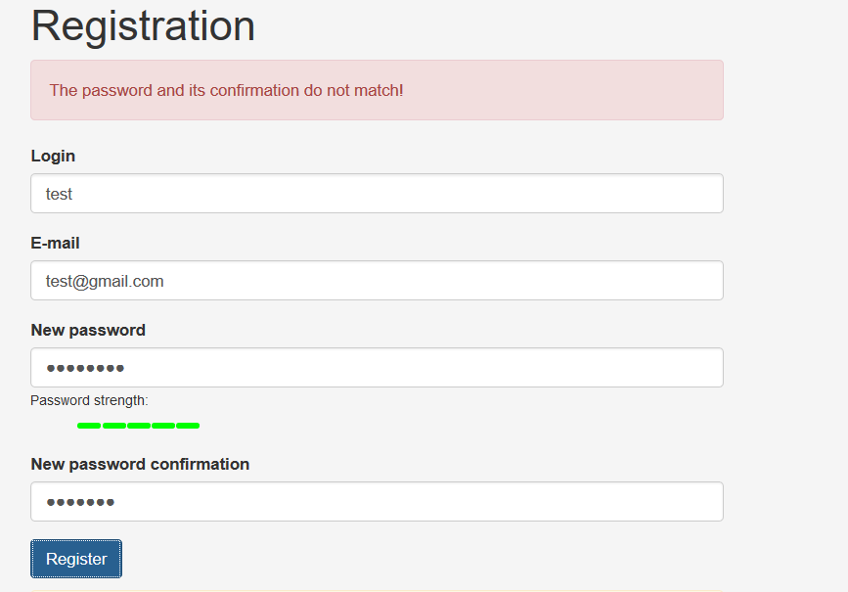

**3.Defect ID:** Defect-03

**Summary:** No pagination found in Branch screen.

**Steps to reproduce:**

1. Navigate to Branch screen.
2. Create more than 50 Branch.

**Expected Result:** Pagination button should come on Branch page.

**Actual Result:** No pagination found in Branch screen.