WEEK-1
2520030182 P.VENKATA SRI SAI MADHURIMA

1.CREATE DATABASE
A data base is created
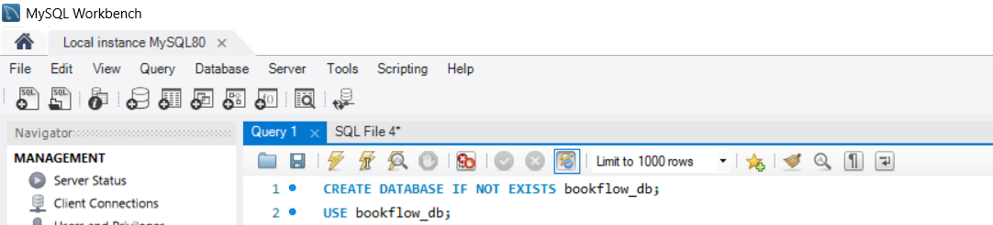

2.Create tables members ,books
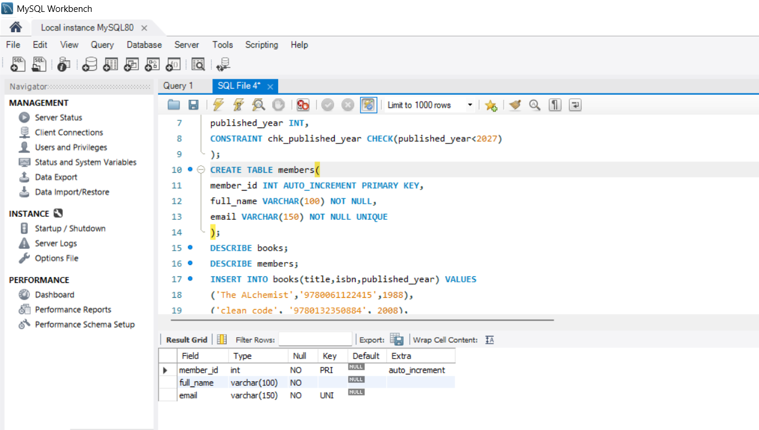
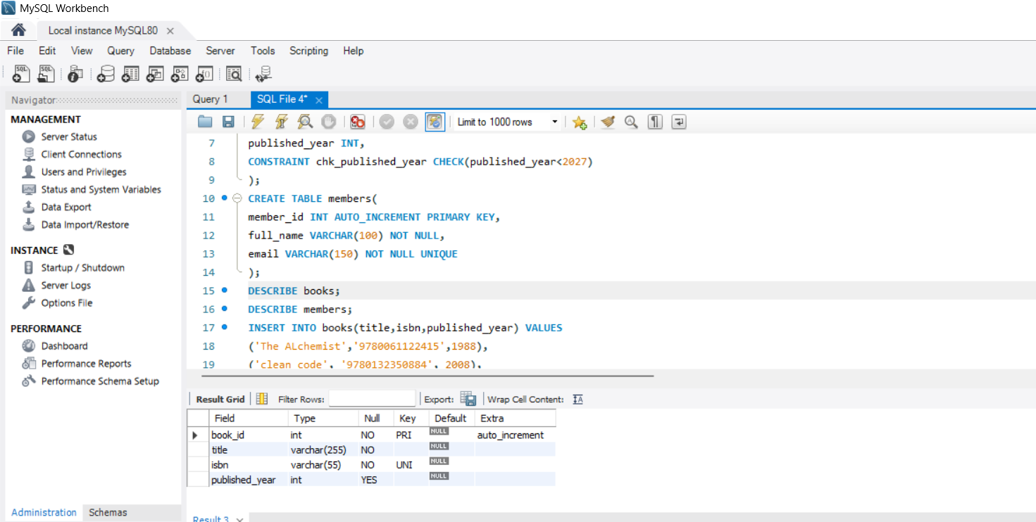

3.Insert values
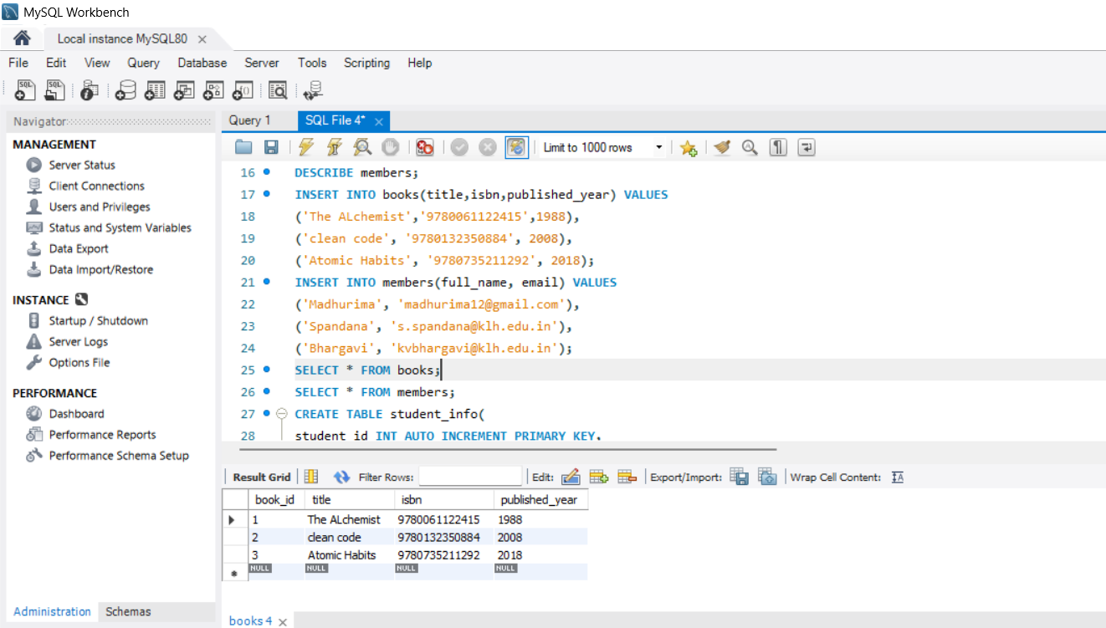

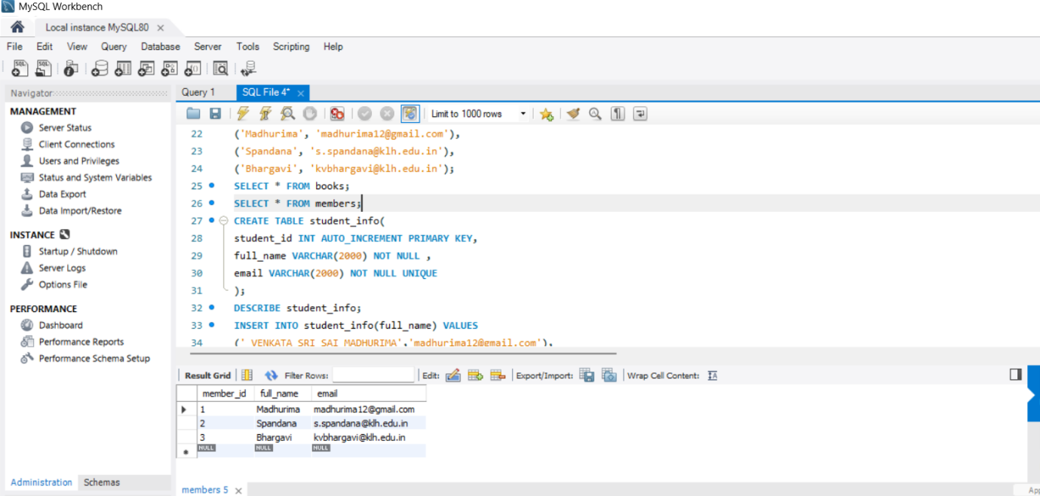

4.Enter Values into table:
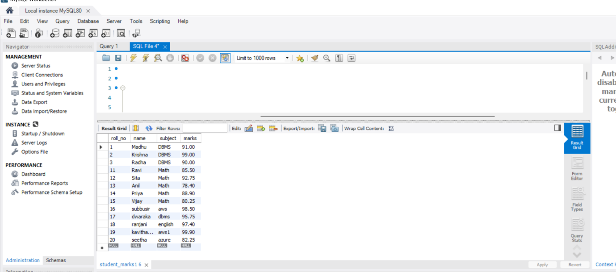

5.Aggregate functions ,filtering queries

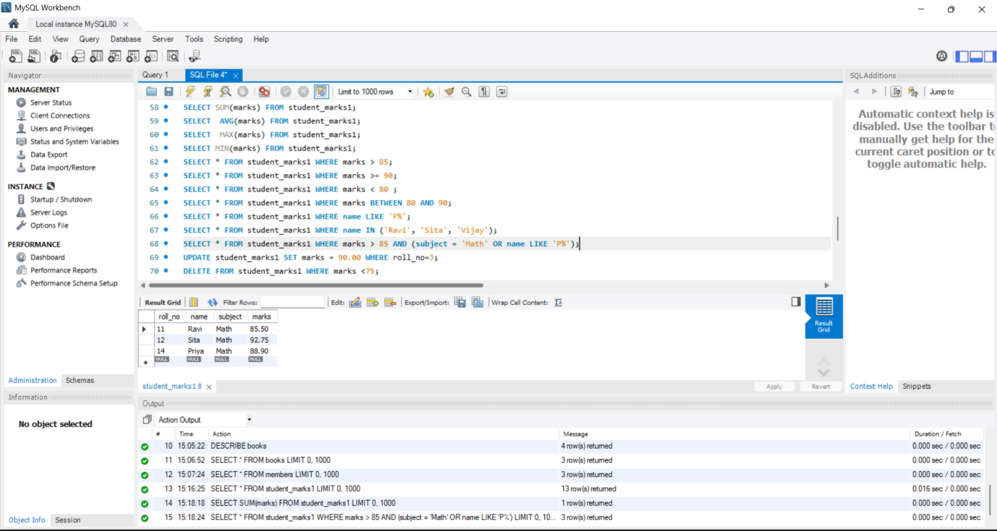

6.Update ,delete Queries
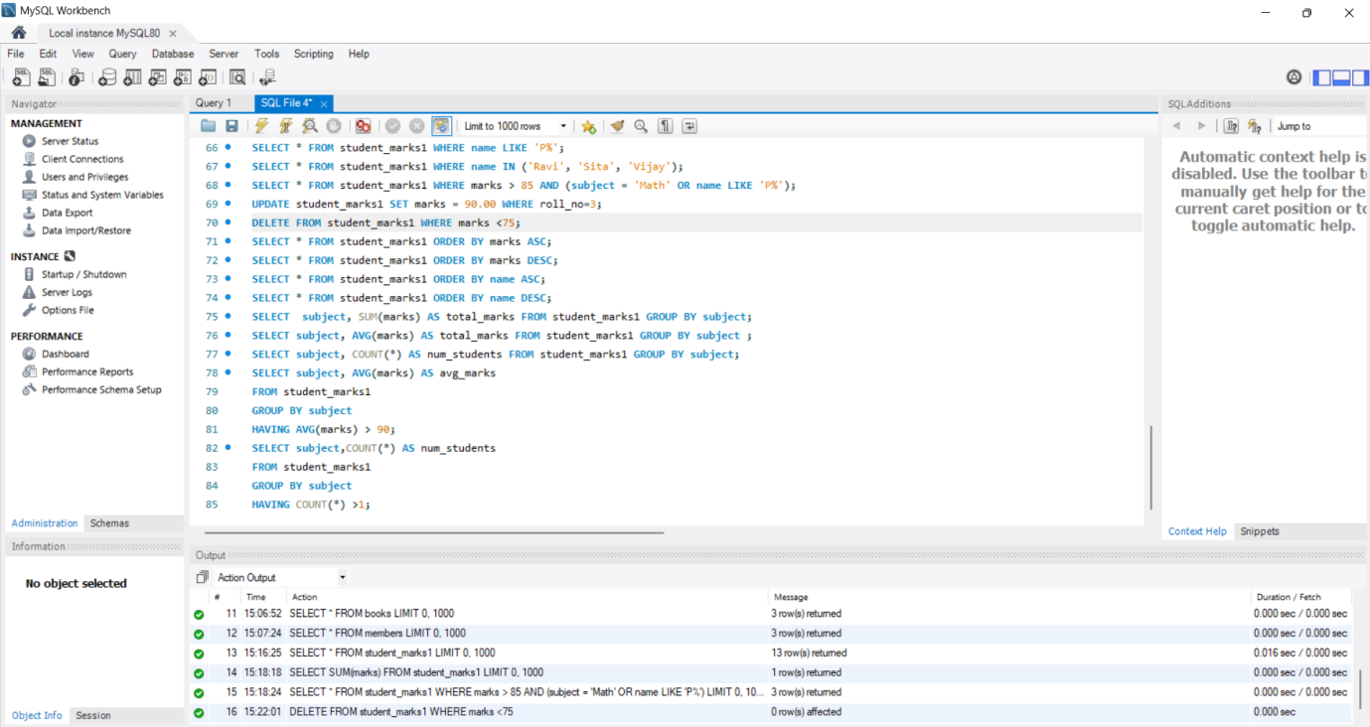

7.Group By
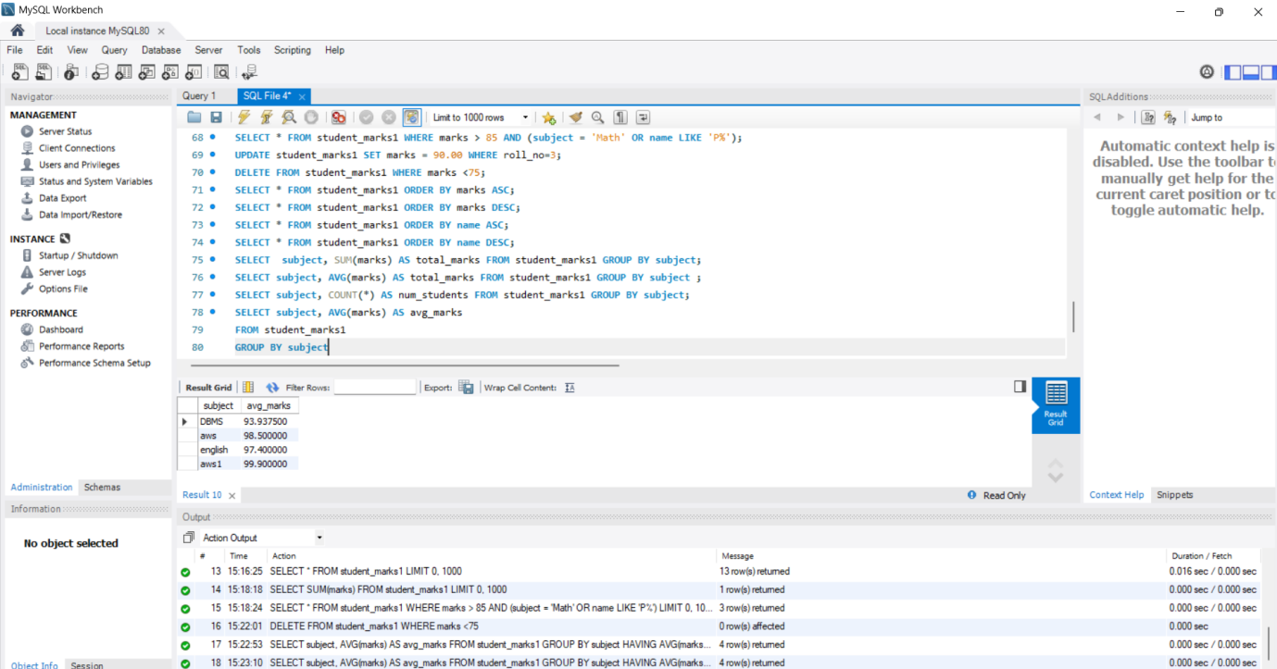

8.HAVING
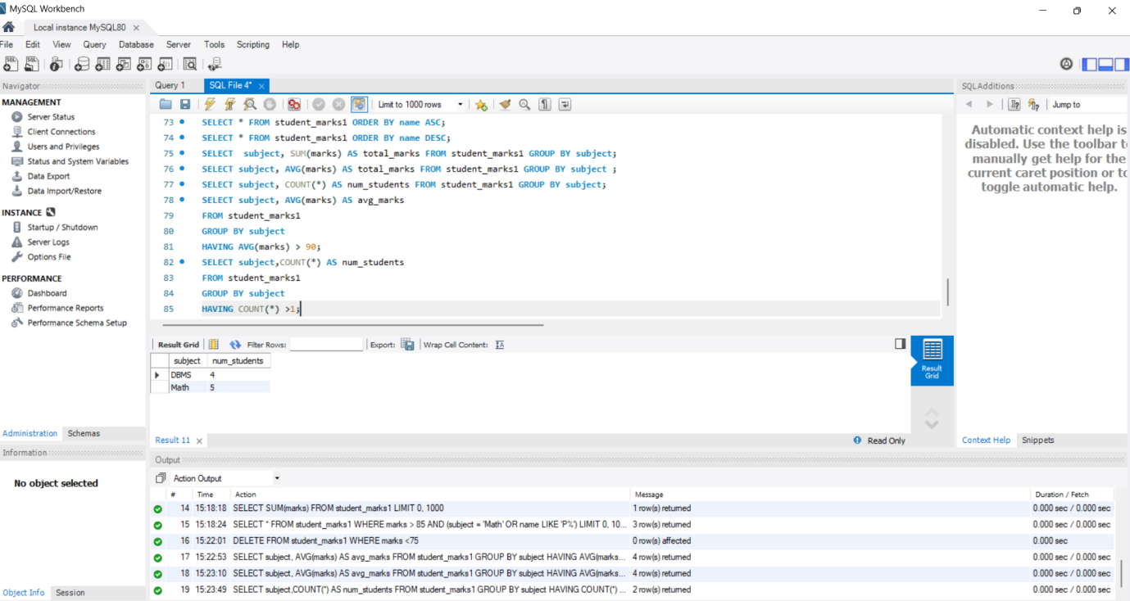

WEEK 1 COMPLETED
P.VENKATA SRI MADHURIMA
2520030182

