Project Title
Citation Flow Analysis for Identifying Influential Research Papers
Project Report submitted for the partial fulfilment of grade for the course

Data Structures and Algorithms -3 (25CS2103E)
in

A.Y. 2026-2027

Submitted by
M. Jagadish Krishna (2520030165)
Sai Teja (2520030241)
P. Venkata Sri Sai Madhurima (2520030182)

Team Number:
Section:

Under the guidance of

Prof. Anuradha

Department of CSE
Hyderabad-500090, Telangana, India.

K L (Deemed to be) University
DEPARTMENT OF COMPUTER SCIENCE AND ENGINEERING



DECLARATION

The Mini Project Report entitled “Citation Flow Analysis for Identifying Influential Research Papers” is a record of Bonafide work of M. Jagadish Krishna – 2520030165, Sai Teja – 2520030241, P. Venkata Sri Sai Madhurima – 2520030182 submitted in partial fulfillment for the award of B. Tech in Computer Science and Engineering to the K L University. The results embodied in this report have not been copied from any other departments/University/Institute.

M. Jagadish Krishna – 2520030165
Sai Teja – 2520030241
P. Venkata Sri Sai Madhurima – 2520030182

K L (Deemed to be) University
DEPARTMENT OF COMPUTER SCIENCE AND ENGINEERING
CERTIFICATE

This is to certify that the mini project based report entitled “Citation Flow Analysis for Identifying Influential Research Papers” is a bonafide work done and submitted by M. Jagadish Krishna – 2520030165, Sai Teja – 2520030241, P. Venkata Sri Sai Madhurima – 2520030182 in partial fulfillment of the requirements for the award of the degree of BACHELOR OF TECHNOLOGY in Department of Computer Science and Engineering, K L (Deemed to be University), during the academic year 2026-2027.

Signature of the Supervisor

Signature of the HOD Signature of the External Examiner

ACKNOWLEDGEMENT

The success in this project would not have been possible but for the timely help and guidance rendered by many people. Our wish to express my sincere thanks to all those who has assisted us in one way or the other for the completion of my project.

Our greatest appreciation to our guide, Prof. Anuradha, Department of CSE, which cannot be expressed in words for the tremendous support, encouragement and guidance for this project.

We express our gratitude to Dr. P. Venkateshwar Rao (CSE), Head of the Department of Computer Science and Engineering, for providing us with adequate facilities, ways and means by which we are able to complete this project-based Lab.

We thank all the members of teaching and non-teaching staff members, and also who have assisted me directly or indirectly for successful completion of this project. Finally, I sincerely thank my parents, friends and classmates for their kind help and cooperation during my work.

M. Jagadish Krishna – 2520030165
Sai Teja – 2520030241
P. Venkata Sri Sai Madhurima – 2520030182
TABLE OF CONTENTS

S.No. | Contents | Page no.
1. | Abstract | 6
2. | Introduction | 7
3. | Literature survey | 7
4. | Problem Statement and Objectives | 9
5. | Hardware and Software requirements | 10
6. | Implementation | 11
7. | Results & Discussion | 15
8. | Conclusion & Future Scope | 16
9. | References | 17

1.ABSTRACT

This project presents a simple, graph-based citation analysis system that helps in understanding how research papers are connected through citations. Each research paper is represented as a node and every citation as a directed edge, so the collection of papers forms a directed citation network that is stored as an adjacency list. The network is built from the Cora citation dataset using Java. Starting from any selected paper, the system explores the network with Breadth-First Search (BFS), which visits connected papers level by level, and Depth-First Search (DFS), which follows one citation path deeply before backtracking. The system also counts how often each paper is cited and lists the most cited papers, which gives a first indication of influential publications. The results show how citations move from one paper to another and how knowledge spreads across related work. The project demonstrates a practical use of data structures and algorithms on a real-world problem and provides a foundation for advanced techniques such as PageRank, centrality analysis and research-trend detection.
Team Name:

Team Logo (if any):

Team Members:
- M. Jagadish Krishna, 2520030165
- Sai Teja, 2520030241
- P. Venkata Sri Sai Madhurima, 2520030182

- INTRODUCTION

Research papers do not exist in isolation. Every paper builds on earlier work and refers to it through citations, and together these citations form a large network of academic knowledge. When the number of publications is high, it becomes difficult to find out which papers are influential, how ideas move from one paper to another, and which papers are related to each other.
This project models the citation data as a directed graph. Each research paper is a vertex, and each citation is a directed edge from the citing paper to the cited paper. The graph is built from the Cora dataset and stored as an adjacency list in Java. The graph traversal algorithms Breadth-First Search (BFS) and Depth-First Search (DFS) are then used to explore the network from any selected paper and to show how citations flow between papers. The most cited papers are also listed to give an idea of which publications are influential.
The system is intentionally simple. It does not need external databases or heavy network-analysis libraries, so the underlying data structures and algorithms stay easy to follow for students and researchers who want to explore academic literature.
The rest of this report is organised as follows: Section 3 reviews related work, Section 4 states the problem and objectives, Section 5 lists the hardware and software requirements, Section 6 presents the implementation, Section 7 discusses the results, Section 8 gives the conclusion and future scope, and Section 9 lists the references.
- LITERATURE SURVEY
Several research studies have used graph-based techniques to analyse citation networks and the relationships between scientific publications. Traditional citation analysis focuses mainly on citation counts, where the number of times a paper is cited is used as an indicator of its importance. However, citation counts alone do not show the complete relationship between papers. In graph-based analysis, publications are nodes and citations are edges, which makes it possible to study the structure of the research network. The following earlier works are related to this project.
Citation indexing (Garfield, 1955) [1]. Garfield proposed citation indexes that list, for every paper, the later papers that cite it. This made it possible to trace how ideas flow through the literature and became the basis of modern citation databases. Our project follows the same idea by storing every citation as a link between two papers.
Networks of scientific papers (Price, 1965) [2]. Price studied the pattern of references between scientific papers and showed that they form a network in which a small number of papers receive a large share of the citations. This work motivates treating a collection of papers as a graph, which is the representation used in this project.
The h-index (Hirsch, 2005) [3]. Hirsch proposed the h-index, a single number that combines how many papers an author has with how often they are cited. It is still built on citation counts, which shows why counting is the usual starting point for measuring influence and why structure-aware methods are needed for a fuller picture.
PageRank (Page et al., 1999) [4]. PageRank ranks items by considering not only how many links point to them but also how important the linking items are. The same idea can be applied to citation graphs to rank influential papers. It is a natural next step for this project and is listed under future scope.
Graphs over time (Leskovec et al., 2005) [5]. This study analysed how large real-world graphs grow, including a high-energy physics citation network that is available as the cit-HepTh dataset. It confirms that citation data is naturally modelled as a directed graph, but such datasets are large and need considerable computing resources.
The Cora dataset (McCallum et al., 2000; Sen et al., 2008) [6][7]. Cora contains machine-learning papers and the citation links between them, grouped into subject categories. It is a widely used benchmark for citation networks and is the dataset used in this project to build the directed citation graph.
Graph neural networks on citation graphs (Kipf and Welling, 2017) [8]. This work classifies papers in citation networks such as Cora using graph convolutional networks. Such machine-learning approaches give strong results, but they need training data and complex libraries, whereas this project concentrates on the basic graph data structure and traversal algorithms.
Graph traversal (Cormen et al.) [9]. BFS explores a graph level by level using a queue, whereas DFS explores one path as deeply as possible before backtracking. Both run in O(V + E) time on an adjacency-list graph, which makes them suitable for exploring citation networks.
Many advanced citation-analysis systems require large datasets, external databases, complex network-analysis libraries and considerable computational resources. The proposed project instead focuses on a simpler Java-based implementation that demonstrates the fundamental concept of citation flow using graph data structures and traversal algorithms.
- Problem Statement and Objectives

Problem Statement:
Research papers are linked by a very large number of citations, and understanding manually how citations flow between them becomes difficult as the number of papers grows.

Problem Description:
A systematic, graph-based method is needed to represent papers and their citation relationships and to explore the resulting network using graph traversal algorithms (BFS and DFS).
Objectives:
Identify the Project’s Purpose: The project was initiated because citation relationships are too numerous to understand manually. It solves this by representing papers and citations as a directed graph and exploring it with BFS and DFS, which gives a clear picture of how citations flow between papers. The objectives of the project are:
- To represent research papers as nodes in a directed graph.
- To represent citation relationships as directed edges.
- To construct and display a citation graph.
- To implement Breadth-First Search (BFS) for citation traversal.
- To implement Depth-First Search (DFS) for citation traversal.
- To analyze the connections between research papers.
- To provide a simple Java-based implementation of citation network analysis.
- To create a foundation for future citation analysis techniques such as influence analysis and research trend detection.
- HARDWARE AND SOFTWARE REQUIREMENTS
Hardware Requirements:
- Processor – Intel Core i3 or above
- RAM – 4 GB minimum
- Storage – 1 GB free space
- Keyboard and mouse
- Internet connection
Software Requirements:
- Operating system – Windows / Linux / macOS
- Java JDK 17 or above (JVM and javac)
- Visual Studio Code (editor)
- Dataset – Cora citation dataset
- Concepts used – directed graph (adjacency list), BFS and DFS
- IMPLEMENTATION

The system is implemented in Java using four modules: Paper, CitationGraph, Traversal and Main. Figure 6.1 shows the workflow of the system: the Cora dataset is loaded, the directed citation graph is built, a starting paper is selected, BFS or DFS is performed, and the citation relationships are displayed.
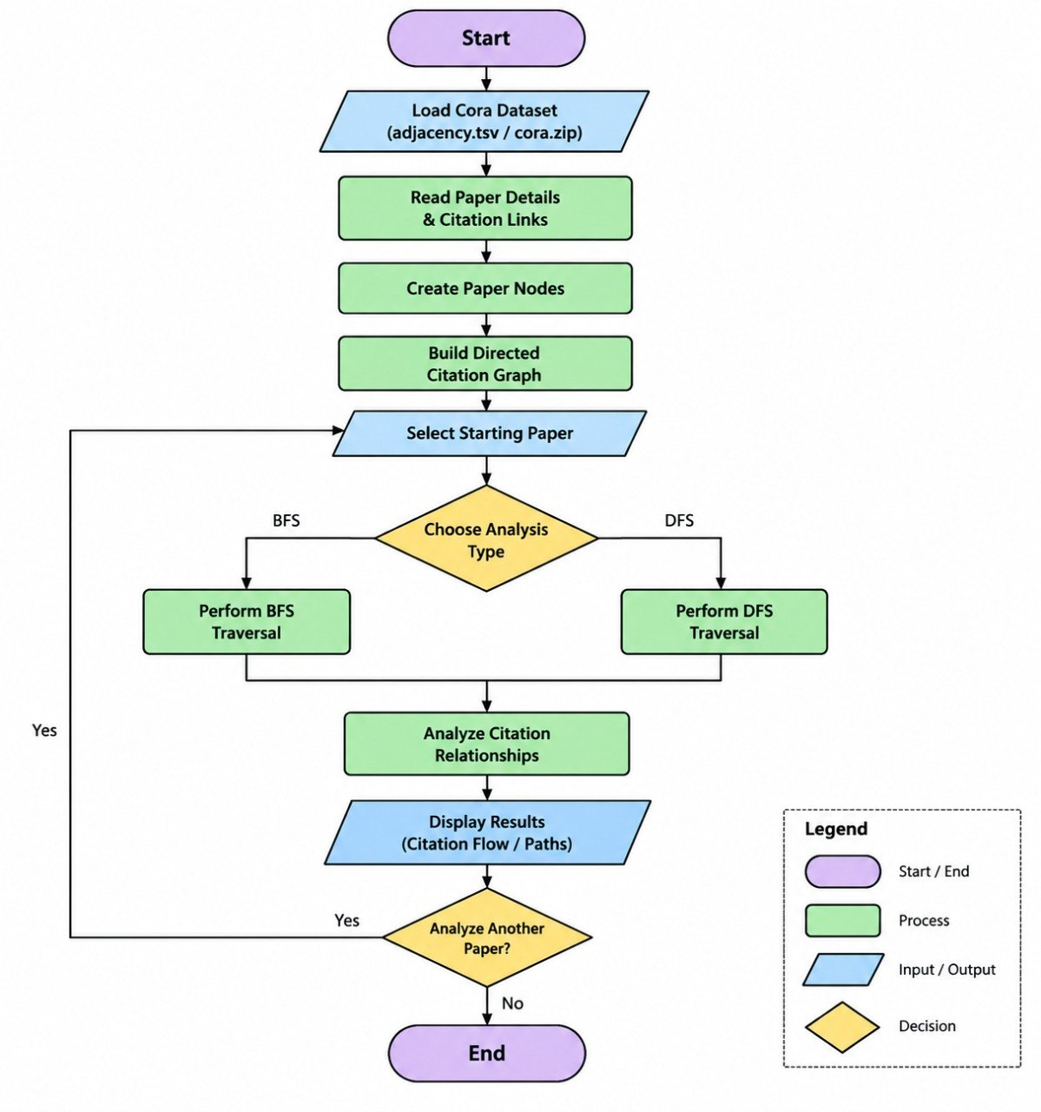
Figure 6.1: Flowchart of the Citation Flow Analysis system
Module 1 – Paper.java (vertex)
Each research paper is a vertex. It stores the paper id, its subject category and the list of papers it cites (its outgoing edges).
import java.util.ArrayList;
import java.util.List;

/** Represents one research paper (a vertex of the citation graph). */
public class Paper {
private final String id;
private String category = "Unknown"; // subject label
private final List<String> cites = new ArrayList<>(); // outgoing edges

public Paper(String id) { this.id = id; }

public String getId() { return id; }
public String getCategory() { return category; }
public void setCategory(String category) { this.category = category; }
public List<String> getCites() { return cites; }
public void addCitation(String targetId) { cites.add(targetId); }
}

Module 2 – CitationGraph.java (graph construction)
Builds the directed citation graph as an adjacency list. It loads the Cora files, adds each citation as a directed edge from the citing paper to the cited paper, counts papers per subject and finds the most cited papers (highest in-degree).
import java.io.BufferedReader;
import java.io.FileReader;
import java.io.IOException;
import java.util.*;

/** Directed citation graph stored as an adjacency list. */
public class CitationGraph {
private final Map<String, Paper> papers = new LinkedHashMap<>();
private final Map<String, Integer> inDegree = new HashMap<>();

private Paper getOrCreate(String id) {
return papers.computeIfAbsent(id, Paper::new);
}

/** Adds the directed edge source -> target (source cites target). */
public void addCitation(String source, String target) {
getOrCreate(source).addCitation(target);
getOrCreate(target);
inDegree.merge(target, 1, Integer::sum);
}

/** Reads cora.content: first token = paper id, last token = subject label. */
public void loadContent(String path) throws IOException {
try (BufferedReader br = new BufferedReader(new FileReader(path))) {
String line;
while ((line = br.readLine()) != null) {
String[] t = line.trim().split("\\s+");
if (t.length >= 2) getOrCreate(t[0]).setCategory(t[t.length - 1]);
}
}
}

/** Reads cora.cites: each line is "citedPaper citingPaper". */
public void loadCites(String path) throws IOException {
try (BufferedReader br = new BufferedReader(new FileReader(path))) {
String line;
while ((line = br.readLine()) != null) {
String[] t = line.trim().split("\\s+");
if (t.length >= 2) addCitation(t[1], t[0]); // citing -> cited
}
}
}

public boolean contains(String id) { return papers.containsKey(id); }
public Paper getPaper(String id) { return papers.get(id); }
public int paperCount() { return papers.size(); }

public int edgeCount() {
int total = 0;
for (Paper p : papers.values()) total += p.getCites().size();
return total;
}

/** Number of papers in every subject category. */
public Map<String, Integer> categoryCounts() {
Map<String, Integer> counts = new TreeMap<>();
for (Paper p : papers.values()) counts.merge(p.getCategory(), 1, Integer::sum);
return counts;
}

/** The n most cited papers (highest in-degree). */
public List<Map.Entry<String, Integer>> topCited(int n) {
List<Map.Entry<String, Integer>> list = new ArrayList<>(inDegree.entrySet());
list.sort((a, b) -> b.getValue() - a.getValue());
return list.subList(0, Math.min(n, list.size()));
}
}

Module 3 – Traversal.java (BFS and DFS)
Implements the two traversal algorithms. BFS uses a queue and visits papers level by level; DFS uses recursion and follows one citation path deeply before backtracking. Both take O(V + E) time.
import java.util.*;

/** BFS and DFS traversals over the citation graph. */
public class Traversal {

/** Level-by-level traversal using a queue. */
public static List<String> bfs(CitationGraph g, String start) {
List<String> order = new ArrayList<>();
Set<String> visited = new HashSet<>();
Queue<String> queue = new LinkedList<>();
queue.add(start);
visited.add(start);
while (!queue.isEmpty()) {
String cur = queue.poll();
order.add(cur);
for (String next : g.getPaper(cur).getCites()) {
if (visited.add(next)) queue.add(next);
}
}
return order;
}

/** Deep-first traversal using recursion (backtracks when stuck). */
public static List<String> dfs(CitationGraph g, String start) {
List<String> order = new ArrayList<>();
dfsVisit(g, start, new HashSet<>(), order);
return order;
}

private static void dfsVisit(CitationGraph g, String cur,
Set<String> visited, List<String> order) {
visited.add(cur);
order.add(cur);
for (String next : g.getPaper(cur).getCites()) {
if (!visited.contains(next)) dfsVisit(g, next, visited, order);
}
}
}

Module 4 – Main.java (user interface)
Console program that loads the dataset, prints the graph summary, asks for a starting paper and the analysis type (BFS or DFS), and repeats until the user stops.
import java.util.List;
import java.util.Map;
import java.util.Scanner;

/** Console driver: load graph, show summary, then run BFS / DFS on request. */
public class Main {
public static void main(String[] args) throws Exception {
CitationGraph g = new CitationGraph();
g.loadContent(args.length > 0 ? args[0] : "cora.content");
g.loadCites(args.length > 1 ? args[1] : "cora.cites");

System.out.println("Papers (nodes) : " + g.paperCount());
System.out.println("Citations (edges) : " + g.edgeCount());
System.out.println("Papers per subject:");
for (Map.Entry<String, Integer> e : g.categoryCounts().entrySet())
System.out.println(" " + e.getKey() + ": " + e.getValue());

System.out.println("Top 5 cited papers:");
for (Map.Entry<String, Integer> e : g.topCited(5))
System.out.println(" " + e.getKey() + ": " + e.getValue() + " citations");

Scanner sc = new Scanner(System.in);
String again;
do {
System.out.print("\nEnter starting paper id: ");
String start = sc.next();
if (!g.contains(start)) {
System.out.println("Paper not found.");
} else {
System.out.print("Choose analysis (1 = BFS, 2 = DFS): ");
int choice = sc.nextInt();
List<String> path = (choice == 1) ? Traversal.bfs(g, start)
: Traversal.dfs(g, start);
System.out.println((choice == 1 ? "BFS" : "DFS") + " order: "
+ String.join(" -> ", path));
}
System.out.print("Analyze another paper? (yes/no): ");
again = sc.next();
} while (again.equalsIgnoreCase("yes"));
System.out.println("Done.");
}
}

- RESULTS & DISCUSSION
The system shows how research papers are connected through citations. Each research paper is treated as a node and each citation as a link between two papers. The system builds the citation graph and can start from any selected paper, using either of two methods: BFS or DFS. BFS checks the connected papers step by step, level by level, whereas DFS follows one path deeply before going back and checking another path.
7.1 Dataset summary and most cited papers
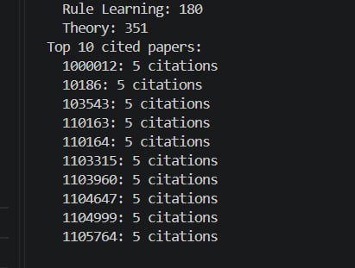
Figure 7.1: Program output on the Cora dataset
The program loads the Cora dataset and counts the papers in every subject category (for example Rule Learning: 180 and Theory: 351). It then lists the top 10 cited papers, each of which is cited 5 times in the dataset.
7.2 BFS and DFS traversal
The sample run below uses a small test graph in the Cora file format so that the traversal can be followed by hand. The starting paper is P103 and the analysis is run once with BFS and once with DFS.
Papers (nodes) : 8
Citations (edges) : 8
Papers per subject:
Neural_Networks: 2
Rule_Learning: 2
Theory: 4
Top 5 cited papers:
P120: 2 citations
P115: 1 citations
P125: 1 citations
P105: 1 citations
P110: 1 citations

Enter starting paper id: P103
Choose analysis (1 = BFS, 2 = DFS): 1
BFS order: P103 -> P105 -> P108 -> P110 -> P112 -> P115 -> P120 -> P125
Analyze another paper? (yes/no): yes

Enter starting paper id: P103
Choose analysis (1 = BFS, 2 = DFS): 2
DFS order: P103 -> P105 -> P110 -> P115 -> P125 -> P120 -> P108 -> P112
Analyze another paper? (yes/no): no
Done.
Figure 7.2: Console output of BFS and DFS from paper P103
BFS visits P103 first, then its direct citations P105 and P108, and only then goes deeper; the path to P115 is P103 → P105 → P110 → P115. DFS follows one path to the end before going back, so after P103 → P105 → P110 it first reaches P115 and P125, and then returns to P110 to reach P120 (path P103 → P105 → P110 → P120). In this way the system shows how papers are connected and how citations move from one paper to another.
- CONCLUSION & FUTURE SCOPE
The Citation Flow Analysis project demonstrates the application of graph theory and graph traversal algorithms to academic citation networks. Research papers are modelled as vertices and citation relationships as directed edges, and with this representation the system can display and explore the relationships between papers. The implementation of BFS and DFS provides two different ways of traversing the citation network: BFS explores relationships level by level, while DFS explores citation paths deeply. All the objectives stated in Section 4 were met. The project gives a simple and practical understanding of how data structures and algorithms can be applied to a real-world research problem.

The project can be extended in the following directions:
- Near term: handle larger citation datasets and more complex research networks, and add graph visualization to display the citation relationships clearly.
- Medium term: add advanced graph algorithms such as PageRank and centrality analysis to identify important and highly connected research papers.
- Long term: integrate a database, add research trend analysis, and introduce machine-learning techniques to give deeper insight into citation patterns.
- REFERENCES
[1] E. Garfield, “Citation indexes for science: a new dimension in documentation through association of ideas,” Science, vol. 122, no. 3159, pp. 108–111, 1955. https://doi.org/10.1126/science.122.3159.108
[2] D. J. de Solla Price, “Networks of scientific papers,” Science, vol. 149, no. 3683, pp. 510–515, 1965. https://doi.org/10.1126/science.149.3683.510
[3] J. E. Hirsch, “An index to quantify an individual’s scientific research output,” Proc. Natl. Acad. Sci. USA, vol. 102, no. 46, pp. 16569–16572, 2005. https://doi.org/10.1073/pnas.0507655102
[4] L. Page, S. Brin, R. Motwani and T. Winograd, “The PageRank citation ranking: bringing order to the web,” Stanford InfoLab, 1999. http://ilpubs.stanford.edu:8090/422/
[5] J. Leskovec, J. Kleinberg and C. Faloutsos, “Graphs over time: densification laws, shrinking diameters and possible explanations,” KDD 2005. Dataset: https://snap.stanford.edu/data/cit-HepTh.html
[6] A. McCallum, K. Nigam, J. Rennie and K. Seymore, “Automating the construction of internet portals with machine learning,” Information Retrieval, vol. 3, pp. 127–163, 2000. Cora dataset: https://linqs.org/datasets/
[7] P. Sen, G. Namata, M. Bilgic, L. Getoor, B. Galligher and T. Eliassi-Rad, “Collective classification in network data,” AI Magazine, vol. 29, no. 3, pp. 93–106, 2008. https://doi.org/10.1609/aimag.v29i3.2157
[8] T. N. Kipf and M. Welling, “Semi-supervised classification with graph convolutional networks,” ICLR 2017. https://arxiv.org/abs/1609.02907
[9] T. H. Cormen, C. E. Leiserson, R. L. Rivest and C. Stein, Introduction to Algorithms, MIT Press (BFS and DFS chapters).
[10] Oracle, “Java SE 17 Documentation.” https://docs.oracle.com/en/java/javase/17/

