A CASE-STUDY BASED REPORT
ON
AN EMPIRICAL STUDY OF ANOMALY DETECTION USING DENSITY-BASED AND REPRESENTATIVE-BASED CLUSTERING ALGORITHMS
submitted in partial fulfilment of the requirements for the Course
MACHINE LEARNING
BACHELOR OF TECHNOLOGY
in
A.Y.: 2026-27
by
P.Venkata Sri Sai Madhurima 2520030182
Deepshika 2520030205
Alekhya 2520030209
Under the Esteemed guidance of
Mr. Shaik Asif
Asst.Professor, Dept. of CSE




INDEX
Abstract
Introduction
Background
Motivation for the Project
Overview of the Work Carried Out
Scope and Responsible-Use Statement
Problem Statement
Case-Study Scenario
Central Case-Study Question
Formal Problem Definition
Objectives that Guide the Study
Assumptions and Limitations
Dataset and Exploratory Data Analysis
About the Dataset
Purpose of EDA
Preparation Steps Actually Performed
EDA Exploration - Implementation
Summary of EDA Findings
Algorithm Selection and Implementation

Conclusion

Signature of the Team members

1. Abstract
Anomaly detection is the task of finding observations that deviate from the rest of a data set. It is used in medicine, finance, cybersecurity, banking, networking and transportation, where rare unusual records often matter more than typical ones. Labelled examples of anomalies are scarce and expensive to obtain, so unsupervised methods that need no labels are widely used in practice.
This case study is based on the research paper “An Empirical Study on Anomaly Detection Using Density-based and Representative-based Clustering Algorithms” (Fuhnwi, Agbaje, Oshinubi and Peter, Journal of the Nigerian Society of Physical Sciences, vol. 5, 2023, article 1364). The study compares three clustering approaches used as anomaly detectors: DBSCAN, DBSCAN++ (uniform and k-center initialization, with and without approximate nearest neighbours) and k-means−−. They are tested on six imbalanced benchmark data sets (Pima, Cardio, Wine, Glass, BreastW and Shuttle) whose outlier share ranges from 4.2% to 35%.
Performance is measured with the F1-score, false alarm rate, adjusted Rand index and Jaccard coefficient, together with running time. The main findings are that k-means−− is the more robust method overall, that DBSCAN works well on small data sets with clear density structure (Wine, BreastW), and that density-based methods struggle when outliers form small clusters, as in the Shuttle data. A small modification to DBSCAN (a cluster-size threshold) raised the Shuttle F1-score to 0.993. The choice of algorithm clearly changes detection quality and should be matched to the structure of the data.

2. Introduction

2.1 Background
In data mining and statistics, an anomaly (also called an outlier, deviant or exception) is a value or observation that differs significantly from the expected pattern. Anomaly detection methods fall into two groups. Supervised methods train on data in which anomalies are explicitly labelled. Unsupervised methods find anomalies without labels, using only the structure of the data. Unsupervised methods are more common in practice because labelled anomalies are rare.
Clustering-based techniques are a popular unsupervised option. They group similar points together, and points that fit no group well are treated as anomalies. They are usually fast because they work on the output of one clustering run. The paper looks at two families:
- Density-based clustering (DBSCAN, DBSCAN++): clusters are dense regions of points, and points in sparse regions are labelled noise.
- Representative-based clustering (k-means−−): each cluster is described by a representative centre, and the points farthest from every centre are labelled outliers.

2.2 Motivation for the Project
- Algorithm choice is unclear. Many clustering-based detectors exist, yet there are few side-by-side comparisons on data sets with different outlier shares and shapes. The authors state that this is, to their knowledge, the first empirical study of k-means−−, DBSCAN and DBSCAN++ together for anomaly detection.
- Labels are a bottleneck. Reliable labels for normal and abnormal cases are hard to get. A clustering method that finds noise points can pre-label data so that a supervised detector can be trained afterwards.
- Scalability and tuning. DBSCAN is sensitive to its parameters (eps, minPts) and slow on large data. DBSCAN++ promises speed, but its claims needed independent checking.
- Practical guidance. Practitioners need to know which method suits which kind of data, not only which method scored highest once.

2.3 Overview of the Work Carried Out
The work in the paper, and so in this case study, followed these steps:
- Selected six benchmark data sets from the UCI repository and changed some of them because plain DBSCAN could not process very large ones.
- Plotted class histograms and decided which class labels count as normal and which as noise, then reduced all labels to two classes (0 = normal, 1 = noise).
- Implemented k-means−− in Python from its pseudo-code, used scikit-learn for DBSCAN, and implemented DBSCAN++ from its pseudo-code using a KD-tree, with uniform and k-center initialization.
- Added an approximate-nearest-neighbour (ANN) version of DBSCAN and DBSCAN++ using the Annoy library so that the 43,500-record Shuttle data could be processed.
- Proposed and tested a small DBSCAN modification: a threshold on cluster size so that tiny clusters are marked as noise.
- Evaluated every run with F1-score (weighted), false alarm rate, Jaccard coefficient and adjusted Rand index, and compared run times.

2.4 Scope and Responsible-Use Statement
Scope. The study covers unsupervised, clustering-based anomaly detection on six tabular benchmark data sets. It compares DBSCAN, DBSCAN++ and k-means−− and does not cover deep-learning detectors, Isolation Forest, One-Class SVM or time-series data, which the authors list as future work.
Responsible use. Some of the data sets come from medicine (Pima diabetes, cardiotocography, breast cancer), so the following limits apply:
- The results are for comparing algorithms on public benchmark data. They are not a diagnostic tool and must not be used to make decisions about real patients.
- A point flagged as an anomaly is a candidate for human review, not proof of a fault or a condition. False alarm rates in the study are often high (for example 0.42 to 0.65 on Pima), so automatic action on flagged records would be unsafe.
- Only public, anonymised UCI data is used. No personal data is collected, and anyone reusing the method on real records must follow the relevant privacy rules.
- Reported scores depend on how classes were relabelled as “normal” and “noise”. Results should be quoted together with that choice.

3. Problem Statement

3.1 Case-Study Scenario
Consider an analyst who receives a table of records with no reliable labels, for example patient measurements, sensor readings or chemical test results. A small share of the records is unusual, and the analyst must find them to check for errors, faults or rare cases. Time is limited and the number of normal groups in the data is not known in advance.
Several clustering algorithms could do the job, but they behave very differently. DBSCAN needs no cluster count but is sensitive to eps and minPts. k-means−− needs the number of clusters (k) and of outliers (l). DBSCAN++ is meant to be faster than DBSCAN but needs extra settings. The analyst needs evidence for which one to choose.

3.2 Central Case-Study Question
Which clustering-based method (DBSCAN, DBSCAN++ or k-means−−) detects anomalies most reliably and efficiently, and how does the answer change with the size of the data set, the share of outliers and the way outliers are grouped?

3.3 Formal Problem Definition
Let X = {x₁, …, xₙ} be a set of n points in d dimensions, with a hidden ground-truth label y(xᵢ) ∈ {0, 1}, where 0 means normal and 1 means anomaly. The labels are never shown to the algorithms. They are used only for scoring.
Each algorithm A with a parameter setting θ returns a prediction ŷ = A(X; θ) ∈ {0, 1}ⁿ, where points assigned to no cluster (noise, or the l farthest points in k-means−−) receive label 1. The problem is to compare algorithms by measuring how closely ŷ matches y:
Score(A, θ) = ( F1_weighted , FAR , ARS , JS , runtime )
FAR = (normal points predicted as noise) / (all points predicted as noise)
JS = TP / (TP + FN + FP) (pair-counting Jaccard coefficient)
Goal: find the A and θ giving high F1, ARS and JS, low FAR and low runtime
on each data set, and explain the differences between data sets.

3.4 Objectives that Guide the Study
- Evaluate how density-based (DBSCAN, DBSCAN++) and representative-based (k-means−−) clustering perform at finding anomalies.
- Compare them on six data sets with different sizes, dimensions and outlier proportions.
- Measure quality with F1-score, false alarm rate, Jaccard coefficient and adjusted Rand index, and measure running time.
- Study how algorithm parameters (eps, minPts, factor, k, l) change the results.
- Check whether DBSCAN++ really runs faster than DBSCAN, as claimed in its original paper.
- Make DBSCAN usable on large data with approximate nearest neighbours and test a cluster-size threshold for small outlier clusters.
- Give practical guidance on which algorithm to choose for which kind of data.

3.5 Assumptions and Limitations
Assumptions
- In each data set the minority class (the one with fewer records) is treated as the anomaly class, unless the data description says otherwise.
- Ground-truth labels are correct and are used only for evaluation.
- For k-means−−, the number of outliers l is set from the known outlier count. This is an advantage that real use would not always have.
- In Shuttle, class 1 (about 80% of the data) is normal, class 4 is removed, and the other classes are outliers.
Limitations
- The paper’s own DBSCAN++ code uses a KD-tree in Python, so it cannot be run on large data, and the k-center version was slower than DBSCAN, which contradicts the original DBSCAN++ paper. The authors suspect a C++ implementation could change this.
- Annoy returns approximate k-nearest neighbours rather than all points inside a radius, so the study queries 2 × minPts neighbours and counts those within eps. This can miss some points and raises false alarms.
- k-means−− needs k and l in advance and can fail on non-Gaussian clusters or noise.
- The modified DBSCAN was tested only on Shuttle, the only data set with small outlier clusters.
- Density-based methods did not suit Pima. This data has clusters of different densities and 35% outliers.
- Only six data sets were used, so conclusions may not carry over to every domain.

4. Dataset and Exploratory Data Analysis

4.1 About the Dataset
The experiments use six public benchmark data sets from the UCI Machine Learning Repository. Table 1 lists their size and outlier share, taken from Table 1 of the paper.
Data set | #points | #dim | #outliers | Outlier %
Pima | 768 | 8 | 268 | 35
Cardio | 1,831 | 21 | 176 | 9.60
Wine | 129 | 13 | 10 | 7.70
Glass | 214 | 9 | 9 | 4.20
BreastW | 683 | 9 | 239 | 35
Shuttle | 43,500 (36,752 used) | 9 | 2,644 | 7.19

Table 1: Data sets used in the study (source: Table 1 of the paper)
The data sets cover different domains: Pima (diabetes measurements), Cardio (cardiotocography), Wine (chemical analysis), Glass (glass composition), BreastW (Wisconsin breast cancer) and Shuttle (space shuttle sensor data). Four of them have fewer than 2,000 records. Shuttle is large, and plain DBSCAN could not process the original version, so the authors changed the data proposed at first and moved to an ANN-based method for Shuttle.

4.2 Purpose of EDA
Exploratory data analysis was used to answer the questions that decide how the rest of the study is set up:
- How many classes does each data set contain, and how are the records spread across them?
- Which class should count as normal and which as noise? Normally the rarer class becomes the anomaly.
- How large is the outlier share? This decides parameters such as minPts and l and explains later behaviour (for example 35% outliers in Pima).
- Do the data sets have a cluster structure that density-based methods can use, or do outliers form small clusters of their own?
- Is preprocessing such as normalization or dimensionality reduction needed?

4.3 Preparation Steps Actually Performed
The following steps are those reported in the paper:
- Histograms of ground-truth labels were plotted for each data set (Figures 4 to 6 of the paper) to see class frequencies.
- Choosing normal and noise classes. Where the data description gave this, it was followed. Otherwise the class with fewer records was labelled noise.
- Binary relabelling. Ground-truth labels and predicted cluster labels were both reduced to two classes (0 = normal, 1 = noise). The exact number of clusters then no longer matters, only whether noise is found.
- Shuttle preparation. Class 4 records were removed, class 1 was kept as normal and all other classes were treated as outliers, leaving 36,752 records of which 2,644 are outliers.
- Pima preprocessing. The Pima data was normalized and reduced with PCA to the best 7 components, after which DBSCAN and DBSCAN++ were rerun with minPts raised to the 270 to 290 range (Table A5 of the paper).
- Parameter sweeps. For every data set a range of eps, minPts, factor, k and l values was tried, and the paper reports the range of results.
- Algorithm adaptations. Annoy was used for approximate nearest neighbours on Shuttle, and a cluster-size threshold (0.2 of the data) was added to DBSCAN on ANN.

4.4 EDA Exploration - Implementation
The code below reproduces the main EDA checks: class counts, outlier share, a class histogram, and the binary relabelling. It is a runnable template written for this case study. The file path and the name of the label column must be set for each data set.
import pandas as pd, numpy as np
import matplotlib.pyplot as plt

def explore(path, label_col, noise_labels):
df = pd.read_csv(path)
print("Shape:", df.shape) # points x (features + label)
print("Missing values:", df.isna().sum().sum())
print(df.describe().T.head(10)) # feature ranges / scales

counts = df[label_col].value_counts()
print(counts) # class frequencies

# binary relabelling: 1 = noise (anomaly), 0 = normal
y = df[label_col].isin(noise_labels).astype(int).values
print(f"Outliers: {y.sum()} ({100*y.mean():.2f}%)")

df[label_col].hist() # class distribution plot
plt.title("Class distribution"); plt.show()
X = df.drop(columns=[label_col]).values
return X, y

# Example: Shuttle -> drop class 4, class 1 is normal, other classes are outliers
# df = df[df.cls != 4]; X, y = explore("shuttle.csv", "cls", [2, 3, 5, 6, 7])

# Pima: normalize, then PCA with 7 components (as in the paper)
from sklearn.preprocessing import StandardScaler
from sklearn.decomposition import PCA
# X_pima = PCA(n_components=7).fit_transform(StandardScaler().fit_transform(X))

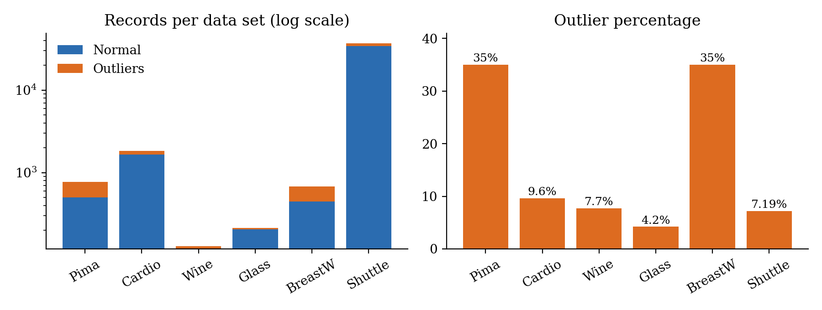
Figure 1: Size and outlier percentage of the six data sets (drawn from Table 1 of the paper)

4.5 Summary of EDA Findings
- Every data set is imbalanced. The outlier share goes from 4.2% (Glass) to 35% (Pima and BreastW). The class histograms in the paper show one tall bar for the normal class and a small bar for the outlier class.
- Size differs widely. Wine has only 129 records and Shuttle has about 36,752 after cleaning, which is why DBSCAN needed an ANN version for Shuttle.
- Pima has no clear density structure. It has 35% outliers and mixed densities, so DBSCAN could not separate noise from clusters, and PCA with a high minPts was needed to get better results.
- BreastW has a clear structure. Its Gaussian-like, density-based cluster structure explains why every method works well on it.
- Shuttle outliers form small clusters. Classes 2, 3, 5, 6 and 7 are small groups with their own densities. This breaks the assumption behind plain DBSCAN and motivates the cluster-size threshold.
- Labels needed simplification. Reducing all labels to normal or noise lets the study focus on noise detection instead of cluster counts.

5. Algorithm Selection and Implementation

5.1 Why these algorithms
The three methods represent two different ideas of what an anomaly is. In k-means−− an anomaly is a point far from every cluster centre. In DBSCAN and DBSCAN++ an anomaly is a point in a low-density region. All three are unsupervised, assign noise labels directly and run on unlabelled data, which suits the scenario in Section 3.
 | k-means−− | DBSCAN | DBSCAN++
Family | Representative-based | Density-based | Density-based (sampled)
Needs k? | Yes (k and l) | No | No
Key parameters | k, l, iterations | eps, minPts | eps, minPts, factor (sample size m)
Cluster shapes | Round (Gaussian-like) | Arbitrary | Arbitrary
Implementation | Written from pseudo-code | scikit-learn (KD-tree) | Written from pseudo-code (KD-tree, Annoy)

Table 2: Comparison of the three algorithms

5.2 k-means−−
k-means−− extends k-means by removing outliers inside the clustering loop. It starts with k random centres. In each iteration it computes every point’s distance to its nearest centre, marks the l points with the largest distances as outliers, and updates each centre as the mean of its cluster’s remaining points. The l outliers in the final iteration are the detected anomalies. The paper implemented it in Python from the pseudo-code because scikit-learn does not include it.
import numpy as np
from scipy.spatial.distance import cdist

def kmeans_minus_minus(X, k, l, iters=50, seed=0):
rng = np.random.default_rng(seed)
C = X[rng.choice(len(X), k, replace=False)] # k random starting centres
for _ in range(iters):
d = cdist(X, C)
nearest, dist = d.argmin(1), d.min(1)
is_out = np.zeros(len(X), bool)
if l > 0:
is_out[np.argsort(dist)[-l:]] = True # l farthest points = outliers
newC = np.array([X[(~is_out) & (nearest == j)].mean(0)
if ((~is_out) & (nearest == j)).any() else C[j]
for j in range(k)])
if np.allclose(newC, C): # converged
break
C = newC
return C, is_out.astype(int) # 1 = anomaly

5.3 DBSCAN
DBSCAN finds core points (points with at least minPts neighbours within distance eps), connects core points that lie within eps of each other, and forms clusters from the connected components. Points that belong to no cluster are noise, and these are the anomalies. The paper used the scikit-learn implementation, which builds a KD-tree and therefore struggles with large, high-dimensional data.
from sklearn.cluster import DBSCAN

def dbscan_noise(X, eps, min_pts):
labels = DBSCAN(eps=eps, min_samples=min_pts).fit_predict(X)
return (labels == -1).astype(int) # -1 = noise -> anomaly

5.4 DBSCAN++
DBSCAN++ speeds up DBSCAN by checking only a sample of m points (m = factor × n) as possible core points, so far fewer neighbour queries are needed. Two ways of choosing the sample were tested: uniform initialization (random sample) and k-center initialization (a greedy k-center selection that spreads the sample over the data). No Python implementation existed, so the authors wrote both from the pseudo-code using a scipy KD-tree.
from scipy.spatial import cKDTree
from scipy.sparse import csr_matrix
from scipy.sparse.csgraph import connected_components

def dbscan_pp_uniform(X, eps, min_pts, factor, seed=0):
n = len(X); tree = cKDTree(X)
rng = np.random.default_rng(seed)
S = rng.choice(n, int(factor * n), replace=False) # uniform sample
cnt = tree.query_ball_point(X[S], r=eps, return_length=True)
core = S[cnt >= min_pts] # core points in sample
rows, cols = [], []
for c, nb in zip(core, tree.query_ball_point(X[core], r=eps)):
rows += [c] * len(nb); cols += nb # edges core -> neighbours
G = csr_matrix((np.ones(len(rows)), (rows, cols)), shape=(n, n))
n_comp, comp = connected_components(G, directed=False) # clusters
covered = np.zeros(n, bool); covered[rows] = True; covered[cols] = True
return (~covered).astype(int) # uncovered points = noise

ANN versions. Because the KD-tree versions could not handle Shuttle, the authors used the Annoy library (a C++ approximate nearest-neighbour index). Annoy returns the k nearest neighbours rather than all points in a radius, so for each core-point query they fetch 2 × minPts neighbours and test whether more than minPts of them are closer than eps. This was much faster to build, with the approximation costs described in Section 3.5.
Modified DBSCAN (cluster-size threshold). After DBSCAN finishes, any connected component containing less than a threshold fraction of the points (0.2 for Shuttle) is relabelled as noise. This lets density-based detection find small outlier clusters.

5.5 Evaluation metrics
- False alarm rate (FAR) = normal points wrongly flagged as noise ÷ all points flagged as noise. Lower is better.
- F1-score (weighted) = the harmonic mean of precision and recall of each class, weighted by class size: F = Σ wᵢ · Fᵢ, with Fᵢ = 2 · precᵢ · recallᵢ ÷ (precᵢ + recallᵢ).
- Jaccard coefficient = TP ÷ (TP + FN + FP), counted on pairs of points, ignoring true negatives.
- Adjusted Rand index (ARS) = agreement between predicted and true labelling, corrected for chance. The paper reports it but does not use it for conclusions.
from sklearn.metrics import f1_score, adjusted_rand_score
from sklearn.metrics.cluster import pair_confusion_matrix

def evaluate(y, pred):
f1 = f1_score(y, pred, average="weighted")
fp = ((pred == 1) & (y == 0)).sum()
far = fp / max(pred.sum(), 1) # false alarm rate
ars = adjusted_rand_score(y, pred)
(tn, fp_p), (fn_p, tp) = pair_confusion_matrix(y, pred)
js = tp / (tp + fn_p + fp_p) # pair-counting Jaccard
return dict(f1=f1, far=far, ars=ars, js=js)

5.6 Results (best reported settings)
Table 3 collects the best-marked rows from the paper’s Tables 2 to 4, A1 and A5. Figure 2 compares false alarm rate and Jaccard coefficient across algorithms.
Data set | Algorithm | Best parameters | F1 | FAR | Jaccard
Pima | DBSCAN | minPts 20, eps 5 | 0.1805 | 0.651 | 0.349
 | DBSCAN++ k-center | factor 0.35, eps 2 | 0.6797 | 0.3396 | 0.4136
 | k-means−− | k=2, outliers=268 | 0.7057 | 0.4216 | 0.4068
Cardio | DBSCAN | minPts 10, eps 5 | 0.88 | 0.15 | 0.12
 | DBSCAN++ k-center | factor 0.5, eps 5 | 0.8835 | 0.1538 | 0.1222
 | k-means−− | k=3, outliers=176 | 0.9421 | 0.3011 | 0.5371
Wine | DBSCAN | minPts 4, eps 38 | 0.98 | 0.16 | 0.83
 | DBSCAN++ uniform | factor 0.3, eps 72 | 0.98 | 0.16 | 0.83
 | k-means−− | k=2, outliers=10 | 0.9845 | 0.1 | 0.8182
Glass | DBSCAN | minPts 8, eps 1 | 0.8767 | 0.8043 | 0.1957
 | k-means−− | k=2, outliers=9 | 0.9252 | 0.8889 | 0.0588
BreastW | DBSCAN | minPts 10, eps 4 | 0.9636 | 0.072 | 0.9027
 | DBSCAN++ k-center | factor 0.5, eps 4 | 0.96 | 0.07 | 0.89
 | k-means−− | k=2, outliers=239 | 0.9444 | 0.0795 | 0.8527

Table 3: Best reported results per data set (values from the paper’s tables)
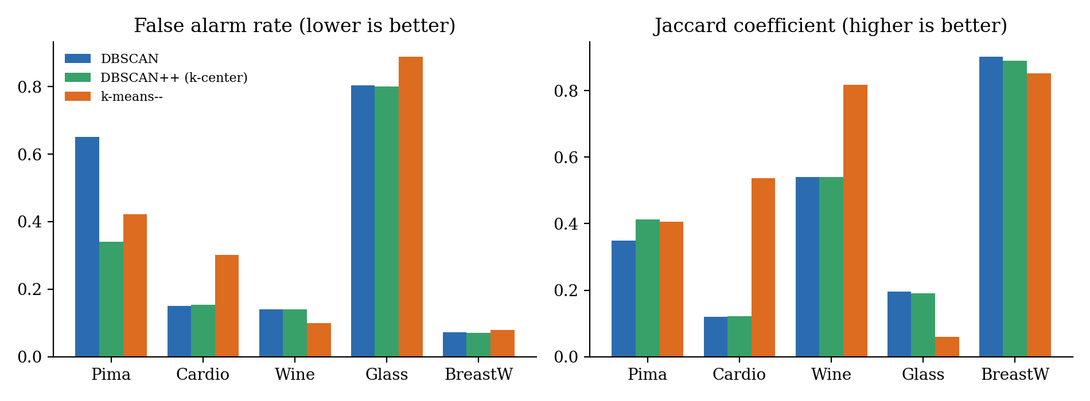
Figure 2: False alarm rate and Jaccard coefficient on the five smaller data sets
Shuttle (large data set). Table 4 and Figure 3 show the results on Shuttle, where DBSCAN and DBSCAN++ were run on ANN.
Method | Best parameters | F1 | FAR | Jaccard | Time
DBSCAN on ANN | minPts 10, eps 9 | 0.9052 | 0.5046 | 0.0919 | –
DBSCAN++ ANN, uniform | factor 0.1, eps 5.5 | 0.8134 | 0.8698 | 0.1092 | –
DBSCAN++ ANN, k-center | factor 0.1, eps 6 | 0.7394 | 0.9412 | 0.0500 | –
k-means−− | k=1, outliers=2644 | 0.9703 | 0.0908 | 0.6381 | 45
k-means−− | k=2, outliers=2644 | 0.9723 | 0.0861 | 0.6591 | 128
Modified DBSCAN on ANN | minPts 10, eps 10, threshold 0.2 | 0.9931 | 0.0883 | 0.9110 | –

Table 4: Shuttle results (time is as reported in the paper’s Table 6; not reported for the other rows)
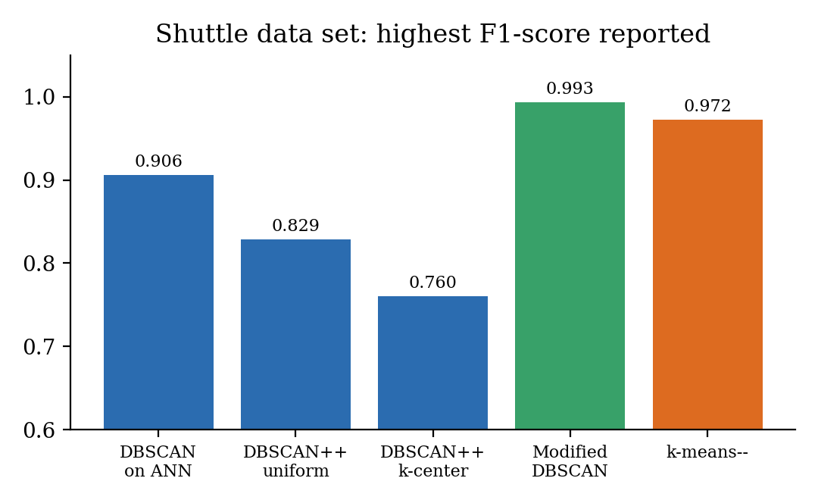
Figure 3: Highest F1-score reported for each method on Shuttle

5.7 Discussion of results
- k-means−− is the most robust overall. It had the best or near-best scores on Pima, Cardio, Wine and Shuttle, ran quickly, and held up when k or l changed slightly. Its drawback is that k and the outlier count must be known.
- DBSCAN works best on small, well-structured data. On Wine (F1 0.98, Jaccard 0.83) and BreastW (F1 0.96, FAR 0.07) it matched or beat the alternatives, and BreastW has a Gaussian, density-based structure.
- Density-based methods failed on Pima and struggled on Glass. Pima has 35% outliers and mixed densities. On Glass every method had a false alarm rate above 0.8.
- Small outlier clusters break plain DBSCAN. On Shuttle its false alarm rate stayed above 0.5, but adding the cluster-size threshold raised F1 from 0.905 to 0.993 and Jaccard from 0.09 to 0.91.
- DBSCAN++ speed claims were only partly confirmed. Uniform initialization ran faster than every other method. K-center initialization took longer than DBSCAN in this implementation, in contrast to the original DBSCAN++ paper.
- Choice of algorithm matters. No single method won on every data set, so the structure of the data should guide the choice.

6. Conclusion
This case study examined how well DBSCAN, DBSCAN++ and k-means−− detect anomalies in six imbalanced benchmark data sets. The study found that k-means−− is the most robust choice in terms of quality and running time, especially when small outlier clusters of different densities are present, as in Shuttle. Its limits are that k and the outlier count must be known beforehand and that it can struggle with non-Gaussian clusters.
Density-based methods find outliers well when the data has a clear density structure (Wine, BreastW) but have difficulty when outliers form small, dense clusters or when the outlier share is high (Pima). The cluster-size threshold added to DBSCAN, together with approximate nearest neighbours, fixed much of this weakness on Shuttle (F1 0.993) while running quickly.
Future directions named in the paper: a parallel k-center initialization to cut DBSCAN++ run time, testing the modified DBSCAN on more data sets, comparing against Isolation Forest, One-Class SVM and k-nearest-neighbour detectors, building synthetic data that is hard for k-means−−, and applying density-based detection to time-series data.
Reference. G. S. Fuhnwi, J. O. Agbaje, K. Oshinubi and O. J. Peter, “An Empirical Study on Anomaly Detection Using Density-based and Representative-based Clustering Algorithms,” J. Nig. Soc. Phys. Sci. 5 (2023) 1364.

Signature of the Team members

