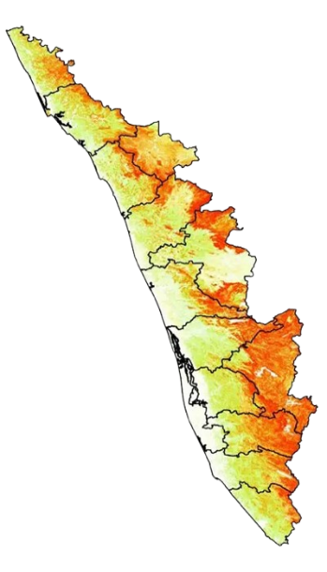
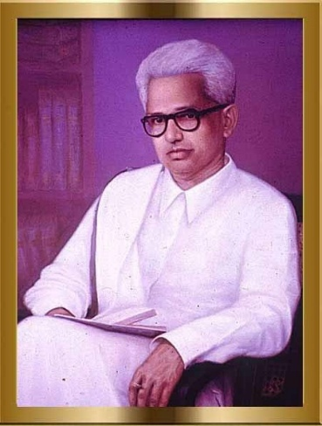
Jnanpith Awardee from Kerala

G. Sankara Kurup (1901–1978) was a celebrated Malayalam poet, essayist, critic, and translator, best known as the first recipient of the Jnanpith Award in 1965 for his poetry collection Odakkuzhal (The Bamboo Flute).

G. Sankara Kurup, fondly known as Mahakavi G., was the first recipient of the prestigious Jnanpith Award in 1965, conferred for his renowned poetry collection Odakkuzhal (The Bamboo Flute), a work that revolutionized Malayalam poetry with its rich symbolism and lyrical elegance. Born on 3 June 1901 in Nayathode, Kerala, Kurup’s literary journey spanned poetry, essays, short stories, plays, and translations. His writings reflected a deep engagement with nature, human emotions, and philosophical contemplation, blending traditional aesthetics with modernist sensibilities.
Over his illustrious career, Kurup authored around 25 poetry collections, notable among them being Suryakanthi (Sunflower), Nimisham (The Moment), Padikante Paattu (The Traveller’s Song), Vishwadarshanam (Vision of the Universe), Moonnaruviyum Oru Puzhayum (Three Streams and a River), Jeevana Sangeetham (The Music of Life), and Sahithya Kauthukam. His Jnanpith-winning Odakkuzhal consists of sixty poems that explore universal themes with profound simplicity and musical rhythm. Besides poetry, he made a mark as a prose writer with collections such as Rajanandini, Harischandran, Radharaani, Mutthum Chippiyum (Pearl and Oyster), G-yude Note Book, and Ormayude Olangalil (In the Waves of Memory). Kurup’s plays like Iruttinu Munpu (Before Darkness), Sandhya, and August 15 reflect his engagement with social realities and historical change, while his essays and critical writings contributed immensely to Malayalam literary discourse.
Kurup also played a vital role as a translator, introducing global classics to Malayalam readers through his translations of Rabindranath Tagore’s Gitanjali, Kālidāsa’s Meghadūta, and Omar Khayyām’s Rubaiyat. His works were celebrated for their fusion of Indian tradition with modern thought, earning him not only the Jnanpith but also honors such as the Kerala Sahitya Akademi Award, Sahitya Akademi Award, Padma Bhushan, and the Soviet Land Nehru Award. Beyond literature, Kurup served as a nominated member of the Rajya Sabha and established the Odakkuzhal Award to encourage Malayalam writers.
Mr. G. Sankara Kurup
Malyalam poet and essayist
Read more at:
http://timesofindia.indiatimes.com/articleshow/119342692.cms?utm_source=contentofinterest&utm_medium=text&utm_campaign=cppst

