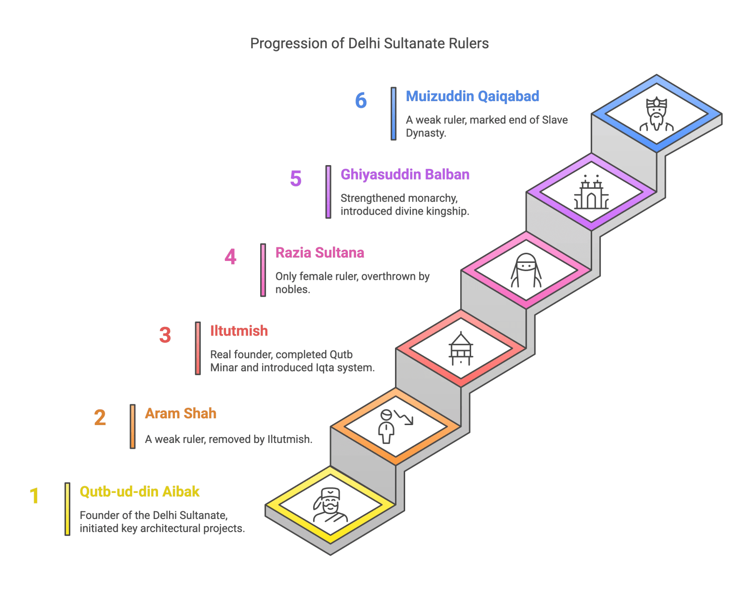
Slave Dynasty

The Slave Dynasty (also called the Mamluk Dynasty) was the first ruling dynasty of the Delhi Sultanate. It was established by Qutb-ud-din Aibak in 1206 after the death of Muhammad Ghori. The dynasty ruled for 84 years (1206–1290) before being overthrown by the Khilji Dynasty.
Link:
https://easymindmaps.com/history/the-rise-and-fall-of-the-delhi-sultanates-slave-dynasty/

