Name : Madhuri Pappu  
  
ID : 700735259  
  
Video link : <https://drive.google.com/file/d/1u_y02deZLDFuwJsT4l4OQZ61zFSM0nZv/view?usp=share_link>

Github link :

<https://github.com/madhuripappu/assignment4/upload>

Q1)

Q2)   
  
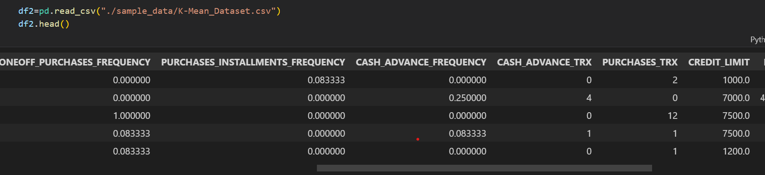

Q3)

