**ASSIGNMENT 10**

**FLOWCHART:**

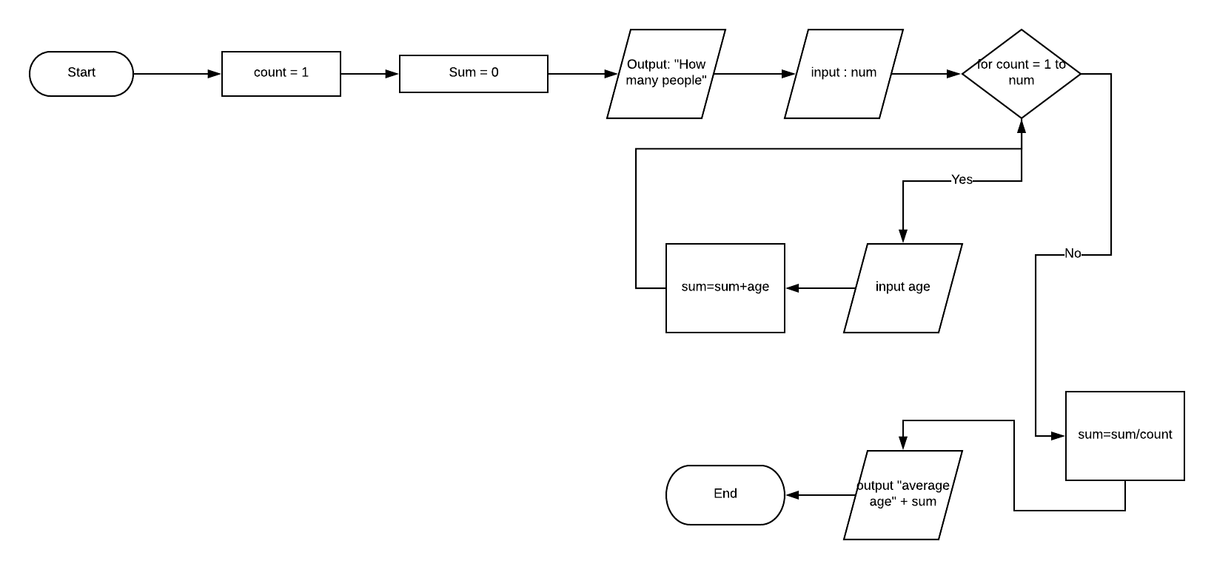

**Pseudocode**

1. DECLARE INT Count



1. DECLARE INT num
2. DECLARE INT age
3. DECLARE INT sum
4. OUTPUT “How many people”
5. INPUT num
6. For Count = 1 to num
7. OUTPUT “Age of person” +count
8. INPUT age
9. sum=sum+age
10. Endfor count
11. Sum=sum/Count
12. OUTPUT “Average age=”+ sum
13. ENDIF

**Trace:**

|  |  |  |  |  |  |  |
| --- | --- | --- | --- | --- | --- | --- |
| Line no | Input Buffer | Num | Age | Sum | Count | Output Buffer |
| 1. |  | - | x | x | x |  |
| 2. |  | - | - | x | x |  |
| 3. |  | - | - | - | x |  |
| 4. |  | - | - | - | - |  |
| 5. |  | - | - | - | - | How many people |
| 6. |  | - | - | 0 | - |  |
| 7. | 3 | 3 | - | 0 | - |  |
| 8. | - | 3 | - | 0 | 1 |  |
| 9. | - | 3 | - | 0 | 1 | Age of person 1 |
| 10. | 20 | 3 | 20 | 0 | 1 |  |
| 11. | - | 3 | 20 | 30 | 50 | - |
| 12. | - | 3 | 20 | 30 | 50 | - |
| 13 | - | 3 | 3 | 30 | 50 | Age of person 3 |
| 14. | 40 | 3 | 3 | 40 | 90 | - |
| 15. | - | 4 | 3 | 40 | 90 | - |
| 16. | - | 4 | 3 | 40 | 30 | - |
| 17. | - | 4 | 3 | 40 | 30 | Average age is 30 |