BigQuery using Machine Learning

We used Machine learning models to build, train and evaluate the model using BigQuery on Google Cloud Platform. We applied Logistic regression and Linear regression on the data set we have chosen.

First, we created the project and uploaded the pre-processed dataset. Then we create a bucket and upload the dataset. Then in BigQuery we create a dataset and further create tables inside the dataset. The project name if thematic-flash-266714, dataset name is australia_weather and the table name is preprocessed.

**1.Query to create model**

CREATE OR REPLACE MODEL

`thematic-flash-266714.australia_weather.model`

OPTIONS

(model_type='linear_reg',

input_label_cols=['RainTomorrow']) AS

SELECT

*

FROM

`thematic-flash-266714.australia_weather.preprocessed`

WHERE

RainTomorrow IS NOT NULL;

2. Evaluating model

SELECT

*

FROM

ML.EVALUATE(MODEL ` thematic-flash-266714.australia_weather.model `,

(

SELECT

*

FROM

` thematic-flash-266714.australia_weather.preprocessed `

WHERE

RainTomorrow IS NOT NULL

));

Below is the result for evaluation query:

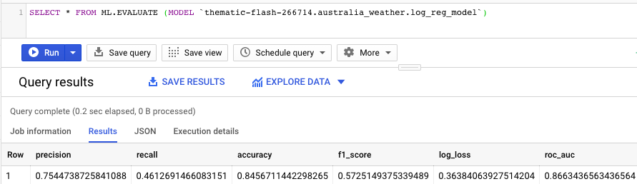

3. Predicting model

SELECT

RainTomorrow

FROM

ML.PREDICT(MODEL ` thematic-flash-266714.australia_weather.model `,

(

SELECT

*

FROM

` thematic-flash-266714.australia_weather.preprocessed `

));