Lab Assignment 3

Name: Madhuri Sarda ID: 16291679 Class ID: 21 Lab ID: 6_2

In the assignment the agenda was to call 2 API's Nutritionix and ResponsiveVoice API. Using Nutritionix API we are sending a food item and when we click on go we hit the API using unique AppID and API key and get the data and using Typescript we iterate over the data and get the values that we need like calories and serving weight in grams. Using the text to speech API ResponsiveVoice, we are converting the results in speech format.

The link to the document with the code snippet is <https://github.com/madhurisarda/ASE/blob/master/Lab3_NutritionChecker/SourceCodeDocument.docx>

Login.component.html

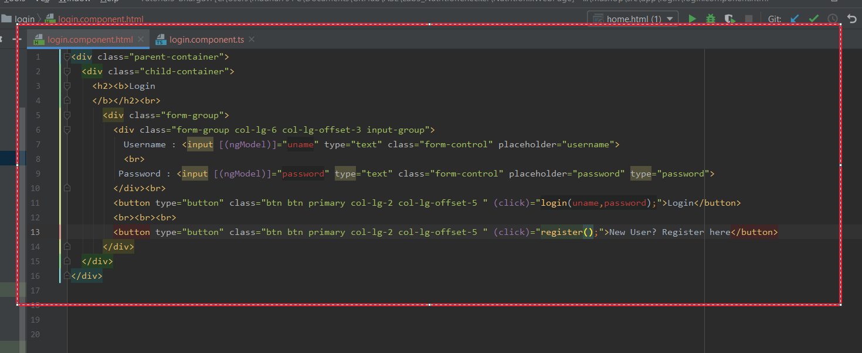

Login.component.ts

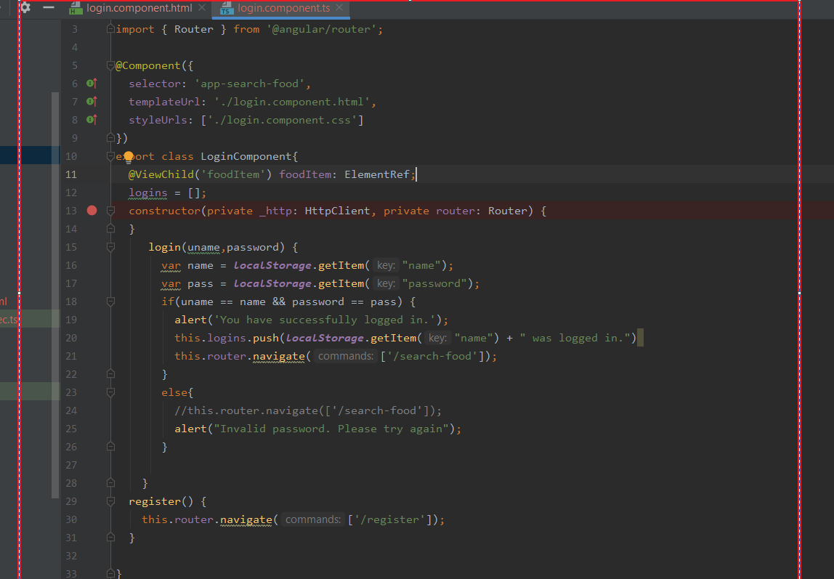

Register.component.html

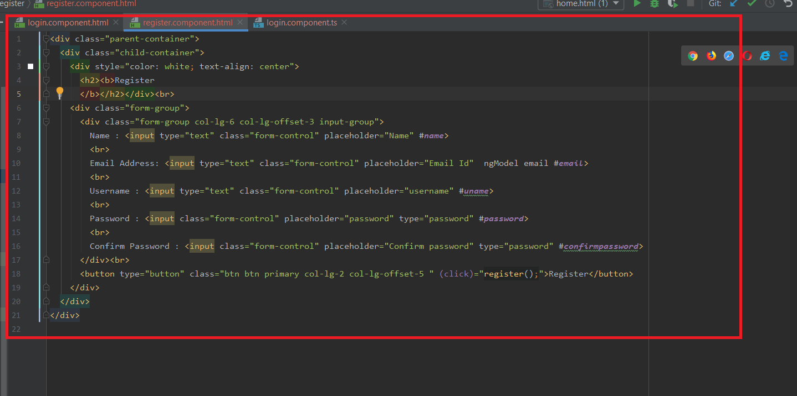

Register.component.ts

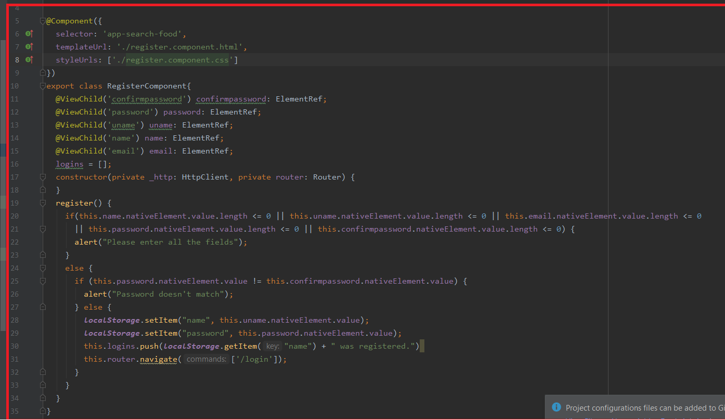

Search-food.component.html

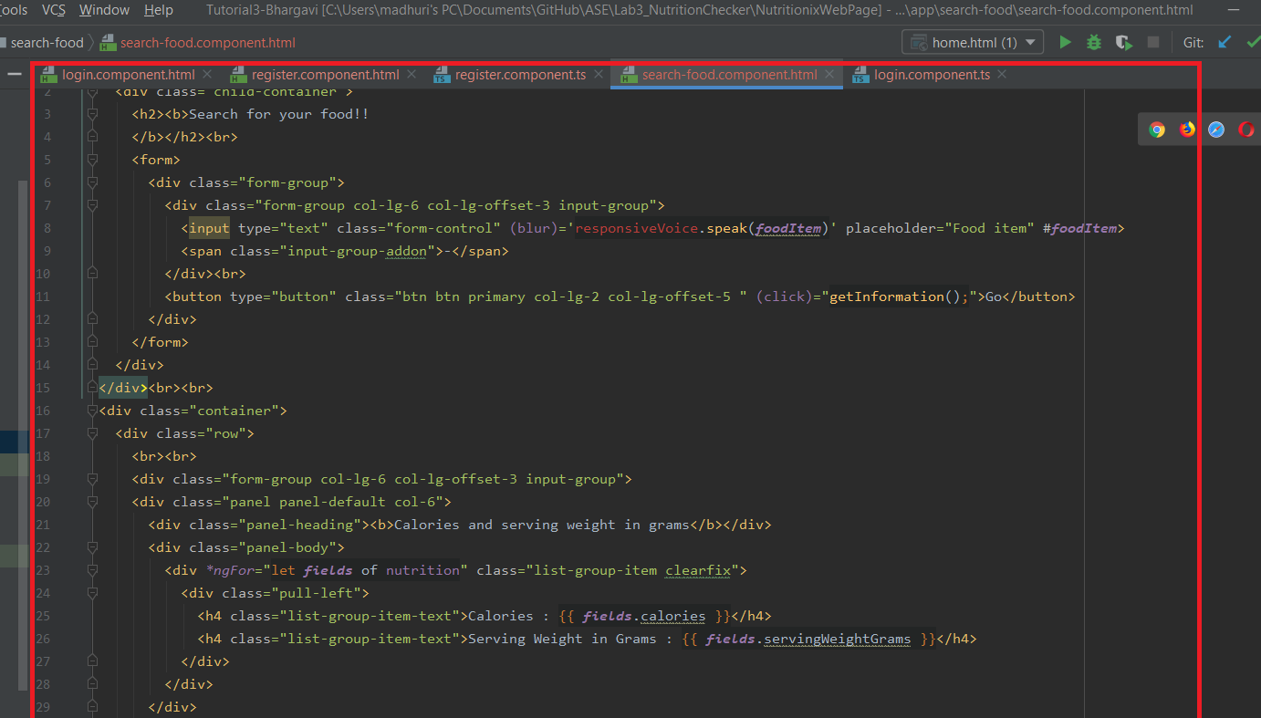

Search-food.component.ts

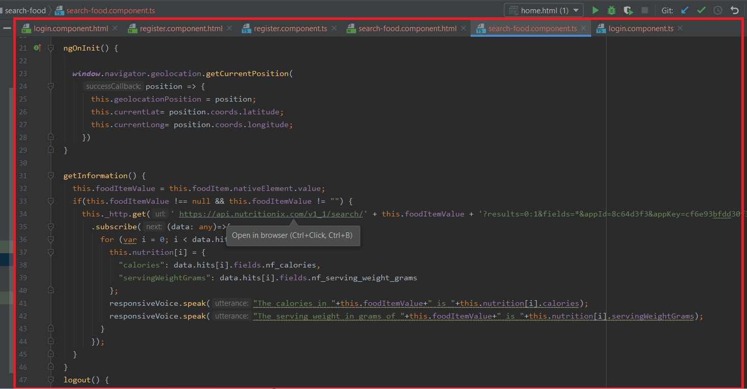

App-routing.module.ts

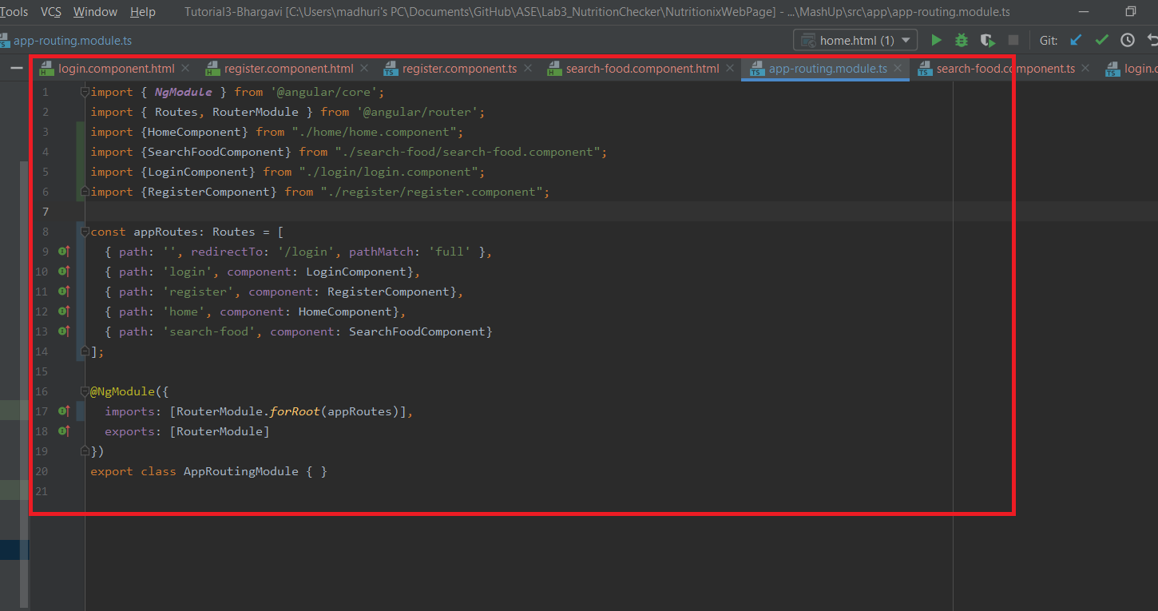

Index.html

