**JWT token authentication**

**Lab ID: 6_2**

**Authors:**

**Madhuri Sarda : 21**

**Udaya Byreddy : 03**

**Introduction:**

Jwt authentication using JWT token

**Design/Implementation:**

We have followed below steps to successfully complete this lab assignment:

**Step-1:**

We make sure all the pre-requisites are ready before start of the project and below are the technologies/languages used:

1. WebStorm IDE

2. Node

3. Npm

4. Expressjs :

* Installation: npm install express

* Importing: const app= express();

5. Angular

6. JWT:

* Installation: npm install jsonwebtoken

* Importing: const jwt= require(‘jsonwebtoken’)

7. Cors: below are commands used

* Installation: npm install cors

* Importing: const cors = require(‘cors’);

8. Enabling cors: app.use(cors());

9. Also need to setup nodejs for porting

**Step-2:**

We have done the required configurations for components in the app.routing.module.ts file

**Step-3:**

We have written below html code for home and login page as below Login.html

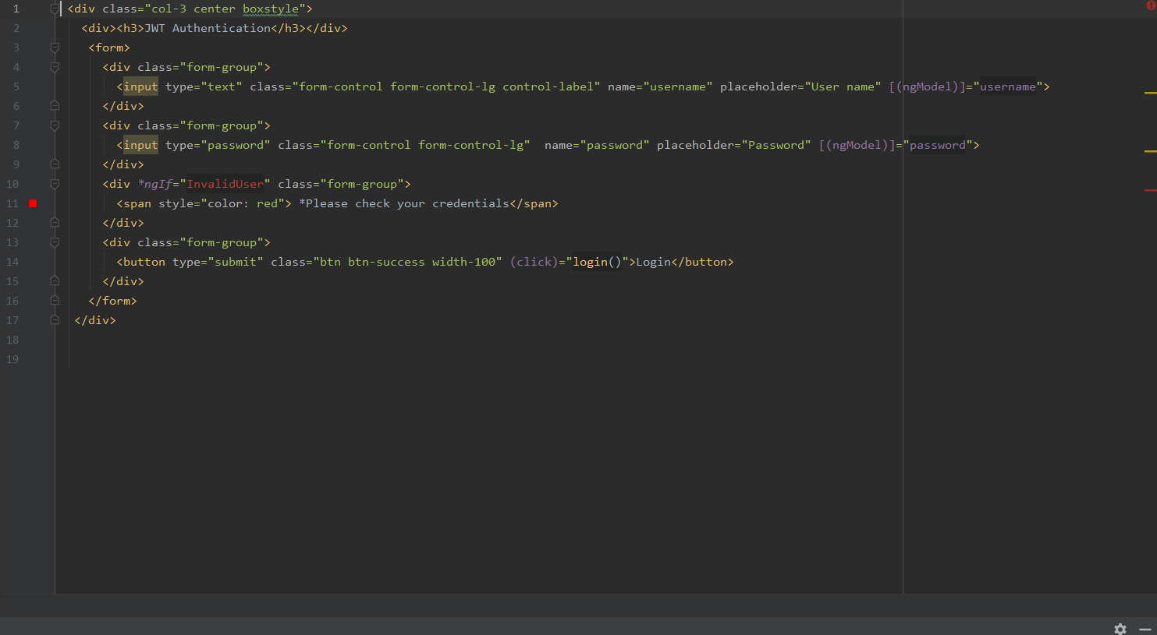

* Home.html

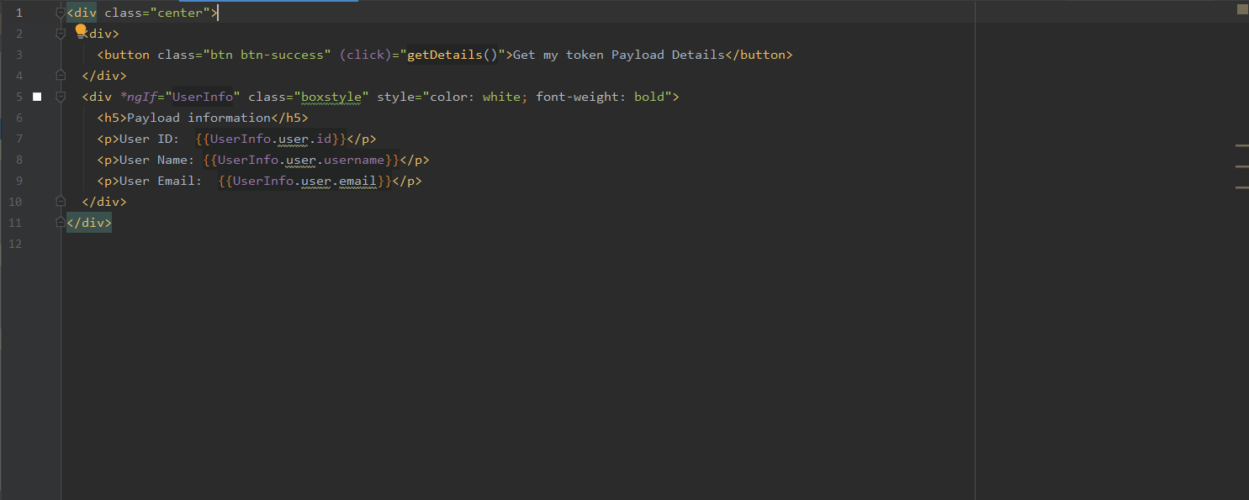

**Step-4:**

Our login.components.ts is sending a request to nodejs server using url:http://localhost:4200/api/login for authentication and then it store received response into local storage and navigate to home page along with response data received.

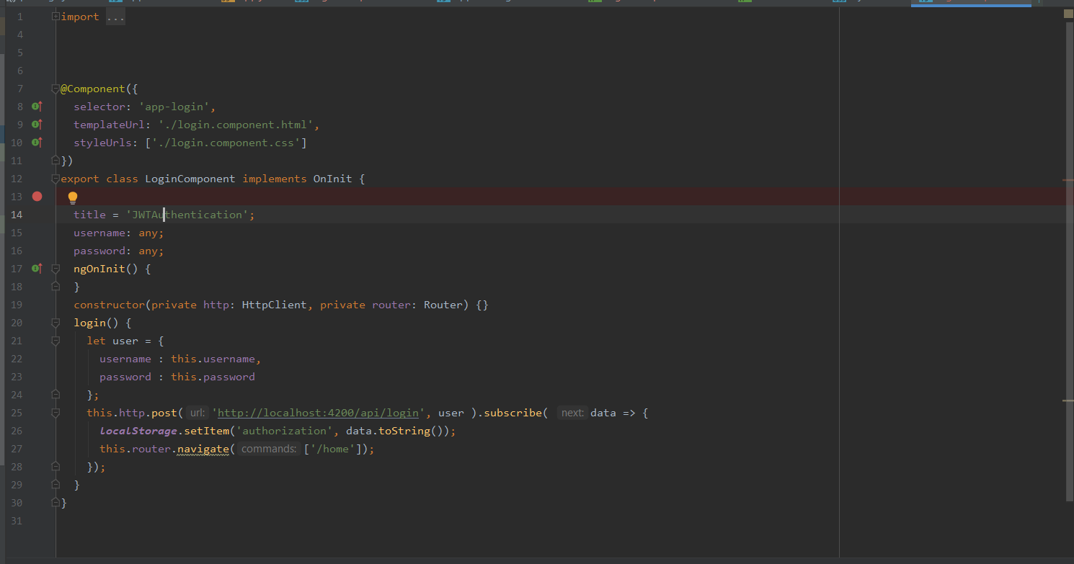

**Step-5:**

We have our backend layer which handles authentication and creation of JWT token. By receiving request from “login” it creates token and send as the same with the response header and when it receives request from “getDetails” it verify the token received and authenticate and sends the payload as one of the response.

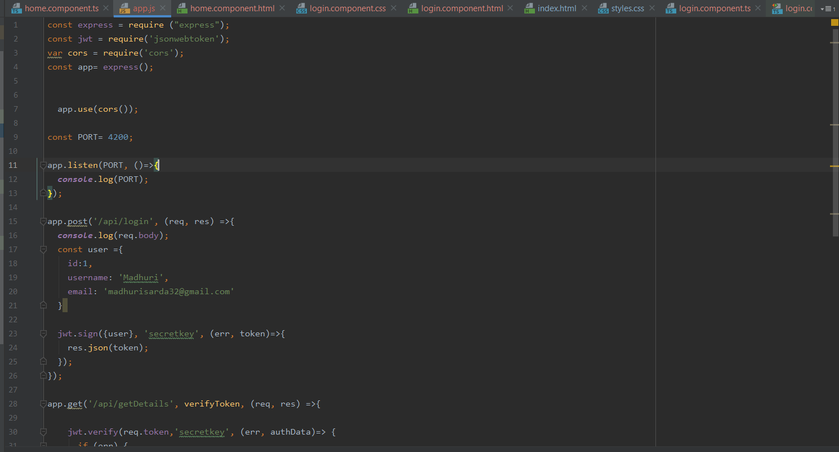

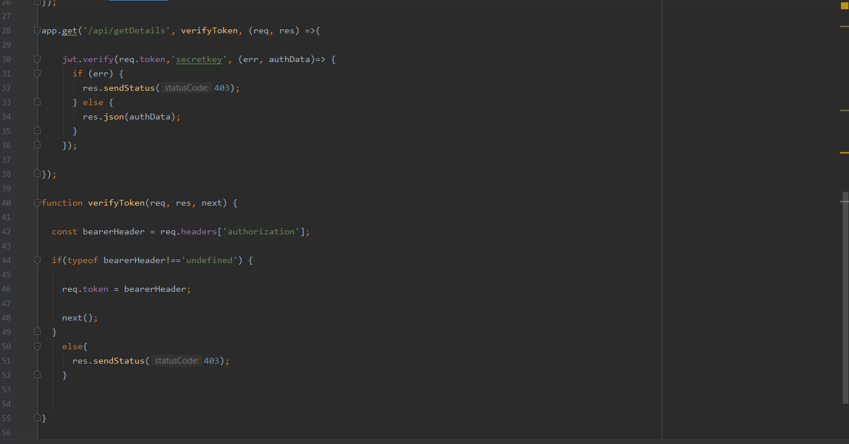

**Step-6:**

We are using local storage to get data from login component and sending a request along with “token” for verification using HttpHeaders and receiving payload as a response.



**Sample Output**

**Login Page:**

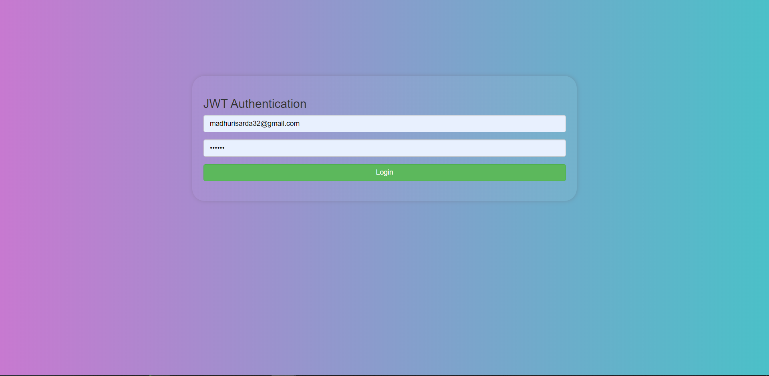

**Home Page:**

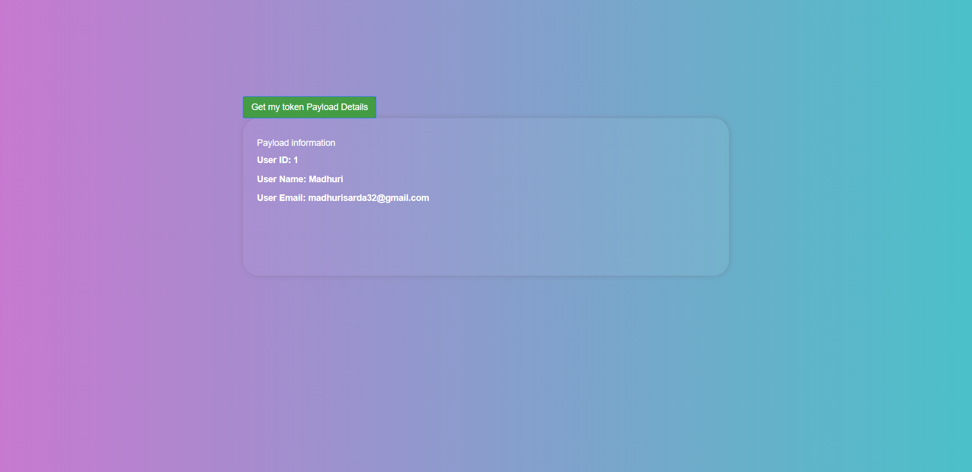

**Conclusion:**

As part of this exercise we gained new technique that is token based Authentication using JWT which we can also use this in our upcoming projects.