**Assignment : 02**

***Aim*** : To create bucket in AWS(Amazon Web Service) by using S3 service

Steps to create bucket are as follows :

Step 1: Login to your AWS account and search for S3 service in Services.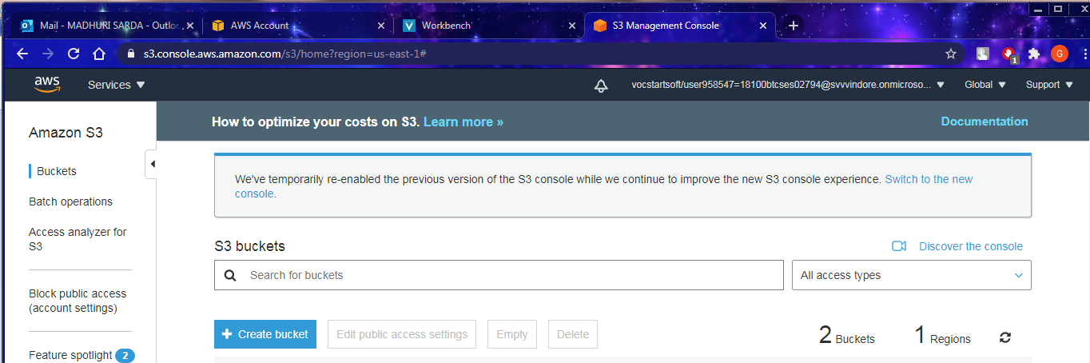Click on “Create bucket”

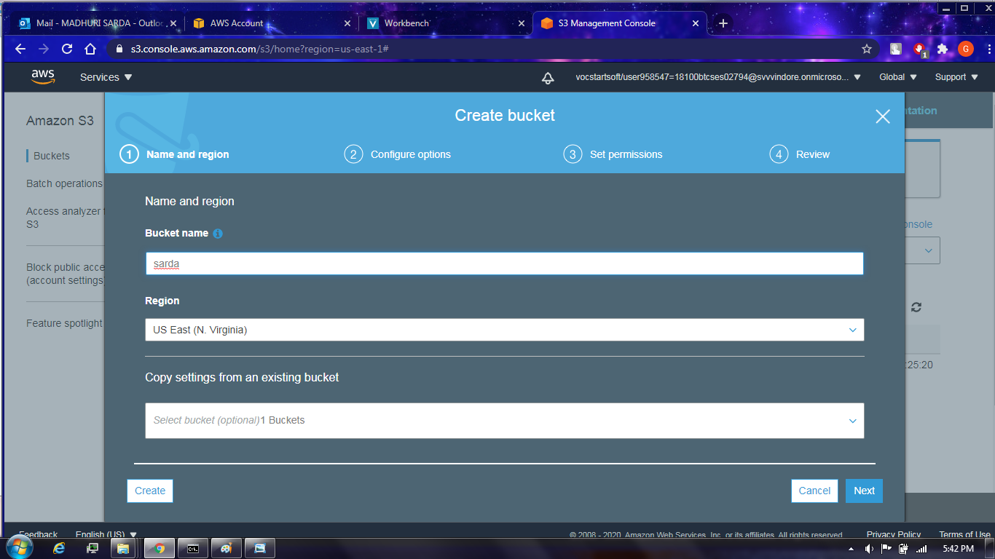Step 2 : In **Bucket name**, enter a DNS-compliant name for your bucket The bucket name must:

a. Be unique across all of Amazon S3.

b. Be between 3 and 63 characters long.

c. Not contain uppercase characters.

d. Start with a lowercase letter or number.

Step 3 : In **Region**, choose the AWS Region where you want the bucket to reside and then click on next.

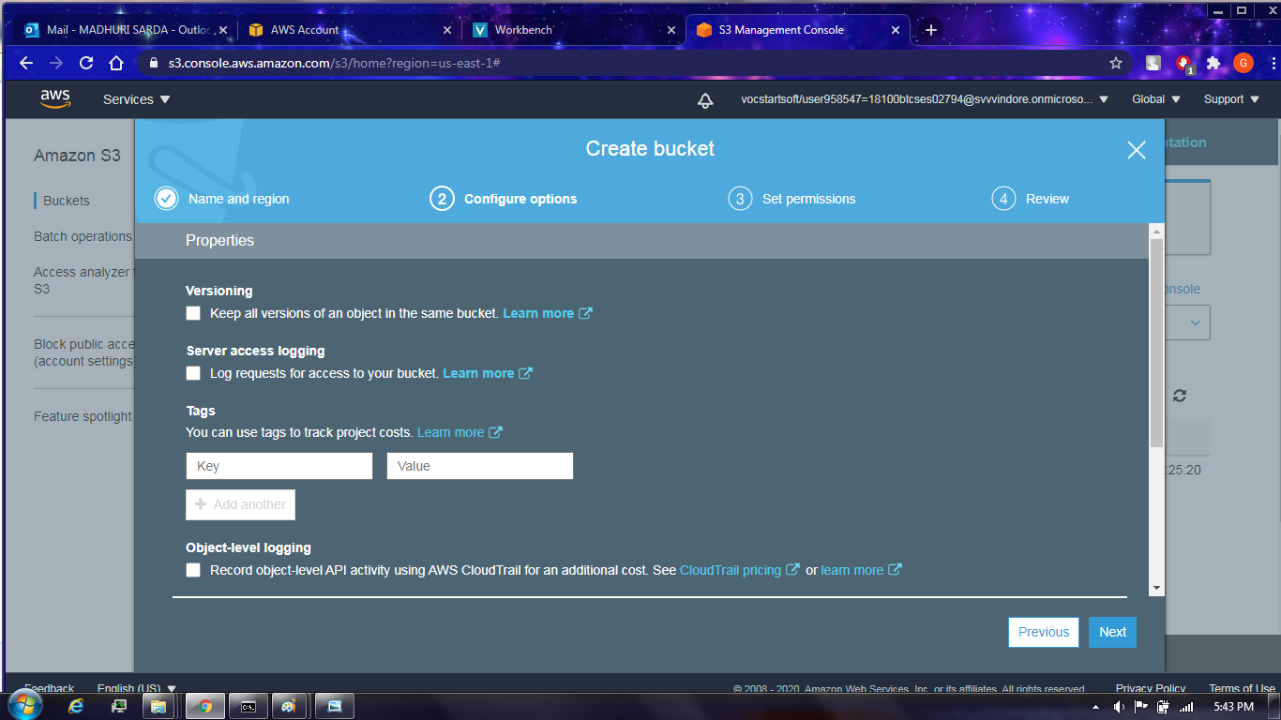Step 4:Configure bucket by the default option(for now disable all the options)

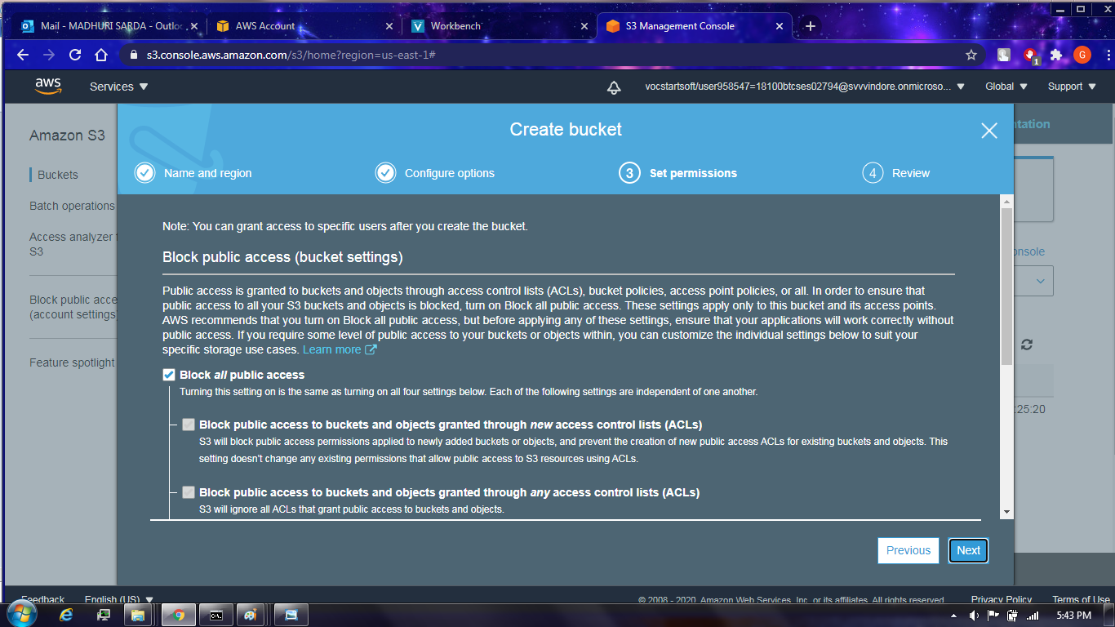Step 5:Choose the Block Public Access settings to block the public access i e to make the bucket access private .

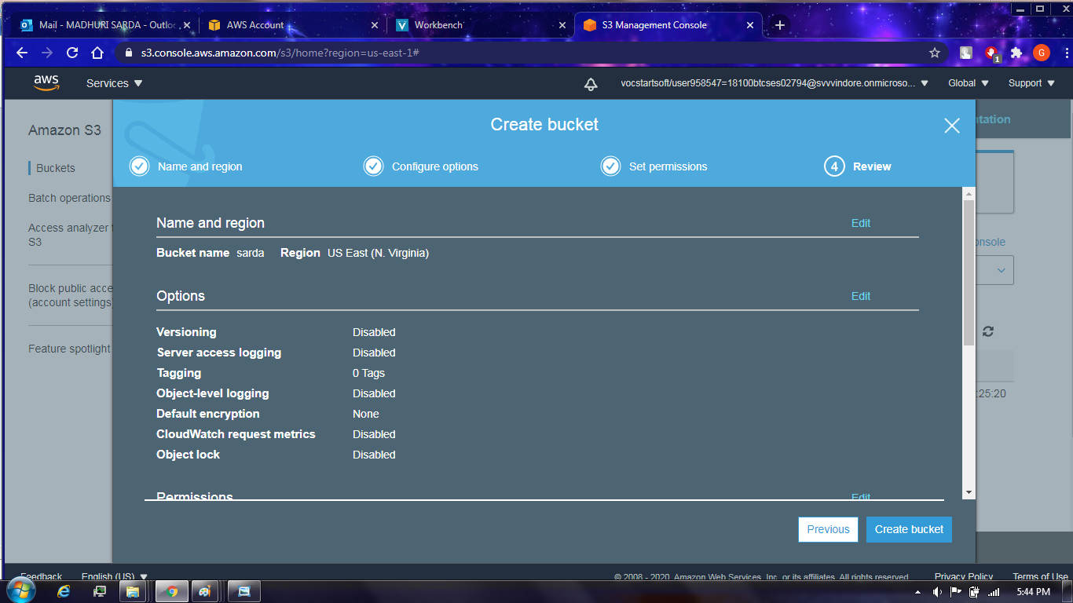Step 6: If you want to edit you can use that previous option or for further process go for create bucket option.

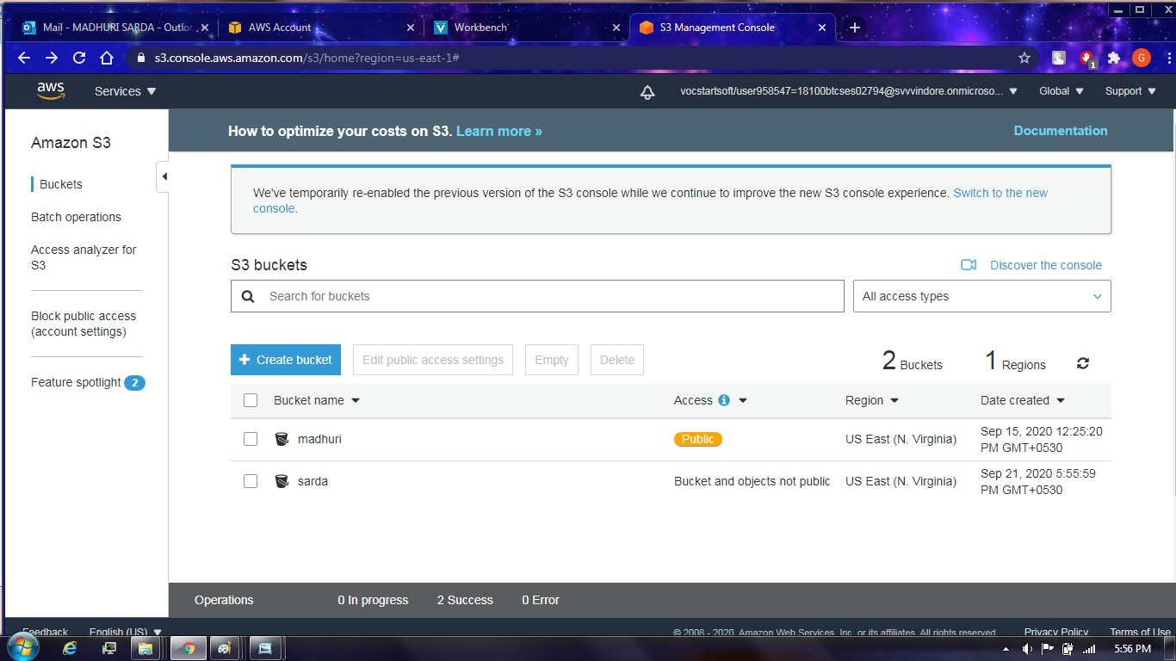Here our bucket name is “sarda” which is not public as we have already block all the public access.

Bucket Created (public)

**Now how to upload object to bucket steps are as follows:**

Step 1: Click on the bucket name on which you want to upload the object Then this window will appear

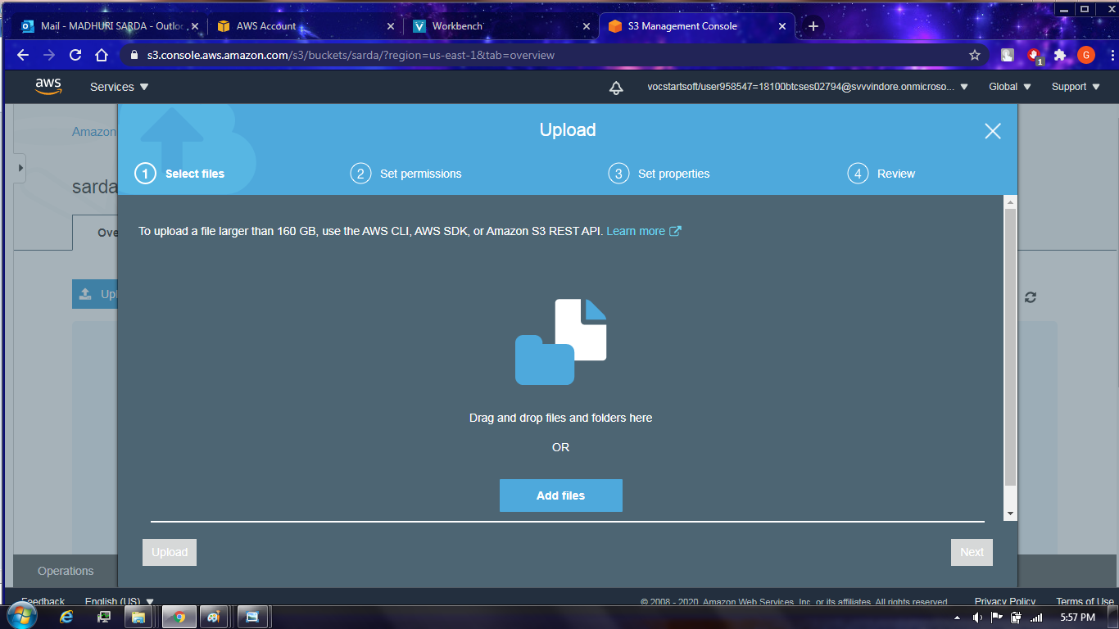Step 2:By clicking on the add files option you can browse your file which you want to upload on your bucket

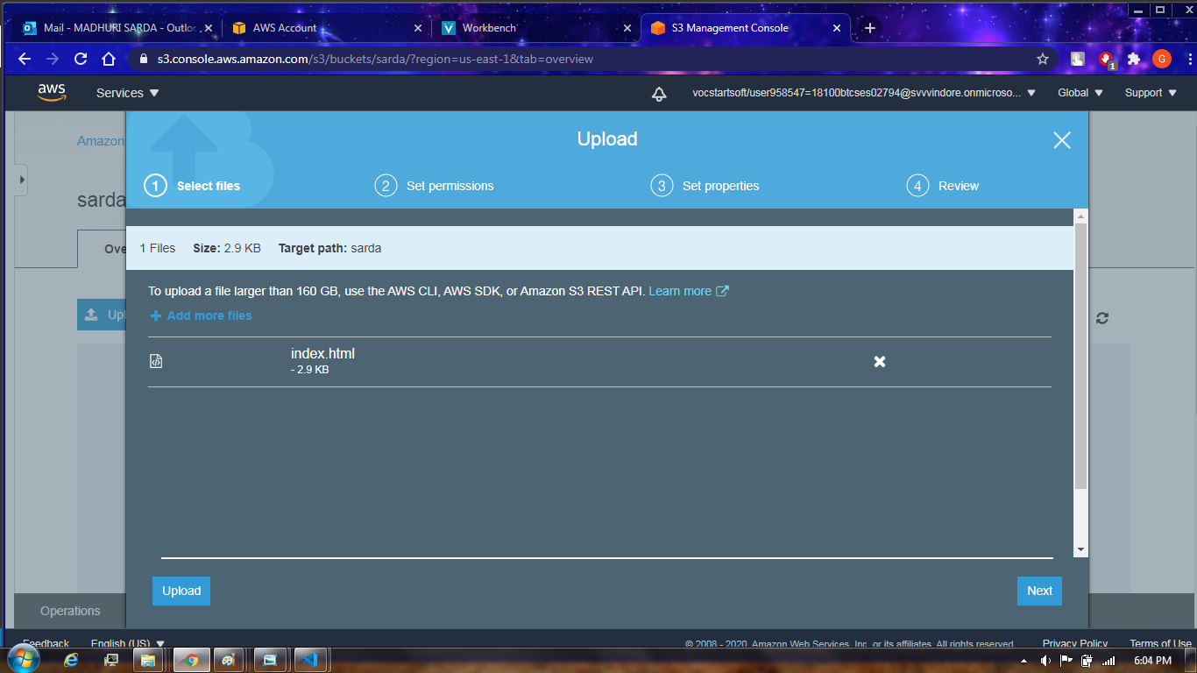

Step: This is the file which I have chosen to upload “index html” Now click on upload to upload on to your bucket

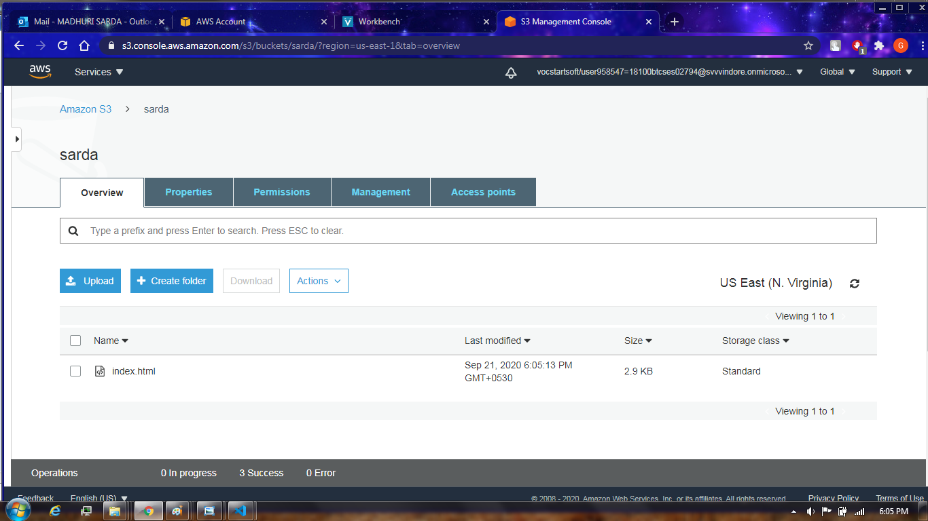

As you can see that file which I have chosen is now uploaded to my bucket and if you want to add more files click on the upload option to upload more files

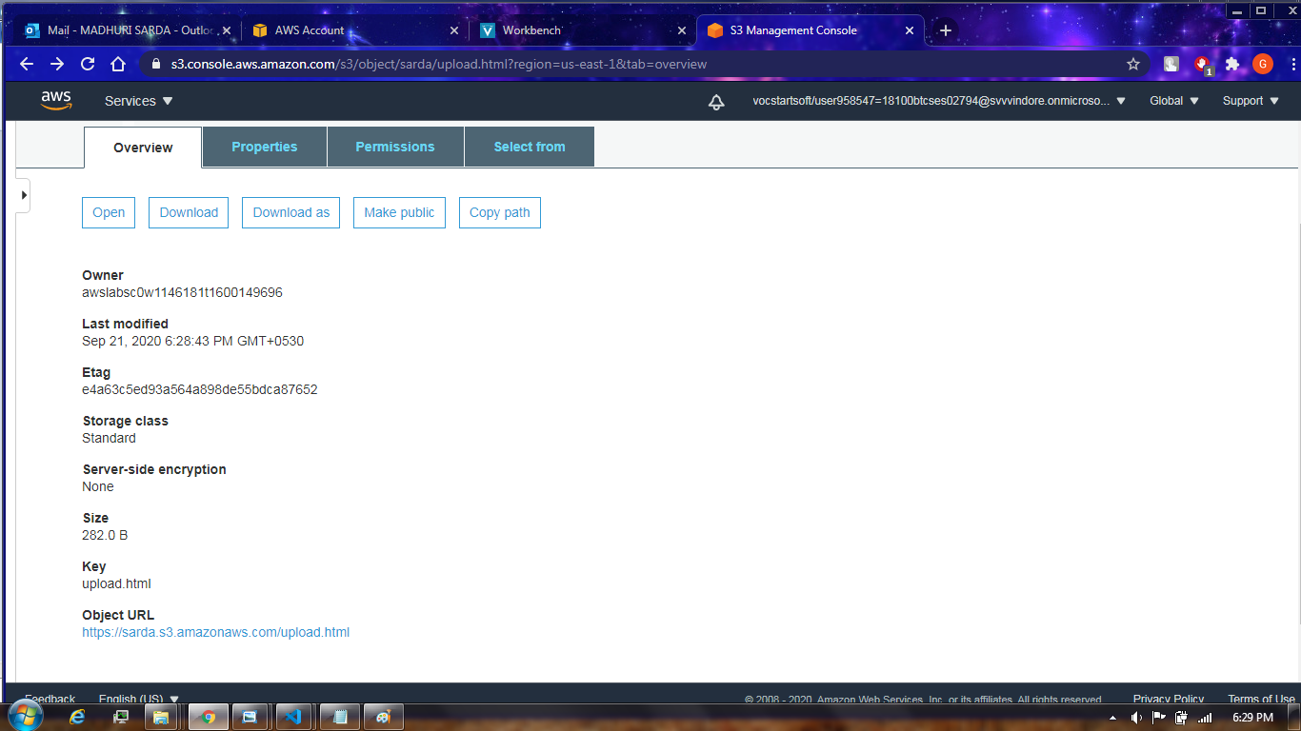

Click on the file name then this dialog box will appear

This Object URL will give you error because right now the bucket is private as we blocked all the public access 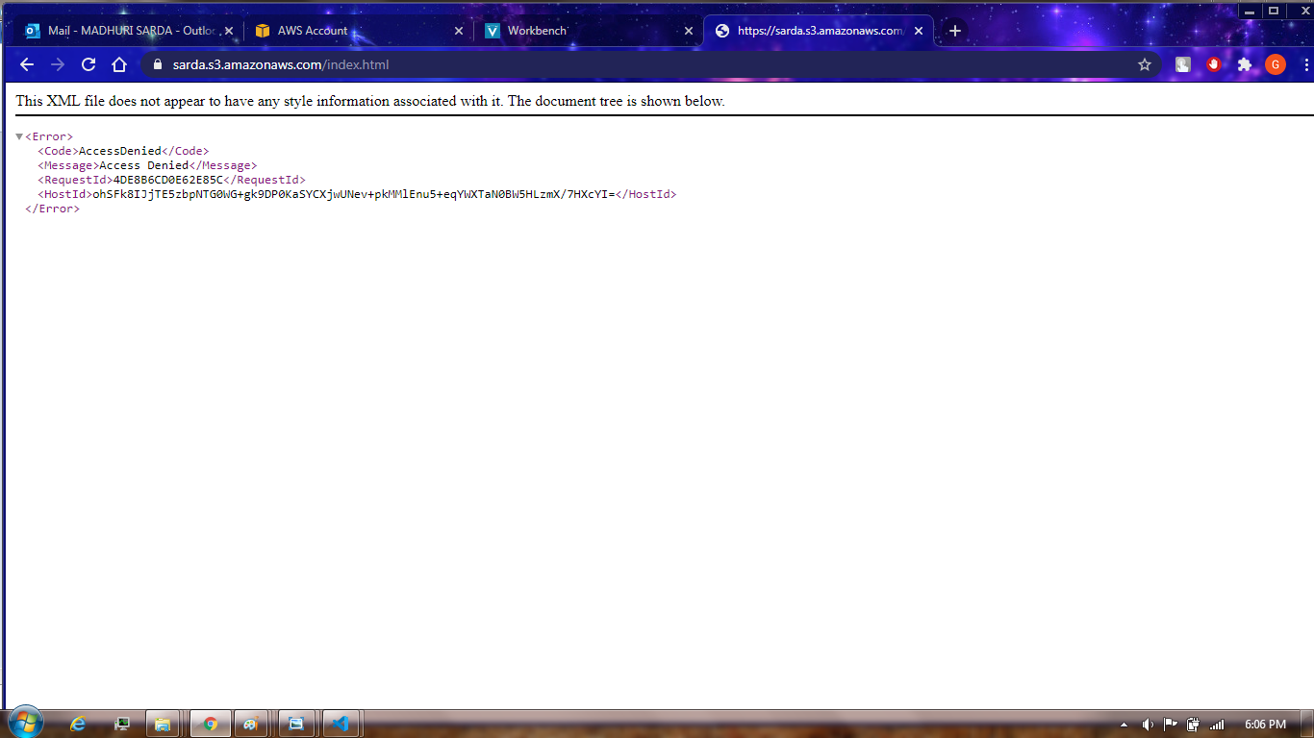This error comes when bucket is private

**To delete object from bucket :**

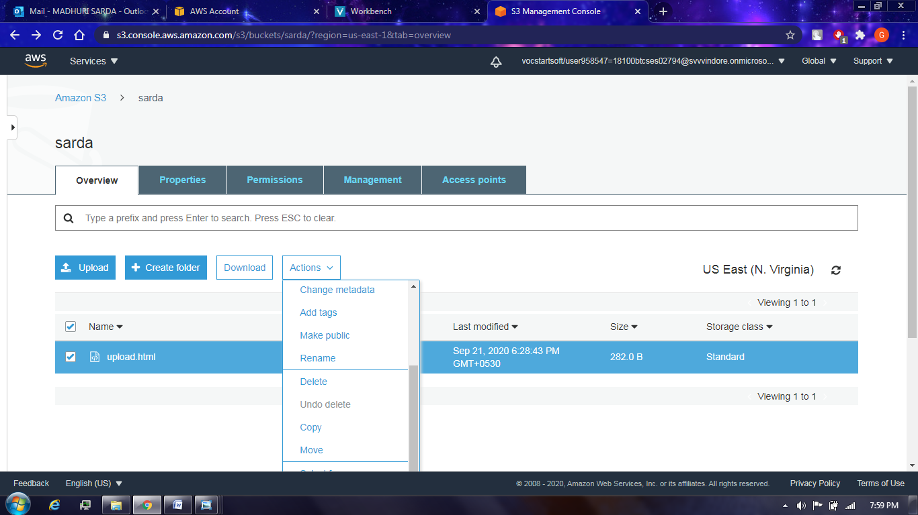Click on file’s checkbox which you have uploaded then click on actions and it will show delete option then click on it to delete

**Now we will make the bucket public**

Following are the steps:

1 Click on the bucket name and this dialog box will appear

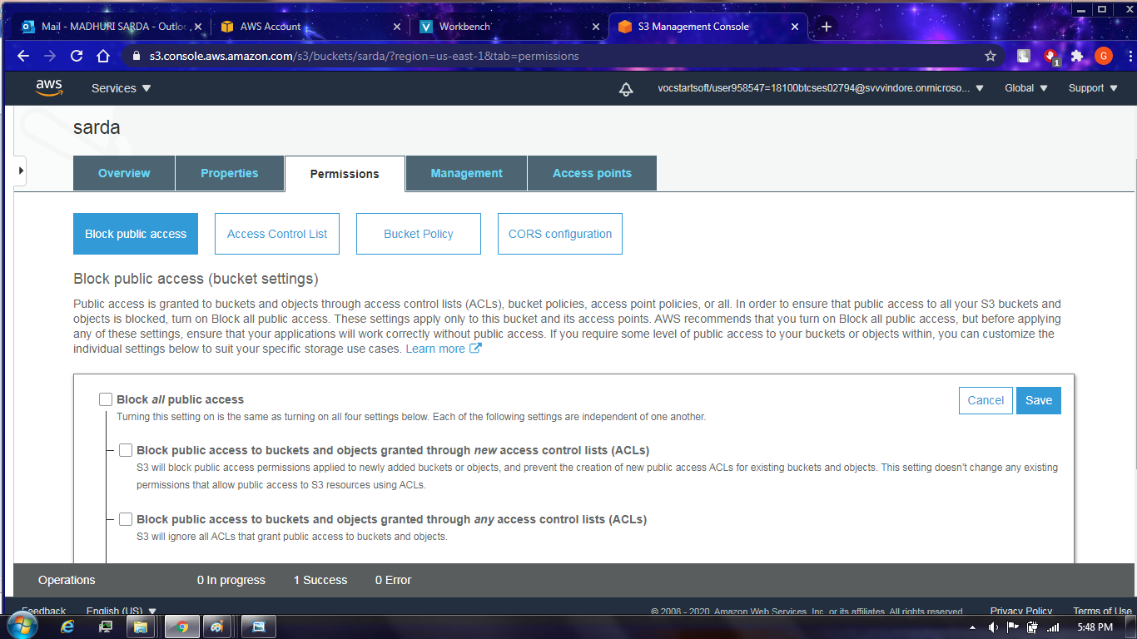Then go on permissions and disable the block all public access to make bucket access public.Then go on bucket policy :

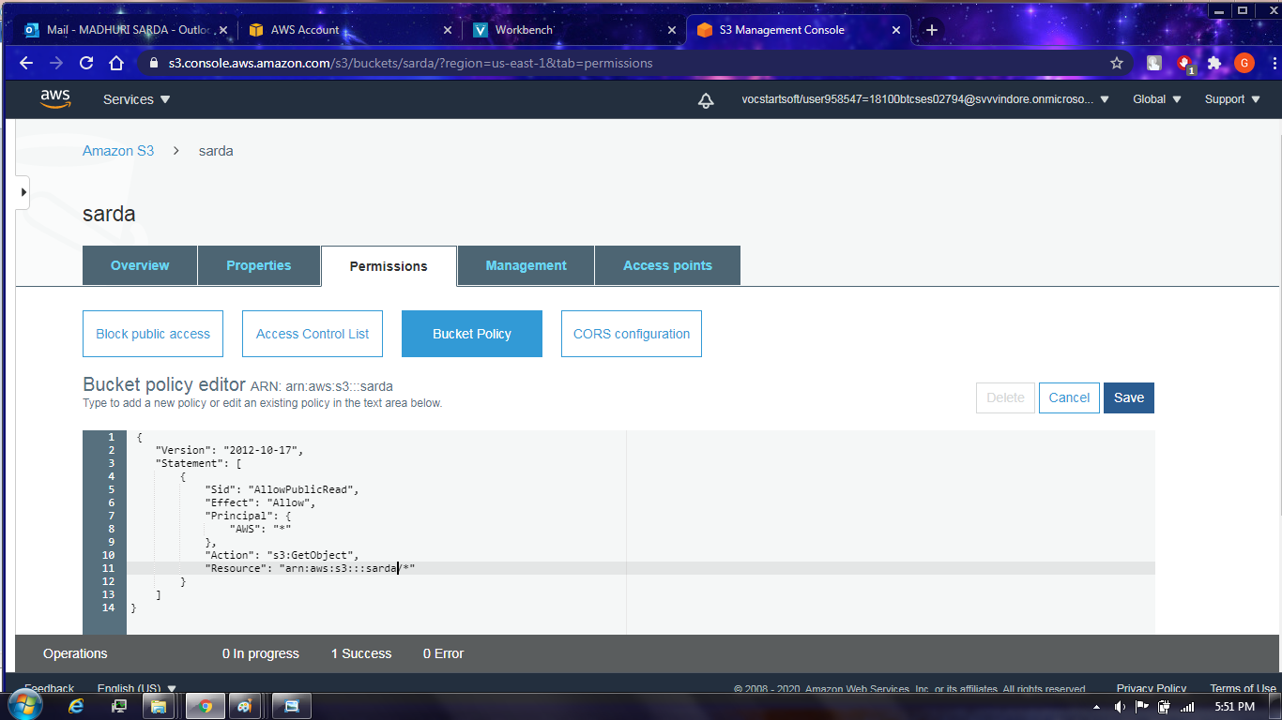

Type to add new policy ,or edit an existing policy in the text box given, then click on save.Now after this our bucket will have the public access after few seconds

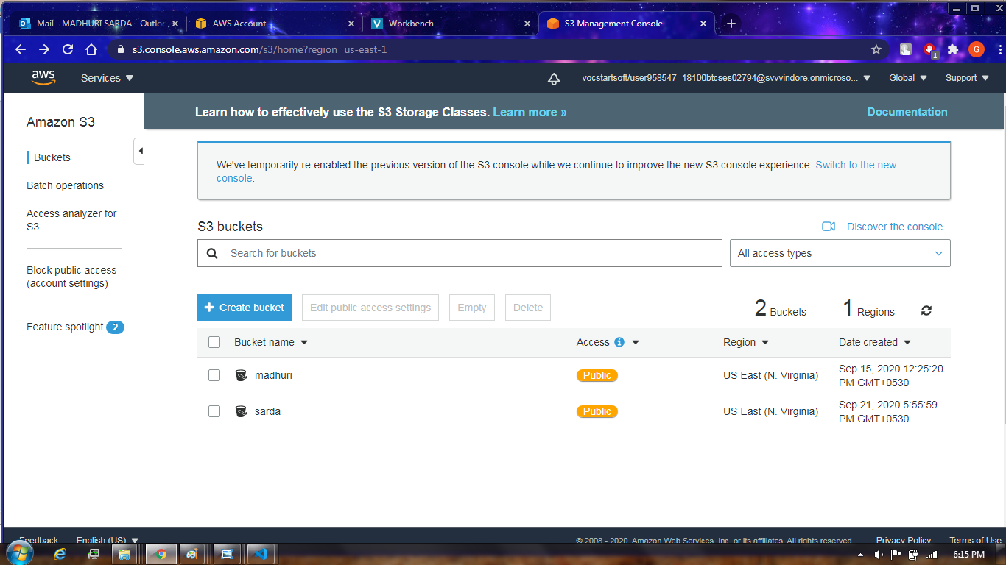

This public in orange is proof of that bucket is public (all public access) now we can access file through the object URL link

**Object URL Link** : https://sarda.s3.amazonaws.com/upload.html