CKA-Task 2

Launch ec2-instances on AWS Cloud eg. for master and slave.

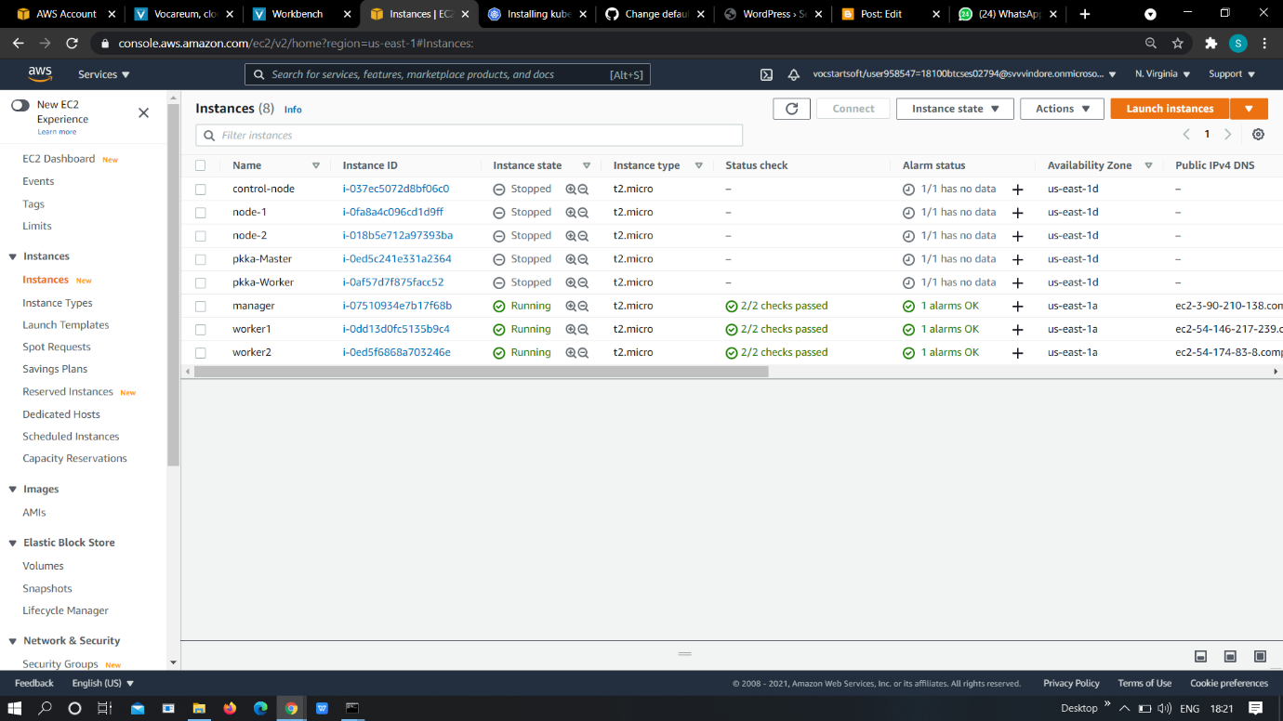

configure master node and slave node seperately.



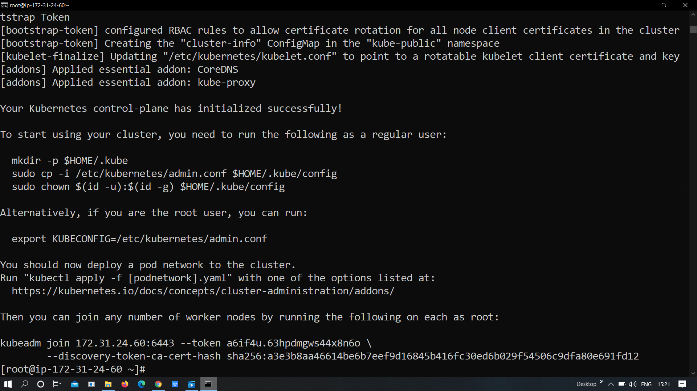



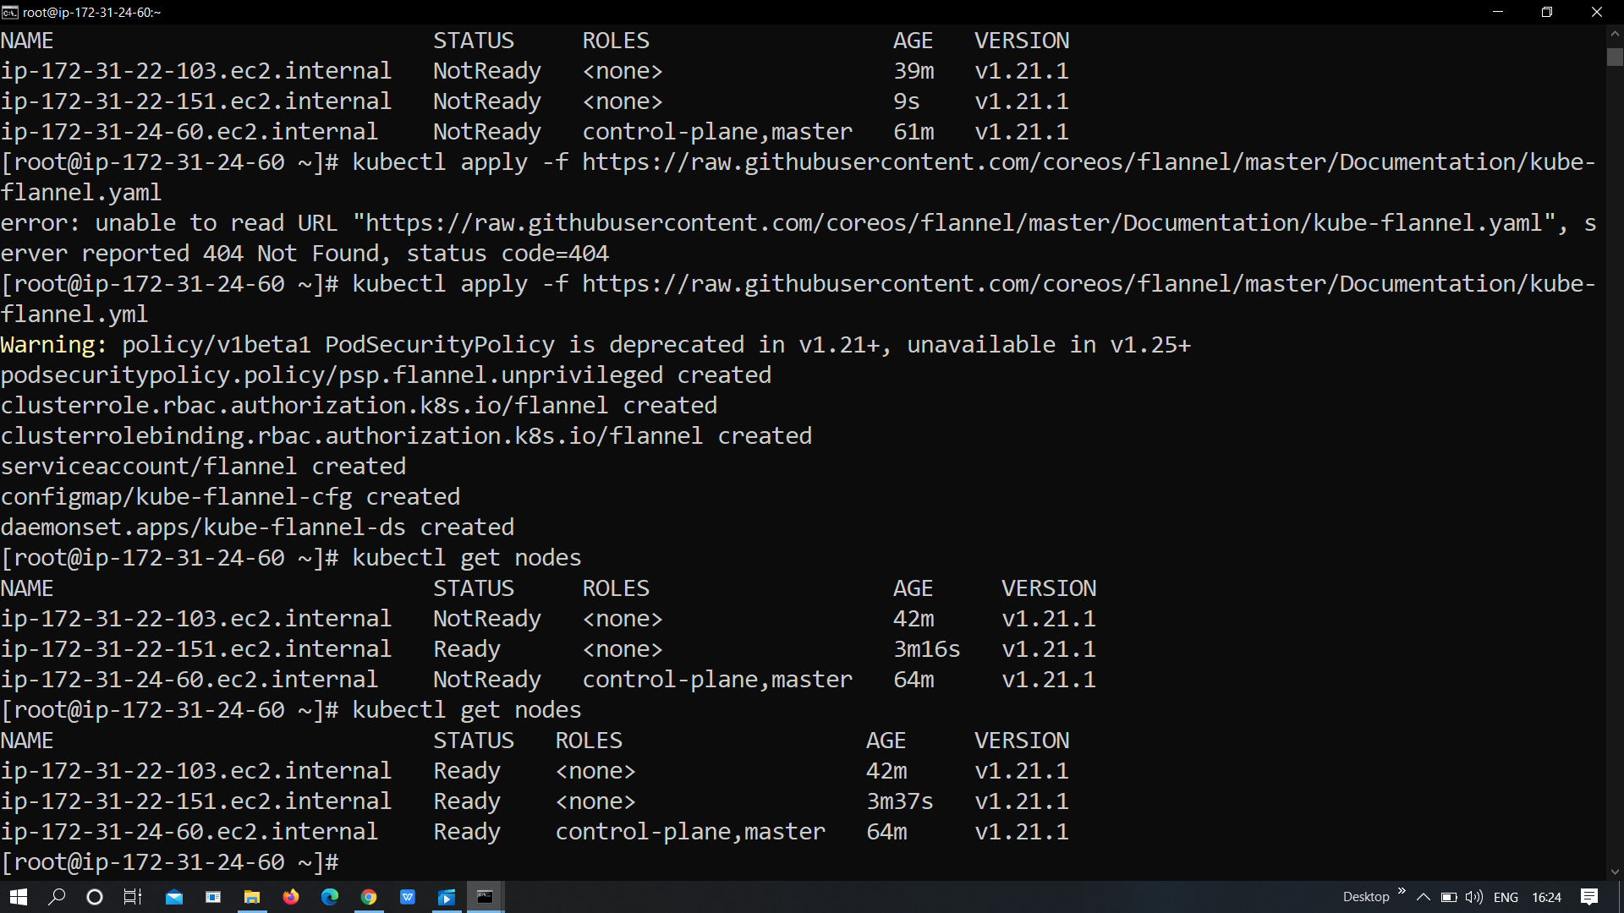

Launch a wordpress and mysql database connected to it in the respectine slaves.



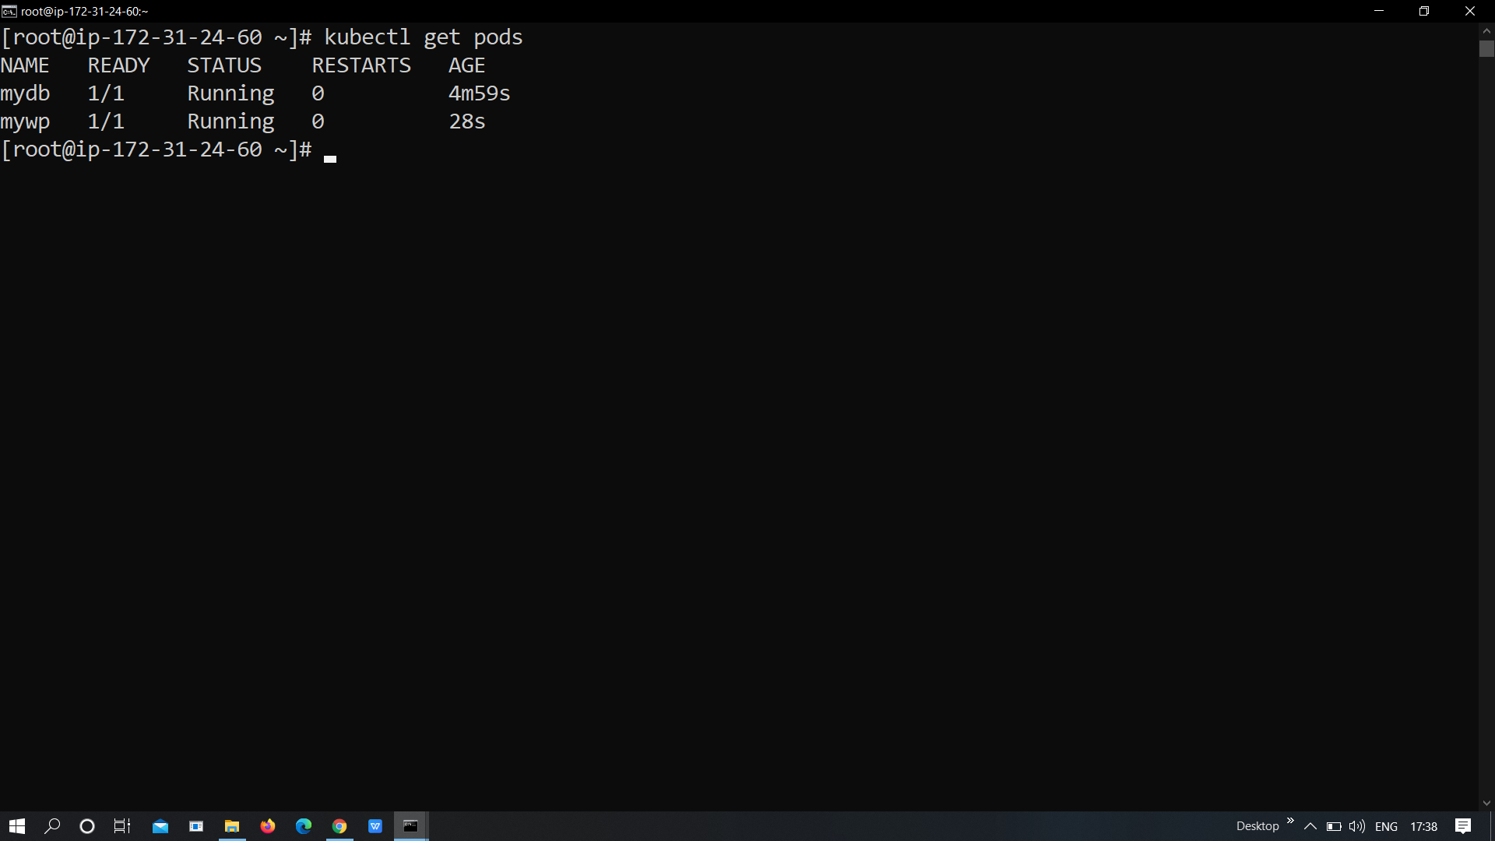

Expose the wordpress pod and client able hit the wordpress ip with its respective port.



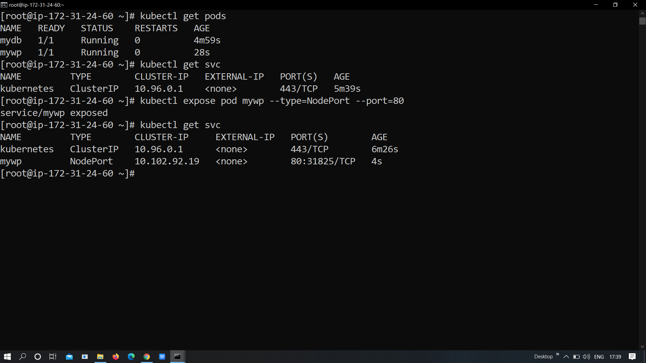



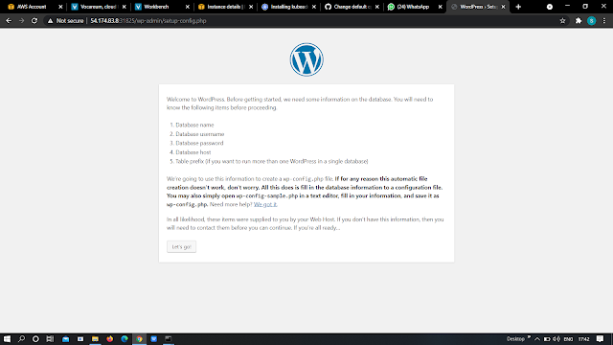



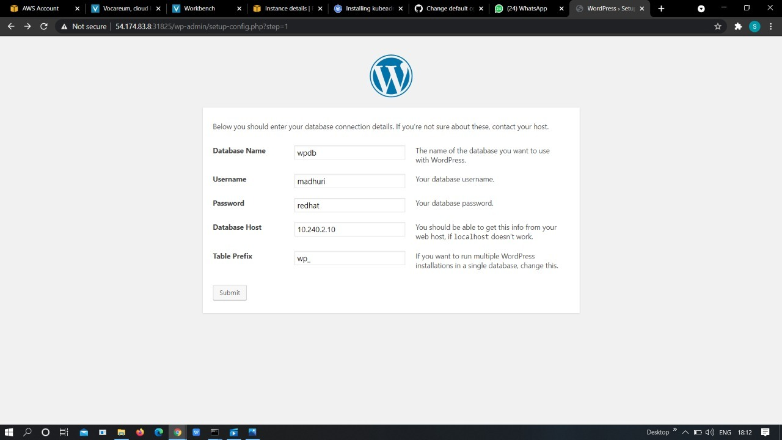

**#vimaldaga #worldrecordholder #rightapproach #rightmentor #ckabylw #ckadbylw #multinodecluster #kubernetes #aws**