eCourts Citizen Case Companion
Project Brief — citizen-first redesign of India’s eCourts experience
BUILD WHAT MOVES INDIA • v0 • 20 AUGUST 2026
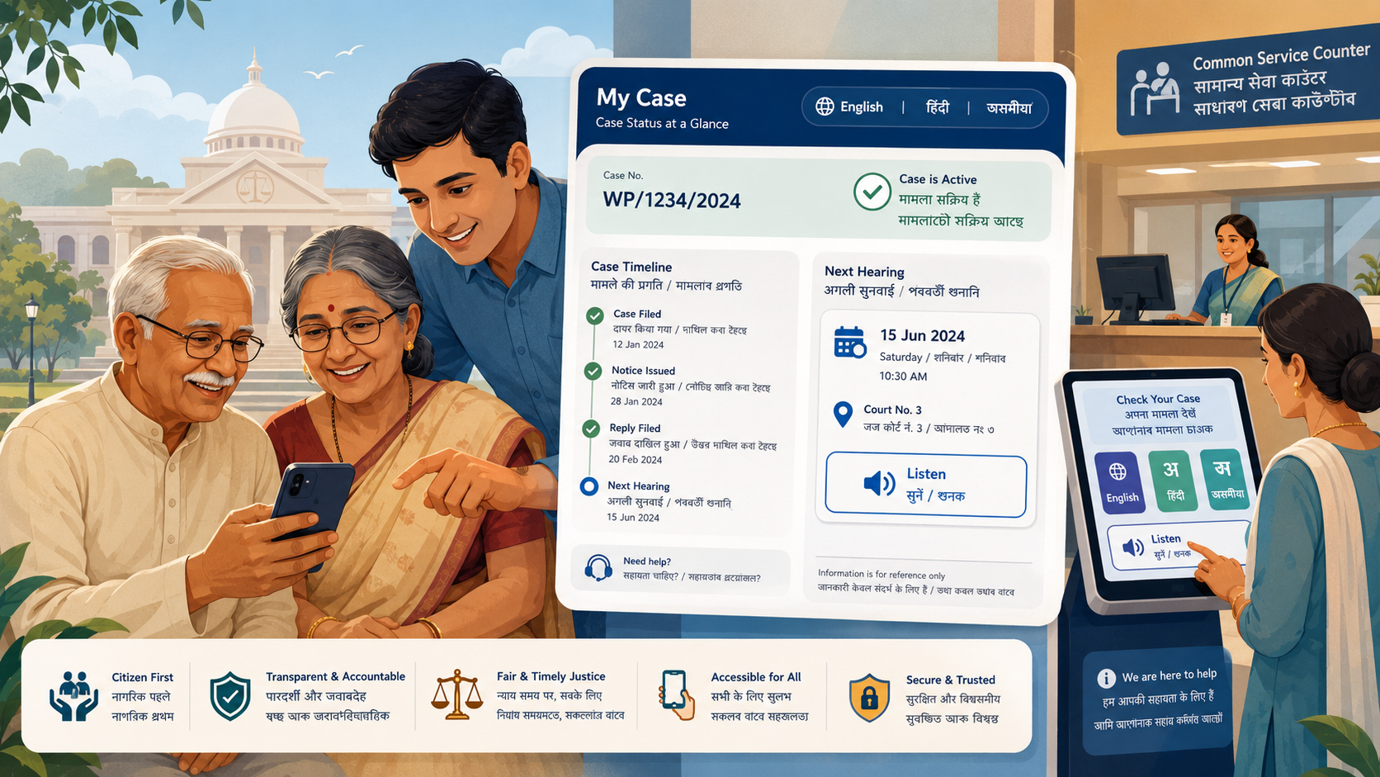
Independent prototype. Synthetic case data. Not an official government product.
One-line concept
Help ordinary people find a case, understand what happened, hear it in their language, know what to do next, and reach legitimate legal help — without requiring fluent English, legal vocabulary, or high digital literacy.

The problem
eCourts already exposes extensive case information and services. The main opportunity is the gap between a technically correct court record and what an ordinary litigant actually needs to understand.
- What happened in my case?
- When is the next hearing?
- Do I need to attend or file something?
- What does this order mean?
- Who can help me if I do not understand it?
The current ecosystem is organised around identifiers and service boundaries such as CNR, filing number, FIR, case type, court complex, cause list, District Court Services, High Court Services, ePay, eFiling, and Judgment Search. The redesign organises the experience around the citizen’s case instead.
Core flow
FIND → UNDERSTAND → LISTEN → ACT → GET HELP

Who we are designing for
User | Design requirement
Older citizens | Large tap targets, fewer decisions, voice/read-aloud, clear next steps.
Regional-language / low-literacy users | Critical journeys must not depend on English; use plain language, icons + text, and audio.
People with disabilities | Screen-reader structure, high contrast, scalable text, keyboard access, accessible document alternatives.
Low digital confidence | Progressive guidance, no hidden jargon, strong error recovery and human help.

What v0 already demonstrates
- Simplified homepage with three large citizen task paths.
- English, Hindi and Assamese switching for key content.
- Read-aloud, Simple View and High Contrast.
- Working mobile menu and layered/parallax visual system.
- Synthetic CNR search and clearly labelled fictional Varun Mayya demo case.
- Citizen-oriented case workspace: next hearing, listing purpose, attendance uncertainty, timeline and latest update.
- Simulated AI Case Assist with explicit uncertainty and official-source boundaries.
- Public-service-first legal help: Legal Aid / Tele-Law before a neutral advocate directory.

AI role and guardrails
AI is an assistive interpretation layer, not a lawyer, judge, or authoritative record. In v0 the AI behaviour is simulated locally so the interaction and safeguards can be demonstrated without paid API usage.
AI can | AI must not
• Explain court language in plain language | • Predict case outcomes
• Translate/explain in regional languages | • Invent deadlines or attendance duties
• Separate known facts from uncertainty | • Present legal strategy as definitive advice
• Suggest questions to ask a lawyer | • Recommend a particular advocate
• Route to legitimate human help | • Replace the official court record

Why legal help is not a marketplace
Bar Council of India professional-conduct rules prohibit advocates from advertising or soliciting work. The product therefore uses a neutral “Find Legal Help” model rather than ratings, sponsored listings, success claims, bidding, or “hire now” mechanics.
- 1. Free Legal Aid / Legal Services Authorities
- 2. Tele-Law / government-supported consultation
- 3. Neutral advocate information by state, district and court
- 4. Profile claiming only for factual identity/enrolment verification and permitted corrections

Submission thesis
Positioning
eCourts digitised the court record. Citizen Case Companion redesigns what that record means to the person whose life is inside it.

Current limitations
- Synthetic case and advocate data only.
- No undocumented/private eCourts API access.
- AI responses are simulated locally in v0.
- No production authentication, payments, or legal-aid submission yet.
- Regional-language content is a prototype subset, not a production legal-translation system.

Evidence base
The brief is grounded in official eCourts/e-Committee documentation, eCourts app guidance, accessibility statements, NALSA and Tele-Law public-service material, and Bar Council of India professional-conduct rules. Full source URLs are listed in the Project Report.

