eCourts Citizen Case Companion
Project Report & Submission Rationale — v0
BUILD WHAT MOVES INDIA • v0 • 20 AUGUST 2026
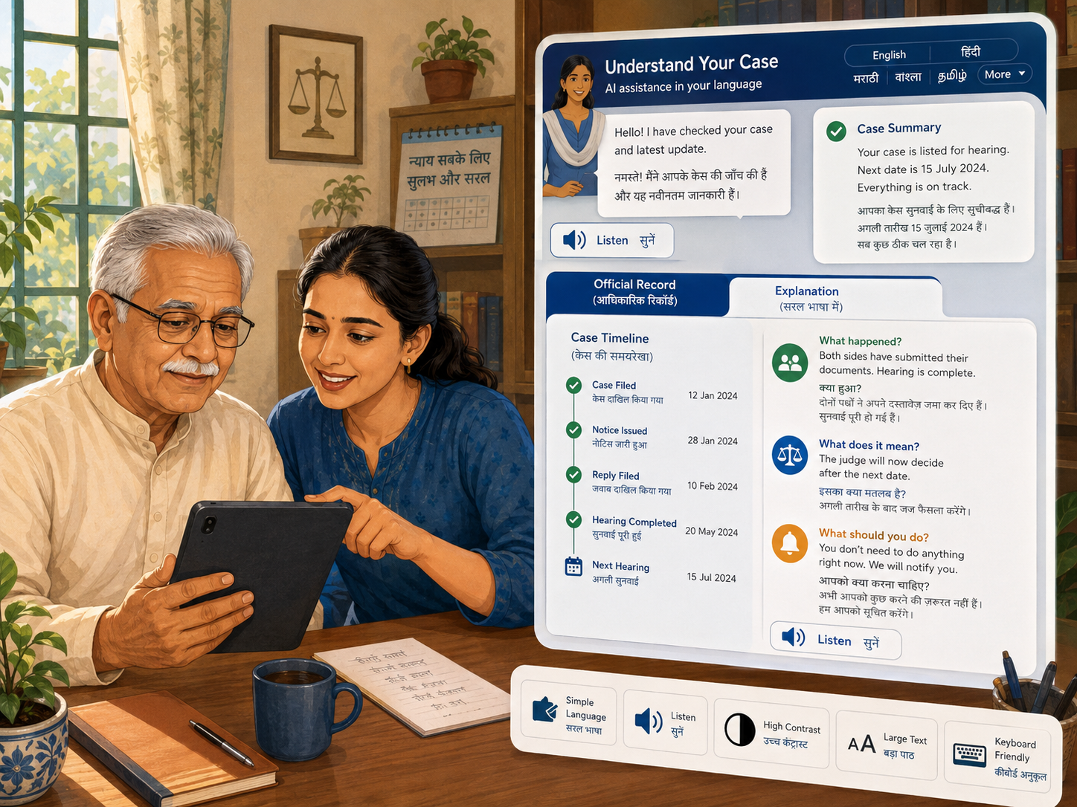
Independent prototype. Synthetic case data. Not an official government product.
Project thesis
eCourts already digitises court information. Our project turns that information into an understandable, accessible citizen journey — Find → Understand → Listen → Act → Get Help.

1. Executive summary
The eCourts Project is one of India's most important public digital infrastructures. It provides access to case information, orders, judgments, court schedules, payments, filing, and related services across High Courts and District Courts. Its current Phase III vision explicitly prioritises citizen-centric services, inclusion, interoperability, simplification, and the move toward an Integrated Digital Court.
The opportunity addressed by this project is not a lack of court data. It is a gap between court data and citizen understanding.
For an ordinary litigant, a technically correct status is often not enough. A person needs to know what happened, what it means, what happens next, whether they must act, and where to obtain legitimate help. The current ecosystem frequently exposes internal court terminology, identifiers, and separate service boundaries directly to the public.
Citizen Case Companion proposes a citizen-facing layer organised around a persistent case workspace and five human tasks:
Find → Understand → Listen → Act → Get Help
The prototype prioritises older users, low-English and low-literacy citizens, people with disabilities, and users with limited digital confidence. It combines simplified information architecture, multilingual UI, read-aloud support, accessible visual states, plain-language explanations, transparent uncertainty, and a public-service-first legal-help flow.
The project does not replace official court records. It creates a safer interpretation and navigation layer over them.

2. Context: what eCourts already does well
The redesign is deliberately not based on the claim that eCourts is obsolete or without useful functionality. The official eCourts Services app already supports case search through CNR, case number, filing number, FIR number, party name, advocate information, case type, and Act. It also includes My Cases, case history, hearing dates, court proceedings, orders, a calendar view, a court-complex locator, and multiple interface languages.
The official eCourts 2.0 homepage also states goals around citizen-centric delivery, transparency, affordable and accessible justice, case management, and interoperability with other justice-sector programmes.
This makes the redesign challenge more meaningful: the information and many core services already exist. The problem is how they are assembled and understood from the litigant's point of view.

3. Problem diagnosis

3.1 Inside-out information architecture
The public entry point exposes services such as High Court Services, District Court Services, Virtual Courts, ePay, eFiling, Judgment Search, and related systems. These labels correspond to institutional or product boundaries.
A citizen's mental model is usually different:
- Find my case.
- Understand the latest update.
- See my next hearing.
- Read an order.
- Pay something required in my case.
- File something required in my case.
- Get legal help.
The redesign therefore treats the case as the primary object and hides system fragmentation beneath it.

3.2 Search requires legal and procedural knowledge
The official eCourts app documentation supports multiple search paths, which is valuable for expert users. However, those paths can require knowledge such as court complex, filing number and year, FIR number and police station, advocate registration format, case status, Act, and other structured identifiers.
For an ordinary citizen, “I know the person's name and roughly which court we visited” is meaningful information. The product should translate human knowledge into the appropriate search route instead of forcing the citizen to choose the database query model first.

3.3 Record availability is not record comprehension
Current case history can provide hearing dates, judge details, parties, advocates, FIR details, proceedings, and orders. Yet the citizen may still be unable to answer:
- What happened today?
- Was a final decision made?
- Why is there another date?
- Does the order explicitly require something from me?
- Do I need to attend?
The proposed system therefore adds a plain-language interpretation layer while preserving the official record as authoritative.

3.4 Fragmentation creates continuity problems
A user's case journey can cross multiple public products: case status, orders, ePay, eFiling, Virtual Courts, and legal-aid services. The user repeatedly has to re-establish context.
A persistent Case Workspace would maintain the citizen's context and expose the appropriate action inside the case, while existing systems continue to operate as underlying services.

3.5 Accessibility must include comprehension, not only controls
The current ecosystem includes accessibility efforts, including screen-reader support and interface controls. The eFiling accessibility statement also acknowledges that PDF files are currently not accessible.
In a court context, inaccessible PDFs are especially important because orders and judgments may contain the information most critical to a litigant.
Citizen Case Companion treats accessibility as a combination of:
- Perceivability: high contrast, scalable text, screen-reader-friendly structure.
- Operability: keyboard, large touch targets, voice/read-aloud support.
- Understandability: plain language, progressive disclosure, reduced cognitive load.
- Language access: regional languages for critical tasks.
- Accessible documents: official file + structured accessible text + plain-language explanation.

3.6 English and legal literacy cannot be prerequisites for digital justice
The target public includes citizens who may not read English comfortably, may have limited literacy, or may rely on a family member or service centre to use digital systems.
The prototype therefore makes language selection visible, supports English/Hindi/Assamese in v0, and includes read-aloud behaviour. The product vision extends this to regional-language explanation and voice-led navigation.

3.7 Legal help needs a public-service model, not a marketplace
A natural product extension is helping citizens reach a lawyer. A conventional lawyer marketplace would be inappropriate for a public judicial interface and creates regulatory and trust concerns.
Bar Council of India professional-conduct rules state that advocates must not advertise or solicit work. Therefore the project proposes Find Legal Help, not “Hire a Lawyer”.
The hierarchy is:
1. Free Legal Aid / Legal Services Authorities.
2. Tele-Law or other public consultation channels.
3. Neutral verified advocate information by state, district, and court.
No ratings, paid ranking, sponsored placement, win rates, bidding, or commercial recommendation are included.

4. Target users and inclusive design requirements
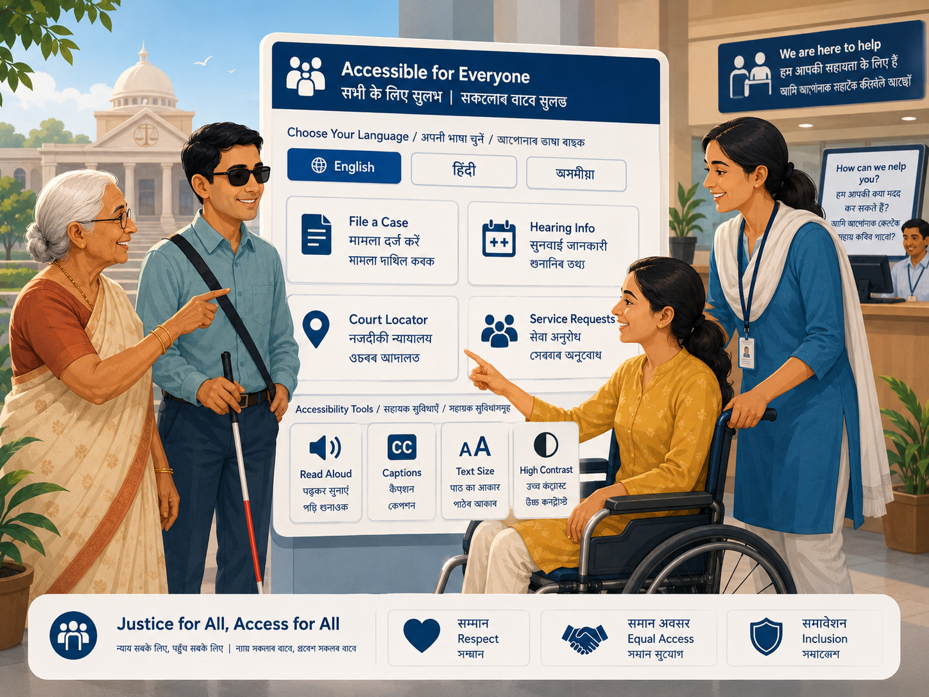

4.1 Older citizen
Needs:
- large readable text and buttons;
- minimal decisions per screen;
- no hidden menu dependency for critical actions;
- read-aloud support;
- familiar language;
- clear confirmation and error recovery.

4.2 Low-English or low-literacy citizen
Needs:
- regional language throughout critical tasks;
- icons paired with text;
- voice input and spoken output;
- short sentences and plain language;
- no assumption that the user recognises legal abbreviations.

4.3 Person with visual impairment
Needs:
- semantic headings and labels;
- screen-reader compatibility;
- keyboard navigation and visible focus states;
- high contrast and scalable text;
- structured alternatives to inaccessible PDFs.

4.4 Person with hearing impairment
Needs:
- no dependence on voice/phone-only assistance;
- captions/transcripts for any audio/video;
- all important alerts available visually and textually.

4.5 Person with motor disability
Needs:
- large touch targets;
- keyboard/switch compatibility;
- no precision tapping requirement;
- minimal drag gestures or timed interactions.

4.6 Cognitive/neurodivergent user
Needs:
- low information density;
- progressive disclosure;
- simple states: what happened / what next / what I need to do;
- consistent navigation;
- clear distinction between known, inferred, and unknown information.

5. Product concept

5.1 Homepage
The homepage is intentionally reduced to three large citizen tasks:
1. Find my case.
2. Understand my update.
3. Find legal help.
A user does not need to decide between internal eCourts products before starting.

5.2 Guided case discovery
Two primary paths:
- I know my case number / CNR.
- I do not know my CNR.
The second path progressively asks what the user does know: name, case number, FIR, lawyer, court paper, district/court, etc.

5.3 Case Workspace
Once a case is identified, the citizen sees one persistent workspace containing:
- current case state;
- next hearing;
- purpose of next listing;
- latest update;
- attendance uncertainty;
- timeline;
- official orders;
- payments/filing actions when applicable;
- AI assistance;
- legal-help handoff.

5.4 Plain-language explanation
Every AI explanation is layered beneath the official record.
The product distinguishes:
- Official record — authoritative source.
- Explanation — plain-language interpretation.
- Known — explicit in the record.
- Not stated / uncertain — cannot safely be concluded.
- Ask a professional — where legal judgment is required.
This prevents the interface from turning a probabilistic model into an authoritative legal source.

5.5 Listen mode
Critical case information can be read aloud in the selected language. This is useful not only for people with visual disabilities, but also for older citizens, low-literacy users, and people who understand a spoken regional language better than written legal language.

5.6 Find Legal Help
The legal-help layer offers:
- legal-aid eligibility routing;
- Tele-Law/public consultation handoff;
- neutral advocate information.
Advocate profiles are informational records, not promotions. A future profile-claim process would verify identity/enrolment and allow permitted factual corrections, without implying endorsement.

6. AI architecture and guardrails

6.1 Intended production flow
1. Retrieve authoritative case metadata and the latest available court record.
2. Extract structured facts: date, listing purpose, order type, explicit directions, deadlines, parties.
3. Generate a plain-language explanation constrained to retrieved facts.
4. Attach source references to every important statement.
5. Separate facts from uncertainty.
6. Translate/explain in the citizen's selected language.
7. Offer procedural questions or possible routes for discussion, not legal strategy.
8. Hand off to a qualified person when professional advice is necessary.

6.2 AI must be assistive, not authoritative
Prohibited behaviours:
- predicting a judgment;
- telling a citizen to file a legal application as definitive advice;
- inventing a deadline or attendance requirement;
- selecting or recommending a particular advocate;
- summarising without a link to the authoritative source;
- silently altering legal terminology.

6.3 Hackathon implementation
The v0 prototype implements deterministic/simulated responses locally. This demonstrates the full interaction, information hierarchy, uncertainty states, and guardrails without paid API usage.
The submission will disclose this clearly. A production version would connect the same interface to an OpenAI model through a retrieval-grounded service with strict prompting, source citation, confidence/uncertainty controls, and audit logs.

7. Legal-help architecture
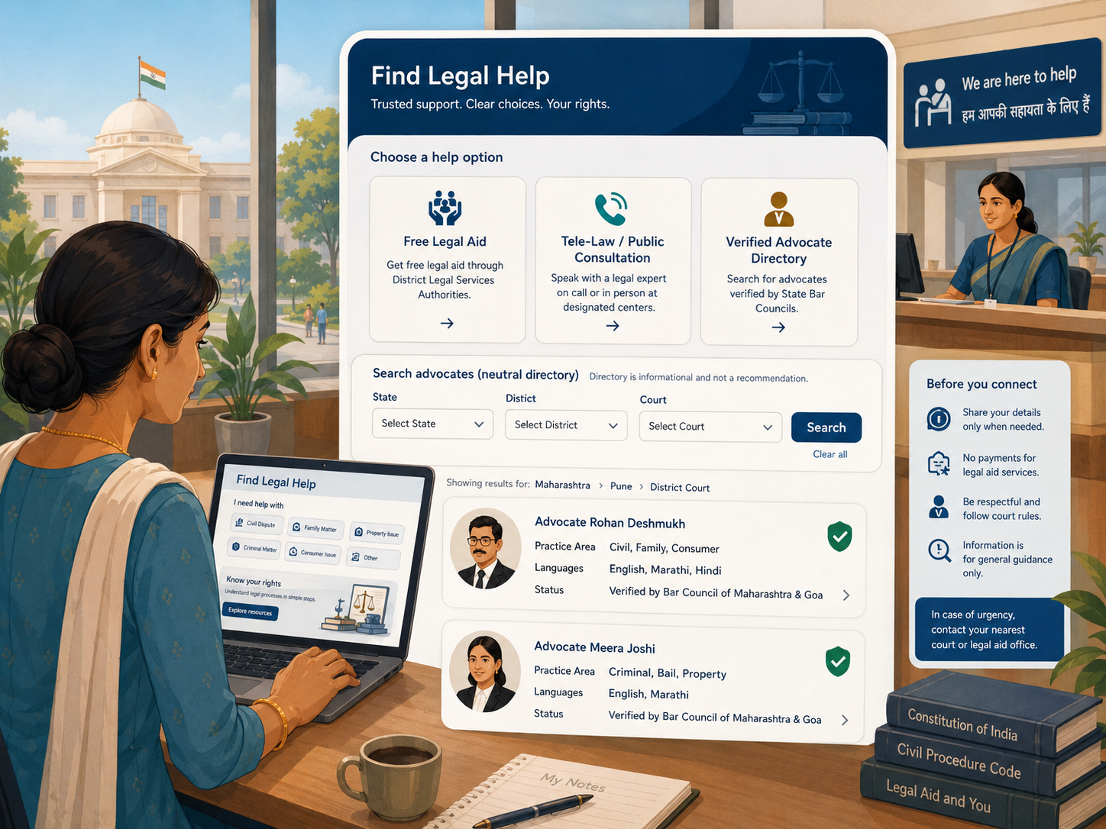

7.1 Public assistance first
NALSA and Legal Services Authorities provide free legal services to eligible categories and legal advice/assistance through statutory institutions. Tele-Law already operates as a Department of Justice public-access programme and supports applicant/lawyer registration and legal advice delivery.
This makes integration or routing to public legal-assistance infrastructure a stronger public-service design than inventing a private marketplace.

7.2 Neutral advocate directory
The directory design can use factual fields such as:
- advocate name;
- enrolment number;
- state/district/bar association;
- languages;
- courts of practice where verifiable;
- contact method where permitted;
- verification status.
It should not include:
- rankings;
- paid placement;
- star ratings;
- “best lawyer” claims;
- win rates;
- case outcome claims;
- promotional descriptions.

7.3 Registry-first, claim-second model
A scalable future design should seed records from authorised registries where lawful and available, then let advocates claim/correct their record through verification. This avoids requiring every advocate to create a fresh marketplace profile.

8. System architecture

8.1 Citizen-facing layer
- Homepage / service discovery
- Guided case search
- Case Workspace
- AI explanation service
- Accessible text and audio
- Legal-help router
- Notification/change layer

8.2 Integration layer
Potential production integrations, subject to authorised documented interfaces:
- case information systems;
- official orders/judgments;
- eFiling;
- ePay;
- notification services;
- Legal Services Authorities / Tele-Law;
- authorised advocate registries.

8.3 Event model
Instead of exposing only raw database statuses, the citizen layer would interpret events such as:
- case filed;
- notice issued;
- hearing listed;
- hearing completed;
- order uploaded;
- date changed;
- document/action required;
- payment pending/reconciled;
- appeal or legal-help request initiated.

8.4 Privacy and security principles
A production implementation should follow data minimisation, authorised access, purpose limitation, encryption, audit logging, secure identity, and clear user consent. The hackathon prototype uses synthetic data and does not connect to live private systems.

9. v0 design decisions

9.1 Simplified homepage for older citizens
The first build originally became too dense. v0 deliberately reduces cognitive load and presents only the most important paths before showing secondary features.

9.2 Visual design
The new design uses:
- high-contrast navy/cream public-service palette;
- larger headings and tap targets;
- restrained rounded cards;
- layered illustration assets rather than a flat single banner;
- subtle parallax on capable devices;
- minimal motion so the interface remains calm and usable.

9.3 Menu behaviour
The menu now opens a dedicated large-link navigation panel on mobile instead of exposing a non-functional control.

9.4 Fictional demo data
“Varun Mayya v. Demo Systems Pvt. Ltd.” is visibly labelled as a fictional demo case. It is used only to make the hackathon demo memorable and does not represent or imply a real legal dispute.

10. Current prototype functionality
Working in v0:
- responsive homepage;
- mobile menu;
- English/Hindi/Assamese switching for key content;
- Simple View;
- High Contrast mode;
- browser-based read aloud;
- synthetic CNR/demo-case opening;
- citizen-oriented case summary;
- next hearing and timeline;
- simulated AI Case Assist;
- simulated legal-help routing;
- neutral advocate directory pattern;
- subtle layered/parallax hero imagery.
Partially mocked or pending:
- “I do not know my CNR” guided search;
- court-paper scanning/upload;
- accessible official order viewer;
- real ePay/eFiling state flows;
- authorised live eCourts integration;
- production OpenAI API integration;
- real legal-aid submission;
- real advocate registry integration;
- production login and security.

11. Submission-critical build plan

P0 — must work before submission
1. Guided “I do not know my CNR” journey.
2. Official order viewer with accessible-text + plain-language tabs.
3. Complete one synthetic case journey end to end.
4. Mobile QA at common Android widths.
5. Clear mocks/limitations page.
6. Public live URL that requires no account/access request.

P1 — highly valuable
1. More polished legal-help flow.
2. Simulated payment/filing action inside the case.
3. Change notification demo.
4. Voice search prototype behaviour.
5. Additional regional-language strings for the demo path.

P2 — only if time remains
1. More animation/parallax polish.
2. Multiple synthetic cases.
3. More advocate-directory filtering.
4. Additional accessibility preferences.

12. Demo narrative (3-minute target)

0:00–0:25 — Problem
Show the current ecosystem and the number of systems/search modes a citizen encounters. Frame the problem as comprehension and continuity, not simply visual ugliness.

0:25–0:55 — Find
Open Citizen Case Companion. Show the simplified homepage, language/read-aloud controls, and case search.

0:55–1:35 — Understand
Open the fictional case. Show the next hearing, latest event, timeline, and uncertainty around attendance/action.

1:35–2:10 — AI Assist
Ask “What happened?” and “What options may exist?”. Show the official-source boundary, uncertainty language, and regional-language/read-aloud behaviour.

2:10–2:35 — Human help
Open Find Legal Help. Show Legal Aid / Tele-Law first, neutral advocate directory second.

2:35–3:00 — System thinking
Reveal the architecture: one citizen case workspace orchestrating existing case data, orders, eFiling, ePay, notifications, and legal-help systems. End on the project thesis.

13. Evaluation alignment

Real problem
The project addresses the gap between available judicial data and the ability of ordinary citizens to understand and act on it.

Working build
The submission will focus on one complete synthetic litigant journey rather than attempting to rebuild every eCourts service.

Usability
The product is designed for mobile use, older citizens, regional-language users, low literacy, low digital confidence, and people with disabilities.

Product thinking
The case is the persistent user object; system boundaries are hidden. AI is assistive and source-grounded. Legal help is public-service-first rather than commercial.

End-to-end thinking
The concept includes authorised integration with case data, orders, eFiling, ePay, notification state, legal aid, Tele-Law, and advocate registries.

Honesty
Synthetic data, simulated AI, missing live integrations, and other dependencies are clearly disclosed.

14. Risks and mitigations

Hallucinated legal guidance
Mitigation: retrieval-grounded explanation, source links, explicit uncertainty, no strategy recommendation, lawyer handoff.

Misleading advocate directory
Mitigation: factual neutral records only; no ratings, ranking, endorsements, or paid placement.

Accessibility added too late
Mitigation: accessibility is a design-system requirement, not a separate mode. Core journeys must work with large text, keyboard/screen reader, and language/read-aloud support.

Scope explosion
Mitigation: ship one end-to-end synthetic case journey first; represent other integrations as architecture/mocks.

Prototype confused with official government service
Mitigation: visible prototype disclaimer, no misuse of government logos, synthetic data, separate branding.

15. Conclusion
The strongest opportunity in eCourts is not to replace the judicial record or redesign every government backend in a hackathon. It is to make the existing digital justice ecosystem legible from the citizen's side.
The project asks a simple question:
If the system already knows what happened in a person's case, why should the citizen need legal vocabulary, fluent English, multiple portals, and expert digital skills just to understand it?
Citizen Case Companion proposes a practical answer: one persistent case workspace, plain language, regional languages, voice/read-aloud access, accessible documents, transparent AI assistance, and legitimate human help.
eCourts digitised the court record. Citizen Case Companion redesigns what that record means to the person whose life is inside it.

References
1. eCourts Services 2.0 homepage — https://ecourts.gov.in/ecourts2.0/
2. eCourts Services Mobile App FAQ — https://services.ecourts.gov.in/App/appfaq.html
3. eCourts Services App Help & User Guide — https://services.ecourts.gov.in/App/apphelp.html
4. eFiling Services Accessibility Statement — https://filing.ecourts.gov.in/pdedev/?p=otherPages/accessStmt
5. e-Committee National Conference 2026 — https://ecommitteesci.gov.in/national-conference-2026/
6. eCourts Phase III Vision Document page — https://ecommitteesci.gov.in/mz/vision-document-for-phase-iii-of-ecourts-project-2/
7. NALSA FAQs / legal aid — https://nalsa.gov.in/faqs/
8. Tele-Law official portal — https://www.tele-law.in/
9. Bar Council of India Rules — https://www.barcouncilofindia.org/info/bci-rules
10. Bar Council of India practising-advocate data notice — https://www.barcouncilofindia.org/info/supply-of--kwnp5t
11. Build What Moves India — https://buildwhatmovesindia.com/

