1**. Perform the following tasks:**

**1. Load the ‘vote.arff’ dataset**

**2. Apply the Apriori association rule**

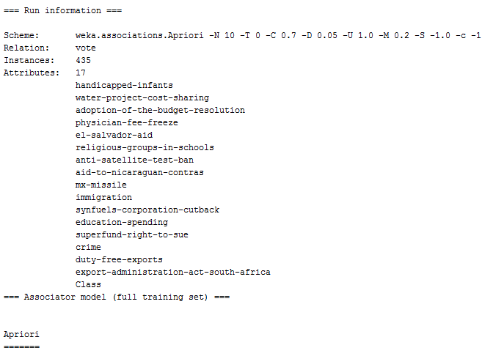

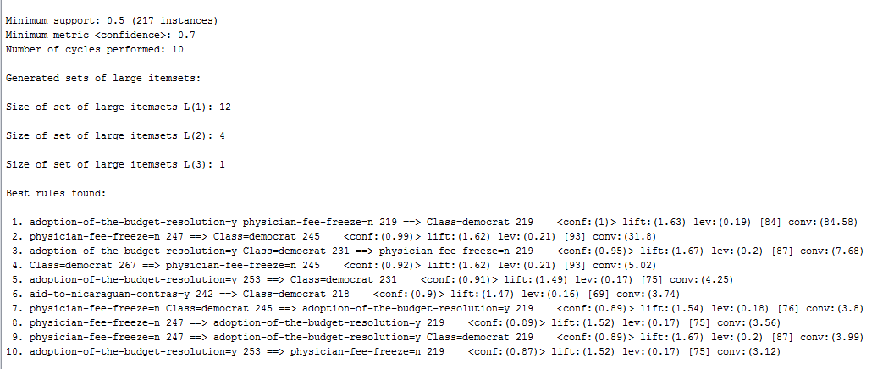

**3. What is the support threshold used? What is the confidence threshold used?**

**Ans :** Minimum Support count – 2

Minimum Confidence – 70%

**4. Write down the top 6 rules along with the support and confidence values.**

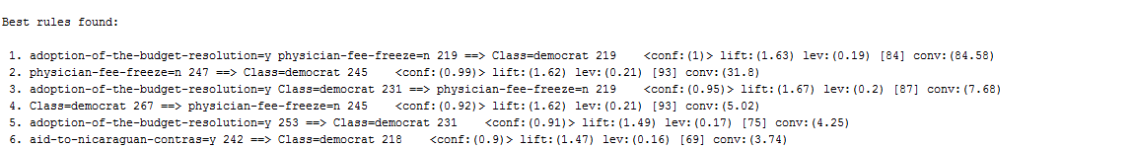

**5. What does the figure to the left of the arrow in the association rule represent?**

**Ans :** The figure to the left of the arrow represents the Antecedent.

**6. What does the figure to the right of the arrow in the association rule**

**represent?**

**Ans :** The figure to the left of the arrow represents the Consequent .

**7. For rule 8, verify that numerical values used for computation of support and confidence are in accordance with the data by using the Preprocess panel. Then compute the support and confidence values. Are they above the threshold values?**

**Ans :** The minimum support count used is 2 and the minimum support confidence used was 70% . The rule 8 values are above these minimum support values with the confidence to 89%.

**2. Perform the following tasks:**

**1. Load the dataset ‘weather.nominal.arff’.**

**2. Apply the Apriori association rule**

**1. Consider the rule “temperature=hot ==> humidity=normal.” Compute the support and confidence for this rule.**

**Ans :** No such rule exist .

**2. Consider the rule “temperature=hot humidity=high ==> windy=TRUE.” Consider the support and confidence for this rule.**

**Ans :** No such rule exist .

**3. Is it possible to have a rule like the following rule: “outlook=sunny temperature=cool” ==> humidity=normal play=yes**

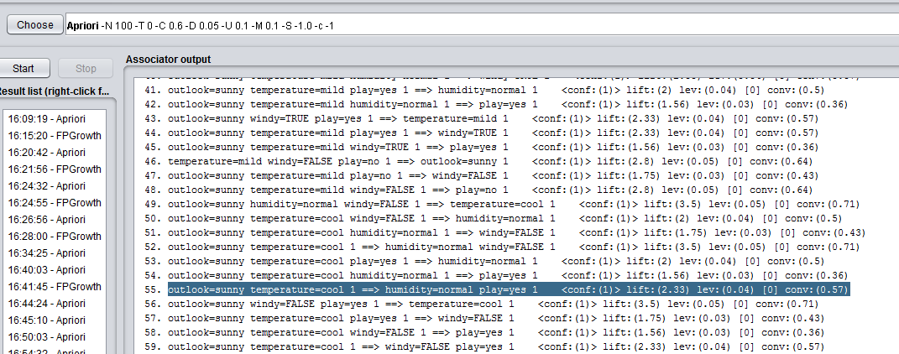

**3. Perform the following tasks:**

**1. Load the bank-data.csv file.**

**2. Apply the Apriori association rule algorithm. What is the result? Why?**

Apriori Algorithm 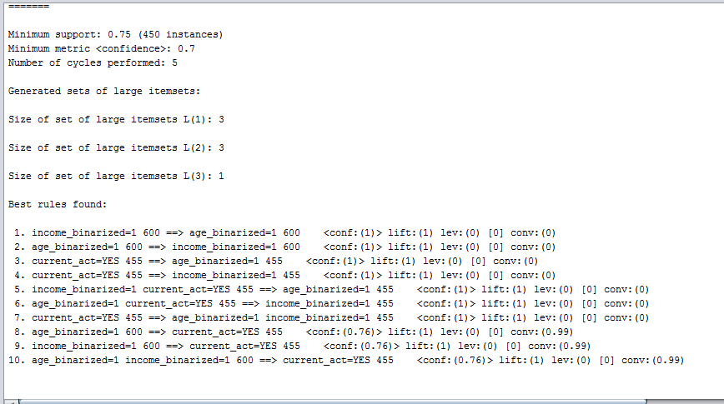

FP Growth Algorithm

