**Ans1:**

Cat data

Concatenate data file and print it on screen.

**Ans2:**

Sort lines of file names.

**Ans3.**

Report repeated lines.

**Ans4:**

Print line contains ab in data file.

**Ans5:**

Print grep (GNU) version number

**Ans6:**

cut -d : -f 5

Remove line from file use DELIM instead of TAB for field delimiter

Print and select those fields that contains no delimiter and first 5 .for file /etc/passwd

**Ans:7:**

cut -c 5-20 /etc/passwd

Print character 5-20 from /etc/passwd

**Ans8:**

wc -l /etc/passwd

Count no of lines of file.

**Ans9:**

sort /etc/passwd

**Ans10:**

cut -d: -f /ect/passwd

**Ans11:**

Wc -l people1 people2 people3

**Ans 12:**

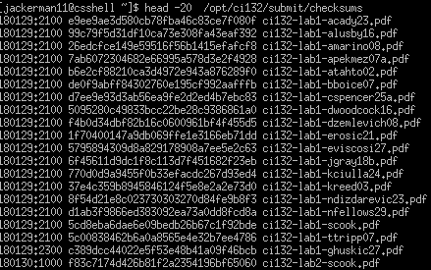

**Ans13:**

grep -n lab5 /opt/ci132/submit/checksums

**Ans14:**

grep -v lab5 /opt/ci132/submit/checksums

**Ans15:**

echo -n Welcome | md5sum

**Ans16:**

cut -d: -f 1,3

**Ans 17:**

sort name_ssh

**Ans18:**

Sort -k2 name_ssh

**Ans19:**

sort -t : -k 2n name_ssn