Locus
Persistent spatial memory for blind and low-vision pedestrians
Meta Global AI Developer Hackathon · Indie developer track
Team: [team member names]
Video: [demo video link] · Code: [repository link]
Submitted November 4, 2026

Summary
Locus watches a first-person video stream, builds a 3D memory of the objects around a walking person, and speaks up only when something is actually on a collision course. Objects stay in memory after they leave the camera's view, so a pole the wearer glanced past is still "at 2 o'clock" when they turn their head away.
The hard part turned out not to be detecting hazards. It was not crying wolf. On a real 36-second city walk from Google's SANPO dataset, an earlier version of the system flagged a critical collision risk on 342 of 539 frames, and reported the wrong side of the street about half the time. The final version raises no false critical alerts on that walk, gets left and right right every time, and speaks 12 short cues, one of them a genuine warning about a pedestrian walking toward the stopped wearer.
On the real SANPO walk (539 frames, 36 s) | Earlier version | Submitted
Reported side matches the side of the image | 55% (a coin flip) | 100%
Frames with a critical (< 2 s) collision alert | 342 | 0
Hazard events shown in the dashboard | 74 | 1
"Velocity" of static objects (poles, trees) | median 13 m/s | 0
Spoken cues over the walk | 25 | 12

The problem
Blind and low-vision pedestrians are not short of information. A white cane and ambient sound already report a great deal. What is scarce is hearing, which is already busy with navigation: traffic, voices, the tap of the cane. Every word an assistive system speaks competes with that. A system that talks constantly, or warns about things that are not dangerous, gets switched off, and abandonment, not inaccuracy, is how assistive devices usually fail.
So the design goal for Locus is narrow: say little, say it in the wearer's own frame of reference, and be right when it does speak. Two technical capabilities make that possible:
- Persistence. A camera-only system forgets anything that leaves the frame. A person who turns their head loses every warning about what is beside them. Locus keeps a world-anchored 3D memory, so objects stay put when the head moves.
- Geometry, not guesswork. Whether something will hit you is a question of distance, closing speed and miss distance. Locus computes those directly from real depth and camera motion, with no learned hazard model.
Locus is evaluated on SANPO, a dataset Google Research built for exactly this problem (outdoor blind/low-vision navigation) and the one behind Google's Project Guideline. It provides real stereo depth and real camera trajectories, so a car closing at 6 m really is a car closing at 6 m, not a stand-in.

What Locus does

The pipeline
- Choose what to look for. Muse Spark (Meta Model API) looks at the scene and proposes the object types worth tracking: poles, cars, people, bins, trees.
- Segment and track. SAM 3.1 finds each proposed object in the image; EdgeTAM then tracks it frame by frame using only past frames, the way a live device would (about 10.5 frames per second on the DGX Spark).
- Place it in 3D. Each object's mask is lifted to a 3D point using the median depth under the mask, then moved into world coordinates using the camera's pose.
- Remember it. A persistent memory graph keeps each object at its last known world position after it leaves view, fading its confidence over time. Static and moving things are remembered differently (below).
- Judge the danger. For every nearby object: distance, clock position relative to the walking direction, time to collision, and how close it will actually pass.
- Decide whether to speak. A speech policy picks at most one thing to say, only when it is news, and keeps silence between cues.
- Speak. Urgent cues use a short fixed form ("person, 12 o'clock, 3s"). Calm mentions of nearby landmarks are phrased naturally by Muse Spark. All speech is synthesized locally with SeamlessM4T v2.

Three kinds of output
Kind | What it is | In Locus
Warning | Something that could hurt you. Unrequested, rare, short. | Built. Short form with seconds to collision.
Ambient orientation | Landmarks nearby ahead. Sparse, once per object, never repeated. | Built. Natural sentence, front and sides only.
On request | "What's around me?" Rich and detailed, when asked. | Deliberately not built. Scoped to the half that can't wait to be asked for.

Positions are given as clock directions ("pole at 2 o'clock"), common practice in orientation-and-mobility and sighted-guide language. Speech describes; it never instructs. Locus says where things are and leaves the decision to the person who knows their own route: no "step left", no "stop".

The demo: a real walk
The demo replays the full pipeline's output on a real recorded SANPO walk through Manhattan (36 s, 539 frames). Every position, alert and audio clip comes from running the actual models on the real recording; the dashboard plays the results back in sync. It is a replay of recorded data, not a live camera feed.
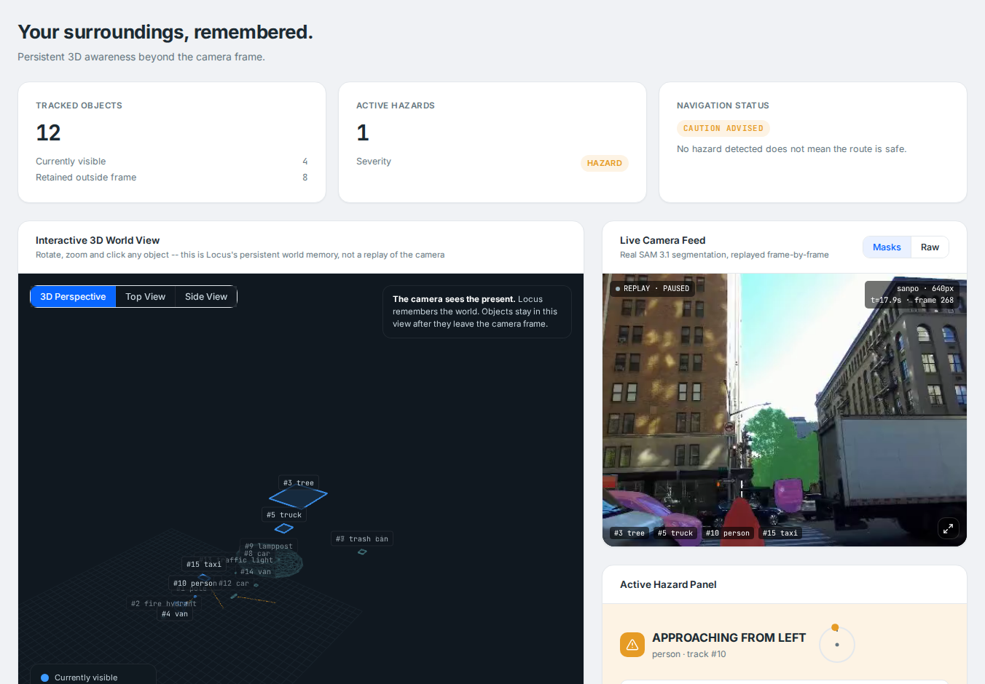
Figure 1. The Locus dashboard at 17.9 s: the camera feed with segmentation (right), the persistent 3D world memory (left), and one active warning, a pedestrian approaching.

What the wearer hears
Time | Spoken cue | What is happening
0–15 s | Tree, pole, fire hydrant, trash bin, trash can, person, each mentioned once | Ambient orientation while walking. Each object is announced once, not every few seconds.
1 s, 5 s | (silence) | Parked vehicles beside the sidewalk. The earlier version raised critical alarms here.
17.9 s | "person, 12 o'clock, 3s" | The wearer has stopped and a pedestrian walks straight toward them at about 1.4 m/s. The one genuine warning on the walk.
20.9 s | "There's a van moving at 1 o'clock." | A van really does drive across in front, but passes about 4 m clear. Mentioned calmly, not alarmed.
24–35 s | Pole, truck, car, person | Ambient mentions after the stop.
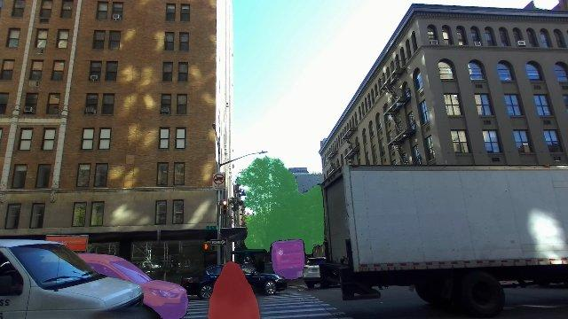
Figure 2. The frame at 17.9 s: the approaching pedestrian (red, centre) and the other tracked objects, segmented by SAM 3.1 + EdgeTAM.

How it works

Three reference frames
Locus keeps three coordinate frames apart: the camera (where the head points), the body (where the person is walking), and the world (fixed). Clock positions come from the body frame, derived from one second of walking motion and held through stops, so turning the head does not move "the pole at 2 o'clock". This invariant is tested directly. It was also checked against SANPO's separate chest-mounted camera: the walking-direction estimate agrees with the chest's measured heading to within 14.7° (median).

Knowing what is safe to remember
Persistence is only safe for things that stay put. Locus sorts the objects it tracks into three groups:
- Static (pole, tree, hydrant, bin, sign, bench): remembered for 20 seconds at their last position, which stays correct after they leave view. Their speed is fixed at zero.
- Moving (person, car, bicycle, dog): forgotten within about a second of leaving view, and never alerted on once unseen for 0.75 s, because a remembered car is a guess that gets worse every frame. Their speed is a straight-line fit over the current track, restarted whenever the tracker swaps one object for another under the same label.
- Unknown objects keep the general-purpose behaviour.

Is it actually going to hit you?
Time to collision is distance divided by closing speed. But walking past a pole a metre to the side closes on it fast without ever reaching it. Locus also computes the closest point of approach, and only treats a closing object as a hazard if it will pass within 0.75 m of the wearer's centre (about shoulder half-width plus a margin for heading error). Objects that will pass clear are still mentioned, just never as hazards.

Deciding when to speak
- News only. An object is announced once, and again only if it becomes more urgent or moves two or more clock hours while ahead of the wearer.
- Silence between cues. Three seconds between routine cues; a rise in urgency cuts straight through.
- No one-frame alarms. A rise in urgency must hold for three frames (0.13 s) before it is spoken, which filters out depth glitches at the cost of a fraction of a second.
- Lead time is budgeted against speech. "Person, twelve o'clock, three seconds" takes about 1.6 s to say; a friendly narrated sentence takes 2.2–2.6 s. Anything on a collision course always gets the short form.
- Never reassure. Locus can only see the objects it was asked to track, not curbs or holes. It never says the way is clear, and the glasses display reads "NO ALERTS", never "PATH CLEAR".

Evidence

Does memory matter? A controlled ablation
Four versions of the system answer "where is the object right now?" on every frame of five synthetic scenarios with exact ground truth (705 questions; 255 of them asked while the object is out of view). Synthetic data is used here because it is the only source with exact ground truth for every frame; perception is held fixed so that memory is the only variable.
Condition | Answered: object in view | Answered: object out of view
A. No memory (forgets anything out of frame) | 100% | 0%
B. One-second sliding window | 100% | 24%
C. Persistent memory, box-based 3D positions | 100% | 100%
D. Persistent memory, mask-based 3D positions (Locus) | 100% | 100%

Without persistence, the system cannot answer at all once the object leaves view; a short window recovers only a quarter of those questions. Masks versus boxes (C vs D) makes a smaller difference: after a head turn, out-of-view range error is about 1.7 cm with boxes and 0.1 cm with masks.

Getting it right on real data
Real recordings have no hazard labels, so the real-data checks are consistency checks against the video and against SANPO's second camera. They found three serious problems in an earlier version, each traced to a cause and fixed:
Problem | Cause | Result after the fix
Left and right a coin flip (55%) | SANPO's camera orientation was being mirrored by a correction that turned out to be a reflection. Proven by reprojecting depth between frames: 16% error with no correction, 45% with the old one. | Side matches the image 100% of the time
Poles "moving" at 13 m/s | Small per-frame depth jitter read as motion and stayed frozen once the object left view. | Static objects pinned to zero speed
Distant trucks "arriving" at a parked one | The tracker sometimes hands one label to a different vehicle; the old speed carried over. | Speed restarted on every identity jump
Walking past things read as collisions | Closing fast is not the same as heading for you. | Closest-approach gate: 0 false critical alerts
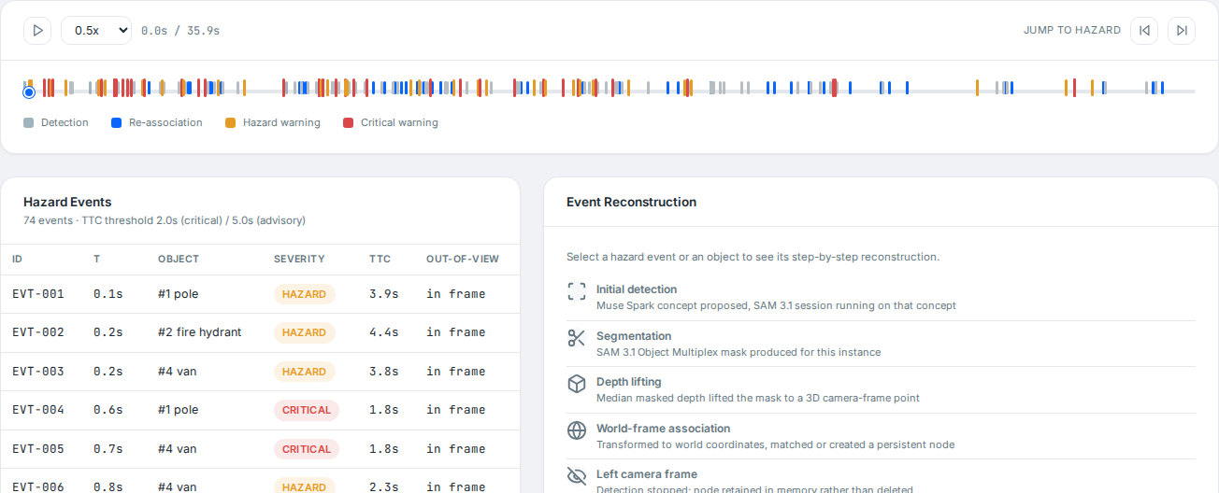
Figure 3a. Hazard timeline of the same walk, earlier version: 74 hazard events, most of them critical.
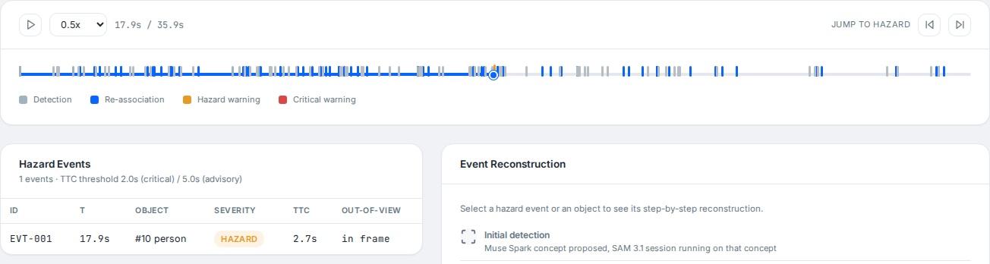
Figure 3b. Submitted version: one hazard event, the pedestrian at 17.9 s.

Meta models and tools used
Model | How it runs | Role in Locus
Muse Spark (muse-spark-1.3) | Meta Model API | Proposes which object types to track; phrases calm ambient mentions.
SAM 3.1 Object Multiplex | Local, open weights | Finds each proposed object in the image from its name.
EdgeTAM | Local, open weights | Tracks objects frame by frame using only past frames (the real-time path).
SeamlessM4T v2 | Local, open weights | Synthesizes all spoken cues on device.

Everything runs on an NVIDIA DGX Spark (GB10, 128 GB unified memory). The hazard decision itself is plain geometry with no language model in the loop: it is predictable, testable, instant, and cannot hallucinate a hazard. The language model only phrases calm mentions, where a slow or failed call costs nothing (it falls back to the short fixed form).

Limitations, stated plainly
- Recorded, not live. The demo replays the real pipeline's output on recorded walks. Tracking and the alert logic are causal and fast enough to run live, but narration and speech were generated ahead of time, and the glasses display is simulated.
- No real-world hazard labels. The controlled ablation is on synthetic data; the real-data results are consistency checks (image side, video inspection, a second camera), not a scored benchmark.
- Only what it is told to look for. Curbs, holes and untracked objects are invisible to it, which is why it never claims a path is clear.
- Depth gets noisy with distance. At 25 m, per-frame positions wander by about ±2 m. Confidence is a single number per object; a real system should carry a position-uncertainty region.
- Memory assumes unobserved space is unchanged. True for buildings, false for traffic, which is why moving objects are forgotten within a second.
- The miss-distance gate is close to the data. Poles on this walk pass at about 1.0 m; the gate is 0.75 m. With 14.7° median heading error, a borderline object can still flip.
- Tracker identity swaps. EdgeTAM sometimes moves a label to a similar object. Locus contains the damage rather than fixing the tracker.

What's next
- Tones for urgency. A tone lands in milliseconds; a sentence takes seconds. Stereo-panned, collision-rate tones are already implemented and tested but not yet played by the pipeline.
- Orientation when the wearer stops. One short summary of what is around, on request or at a pause.
- Familiar routes. A persistent world model makes "what's different today?" possible on a daily route: the bin that's out, the scaffolding that wasn't there.
- Walkable-surface awareness, used only to decide what is worth mentioning, never to claim a path is clear.
- Thresholds set with blind and low-vision users, not by us.

Reproducing the results
Python 3 with the hackathon environment on a DGX Spark. From the repository root:
pytest tests/ # 59 tests
python -m locus.eval.harness # A/B/C/D ablation on synthetic scenarios
python scripts/generate_dashboard_data.py --dataset sanpo --segmenter edgetam \
--concepts "pole,fire hydrant,tree,van,truck,trash bin,person,trash can,car,traffic light,taxi,lamppost" \
--out dashboard/data/sanpo_edgetam_geometry_fix -- -5OCPnbrwJdu3jH70ieU7pUiFsOJQoeG
python dashboard/app.py # then open http://localhost:5050

Data: SANPO (Google Research, CC-BY 4.0, public bucket gs://gresearch/sanpo_dataset/v0) and Aria Everyday Activities for a secondary indoor check.

