US EQUITY – ON BUTTONS to be ENABLED
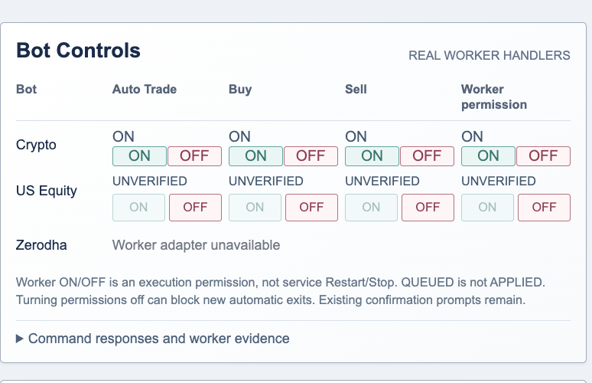
Realized Net P& L- add values live dynamic feed,
Unrealized Net P & L- add values live dynamic feed,
Current Net P & L- add values live dynamic feed,
For Trades and Positions :
Add Total Current Value
Add Total Net P & L

Freeze the top 2 Header rows
Truncate the values to 2 Decimals
Fix the Tables show all fields fit to table
Add Scroll for each table for vertical


