TASK 3 - Website Traffic Analysis
Notebook link (code included):
https://colab.research.google.com/drive/10_viR_bwyOgf3uTSy1dfZHQMoR_Ee6G_
C:\Users\tmadh\Downloads\Traffic_Analysis.ipynb
Visualizations:
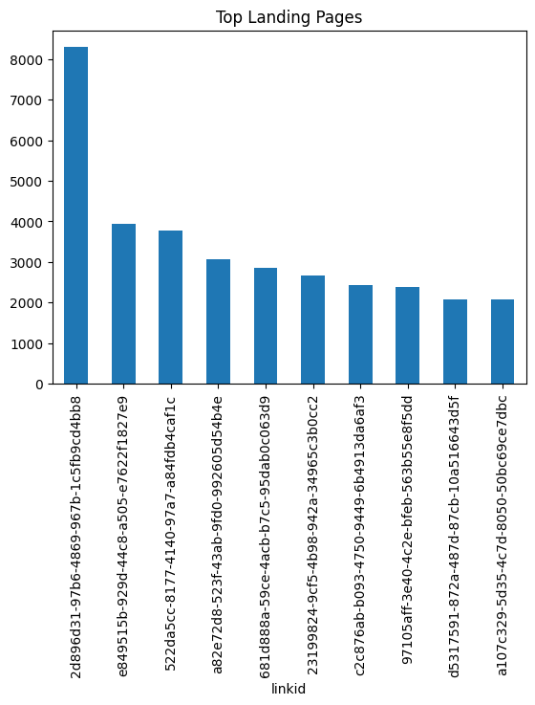

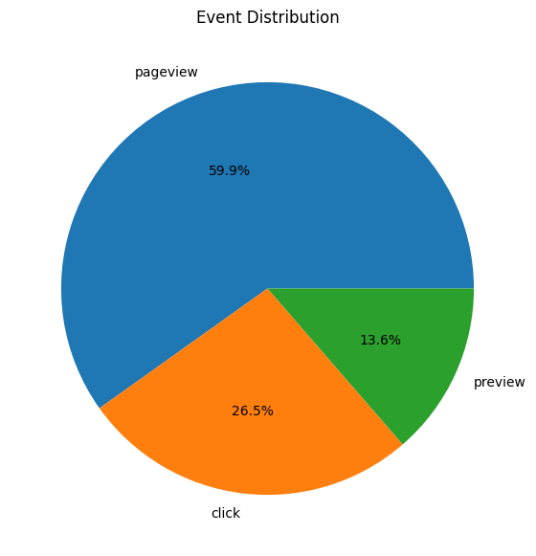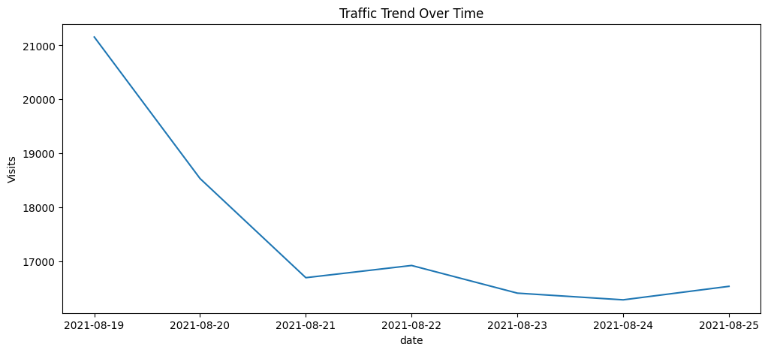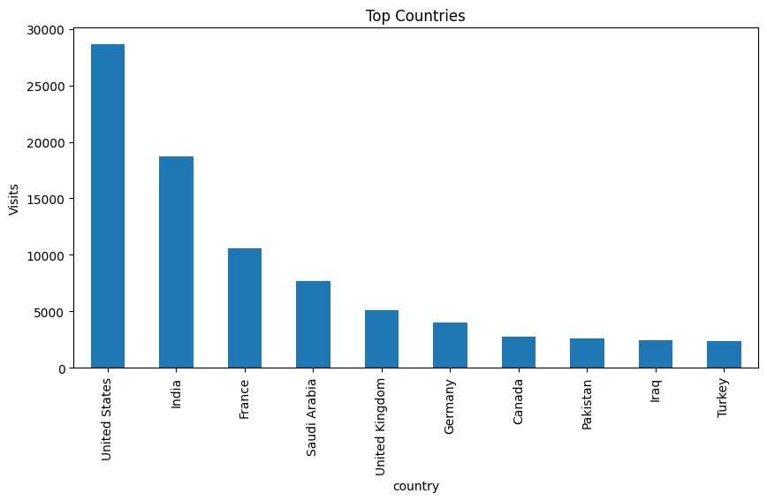
Short Summary:
In this study, I performed an analysis of the website traffic to explore how users interacted with the web pages, where they come from, which landing pages were used and what user engagement looks like. Website traffic logs were analyzed to calculate session, unique user visits, bounce rate and user activities. Different types of visualization have been developed to reveal the best performing webpages, referral sources and user activity.
The results of the analysis showed that only a few pages and referral sources drive most traffic. In addition, it turned out that user engagement is significantly higher when the user visited several web pages. Some pages have high exit rates. Finally, analysis of geolocation and traffic source allowed identifying valuable customer segments.
Overall, the results of the analysis will help Alfido Tech make informed decisions regarding website performance and digital marketing campaigns.

