**News Portal Project Report**

Project Report

# Index

* **Introduction**

# Programming Language

* **Development Models**

# Software Testing

* **Data gathering (Documents and Diagrams)**

# System Design

* **Software requirements**

# Files and Database

* **System Development**

# System Testing

* **Observation**

# System Performance

* **Limitations**

# Future Scope

* **Conclusion**

# Introduction

Now-a-days we live in age of Information Communication and Technology . We can’t think a single moment without technology. From morning to night, we need help of the technology. This is the revolutionary time of computer technology. Most of the works depends on web application. For this reason, anytime, anywhere, anyone can access a website by internet at low cost and we can find our expectable and most update information from website. At present information is one the most valuable resource of the current world. We have developed our project so that we can aware the people.

# Objective of the Present Work

* + - The objective of this project is to develop a web application for Online News Paper website that can aware the people
    - The objective of this project is to provide the daily news.
    - The objective of this project is to provide the breaking news.
    - It makes use of various technologies to get required crime oriented information more quickly, easily, colorfully and attractively.
    - To do this for more widely coverage of distribution and faster dissemination of information in a more timely manner.
    - Anytime, anywhere, anyone can know about the news or information by internet at low cost.
    - Dynamically provides facility.
    - To add any new information without any complexity.

# Literature Review

A lot of project work has carried on Online News Portal System. At the present time, Online News Portal websites are available. But most of this website is static and traditional. There is no feature that can make people awareness. This is why we have done this project. Our project has many features that can aware the people. By using this website one can get more and more information that helps the people in their daily life.

# Organization of the Project

In this project we have develop an Online News Portal website. It is a dynamic system. It can be maintain and changed easily because it is based on database. It’s contain web pages that are generated in real-time. These pages include Web scripting code, such as PHP. It is fully secured from unauthorized access. In a word it can say that our Online News Portal website is a completely dynamic website.

To create the software, we have worked on all possible types of basic codes used for principle design based on mainly on PHP, CSS and HTML. Here we have used incremental model to create the software. We have collected all kinds of information related to this software from the customer. Actually it is one kind of Customized software products.

The project background model specially designed on the basis of certain web programming language like PHP, MYSQL, JAVASCRIPT, CSS etc. In following section here we are going to give a brief description about this language in this project.

# Programming Language

## PHP

* + - PHP stands for PHP: Hypertext Preprocessor
    - PHP is a server-side scripting language,like ASP
    - PHP scripts are executed on the server
    - PHP supports many databases (MYSQL, Informix, Oracle, Sybase, Solid, Generic ODBC, etc.)
    - PHP is an open source software
    - PHP is free to download and use

## MYSQL

* + - MYSQL is a database server
    - MYSQL is ideal for both small and large applications
    - MYSQL supports standard SQL
    - MYSQL compiles on a number of platforms
    - MYSQL is free to download and use

## CSS

* + - Cascading Style Sheets (CSS)
    - Simple mechanism
    - Easy for adding style (e.g., fonts, colors, spacing) to Web documents.

# Development Models

## There are some Software Process Models these are listed below—

* Waterfall model
* Prototype model

# Water fall Model

The waterfall model is probably the oldest and the best-known model as far as software development process models is concerned. The role of the waterfall model in software engineering is as important as its role in software testing. Of course, over the years, there are a number of other software process models which have been designed and implemented, but what is true is that a lot of them are based (in some way or the other) on the fundamental principle of the waterfall model.

**On that note, let us examine the waterfall model in detail.**

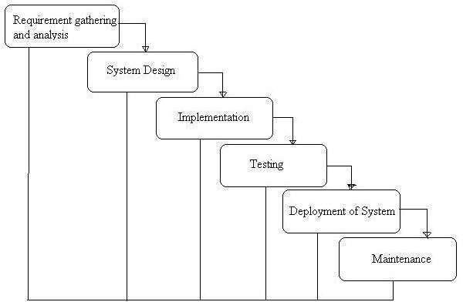

**Fig. 2.1: Waterfall Model**

# Advantages of waterfall model:

* + - * Simple and easy to understand and use.
      * Easy to manage due to the rigidity of the model – each phase has specific deliverables and a review process.
      * Phases are processed and completed one at a time.
      * Works well for smaller projects where requirements are very well understood.

# Disadvantages of waterfall model:

* + - * Once an application is in the testing stage, it is very difficult to go back and change something that was not well-thought out in the concept stage.
      * No working software is produced until late during the life cycle.
      * High amounts of risk and uncertainty.
      * Not a good model for complex and object-oriented projects.
      * Poor model for long and ongoing projects.
      * Not suitable for the projects where requirements are at a moderate to high risk of changing.
      * The project is short.

# Prototype Model

The basic idea here is that instead of freezing the requirements before a design or coding can proceed, a throwaway prototype is built to understand the requirements. This prototype is developed based on the currently known requirements. By using this prototype, the client can get an “actual feel” of the system, since the interactions with prototype can enable the client to better understand the requirements of the desired system. Prototyping is an attractive idea for complicated and large systems for which there is no manual process or existing system to help determining the requirements. The prototypes are usually not complete systems and many of the details are not built in the prototype. The goal is to provide a system with overall functionality.

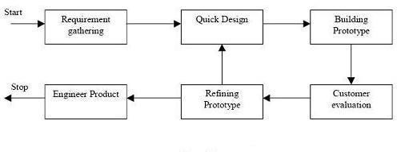

**Fig. 2.2: Prototype Model.**

# Advantages of Prototype model:

* + - * Users are actively involved in the development
      * Since in this methodology a working model of the system is provided, the users get a better understanding of the system being developed.
      * Errors can be detected much earlier.
      * Quicker user feedback is available leading to better solutions. Missing functionality can be identified easily
      * Confusing or difficult functions can be identified Requirements validation, Quick implementation of, incomplete, but functional, application.

# Disadvantages of Prototype model:

* + - * Leads to implementing and then repairing way of building systems.
      * Practically, this methodology may increase the complexity of the system as scope of the system may expand beyond original plans.
      * Incomplete application may cause application not to be used as the full system was designed Incomplete or inadequate problem analysis.

# When to use Prototype model:

* + - * Prototype model should be used when the desired system needs to have a lot of interaction with the end users.
      * Typically, online systems, web interfaces have a very high amount of interaction with end users, are best suited for Prototype model. It might take a while for a system to be built that allows ease of use and needs minimal training for the end user.
      * Prototyping ensures that the end users constantly work with the system and provide a feedback which is incorporated in the prototype to result in a useable system. They are excellent for designing good human computer interface systems.

# Software Testing

Software Testing Process for executing a program with the intent of finding errors that is uncovering errors in a program makes it a feasible task and also trying to find the errors (whose presence is assumed) in a program. As it is a destructive process. To develop our project we use software testing process.

## Introduction

After accepting feasibility report from our departments we have decided to continue under supervisor, Lecturer, Dept. of CSE,CBST .We have tried to understand the proposed system by detailed study of the various operations that will be performed by a system. System analysis is the process of studying an existing system to determine how it works and how it meets user needs. System analysis lays the groundwork for improvements to the system. The analysis involves an investigation, which is turn usually involves establishing a relationship with the client for whom the analysis is done and with the user of the system. This analysis phase is more of a thinking process. In this phase, we have improved logical aspects of the system. To develop the system

We have to consider about a key question “What must be done to solve the problem? [1][2] In this phase we studied the system processes, gathering Operational data, understand the

information flow, finding out weaknesses and evolving solutions for overcoming the weaknesses of the system so as to achieve the goals. During analysis phase we have concerned with:

* **Data gathering**
* **Data analysis**

# Data gathering

To complete this project first we have gathered necessary data or information from our supervisor, our respective teachers, friends, junior students of our department, and internet. It was complex because our system is unique and needed data are not available. It was expensive too and required a lot of work and time. To gather information we have used certain sources:

* + - **Documentation**

**&**

* + - **Onsite observations**

# 3.1.1 Documentation

During data gathering we searched related information in Google. We found various procedures, manual, reports, create account forms, loan request form, and many other materials but all information was difficult to assess. We spend lot of time by reading manual or reports.

* + 1. **Data Flow Diagram**

A data flow diagram is a short road map for that graphically represents how the data moves through the existing system .we have used data flow diagram in design process. The data flow diagram provides facilitating communication between us and user. DFD shows what kinds of information will be input to and output from the system, where the data will come from and go to, and where the data will be stored. It does not show information about the timing of processes, or information about whether processes will operate in sequence or in parallel.

**Circle**

The processes are represented by circle shows what the action take on the data-checking. A process accepts input data needed for the process to be carried out and produces data that it passes on to another part of the DFD.

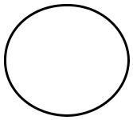

**Fig. 3.1: circle.**

## Arrow

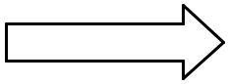Arrow defines direction of the data flow. It shows the direction between a data store to another data store, source to processes.

**Fig. 3.2: Arrow.**

## Square

Square indicate the source and destination of the system.

**Fig. 3.3: Square.**

## Open Rectangle

A database is a repository of data here it represented by open-ended box. This information may be stored either temporarily or permanently by admin .Data may be changed or updated.

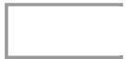

**Fig. 3.4: Open Rectangle.**

## Data flow diagram of Online News Portal for the USER

|  |  |  |
| --- | --- | --- |
| **User** |  |  |
|  |  | **Result** |
| **Or** | **Database** | **Process** |
| **Visitor** |  |  |

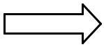**Fig. 3.5: A data flow diagram of Online News Portal for the USER.**

## Data flow diagram of Online News Paper for the Admin

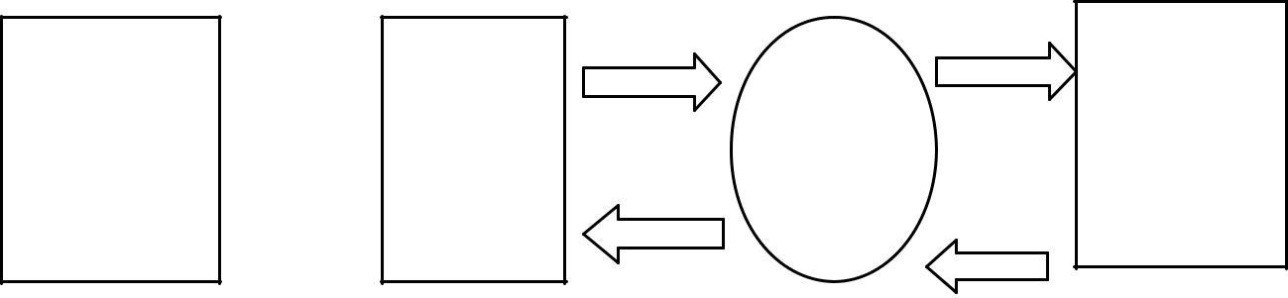

**Data Stored**

**Admin**

**Input**

**in**

**Data**

**Process**

**Database**

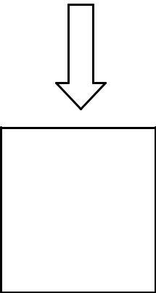

**R**

**es ul t**

**Fig. 3.6: A data flow diagram of Online News Paper for the Admin.**

# Use Case Diagram

**User Case Diagram**

**Visit News Portal**

**Search for News**

**USER**

**View News Category wise**

**Leave comments on News**

**View Contact details and about us page**

**Admin Case Diagram**

**Login**

**Update own**

**Password**

**Admin Dashboard**

**Create Category**

**Update/Delete / Recover**

**Create SubCategory**

**Update/Delete / Recover**

**Publish news/ post**

**/update / delete / recover**

**Manage about and**

**contact page data**

**Manage Comments**

**Approve / Unapprove / Delete**

**Logout**

# ADMIN

## ER Diagram:

The Entity-Relationship (ER) model was originally proposed by Peter in 1976 [Chen76] as a way to unify the network and relational database views. Simply stated the ER model is a conceptual data model that views the real world as entities and relationships. A basic component of the model is the Entity-Relationship diagram which is used to visually represent data objects. Since Chen wrote his paper the model has been extended and today it is commonly used for database design for the database designer, the utility of the ER model is:

* + - * It maps well to the relational model. The constructs used in the ER model can easily be transformed into relational tables.
      * It is simple and easy to understand with a minimum of training. Therefore, the model can be used by the database designer to communicate the design to the end user.
      * In addition, the model can be used as a design plan by the database developer to implement a data model in specific database management software.

## ER Notation

There is no standard for representing data objects in ER diagrams. Each modeling methodology uses its own notation. The original notation used by Chen is widely used in academics texts and journals but rarely seen in either CASE tools or publications by non-academics. Today, there are a number of notations used; among the more common are Bachman, crow's foot, and IDEFIX.

All notational styles represent entities as rectangular boxes and relationships as lines connecting boxes. Each style uses a special set of symbols to represent the cardinality of a connection. The notation used in this document is from Martin. The symbols used for the basic ER constructs are:

* **Entities** are represented by labeled rectangles. The label is the name of the entity. Entity names should be singular nouns.
* **Relationships** are represented by a solid line connecting two entities. The name of the relationship is written above the line. Relationship names should be verbs
* **Attributes**, when included, are listed inside the entity rectangle. Attributes which are identifiers are underlined. Attribute names should be singular nouns.
* **Cardinality** of many is represented by a line ending in a crow's foot. If the crow's foot is omitted, the cardinality is one.

**Existence** is represented by placing a circle or a perpendicular bar on the line. Mandatory existence is shown by the bar (looks like a 1) next to the entity for an instance is required. Optional existence is shown by placing a circle next to the entity that is optional.

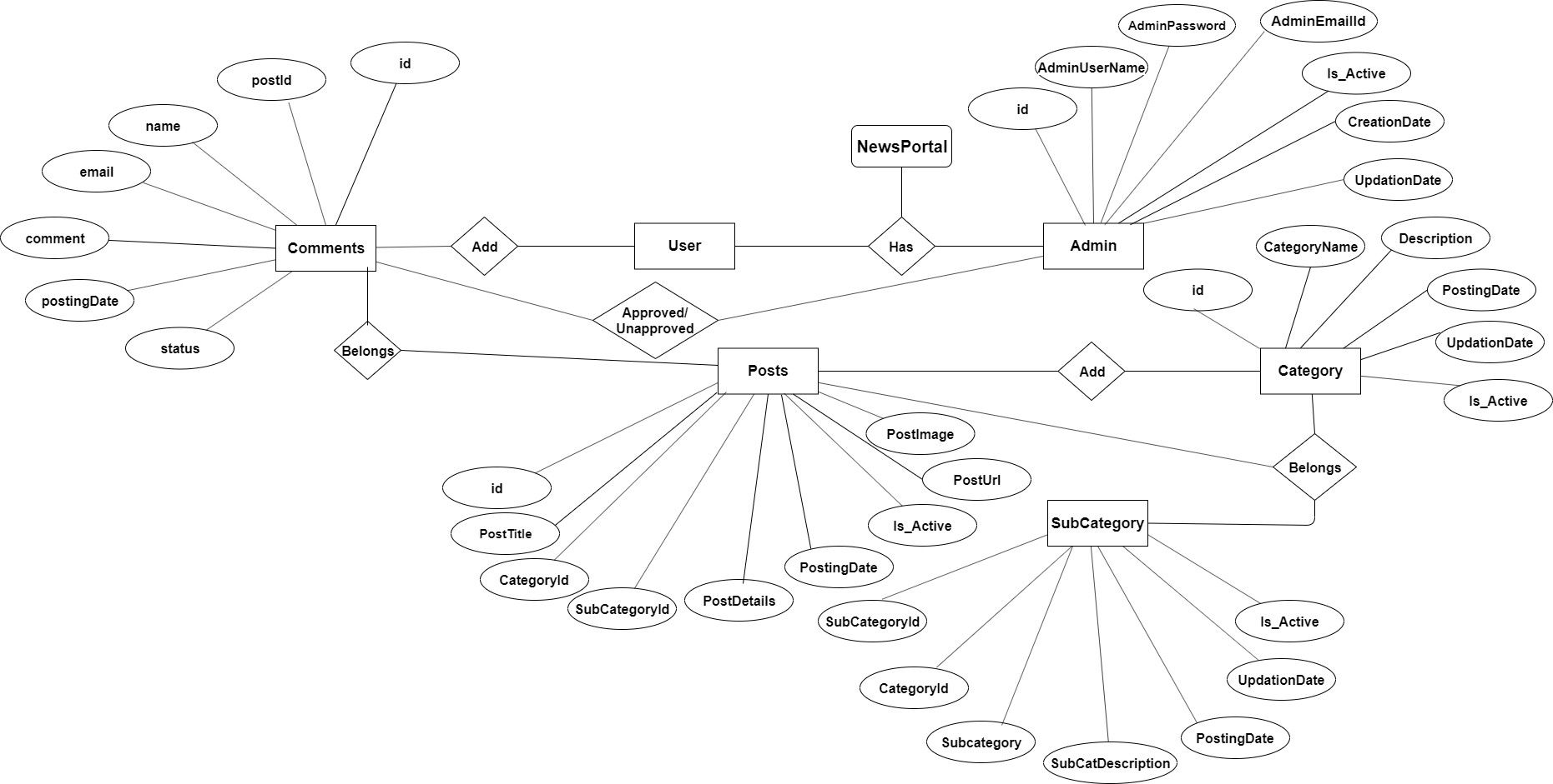

# System Design

System design is the most creative and challenging. The System Design Document describes the system requirements, operating environment, system and subsystem architecture, files and database design, input formats, output layouts, human-machine interfaces, detailed design, processing logic, and external interfaces.

# Before Start Deign

To make web application for Online News Paper website it is need to select a standard PC that can support XAMPP.

* + 1. **Hardware Requirements**

XAMPP Software installs on a standard PC system. Minimum Hardware requirements are as follows:

* + - * Processor –Celeron (R) Dual –Core CPU [T3100@1.90GHz](mailto:T3100@1.90GHz) 1.90 GHz;
      * Installed Memory (RAM) – at least 350 MB;
      * System type-32 bit Operating System;
      * Model-Presario CQ42 Notebook PC; Resolution- 1366/768;

# Software requirements

## XAMPP

XAMPP is an easy to install Apache distribution containing MySQL, PHP and Perl. XAMPP is really very easy to install and to use - just download, extract and start.

## XAMPP for Windows

The distribution for Windows 2000, 2003, XP, Vista, 7 and 8. This version contains: Apache, MySQL, PHP + PEAR, Perl, mod_php, mod_perl, mod_ssl, OpenSSL, phpMyAdmin,

Webalizer, Mercury Mail Transport System for Win32 and NetWare Systems v3.32, Ming, FileZilla FTP Server, mcrypt, eAccelerator, SQLite, and WEB-DAV + mod_auth_mysql.

* Apache 2.4.9
* MySQL10.1.31Maria DB
* PHP 7.2.3
* phpMyAdmin 4.7.9

# Programming Language

* HTML
* CSS
* Jquery
* PHP
* MySQL

# User Panel Design

In user panel design we have done our task for user. Here we provide facility about Online News Paper. In index page user can select any options which is needed by him/her. By selecting options he/she can see the desired page. Then he/she can get the all oriented information finally. The design of user panel is shown in following flow chart….

## User Panel Flow Chart:

**START**

**HOME**

**CATEGORIES**

**SEARCH**

**CONTACT US**

**categories.php?catid=2**

**search.php**

**news-details.php**

**ABOUT**

**about-us.php**

**contact-us.php**

**index.php**

**news-details.php**

**Leave Comment**

**Leave Comment**

**END**

**Fig. 4.1: The user panel flowchart part.**

# Admin Panel Design

We have design user login facility to manage and update all of the information. It is fully secured page. Without appropriate username and password it cannot be accessed by anyone. For admin login after giving username and password we need to click a login button , when we click login button it is not directly entered in home page , it stay in login page. Then it starts a session and set two variables called username and password. If the username and password are matched with database, it can enter in home page. It is not possible without click login button. In case if username or password are not matched with database than Invalid username or password massage is shown. We can describe the login facility in admin login by using below flow chart given below--

**Admin Login Flow Chart:**

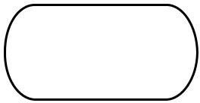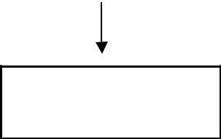

**Start**

**admin Login**

**Manage Comments Approve/ Unapprove / Delete**

**if($_POST['username]==$arr[username] &&**

**password_verify($password, $hashpassword)**

**No**

**Dashboard**

**Yes**

**Wrong username OR**

**password**

**Dashboard.php**

**Change Password**

**Category ADD/ UPDATE /**

**DELETE**

**logout**

**SubCategory ADD/ UPDATE**

**Pages**

**About & Contact us UDATE Details**

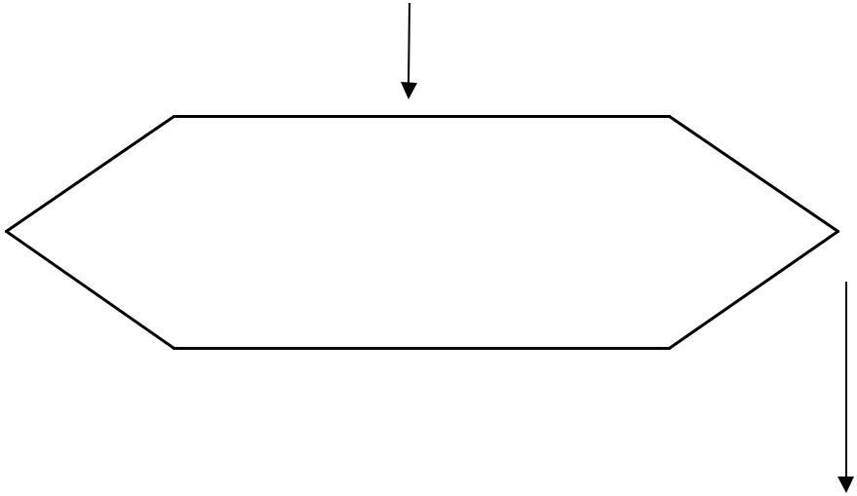

**Posts /News ADD/UPDATE/TRASHED/ RECOVERY/DELETE**

**RESULT**

**STOP**

# Files and Database

**Fig. 4.2: Admin Login Flow Chart.**

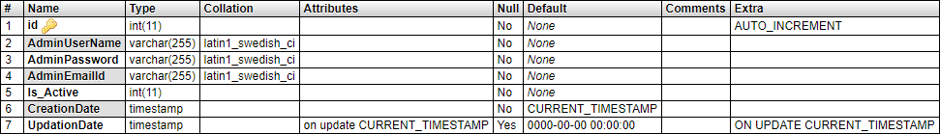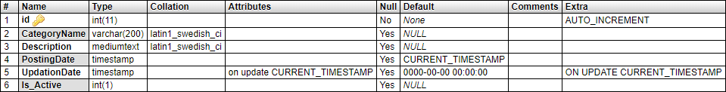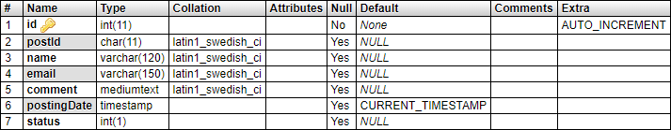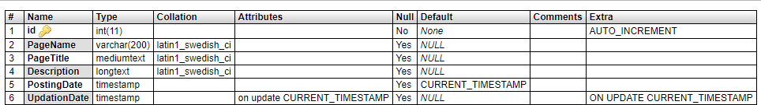

We have organized one database **news portal** for system design. It can be accessed directly or sequentially by registered. The database determines files, record, fields, and characters. It can be easily controlled and updated. This database and its table and component are described by using flow diagram

that is given in the below……….

**Newsportal Database has 6 tables**

* tbladmin
* tblcategory
* tblcomments
* tblpages
* tblposts
* tblsubcategory
  + - * **tbladmin**
      * **tblcategory**
      * **tblcomments**
      * **tblpages**
      * **tblposts**

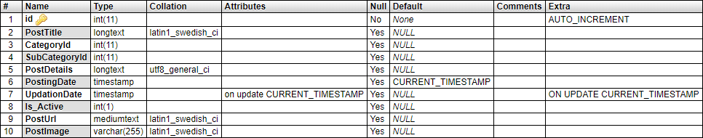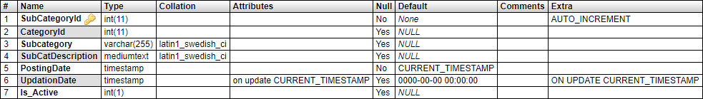

* + - * **tblsubcategory**

# Relationship between tables

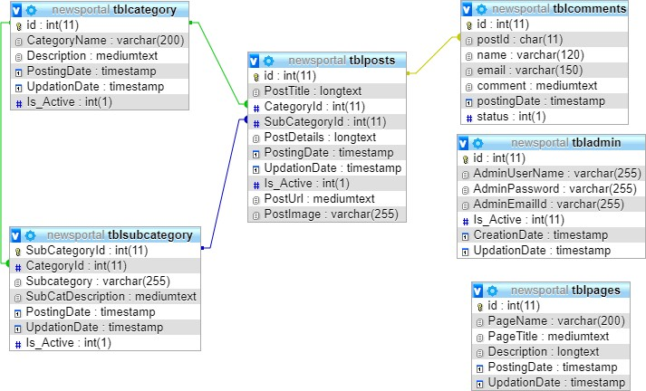

**Introduction**

The development phase is an operational phase of our system .This phase is where we starts to written program code for the development of the system. We follow the requirements specification from the design stage and start to create the new system. The Development Phase features a key step in the project system construction. The previous phases lay the foundation for system development; the following phases ensure that the product functions as required.

## Activities of the System Development

**We divided system development phase’s activities into three categories. These provide components of the development phase that can construct the program and including a list of the programs needed to meet the systems objectives and complete documentation**

**To complete our system development we three type of specification. These are……………..**

1. User specification.
2. Admin specification.
3. Files and database.

## User Specification

The proposed systems are physically developed in this stage. User specification or output specification provides the proposed system goals. User specification stage fulfilled the user need by preparing building blocks of the system .User specification are developed by based on output design. It provides total outlook of the system and offer various features for user.

**After going to** [**http://localhost/newsportal/index.php**](http://localhost/newsportal/index.php) **a user can see the view.**

## Home page Of User specification

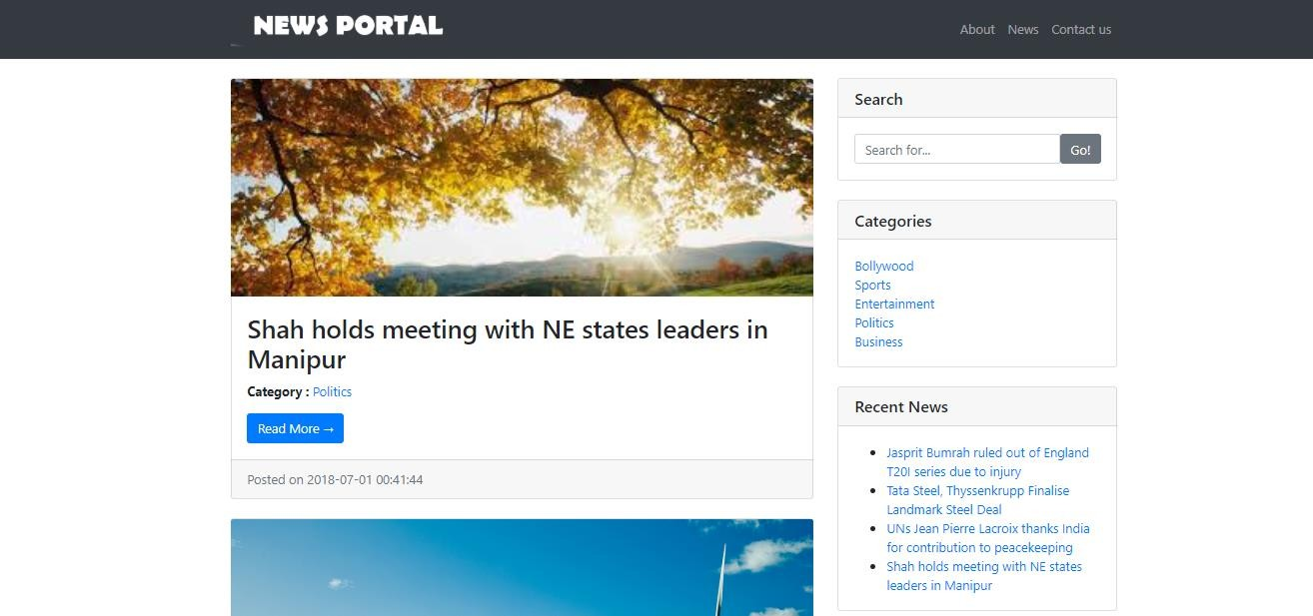

**By clicking on the particular news user will get the news details pages here…**

## Online News Portal News Details Pages

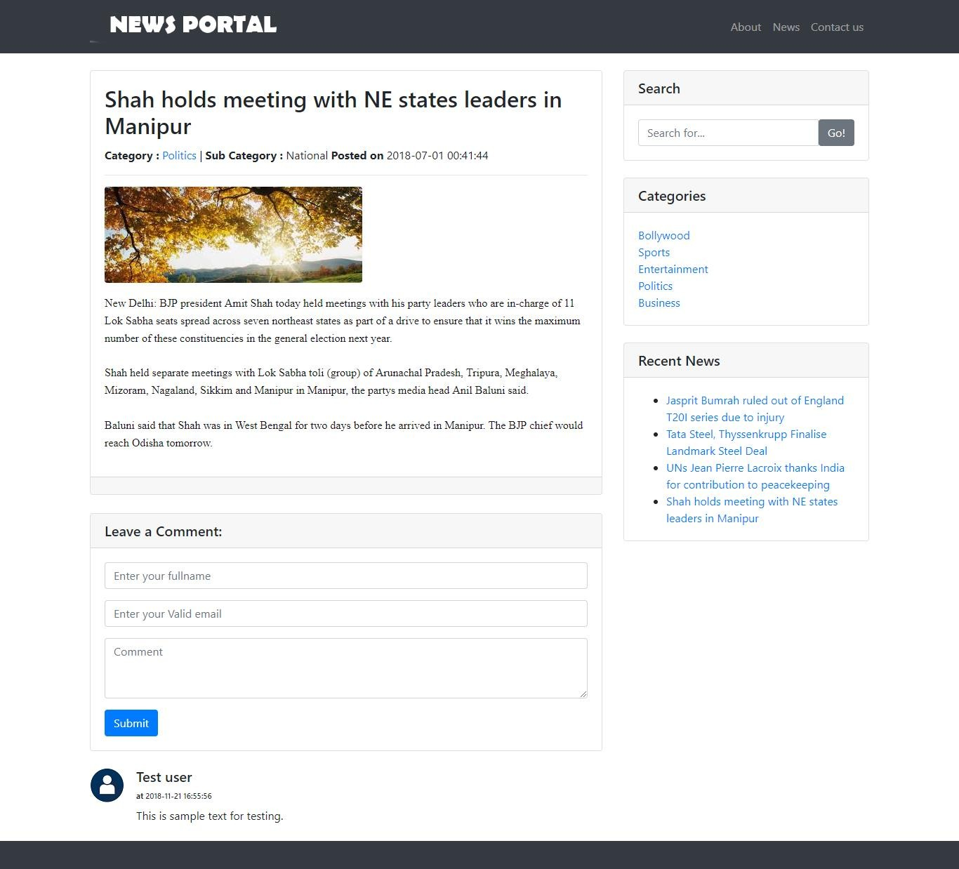

**Online News Portal about us Pages**

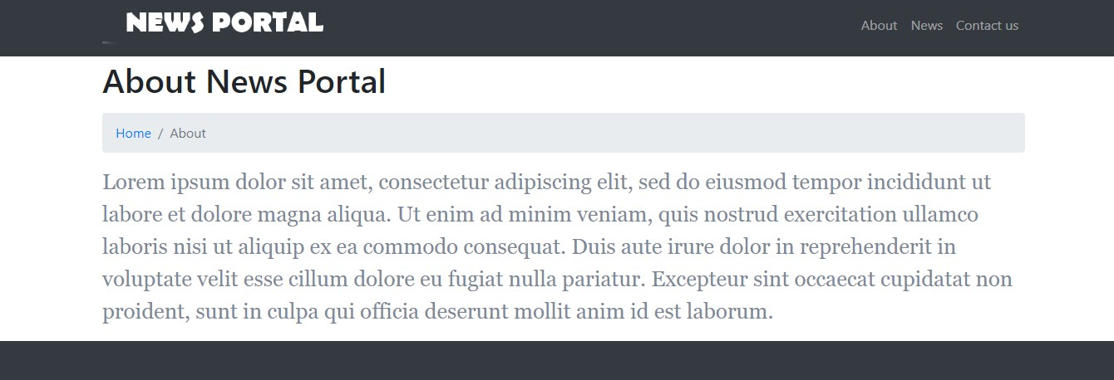

# Admin Specification

This is the input panel of the Online News Paper. We have developed this panel so that we can dynamically control the Online News Paper. It is fully secured system. Without being admin or knowing user name and password no one can access it. It is fully protected from unauthorized access.

**After going to** [**http://localhost/newsportal/admin.php**](http://localhost/newsportal/admin.php) **an admin can see the view.**

**Admin Panel**

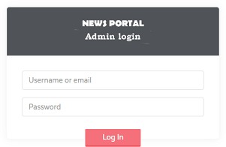

After giving the valid username and password then admin have to click login button. Then admin show the below view. Admin module feature

* + - * Admin login with secure username and password
      * Admin Dashboard
      * Admin can add categories / update / delete and recover from trash folder after deletion
      * Admin can add Subcategories / update / delete and recover from trash folder after deletion
      * Admin can add News / update / delete and recover from trash folder after deletion
      * Admin can manage comments (Approve / Unapproved /Delete )
      * Admin can change own password
      * Logout

## Admin Dashboard

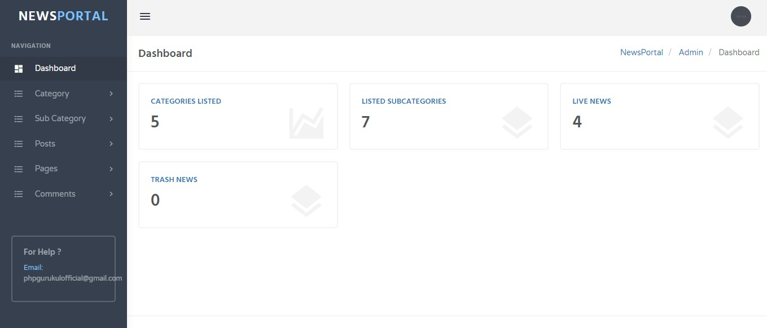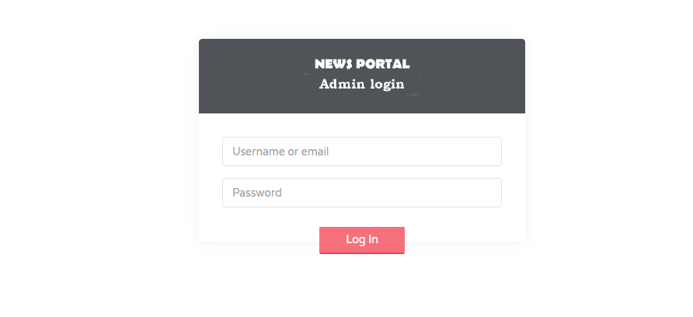

Build up Our project We Use Software Testing Process for executing a program with the intent of finding errors that is uncovering errors in a program makes it a feasible task and also trying to find the errors (whose presence is assumed) in a program. As it is a destructive process.

## 6.1 Type of testing we use in our Project

Here we just mentioned that how the testing is related to this software and in which way we have test the software? In our project we have used 5 types of testing these are listed below-

**Unit Testing:** Unit testing where individual program units or object classes are tested. Here by using this testing we have focused on testing the functionality of methods.

**Module Testing:** Where this is the combination of unit program is called module. Here we tested the unit program (5-6 programs) is where the module programs have dependency.

**Sub-system Testing:** Then we combined some module for the Preliminary System Testing in our Project.

**System Testing:** Where it is the combination of two or more sub-system and then it is tested. Here we tested the Entire system as per the requirements.

**Acceptance Testing:** Normally this type of testing is done to verify if system meets the customer specified requirements. After submitting this project to User then they tested it and to determine whether to accept application. It is the system testing performed by the customer(s) to determine whether they should accept the delivery of the system.

In our project work, an attempt has been made to develop a News or information based web site. We develop this project that helps the people and make them aware so that they can know any news. To establish this website we use various methodologies. To develop this project we have faced many problem but we hardly tried to develop this project. Our supervisor helps us by giving his valuable opinion, decision and time.

# Observation

**The above experiment leads us to the following observations:**

It makes online news oriented information easier to its user.

It provides a wonderful user interface that attracts more and more user.

To provides a flexible way of real time communication that safe user’s time and effort. To provides a safe and secure communication system.

It makes use of various technologies and updated news about various crime and rules and crime oriented information that is more effective and useful for conscious people.

It can offer the faster and informative information system about crime news and rules of the country.

To do this for more widely coverage of distribution and faster dissemination of information in a more timely manner.

To introduce the people about the system

To get information about current world all ages anytime, anywhere, anyone can access by internet at low cost.

# System Performance

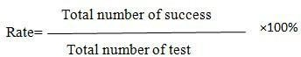System performance totally depends on the output of the system. The percentage of success rate and failure rate has been calculated using the following equations: Success:

**Failure:**

The performance is related to success rate and failure rate. If the success is high then the performance of the system is good. Success rate and Failure rate are contradiction of each other. So when success rate is high then failure rate is low. In the two terms the performance of the system is depended.

# Limitations

**There are some limitations for the current system to which solutions can be provided as a future development:**

* + - We don’t manage news reporting system.
    - Sensibility level could not add.

# Future scope

The future scope of our project is valuable. Our project time duration was only one years .In this time interval we developed our project. It was very difficult to complete project within this time duration. In future if we get chance we will develop this website for large volume. **As for other future developments, the following can be done:**

* + - We will manage news reporting system.
    - We can make video conferencing system.
    - We update our database.
    - Sensibility level could add be added.

# Conclusion

In our project work, an attempt has been made to develop a News or information based web site. We develop this project that helps the people and make them aware so that they can know any news. To establish this website we use various methodologies. To develop this project we have faced many problem but we hardly tried to develop this project. Our supervisor helps us by giving his valuable opinion, decision and time.