1. Which are the top three variables in your model which contribute most towards the probability of a lead getting converted?

**Ans:** We are now assessing the top 3 variables which contribute most towards the probability of lead getting converted using the coefficient values.

* 1. Lead Origin (Lead Add Form)
  2. What is your current occupation (Working Professional)
  3. Last Activity (Had a Phone Conversation)Below is the screen snippet of the coefficient values.

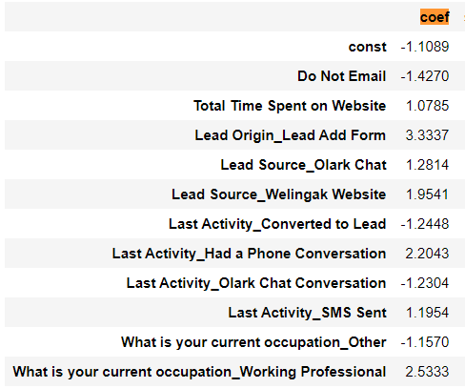

1. What are the top 3 categorical/dummy variables in the model which should be focused the most on in order to increase the probability of lead conversion?

**Ans:** The top 3 Categorical/dummy variables in the model that are to be focused to increase the probability of lead conversion are:

* 1. Lead Origin (Lead Add Form)
  2. What is your current occupation (Working Professional)
  3. Last Activity (Had a Phone Conversation)

1. X Education has a period of 2 months every year during which they hire some interns. The sales team, in particular, has around 10 interns allotted to them. So during this phase, they wish to make the lead conversion more aggressive. So they want almost all of the potential leads (i.e. the customers who have been predicted as 1 by the model) to be converted and hence, want to make phone calls to as much of such people as possible. Suggest a good strategy they should employ at this stage.  
   **Ans:** Sensitivity with respect to a model can be defined as the ratio of total number of actual Conversions correctly predicted to the total no of actual Conversions.

Similarly, Specificity can be defined as the ratio of total no of actual non-Conversions correctly predicted to the total number of actual non-Conversions.

For our model, as one increases, the other decreases and vice versa.

Different values of the sensitivity and specificity can be achieved for the same model by changing the Conversion Probability cutoff threshold value.

In the below image, the final prediction is calculated based on an optimal cut off value of 0.3.  
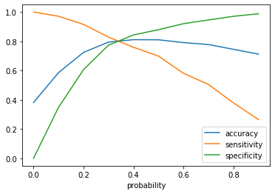

In order to make the sales aggressive, the X company should contact all the leads which have a conversion probability (value = 1) under a cut off 0.3

1. Similarly, at times, the company reaches its target for a quarter before the deadline. During this time, the company wants the sales team to focus on some new work as well. So during this time, the company’s aim is to not make phone calls unless it’s extremely necessary, i.e. they want to minimize the rate of useless phone calls. Suggest a strategy they should employ at this stage.  
   **Ans:** Concluding from the same graph as above, we can say that high specificity will refer to identify all the leads that are not likely to get converted. As the company has already reached the quarter goal and don’t want to make the call unless it’s extremely necessary, they can choose the higher values that have been obtained in Conversion probability of the model.