1. View the total quantity of items available in the stock which has a product name of “Shirt”.

select sum(quantity) from STOCKS where pname like '%sh%';

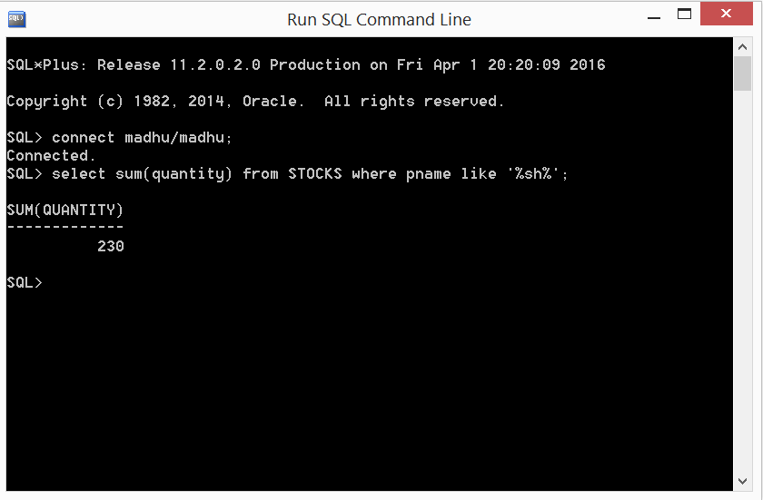

1. View the number of products that was purchased on 2nd of January 2011.

select sum(quantity) from TRANSACTION where tdate='02-JAN-2011';

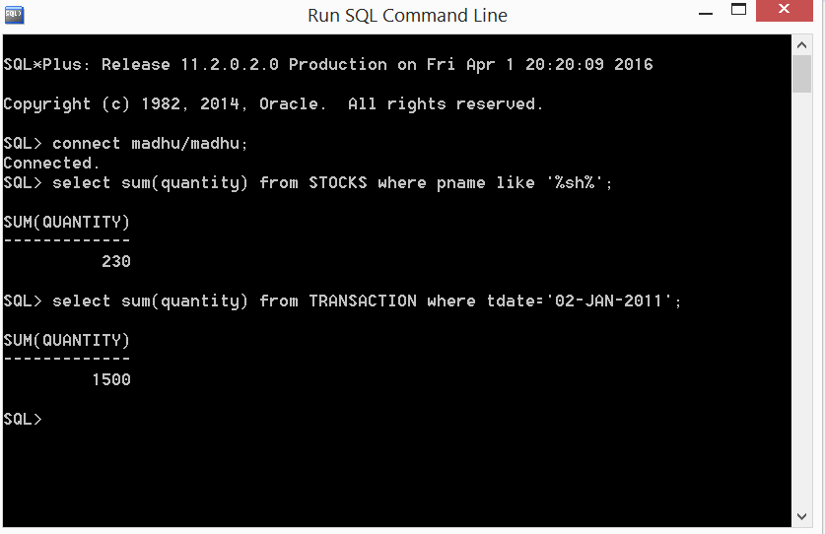

1. Give the transaction id of the product “Pant” purchased on 10th of December 2015.

select tid from TRANSACTION where tdate='10-DEC-2015' and pname='coats';

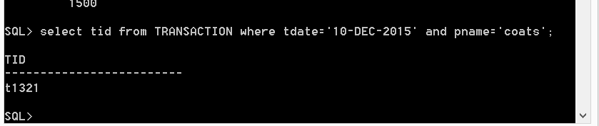

1. View the price of the product with a product id of t110:

select T.SUPPLIER_PRICE AS SUPPLIER_PRICE , S.PRICE AS SELLER_PRICE FROM TRANSACTION T, STOCKS S WHERE T.TID=S.TID AND T.TID='t110';

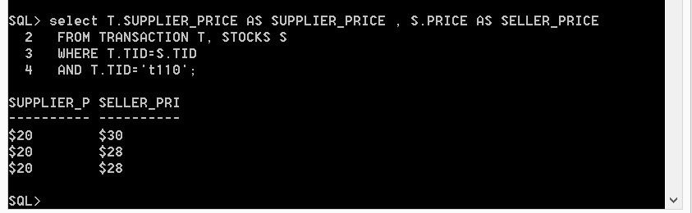

1. View the count of id values in stock sorted in the order of date of moving.

select count(pid), pname,date_of_moving from stocks group by pname,date_of_moving order by date_of_moving;

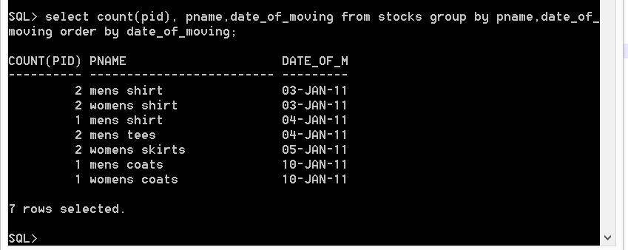

1. List the customers who made a purchase of $1000.

select * from purchase where amount<1000;

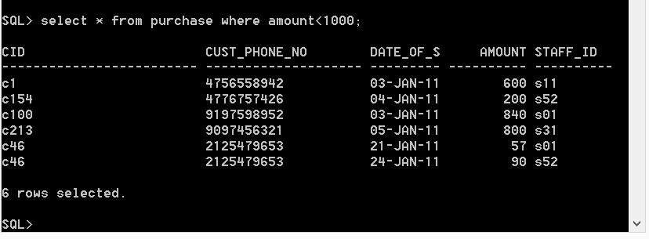

1. View the item that is present in lookup table and also sold out.

select * from lookup where pid in(select pid from sales);

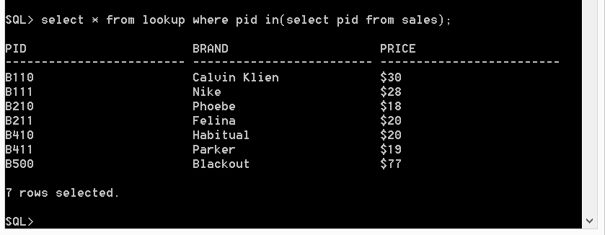

1. View the date of joining of the staff whose id is s01.

select date_of_joining from staff_details where staff_id='s01';

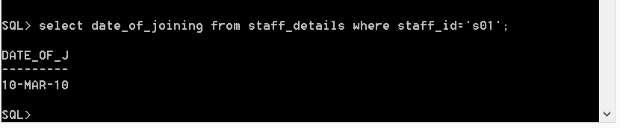

1. View the total sales made by a staff whose id is 79.

select sum(amount) from staff_sales where staff_id='s01';

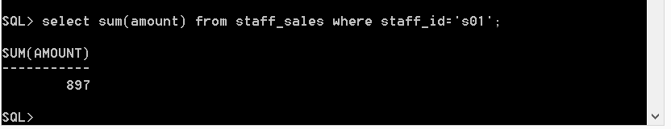

1. Update the salary of the staff by 30% whose id is 2.

update staff_details set salary = salary+(salary*0.3) where staff_id='s01';

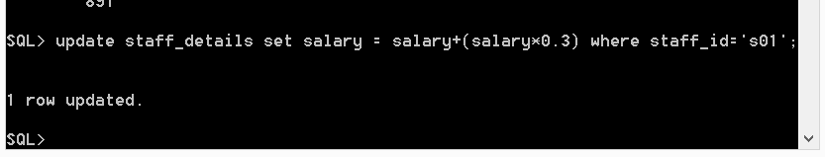

1. View the count of good sold by the store within a period of 10th January 2015 to 20th June 2015.

select count(quantity_sold) , price from sales where period_of_time>='02-JAN-2011' AND

period_of_time <='12-JAN-2011' group by price;

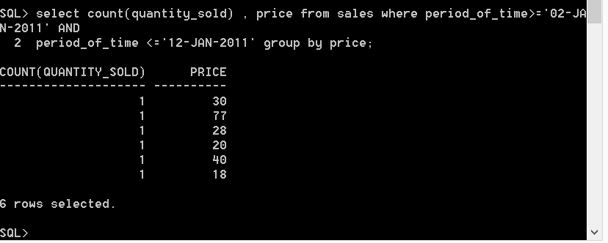

1. Add a new user to the admin.

insert into admin values ('ad697','store');

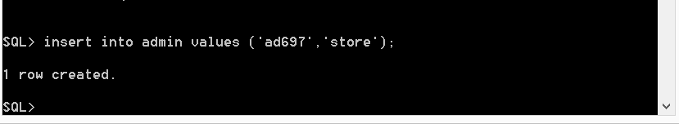

1. Delete the customer with the customer id of 1005.

delete customer where cid='c99';

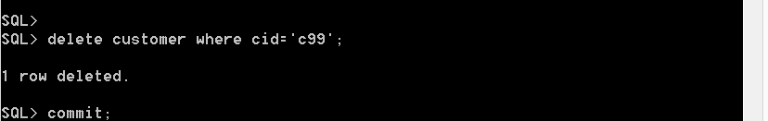

1. Update the phone number of staff with date of joining 30th April 2015.

update staff_details set staff_phone_no='2038767907' where staff_id='s23';

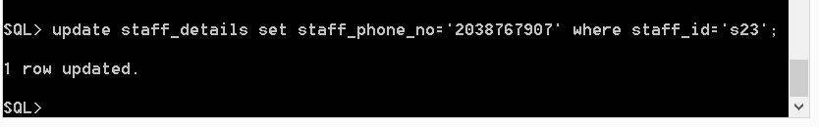

1. View all the customers who purchases in the store.

select unique * from customer join purchase on customer.cid=purchase.cid;

