1. **CREATION OF JOB TO PULL THE SOURCE CODE FROM GIT:**

**Plugins to be install:**

* Git Plugin

**How to install Git Plugin for Jenkins:**

1. Open Jenkins from the any one browser by entering the following address “<http://localhost:8080/> “
2. Navigate to **Manage Jenkins** 🡪 **Manage Plugins**
3. Use the **filter box** to search for **Git plugin** and install the plugin.

**How To Create A Job To Pull Source Code From Git:**

**Creating new Jenkins project:**

**Step 1**: New item 🡪 Give project a name (e.g Git_Pull) 🡪 Freestyle project 🡪 OK 🡪 Automatically, Project configuration window will appear.

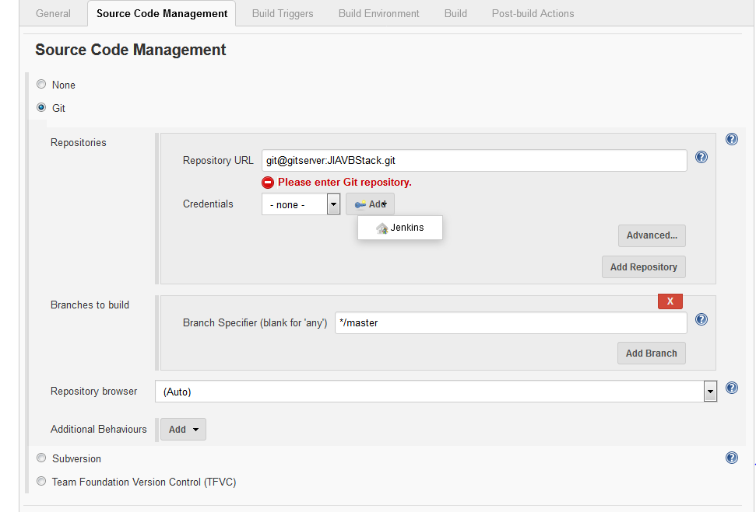

**Step 2 (Configuring a job):**

1. Source Code Management 🡪Git🡪 Provide URL for git & credentials.

**Repository URL:** [**git@gitserver:JIAVBStack.git**](mailto:git@gitserver:JIAVBStack.git)

**Credentials:**

* Add 🡪 Jenkins 🡪 Jenkins Credentials Provider window appears
* Select SSH username with Private key in “kind” field. Give username(e.g madhubala) and copy private key content from .ppk file.

**Note:** .ppk file generated from putty tool by using id_rsa file.(this file given by IT team while git extension installation**)**

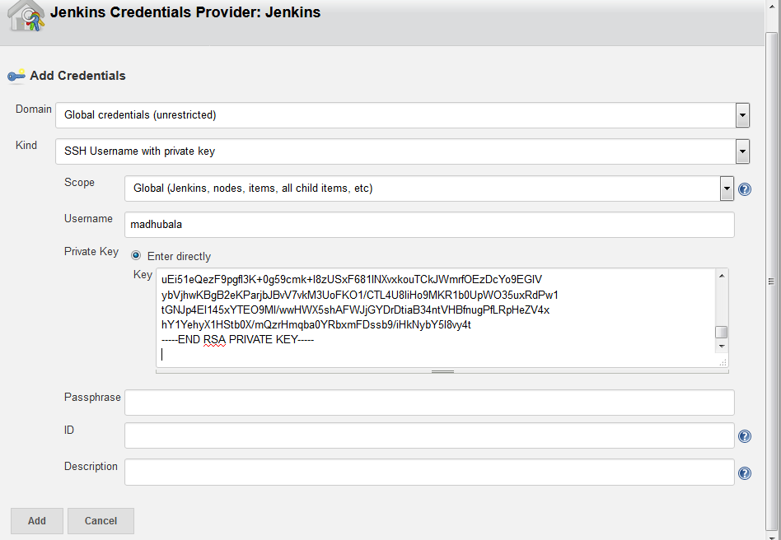

**Step 3:** Click Add 🡪 Save.

**Testing the above job:**

1. Navigate to Project page 🡪 Build Now.
2. In the Build History you can see a with the name “#1”.
3. If job gets “SUCCESS” then the bubble maker stays blue, if not it goes red.
4. Then click **Console Output**.
5. The source code now will be available in the workspace of that project.

**2.CREATION OF JOB TO BUILD THE CODE USING VISUAL STUDIO:**

**Plugins to be install:**

* **MSBuild Plugin**

**How to Install the MSBuild Plugin for Jenkins:**

1. Open Jenkins from the any one browser by entering the following address “<http://localhost:8080/> “
2. Navigate to **Manage Jenkins** 🡪 **Manage Plugins**
3. Use the **filter box** to search for “**MSBUILD plugin**” and install the plugin.

**How to configure MSBuild:**

1. Navigate to Jenkins 🡪 **Manage Jenkins 🡪 Global Tool Configuration**
2. Scroll down the list until you find **MSBuild.**
3. Click **MSBuild installation** 🡪 **Add MSBuild 🡪 MSBuild configuration window will appear.**
4. Give the new MSBuild configuration a name(E.g v4.0.30319)
5. In the path field, insert the fully qualified path to **MSBuild.exe**.

**Note:** On my server the path is: C:\Windows\Microsoft.NET\Framework64\v4.0.30319\MSBuild.exe but this can be different on your system.

1. Click **Save**.

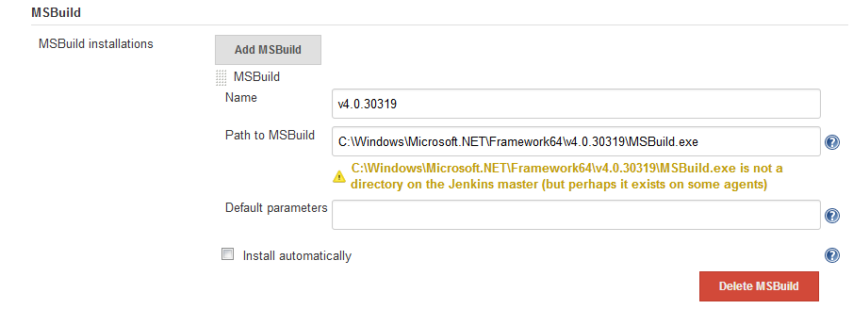

With this step done Jenkins is ready to build and deploy with MSBuild.

**How To Create A Job To Build Code Using Visual Studio**

**Create a new Jenkins project**

**Step 1**: New item 🡪 Give project a name (e.g Build_testing) 🡪 Freestyle project 🡪 OK 🡪 Automatically, Project configuration window will appear.

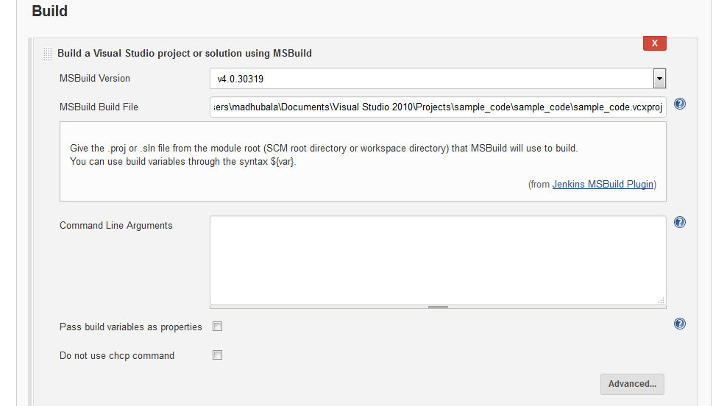

**Step 2 (configuring a job) :**

* 1. Build 🡪 Add build steps 🡪 Build a visual studio project or solution using MSBuild
* **Gi**ve MSBuild version(v4.0.30319)
* In **MSBuild File Path** give visual studio executable file path.

**Step 3 :** click Save

**Testing the above job:**

1. Navigate to **Project page**.
2. Click the **Build Now** to start a Build.
3. In the **Build History** you can see a with the name “#1”.
4. Then click **Console Output**.