WEEK 2: Data Extraction, Transformation, and Loading (ETL) Planning

Virtual Retail Database — Data Extraction, Transformation and Loading
YuvaIntern SQL Developer Internship | MySQL 8.0 | Prepared by: Akarapu Madhu Shalini
Document type: ETL design and implementation guide (proposed plan; sample source systems and records are hypothetical).

1. Objective and Scope
This document proposes a repeatable ETL process for a virtual retail environment. ETL means Extract, Transform and Load: collect data from operational sources, validate and standardize it, and load it into the Week 1 relational database. The design aims to improve data quality, preserve traceability, respect foreign-key dependencies, and support reliable reporting.
The target schema contains 11 tables: categories, suppliers, products, product_suppliers, stores, inventory, customers, customer_addresses, orders, order_items and payments. This is a planning document, not evidence that a production pipeline has already been deployed.

2. Proposed Architecture and Flowchart
The pipeline separates source extraction, raw staging, transformation, validation, target loading and monitoring. Invalid rows are quarantined with a reason instead of being silently discarded. A batch ID links source records, staging rows, logs and target changes.

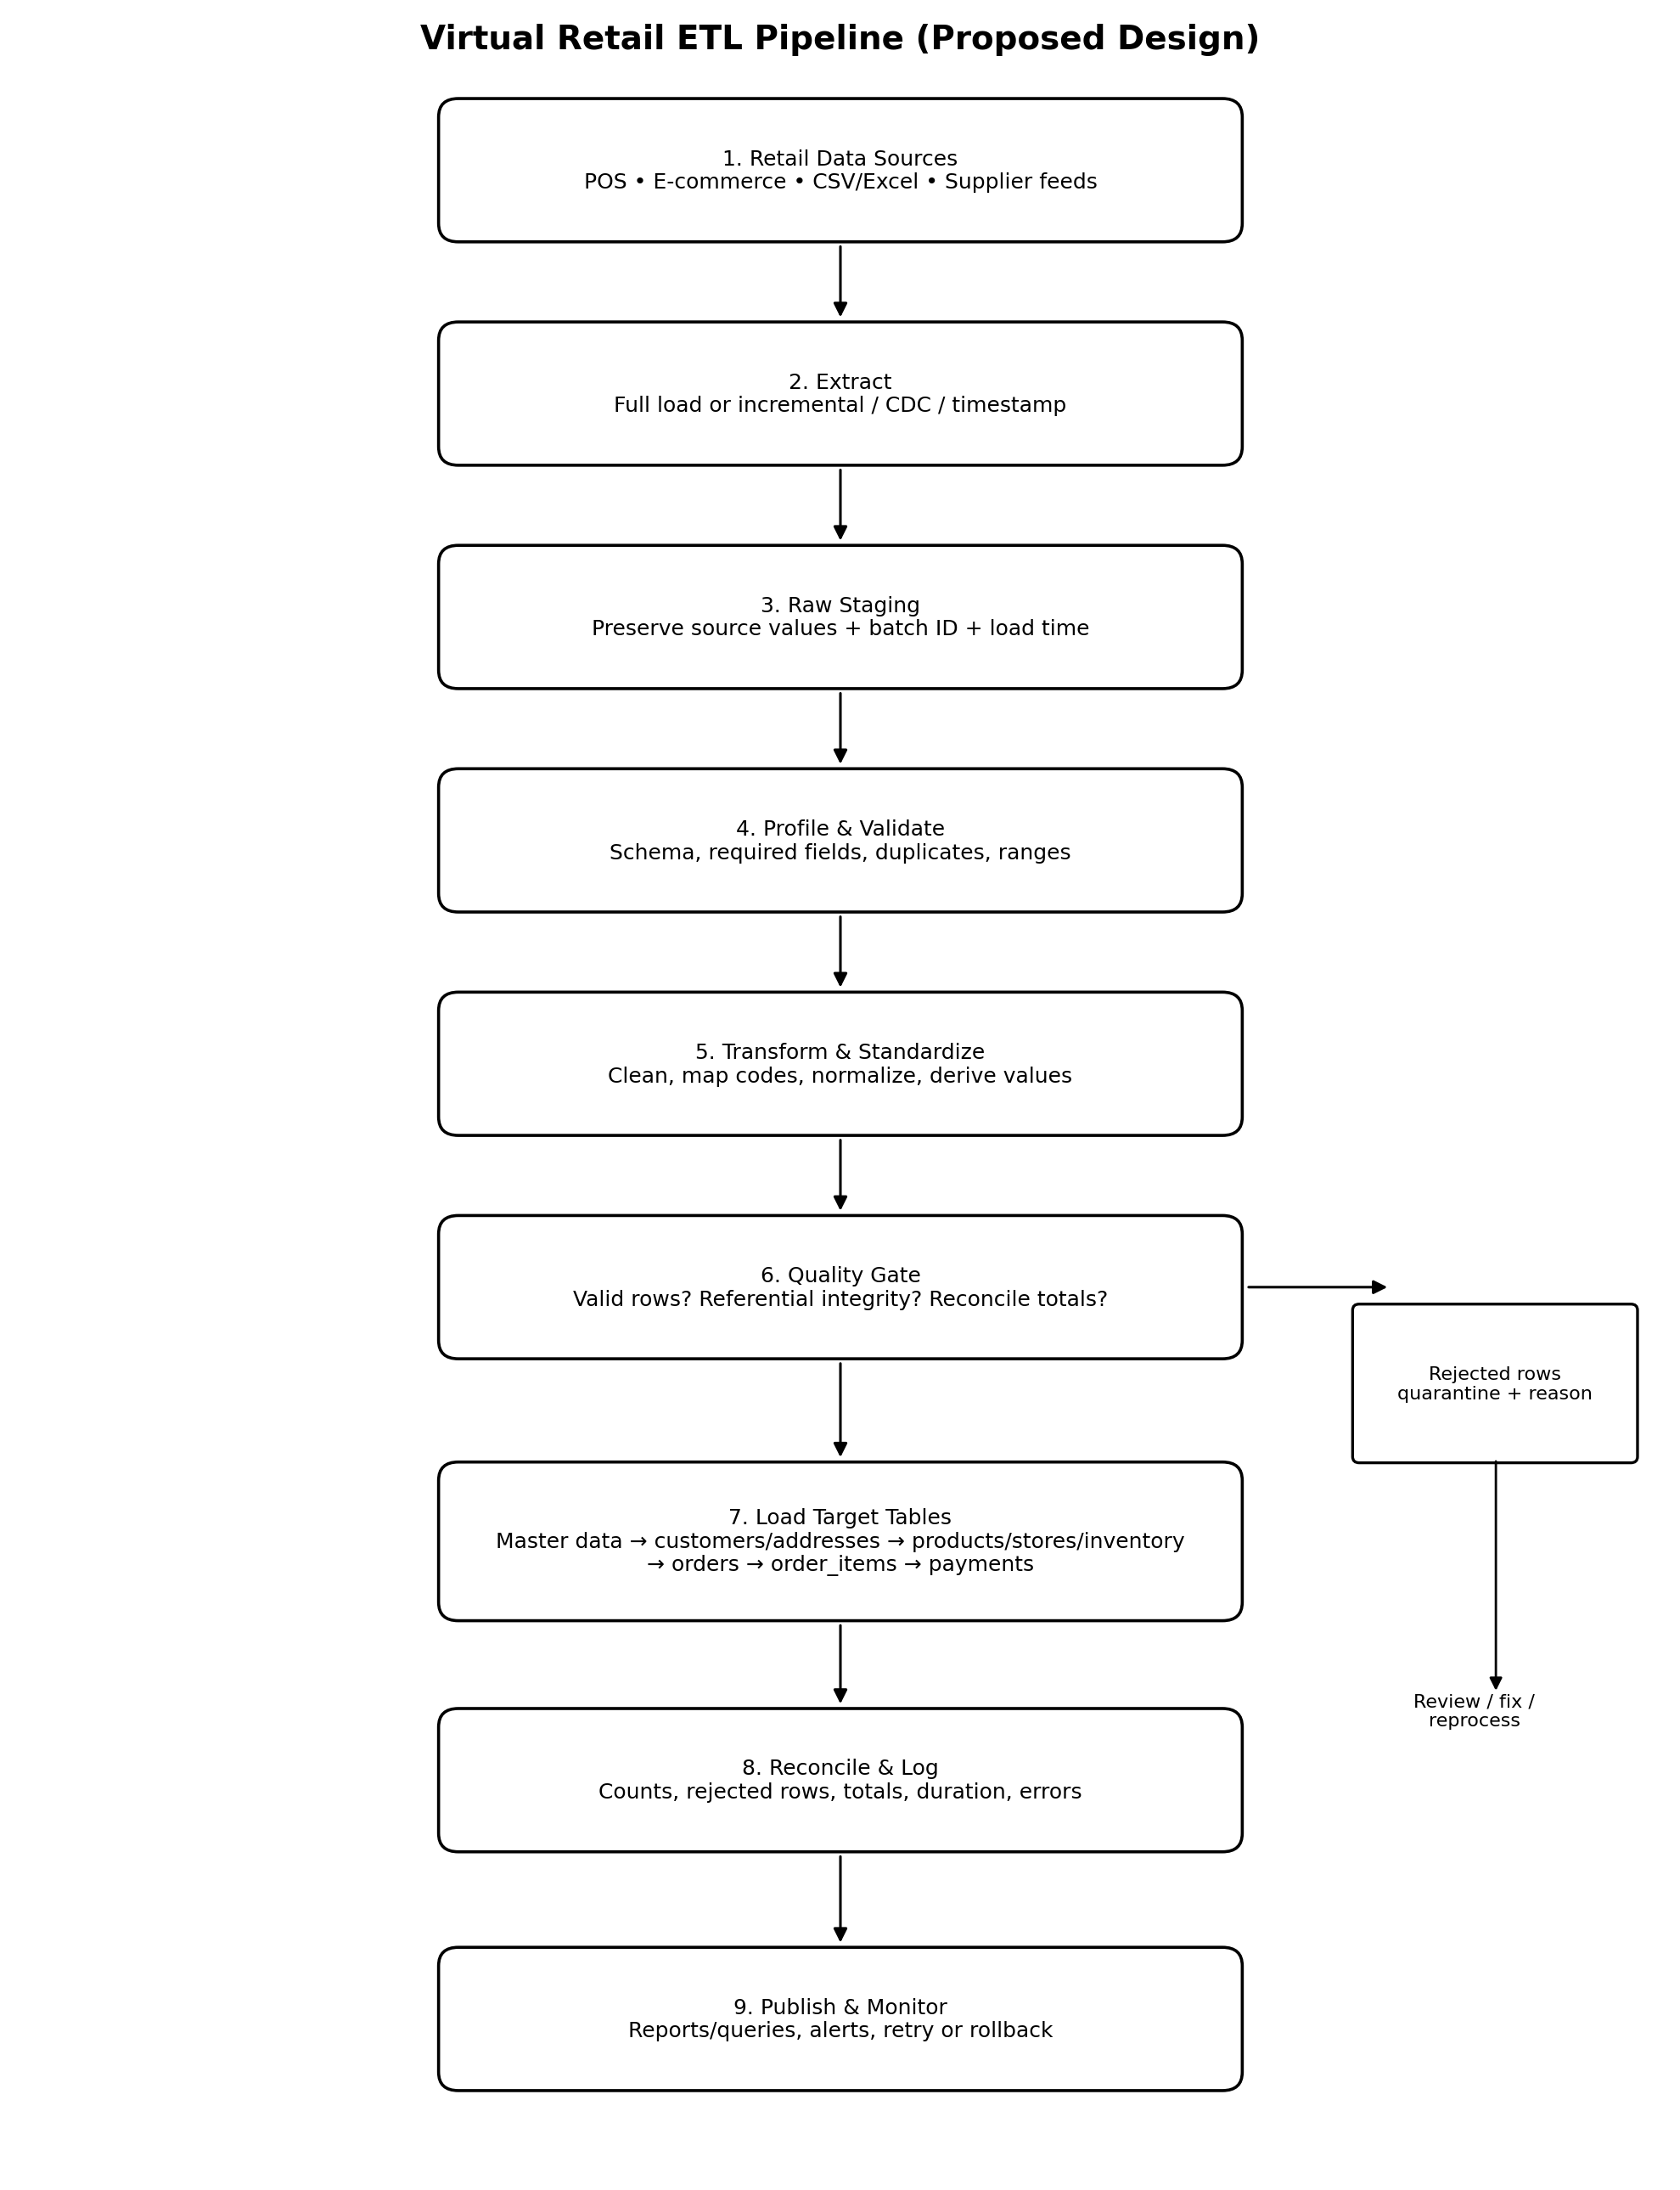
Figure 1. Proposed ETL flow. The reject path sends invalid records to quarantine for investigation and controlled reprocessing.

3. Hypothetical Retail Data Sources
Source | Example data | Extraction method | Target tables
Point-of-sale (POS) | Store sales, order lines, payments | Read-only SQL query; incremental by updated_at/order_id | stores, orders, order_items, payments
E-commerce platform | Customer profiles, addresses, online orders | REST API pagination or database export; watermark/CDC if available | customers, customer_addresses, orders, order_items
Product master spreadsheet | SKU, product name, category, price, cost | CSV/Excel file drop with schema and file-name validation | categories, products
Supplier feed | Supplier identity, supplier SKU, supply price, lead time | CSV/SFTP or authenticated API | suppliers, product_suppliers
Inventory/Warehouse system | Stock by store and product, restock date | Scheduled SQL extract or API snapshot/delta | stores, inventory
All sources above are illustrative. In a real implementation, the owner, connection details, permitted fields, extraction schedule, data retention rules and source-system meaning must be confirmed before development. Use least-privilege, read-only credentials for extraction.

4. ETL Process: Step-by-Step

Step 1 — Agree on the data contract
Document each source, file/API format, field definitions, data types, primary/business keys, update frequency, timezone, currency and null rules. Agree how cancellations, returns, refunds and deleted customers are represented.

Step 2 — Start a batch
Create a unique batch_id and record the start time, source, extraction watermark and pipeline version. Use a control table or job log to track status.

Step 3 — Extract source records
For the first load, take a consistent full snapshot. For later runs, use updated_at watermarks, monotonically increasing IDs, change data capture (CDC), or source-supported API delta tokens. Paginate APIs, retry transient failures with backoff, and save the last successful watermark only after a successful load.

Step 4 — Land raw data
Copy source records into raw staging tables or immutable files. Preserve source identifiers and original values; add batch_id, source_name, extracted_at, source_file and row_number where applicable. Do not overwrite raw evidence during cleaning.

Step 5 — Profile and validate
Check expected columns and types, mandatory fields, duplicate keys, valid dates, allowed status values, numeric ranges, row counts and unexpected schema changes. Classify errors as reject, warning or acceptable exception.

Step 6 — Transform
Standardize formats and codes, trim whitespace, normalize emails, parse dates/timezones, cast numeric values safely, map source IDs to target IDs, deduplicate records, derive totals where business rules allow, and apply reference-data mappings.

Step 7 — Apply quality gates
Before loading, confirm that required parent records exist, values meet constraints, order lines refer to valid products, and reconciliation checks pass. Send failed rows to a quarantine table with the original payload, batch_id, error_code and error_message.

Step 8 — Load targets in dependency order
Load master/reference tables first, then dependent entities. Use transactions for related order data. Use idempotent upserts based on stable business keys so rerunning a batch does not create duplicates.

Step 9 — Reconcile, publish and monitor
Compare extracted, accepted, rejected and loaded counts; compare source and target sales totals; record run duration and errors. Mark the batch successful only after all required checks pass. Alert an operator on failures and retain logs for audit and reruns.

5. Transformation and Data-Cleaning Rules
Issue | Transformation rule | Handling / reason
Null or blank customer email | Trim whitespace; convert empty strings to NULL; validate required email field. | Reject if email is mandatory for customer matching; do not invent an email.
Duplicate customers | Match by stable source customer ID; use normalized email only as a secondary match rule. | Keep a crosswalk from source key to target customer_id; review ambiguous matches.
SKU and product names | Trim SKU; standardize case where business rules say SKU is case-insensitive; preserve display name while trimming extra spaces. | SKU must remain unique; quarantine conflicting SKU-to-product mappings.
Dates and timezones | Parse source timestamps using declared timezone; convert to a consistent storage convention. | Reject unparseable dates; avoid silently shifting order dates.
Prices and quantities | Cast to DECIMAL/integer; reject negative prices/costs and non-positive order quantities. | Align with target CHECK constraints; record rejected values.
Order status and payment method | Map source codes to allowed ENUM values using a controlled mapping table. | Unknown values are quarantined rather than defaulted silently.
Address formats | Trim fields; standardize country/state names using reference mappings; preserve postal codes as text. | Do not treat postal codes as numbers because leading zeros may matter.
Order totals | Calculate line totals from quantity, captured unit price and discount under an agreed rule; reconcile to source total. | Do not overwrite a trusted source total without documenting the business rule.
Inventory duplicates | Aggregate duplicate rows only when they represent separate stock bins for the same store and product. | Target key is (store_id, product_id); otherwise quarantine conflicting records.
Referential integrity | Resolve source product/customer/store/address IDs to target IDs before load. | Reject or defer child rows when the parent record is missing.

6. Target Loading Strategy and Order
The Week 1 schema uses foreign keys, so load order matters. A recommended dependency-aware order is:
- categories (parent categories before child categories, if hierarchical categories are present)
- suppliers and stores
- customers
- customer_addresses (after customers)
- products (after categories)
- product_suppliers (after products and suppliers)
- inventory (after stores and products)
- orders (after customers, stores and any shipping addresses)
- order_items (after orders and products)
- payments (after orders)
For transactional loads, insert an order and its order_items/payments in a controlled transaction where practical. If any critical step fails, roll back the transaction and mark the batch failed. Do not disable foreign-key checks as a routine workaround. If the source contains a shipping address not yet loaded, resolve or load that address before inserting the order, or apply an explicitly approved nullable-address policy.

7. SQL Techniques and Technology Choices
Technology / technique | Application
MySQL 8.0 | Target relational database; primary/foreign keys, CHECK constraints, transactions, indexes and INSERT ... ON DUPLICATE KEY UPDATE for controlled upserts.
SQL staging tables | Temporary or persistent staging tables isolate raw values from target tables and make validation queries repeatable.
CSV + LOAD DATA | Efficient for trusted, structured files. Validate encoding, delimiter, header, quoting and file size before loading. Use only permitted server/client settings.
REST API / Python | Useful for paginated APIs, JSON parsing, retries, authentication and orchestration. Store secrets outside source code.
CDC / updated_at watermark | Reduces repeated extraction by processing changed records. Requires reliable source change tracking and a documented late-arriving-data policy.
Scheduler/orchestrator | Cron, Windows Task Scheduler, or an approved workflow tool can schedule jobs and capture logs; the choice depends on the hosting environment.
Version control | Keep SQL scripts, mapping rules and documentation in Git; use reviewed changes and environment-specific configuration.

8. Illustrative SQL Validation and Load Examples
The following snippets illustrate the approach. They assume staging tables have been created and populated; staging-table definitions are not included in the Week 1 target schema.

8.1 Find missing required values
SELECT *
FROM stg_products
WHERE sku IS NULL OR TRIM(sku) = ''
OR product_name IS NULL OR TRIM(product_name) = ''
OR unit_price IS NULL OR unit_price < 0
OR unit_cost IS NULL OR unit_cost < 0;

8.2 Detect duplicate SKUs in a batch
SELECT TRIM(sku) AS normalized_sku, COUNT(*) AS row_count
FROM stg_products
GROUP BY TRIM(sku)
HAVING COUNT(*) > 1;

8.3 Identify order lines with unknown product SKUs
SELECT oi.*
FROM stg_order_items oi
LEFT JOIN products p ON p.sku = TRIM(oi.product_sku)
WHERE p.product_id IS NULL;

8.4 Example idempotent product load
INSERT INTO products
(sku, product_name, category_id, unit_price, unit_cost, is_active)
SELECT
TRIM(s.sku), TRIM(s.product_name), c.category_id,
s.unit_price, s.unit_cost, 1
FROM stg_products s
JOIN categories c ON c.category_name = TRIM(s.category_name)
WHERE s.batch_id = ?
ON DUPLICATE KEY UPDATE
product_name = VALUES(product_name),
category_id = VALUES(category_id),
unit_price = VALUES(unit_price),
unit_cost = VALUES(unit_cost),
is_active = VALUES(is_active);
Note: This example assumes category names are uniquely mapped and the staging columns exist. The VALUES() form is supported by MySQL 8.0 but is deprecated in newer MySQL 8.0 releases; for a long-lived production pipeline, use the currently recommended row-alias syntax for the exact MySQL minor version. Do not upsert based on non-unique or unstable fields.

9. Performance, Reliability and Security

Batch sizing
Load in manageable batches to limit lock duration and transaction size. Tune based on row volume, hardware and query plans.

Indexes
Use existing indexes where they support joins and filters; avoid adding indexes without a query need because indexes increase load time and storage.

Bulk loading
For large, validated CSV files, use bulk-load methods where available. Measure performance and ensure rejected rows are still captured.

Incremental processing
Use a durable watermark and overlap window if records can arrive late. Make transformations and target writes idempotent.

Transactions and retries
Use transactions for related changes. Retry transient network/deadlock failures with limits; do not endlessly retry data-quality failures.

Security
Use least-privilege accounts, TLS where supported, secret storage, restricted access to customer data, and masking for test datasets.

Privacy and retention
Collect only required fields; define retention and deletion policies for raw staging and logs. Avoid storing real payment-card credentials.

Auditability
Record batch_id, source, start/end times, input/accepted/rejected/loaded counts, watermark, status and error summary.

10. Monitoring and Reconciliation Checklist
- Source row count compared with extracted row count.
- Accepted + rejected records equals the number of extracted records, allowing for documented filtering.
- Target insert/update counts and duplicate-key counts recorded.
- Order count and total sales amount reconciled by date/currency/status.
- Foreign-key orphan checks return zero unexpected rows.
- No unexplained negative price, cost, quantity or payment amount.
- Batch status, run duration, warnings and errors recorded.
- Alerts sent for failed jobs, unexpected volume changes or reconciliation differences.
- Failed batch can be safely rerun without duplicate target records.

11. Risks, Assumptions and Decisions to Confirm
- All source systems and feeds in this document are hypothetical; actual source schemas and access methods must be confirmed.
- The Week 1 target schema does not include source-system IDs, staging tables, ETL audit tables or a currency column. A production implementation may need source-key crosswalks, batch logs and currency handling.
- The target schema uses ENUMs for statuses and methods; source codes must be mapped explicitly before loading.
- The current orders table stores total_amount separately from order_items. Define a single reconciliation rule to prevent totals from drifting.
- The registered_on default and timestamp behavior should be tested against the exact MySQL version and deployment settings.
- Decide whether address history must be preserved when customers update addresses and how returns/refunds are represented.

12. Conclusion
The proposed ETL pipeline provides a controlled path from heterogeneous retail sources to the Week 1 MySQL schema. Raw staging, explicit transformation rules, data-quality gates, dependency-aware loading, idempotent writes, reconciliation and monitoring make the process traceable and repeatable. Before implementation, confirm the source data contracts and add operational staging and audit structures appropriate to the actual environment.

Appendix A — Suggested Batch Log Fields
batch_id, pipeline_name, source_name, started_at, finished_at, extraction_watermark_start, extraction_watermark_end, extracted_count, accepted_count, rejected_count, inserted_count, updated_count, status, error_summary, pipeline_version.

Appendix B — Suggested Quarantine Fields
quarantine_id, batch_id, source_name, source_record_key, raw_payload, error_code, error_message, detected_at, resolution_status, reprocessed_at.

13. Additional Worked Examples and Design Justification
This section adds concrete examples to make the proposed ETL plan easier to implement and to explain why the Week 1 relational design and indexes support the retail workload. The examples use fictional data.

13.1 Worked ETL example: product feed
Hypothetical source CSV row: SKU = ' sku-1001 ', product name = 'Wireless Mouse ', category = 'Accessories', unit price = 799.00, unit cost = 500.00. The pipeline trims leading/trailing spaces, validates that the SKU and name are present, parses both amounts as DECIMAL, checks that neither amount is negative, and resolves 'Accessories' to an existing category_id. If the normalized SKU already exists, the row follows the documented update policy; if the category cannot be mapped or the SKU conflicts with another product, the row is quarantined rather than silently loaded.
Illustrative transformation expression: TRIM(sku) and TRIM(product_name). Before loading, check duplicate normalized SKUs with GROUP BY TRIM(sku) HAVING COUNT(*) > 1. The staging row should retain its batch_id and original source values so the change can be audited.

13.2 Normalization rationale with a retail example
A poorly structured sales file might repeat the customer name, email, product name, category name and supplier details on every order line. Repeating those attributes creates update anomalies: a changed customer email may need to be corrected in many rows, and inconsistent copies can appear.
- Customers and customer_addresses are separate: customer identity is stored once in customers, while one customer can have multiple addresses in customer_addresses.
- Products and categories are separate: products stores category_id as a foreign key, while category_name is maintained in categories rather than repeated for every product.
- Orders and order_items are separate: orders stores order-level facts, while order_items stores each product line. The composite key (order_id, line_no) identifies a line within an order.
- Products and suppliers use product_suppliers: this junction table resolves the many-to-many relationship and stores relationship-specific facts such as supply_price and lead_time_days.
- Inventory uses the composite key (store_id, product_id): a stock quantity is recorded for each product at each store, rather than storing repeated product and store descriptions in every inventory row.
These separations reduce duplicated descriptive data and help the schema approach Third Normal Form (3NF), assuming each non-key attribute depends on the key, the whole key, and nothing but the key. Normalization does not remove every repeated value: for example, order_items.unit_price intentionally preserves the price charged at the time of sale, even if the current product price later changes.

13.3 Index justification with example queries
Indexes should be tied to expected query patterns. They improve reads when the indexed columns are used in filters, joins or ordering, but consume storage and add work to inserts and updates.
Example A — find one customer's orders over a date range. The index idx_orders_customer_date (customer_id, order_date) matches the equality filter on customer_id followed by the date range:
SELECT order_id, order_date, order_status, total_amount
FROM orders
WHERE customer_id = 42
AND order_date >= '2026-01-01'
AND order_date < '2027-01-01'
ORDER BY order_date;
Example B — filter orders by date and status. The index idx_orders_date_status (order_date, order_status) may help a query that filters on a date range and then status:
SELECT order_id, order_status, total_amount
FROM orders
WHERE order_date >= '2026-10-01'
AND order_date < '2026-11-01'
AND order_status = 'DELIVERED';
Example C — find order lines for a product. The index idx_oi_product (product_id) supports locating matching order_items rows:
SELECT order_id, line_no, quantity, unit_price
FROM order_items
WHERE product_id = 1001;
These are expected benefits, not measured performance claims. Confirm actual index use with EXPLAIN on representative data and compare query plans before and after changes. The leftmost-prefix rule matters for composite indexes: idx_orders_customer_date is especially suited to filters beginning with customer_id.

13.4 Data-quality gate and reconciliation example
Suppose a batch extracts 1,000 product rows. Profiling finds 970 valid rows and 30 invalid rows: 12 missing SKUs, 8 duplicate normalized SKUs, 6 negative prices/costs, and 4 unknown categories. The pipeline records these categories and reasons in quarantine. The batch must reconcile as 1,000 extracted = 970 accepted + 30 rejected. If a row is fixed and reprocessed, its original batch and error history should remain traceable.
For order data, reconcile source and target counts and compare totals using the same currency, date window, and status rules. Do not compare totals across different definitions—for example, including cancelled orders in one total but excluding them in the other.

13.5 Example batch log
Batch ID | Source | Extracted / Accepted / Rejected | Status / action
B20261028-001 | product_master.csv | 1,000 / 970 / 30 | Completed with quarantined rejects; review errors
B20261028-002 | supplier_feed.csv | 250 / 248 / 2 | Completed with 2 records held for review

