Waveforms :

Time frame where BTA buffer is populated with bta values given in testbench and btaWriteEn set (with Branch taken predict state 00)

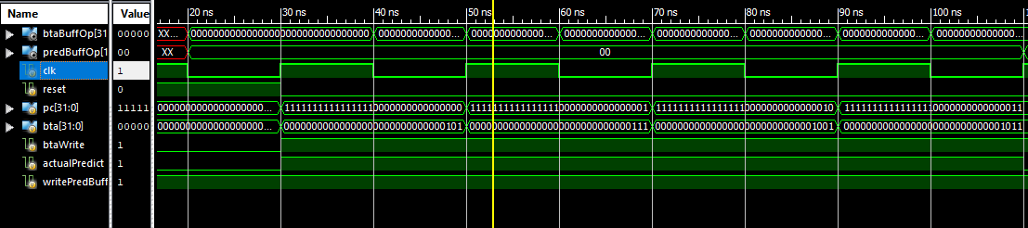

After all 4 values of bta are present in buffer

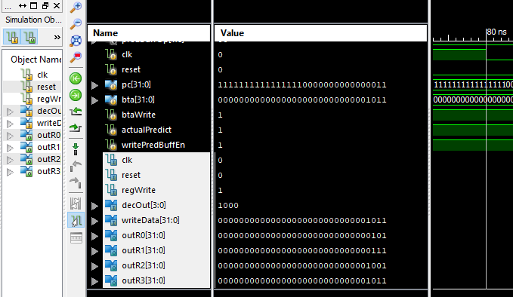

Branch is Not taken – State changes to 01 and buffer updated

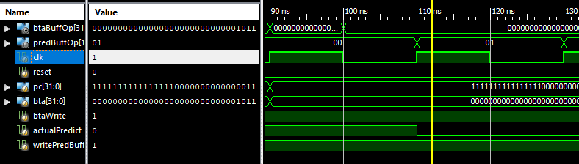

Branch is Not Taken – State changes to 10

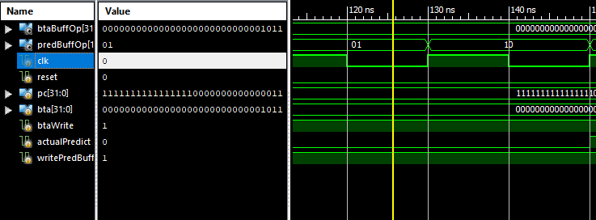

Branch taken – State changes to 11 as well as buffer updated

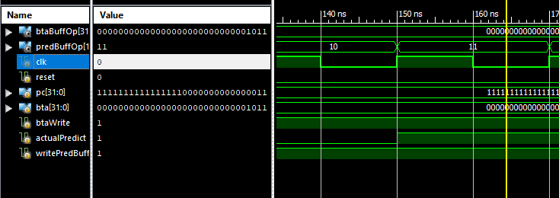

Branch is Taken –State changes to 00 and buffer is updated

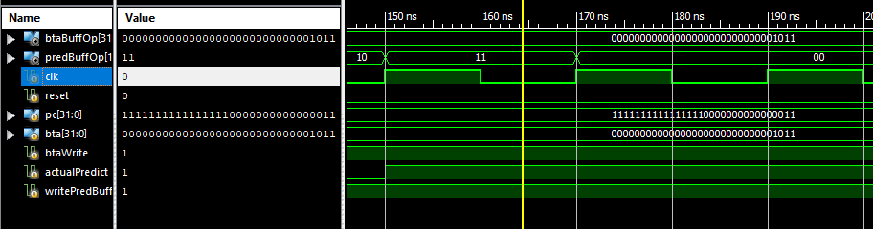

Branch is Taken again – Hence State is 00 and buffer is not updated

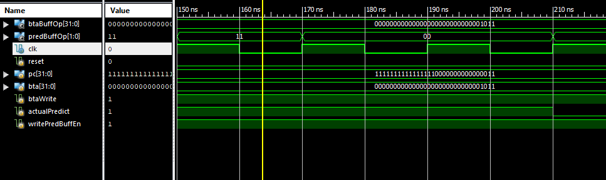

Branch is Not Taken – State becomes 01 –Buffer updated

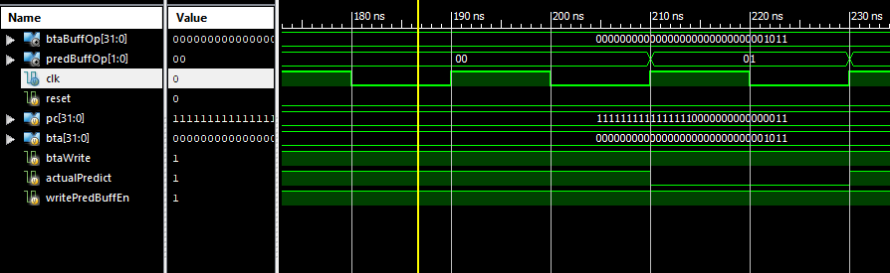

Branch Taken –State becomes 00 –Buffer updated

