Waveforms :

1. mfhi (20 ns -80 ns)

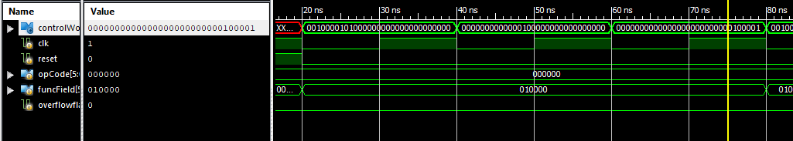

1. mflo (80ns – 140ns)

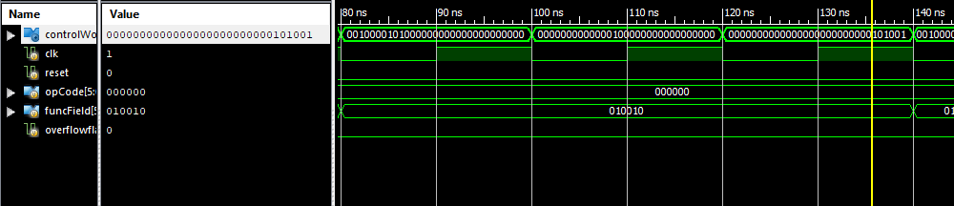

1. mthi (140ns- 200 ns)

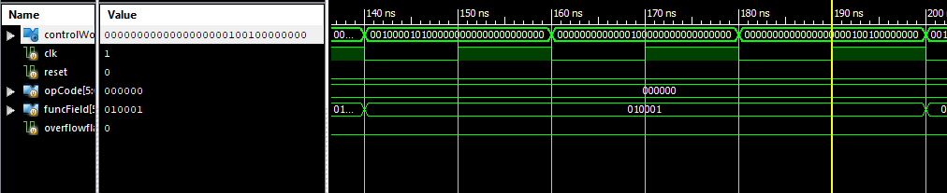

1. mtlo (200ns to 260ns)

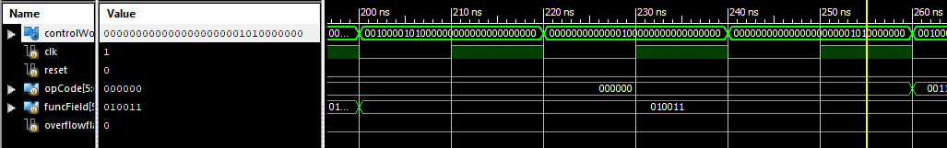

1. lui (260 ns to 320ns)

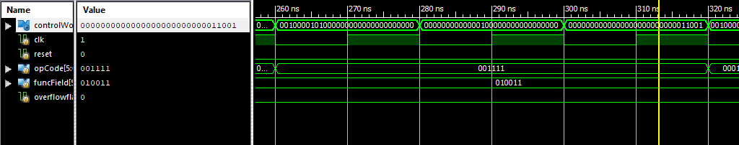

1. beq (320 ns – 380ns)

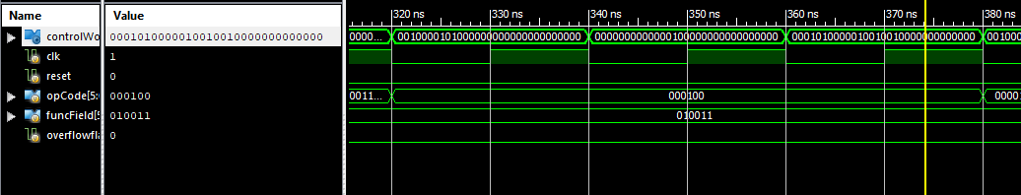

1. j (380ns to 440ns)

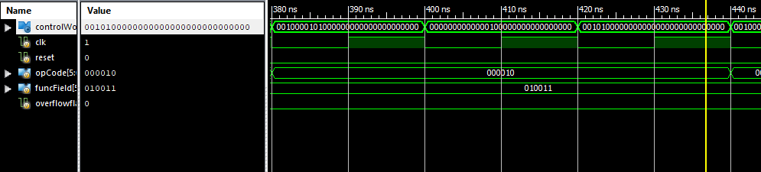

1. jal (440ns to 500ns)

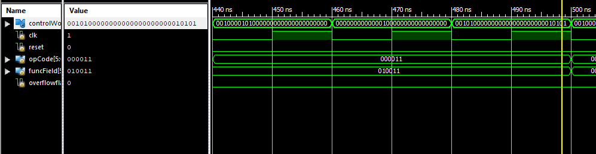

1. jr (500ns -560ns)

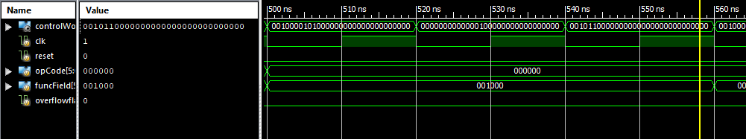

1. jalr (560ns – 620ns)

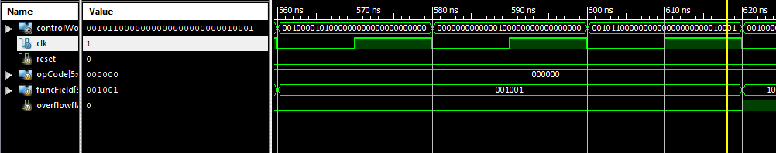

1. add ( with overflow bits set for exception) –(620ns -700 ns)

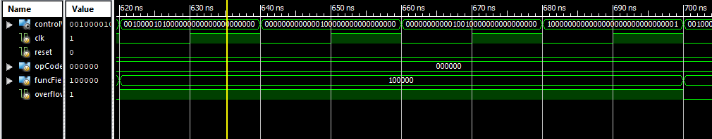

1. sll (700ns -780ns)

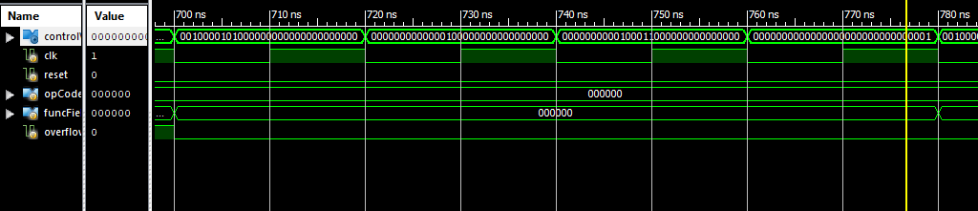

1. sllv (780ns- 860ns)

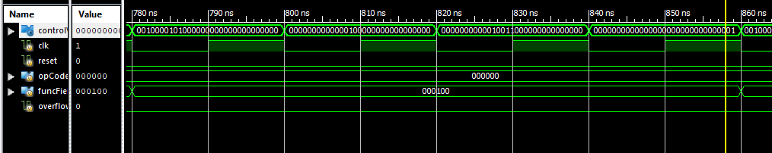

1. div (860ns - 940ns)

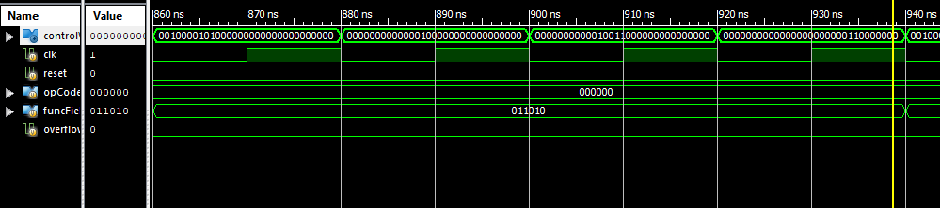

1. mult (940ns – 1020ns)

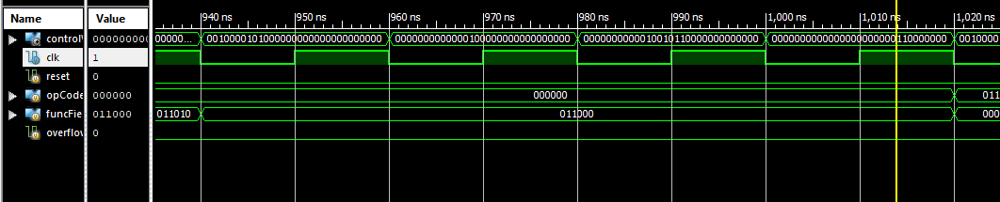

1. madd (1020ns – 1100ns)

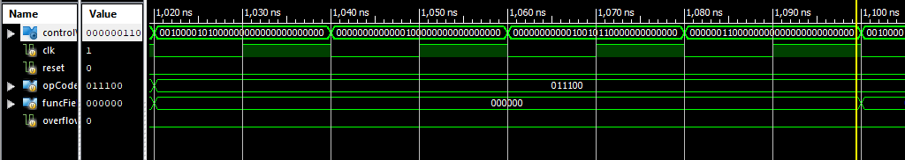

1. msub (1100ns – 1180ns)

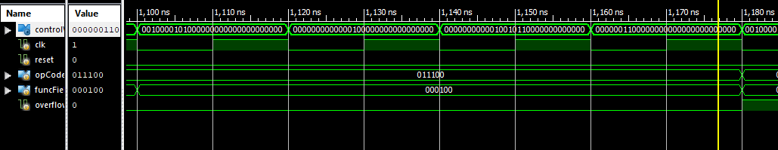

1. addi (with overflow bits set for exception) –(1180ns -1260ns)

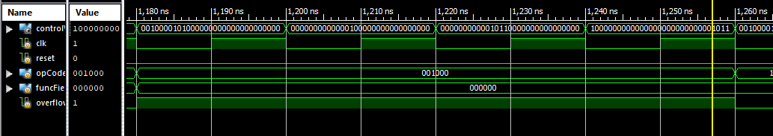

1. sw (1260ns – 1340ns)

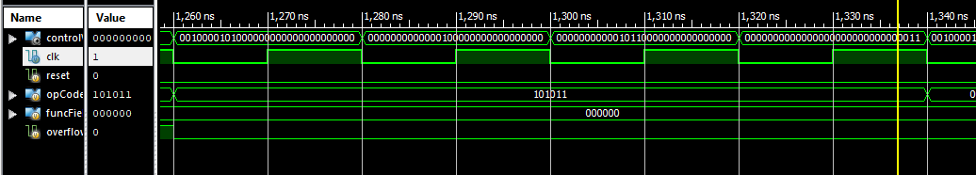

1. ori (1340ns -1420ns)

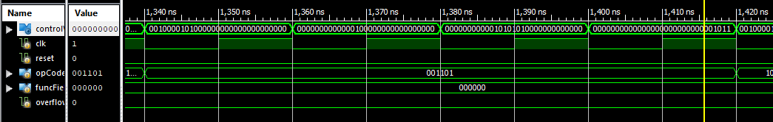

1. lw (1420ns -1520ns)

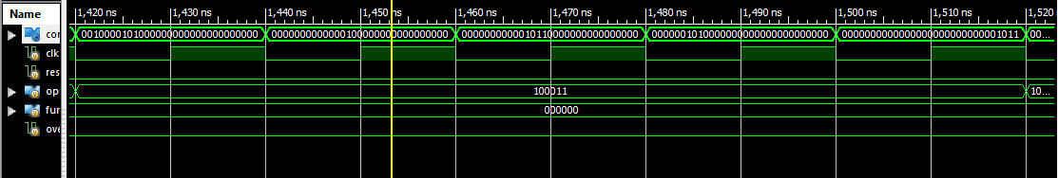

1. Invalid Instruction Exception (leads to new state representation) 1520ns onwards – detected in ID stage

