IBM SKILLSBUILD DATA ANALYTICS WITH AI INTERNSHIP 2026
PROJECT REPORT
CREDIT CARD FRAUD DETECTION
An Exploratory Data Analysis and Machine Learning Approach

Internship / Project Information | Details
Submitted By | Madhusmita Behera
Roll No. | P2725009
Internship ID | IBMUEDA2573
Institution | Maharaja Purna Chandra Autonomous College
Program | 6-week Virtual IBM SkillsBuild Data Analytics with AI Internship 2026
Collaboration | BharatCares – AICTE – IBM SkillsBuild
Trainer | Mr. Kartik Hooda
Internship Period | 17 August 2026 – 30 September 2026
Project Domain | Data Analytics / Predictive Analytics / Machine Learning
Project Application | Credit Card Fraud Detection

Submitted as part of the internship project and final project submission

DECLARATION
I, Madhusmita Behera, declare that this project report titled “Credit Card Fraud Detection” has been prepared as part of the IBM SkillsBuild Data Analytics with AI Internship 2026. The work presented in this report describes the data analysis, machine learning development, model evaluation and Streamlit application implementation carried out for the project.
I further declare that the project work has been prepared for academic and internship learning purposes and that the results reported are based on the dataset, experiments and implementation described in this report.
Name | Madhusmita Behera
Roll No. | P2725009
Internship ID | IBMUEDA2573
Date | 24/09/2026

ACKNOWLEDGEMENT
I would like to express my sincere gratitude to BharatCares, AICTE and IBM SkillsBuild for providing the opportunity to participate in the Data Analytics with AI Internship 2026. The internship provided exposure to data analytics, predictive modeling, machine learning tools and practical project development.
I am thankful to the mentors and subject matter experts for their guidance through the learning sessions and masterclasses. I also acknowledge Maharaja Purna Chandra Autonomous College for supporting my learning journey and providing an academic environment in which I could apply the concepts learned during the internship.
Finally, I am grateful to everyone who supported me during the development, testing and documentation of this project.

ABSTRACT
Credit card fraud detection is a binary classification problem in which transactions are classified as genuine or potentially fraudulent. The main challenge is the highly imbalanced nature of transaction data, because fraudulent transactions form only a very small proportion of all recorded transactions.
This project develops an end-to-end machine learning workflow for detecting fraudulent credit card transactions using the publicly available Credit Card Fraud Detection dataset. The workflow includes data inspection, duplicate removal, exploratory data analysis, feature-target separation, train-test splitting, feature scaling, Random Forest training and model evaluation.
The cleaned dataset contains 283,726 transactions, including 283,253 normal transactions and 473 fraud transactions. A Random Forest classifier with balanced class weights was trained. On the held-out test set, the model achieved a fraud-class precision of 0.97, recall of 0.71 and F1-score of 0.82. The recorded ROC-AUC was 0.9246 and PR-AUC was 0.7958. A Streamlit application was also developed to accept transaction values and display a fraud prediction, probability and risk level.

CONTENTS
- Declaration
- Acknowledgement
- Abstract
- 1. Internship Context
- 2. Introduction
- 3. Problem Statement
- 4. Objectives
- 5. Dataset Description
- 6. Methodology
- 7. Data Preprocessing
- 8. Exploratory Data Analysis
- 9. Machine Learning Model
- 10. Model Evaluation
- 11. Feature Correlation Analysis
- 12. Prediction Demonstration
- 13. Streamlit Application
- 14. Key Findings
- 15. Limitations
- 16. Future Scope
- 17. Conclusion
- 18. Project Structure
- 19. References

1. INTERNSHIP CONTEXT
According to the internship project context, the 6-week Virtual IBM SkillsBuild Data Analytics with AI Internship 2026 focuses on foundational data analytics, predictive analytics, machine learning and practical project development. The internship includes guided learning, expert-led masterclasses and project implementation.
The project follows the analytics workflow covered during the internship: understand the dataset, check data quality, preprocess the data, explore patterns, build a predictive model, evaluate its performance and present the result through an interactive application.
Program Element | Details
Internship | IBM SkillsBuild Data Analytics with AI Internship 2026
Internship ID | IBMUEDA2573
Duration | 17 Aug 2026 – 30 Sep 2026
Learning Areas | Data Analytics, Predictive Modeling, Machine Learning, AI Tools
Project Stage | Project completion and final submission

Source: Internship offer letter supplied for this report.

2. INTRODUCTION
Credit card transactions generate large volumes of financial data. Detecting fraudulent transactions from this data is a challenging classification task because fraud cases are rare compared with genuine transactions. A useful fraud detection system therefore needs to identify fraud cases while keeping false alarms under control.
This project applies a supervised machine learning workflow to historical transaction records. The dataset contains the transaction time, transaction amount, anonymized numerical features V1 to V28, and a binary Class label. Class 0 represents normal transactions and Class 1 represents fraudulent transactions.
The project also demonstrates the complete practical workflow from data preparation and exploratory analysis to model evaluation and an interactive Streamlit prediction interface.

3. PROBLEM STATEMENT
The problem addressed in this project is to develop a machine learning model that can classify a credit card transaction as normal or potentially fraudulent based on transaction-level features.
Input | Transaction Time, Amount and anonymized V1–V28 features
Output | Class: Normal (0) or Fraud (1)

4. OBJECTIVES
- Understand the structure, quality and class distribution of the credit card transaction dataset.
- Identify and remove duplicate records before modelling.
- Explore transaction amount, time and feature relationships through visualization.
- Handle the severe class imbalance during model training.
- Train a Random Forest classification model.
- Evaluate the model using precision, recall, F1-score, ROC-AUC and PR-AUC.
- Study the relationship between individual anonymized features and the fraud class.
- Build a Streamlit application for interactive transaction prediction.
- Document the complete project workflow for internship submission.

5. DATASET DESCRIPTION
The project uses the Credit Card Fraud Detection dataset containing anonymized credit card transactions. The original dataset contains 284,807 records and 31 columns. The target variable is Class, where 0 represents a genuine transaction and 1 represents a fraud transaction.
Column / Feature | Description
Time | Elapsed time in seconds between transactions in the dataset
V1 – V28 | Anonymized numerical features obtained through a PCA transformation
Amount | Transaction amount
Class | Target class: 0 = normal, 1 = fraud

The original dataset contained 1,081 duplicate rows. After duplicate removal, 283,726 records remained. The cleaned data contained 283,253 normal transactions and 473 fraudulent transactions.
Dataset Property | Value
Original records | 284,807
Original columns | 31
Duplicate rows removed | 1,081
Cleaned records | 283,726
Normal transactions | 283,253
Fraud transactions | 473
Fraud rate after cleaning | 0.1667%
Missing values | 0

Dataset source: Kaggle — Credit Card Fraud Detection dataset (MLG-ULB).

6. METHODOLOGY
The project was implemented as an end-to-end machine learning workflow:
- Dataset collection and loading
- Data inspection and quality checking
- Duplicate detection and removal
- Exploratory Data Analysis and visualization
- Feature-target separation
- Stratified 80:20 train-test split
- Standard scaling of model features
- Random Forest training with balanced class weights
- Prediction and probability estimation
- Evaluation using classification metrics, confusion matrix, ROC-AUC and PR-AUC
- Saving the trained model, scaler and feature column list
- Interactive deployment using Streamlit

7. DATA PREPROCESSING
The dataset was inspected before modelling. No missing values were found in the data. Duplicate records were identified and removed. The target column was retained as a binary variable, with Class 0 representing normal transactions and Class 1 representing fraud.
Step | Implementation
Missing values | Checked; no missing values found
Duplicate handling | 1,081 duplicate rows removed
Target variable | Class: 0 = Normal, 1 = Fraud
Features | Time, V1–V28 and Amount
Train-test split | 80% training / 20% testing
Random state | 42
Stratification | Applied to preserve class proportions
Scaling | StandardScaler fitted on training data and applied to test data
Imbalance handling | Random Forest class_weight='balanced'

8. EXPLORATORY DATA ANALYSIS
EDA was performed to understand the transaction distribution, transaction amount, fraud cases over time and the relationship between the anonymized features and the fraud class. Because fraud is a very small minority class, the class distribution was examined first.
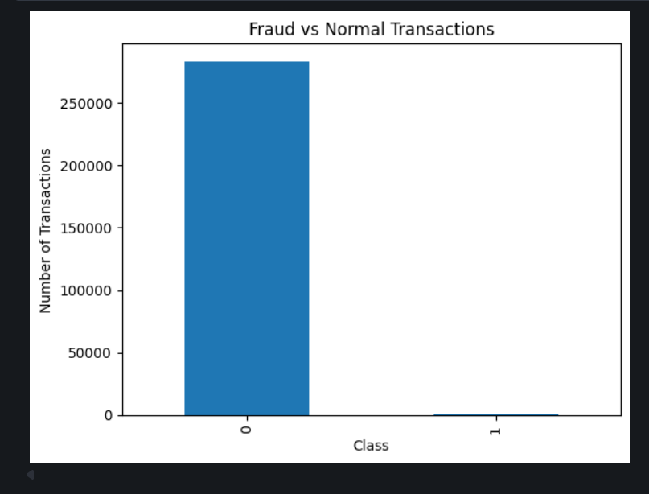
Figure 1: Distribution of normal and fraudulent transactions.
The class distribution is highly imbalanced. After duplicate removal, 283,253 transactions were normal while only 473 were fraudulent, giving a fraud rate of approximately 0.17%.
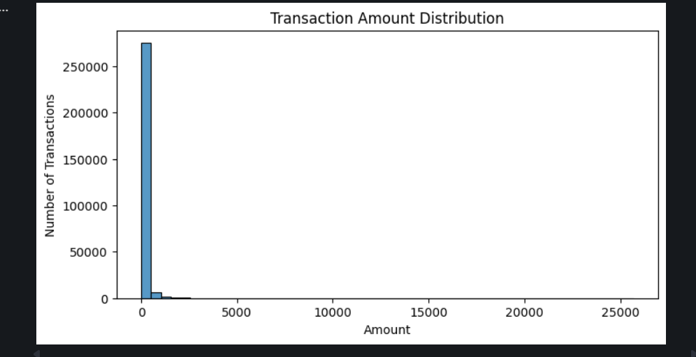
Figure 2: Transaction amount distribution.

8.1 Transaction Amount Analysis
The transaction amount distribution is strongly concentrated around lower values, while a smaller number of transactions have much larger amounts. The boxplot also shows a large number of high-value outliers in the normal class.
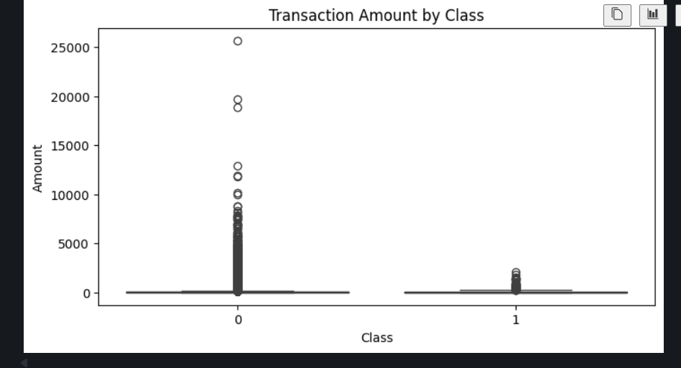
Figure 3: Transaction amount by class.
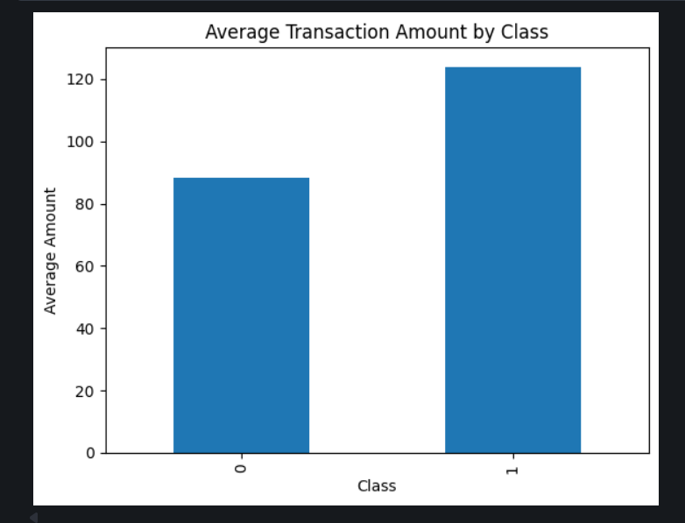
Figure 4: Average transaction amount by class.
The average transaction amount in the cleaned data was approximately 88.41 for normal transactions and 123.87 for fraud transactions. This difference is an observation in this dataset and does not by itself determine whether a transaction is fraudulent.
8.2 Fraud Transactions Over Time
The fraud transactions were plotted against the Time feature to observe how fraud cases are distributed throughout the recorded transaction period.
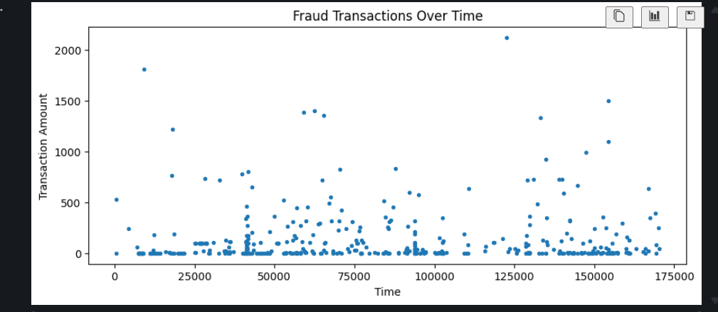
Figure 5: Fraud transactions over time.
The scatter plot shows that fraudulent transactions occur at different points across the recorded time range rather than appearing only at one isolated time value.

8.3 Feature Correlation with Fraud
A correlation analysis was performed between the numerical features and the Class target. The anonymized features show different positive and negative relationships with the fraud label.
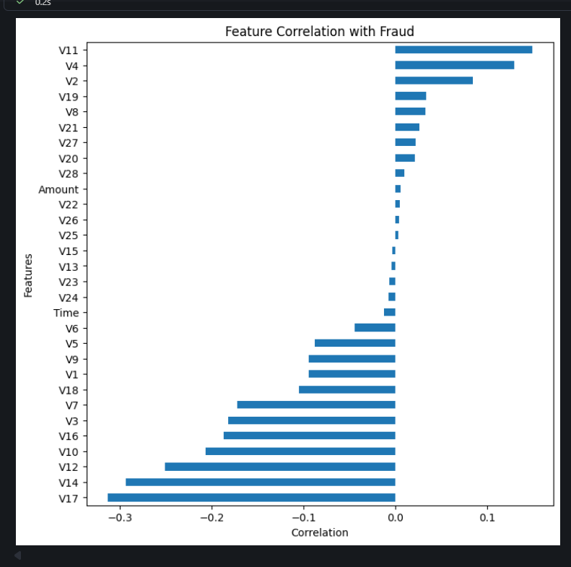
Figure 6: Correlation of features with the fraud class.
Among the recorded correlations, V11 and V4 show positive correlations with the fraud class, while V17, V14, V12, V10 and V16 show relatively stronger negative correlations. Correlation indicates association in the dataset and should not be interpreted as causation.

8.4 EDA Observations
- Fraudulent transactions form a very small fraction of the cleaned dataset.
- Transaction amounts are heavily concentrated at lower values, with a long tail of higher amounts.
- The average transaction amount for fraud cases is higher than the average for normal transactions in this dataset.
- Fraud cases occur throughout the recorded time range.
- Several anonymized PCA features show stronger correlation with the fraud label than Time or Amount.
- Because the target class is severely imbalanced, accuracy alone is not sufficient for judging fraud detection performance.

9. MACHINE LEARNING MODEL
A Random Forest classifier was selected for the project. Random Forest is an ensemble classification algorithm that combines the outputs of multiple decision trees. It can model non-linear relationships and interactions between numerical features.
Model Setting | Value
Algorithm | Random Forest Classifier
Number of trees | 100
Class weighting | balanced
Random state | 42
Parallel processing | n_jobs = -1
Training data | 80% of cleaned dataset
Testing data | 20% of cleaned dataset

Before training, StandardScaler was fitted using the training data and then used to transform both the training and test sets. The trained Random Forest, scaler and feature-column list were saved as pickle files for use by the Streamlit application.

10. MODEL EVALUATION
The model was evaluated on the held-out 20% test set containing 56,746 transactions. Since the fraud class is highly imbalanced, precision, recall and F1-score for the fraud class were considered along with ROC-AUC and PR-AUC.
Metric | Recorded Result
Normal precision | 1.00
Normal recall | 1.00
Normal F1-score | 1.00
Fraud precision | 0.97
Fraud recall | 0.71
Fraud F1-score | 0.82
Accuracy | 1.00 (rounded)
ROC-AUC | 0.9246
PR-AUC | 0.7958

10.1 Selected Model and Confusion Matrix
The Random Forest classifier was used for the project demonstration. The confusion matrix records 56,649 normal transactions correctly predicted as normal, 2 normal transactions predicted as fraud, 28 fraud transactions predicted as normal and 67 fraud transactions correctly predicted as fraud.
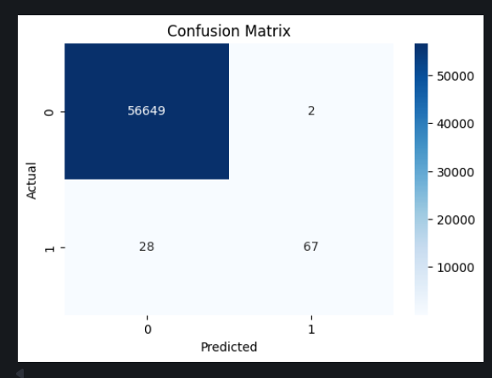
Figure 7: Confusion matrix of the Random Forest classifier.

10.2 Precision-Recall Analysis
Precision-Recall analysis is particularly useful for an imbalanced fraud detection problem because it focuses on the positive class and the trade-off between identifying fraud cases and avoiding false positive alerts. The recorded PR-AUC for the model was 0.7958.
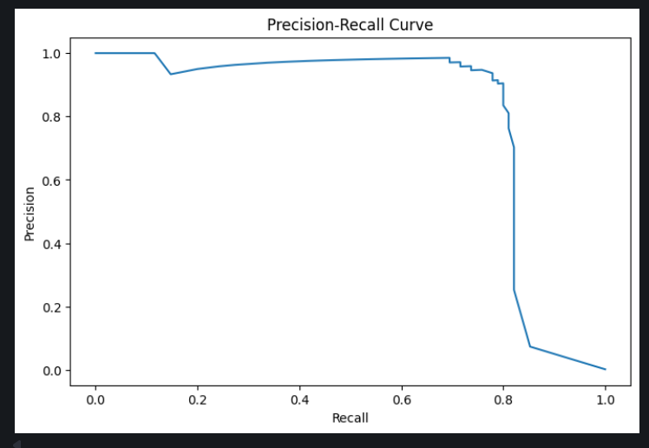
Figure 8: Precision-Recall curve.
The curve shows that precision remains high over a substantial part of the recall range before falling as the model is pushed toward higher recall.

10.3 ROC Analysis
The ROC curve represents the relationship between the true positive rate and false positive rate across different classification thresholds. The recorded ROC-AUC was 0.9246.
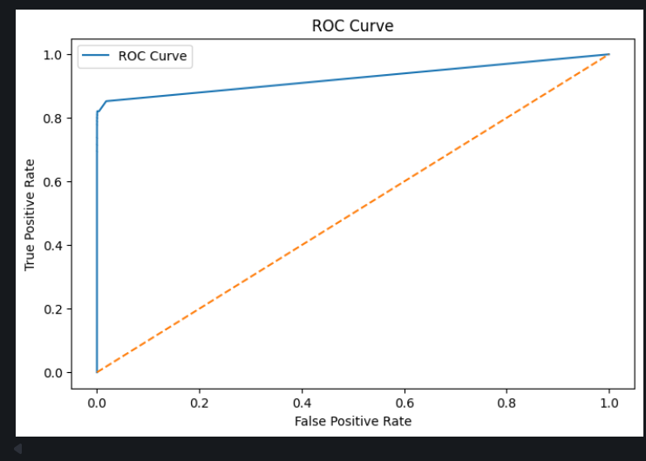
Figure 9: ROC curve.

11. FEATURE CORRELATION ANALYSIS
The original dataset contains anonymized PCA-transformed features V1 to V28. Therefore, these feature names do not directly describe real-world concepts such as merchant type, location or cardholder identity. Correlation analysis was used to understand which anonymized variables had stronger linear association with the fraud label.
Feature | Correlation with Class
V11 | 0.1491
V4 | 0.1293
V2 | 0.0846
V19 | 0.0336
V8 | 0.0331
V21 | 0.0264
V27 | 0.0219
V20 | 0.0215
V28 | 0.0097
Amount | 0.0058
V17 | -0.3135
V14 | -0.2934
V12 | -0.2507
V10 | -0.2160
V16 | -0.2010
V3 | approximately -0.19
V7 | -0.1723

These values describe the observed linear association in the cleaned dataset. They do not establish that a feature causes fraud, and they do not represent model feature importance.

12. PREDICTION DEMONSTRATION
The trained model was saved and then loaded by the Streamlit application. The application accepts the transaction Time and Amount together with the anonymized V1–V28 feature values. The same feature order used during training is reconstructed before scaling and prediction.
Input | Example used in application
Transaction Time | 10,000
Transaction Amount | 100
V1 – V28 | Entered through the anonymized feature input section
Prediction | Normal Transaction
Fraud Probability | 0.00% in the displayed demonstration
Risk Level | Low

The probability displayed by the application is the model output for the supplied input. It is not a guaranteed real-world fraud probability or a replacement for a production financial risk system.

13. STREAMLIT APPLICATION
The trained Random Forest model was integrated into a Streamlit application to provide an interactive prediction interface. The application presents a compact dataset overview, transaction analytics, prediction inputs and the resulting fraud probability and risk level.
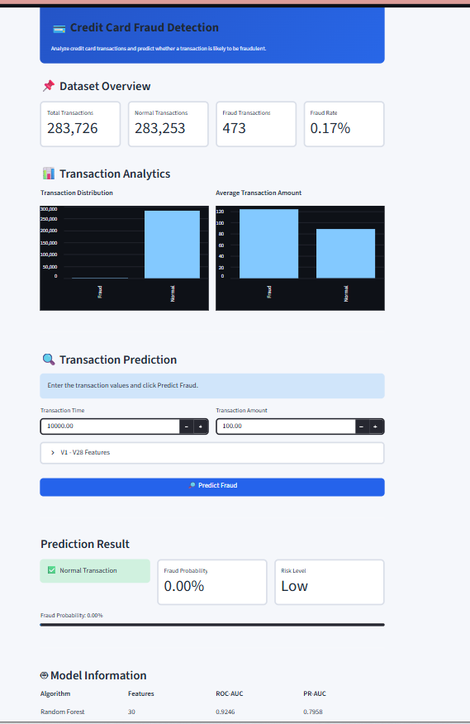
Figure 10: Streamlit application showing the transaction prediction interface.
The interface displays 283,726 total transactions, 283,253 normal transactions, 473 fraud transactions and a 0.17% fraud rate. It also includes transaction-distribution and average-amount charts.

13.1 Application Features
- Dataset overview with total, normal and fraud transaction counts.
- Fraud-rate summary.
- Transaction distribution visualization.
- Average transaction amount visualization.
- Transaction Time and Amount input fields.
- Expandable V1–V28 anonymized feature input section.
- Fraud prediction button.
- Prediction result with Normal/Fraud status.
- Fraud probability display.
- Low, Medium or High risk-level display based on the application threshold.
- Model information including Random Forest, 30 features, ROC-AUC and PR-AUC.
Run command: streamlit run app.py

14. KEY FINDINGS
- The cleaned dataset contains 283,726 transactions after removing 1,081 duplicate rows.
- Only 473 of the cleaned transactions are labelled as fraud, corresponding to approximately 0.17%.
- Fraud detection is therefore a severely imbalanced classification problem.
- The average transaction amount for fraud cases is approximately 123.87 compared with 88.41 for normal cases.
- The Random Forest model achieved fraud precision of 0.97, recall of 0.71 and F1-score of 0.82 on the recorded test set.
- The confusion matrix shows 67 fraud cases detected and 28 fraud cases missed in the test set.
- The recorded ROC-AUC is 0.9246 and PR-AUC is 0.7958.
- Several anonymized PCA features show stronger correlation with the fraud label than Time and Amount.
- The Streamlit application successfully loads the saved model and produces an interactive prediction result.

15. LIMITATIONS
- The model is trained on one historical anonymized dataset and may not generalize to other transaction populations.
- The V1–V28 features are anonymized PCA components, so their business meaning cannot be directly interpreted.
- The dataset contains a severe class imbalance, which makes accuracy alone less informative.
- The model's test-set metrics should not be treated as guaranteed real-world performance.
- The Streamlit application is an academic project demonstration and not a production banking or fraud-monitoring system.
- Fraud probability and risk level shown by the application depend on the supplied feature values and model behaviour.

16. FUTURE SCOPE
- Evaluate additional imbalance-handling techniques such as SMOTE and threshold tuning.
- Compare Random Forest with Gradient Boosting, XGBoost and other ensemble approaches.
- Perform systematic hyperparameter tuning and cross-validation.
- Study precision-recall trade-offs at different fraud-alert thresholds.
- Add explainability methods such as SHAP where appropriate.
- Develop monitoring for model performance and data drift when new transactions become available.
- Improve the application with transaction-history and analytics dashboards.
- Deploy the application only after suitable validation, security, privacy and governance checks.

17. CONCLUSION
This project demonstrates an end-to-end data analytics and machine learning workflow for credit card fraud detection. The work covers data understanding, duplicate removal, exploratory analysis, feature preparation, model training, evaluation and interactive deployment.
The cleaned dataset contains 283,726 transactions, with 473 fraud cases. The Random Forest classifier recorded a fraud precision of 0.97, recall of 0.71 and F1-score of 0.82. The ROC-AUC of 0.9246 and PR-AUC of 0.7958 provide additional evaluation of the model's ability to distinguish fraud from normal transactions, particularly under class imbalance.
The Streamlit application provides a practical interface for demonstrating the prediction workflow. Overall, the project applies the internship learning areas of data cleaning, exploratory data analysis, predictive analytics, machine learning and visualization to a complete documented use case.

18. PROJECT STRUCTURE
credit-card-fraud-detection/
├── data/
│ ├── check_data.py
│ └── creditcard.csv
├── models/
│ ├── feature_columns.pkl
│ ├── fraud_model.pkl
│ └── scaler.pkl
├── notebooks/
│ └── credit_card_fraud_analysis.ipynb
├── app.py
├── README.md
├── requirements.txt
├── .gitignore
└── .gitattributes
The raw creditcard.csv file is kept locally and excluded from the Git repository because of its large file size. The trained model, scaler and feature-column file are included for application execution.

19. REFERENCES
- Kaggle — Credit Card Fraud Detection Dataset (MLG-ULB): https://www.kaggle.com/datasets/mlg-ulb/creditcardfraud
- Scikit-learn documentation — Random Forest, StandardScaler and classification evaluation metrics.
- Streamlit documentation — Python framework for interactive data applications.
- IBM SkillsBuild / BharatCares / AICTE internship material supplied for program details.

