Testcases

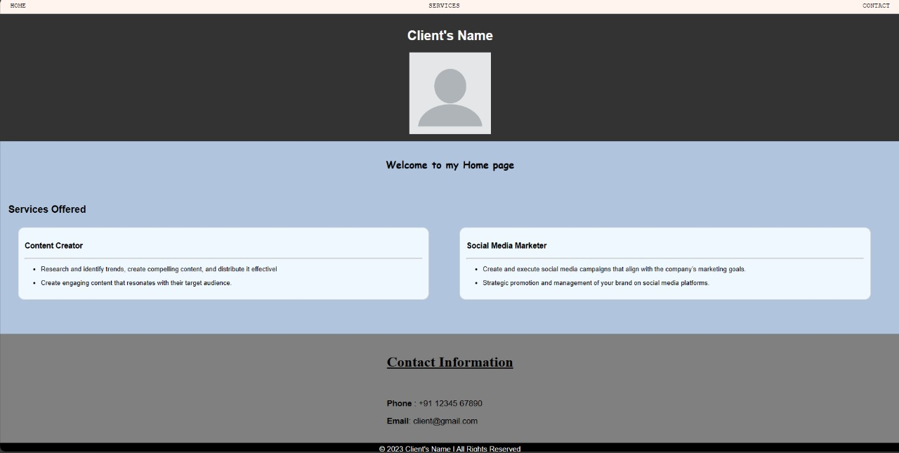

By clicking the HOME it will lead to top of first page



By clicking the SERVICE it will lead to the middle of the page

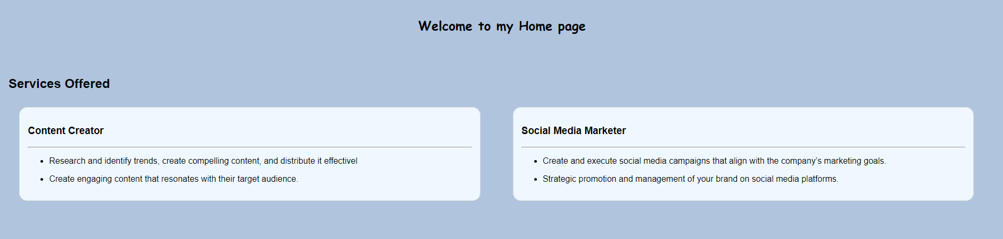

By clicking the CONTACT it will lead to the contact page (bottom )



While clicking those options that will directly lead to the exact destination.

So all the testcases are passed.