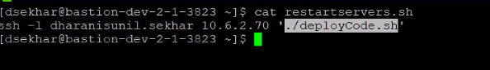

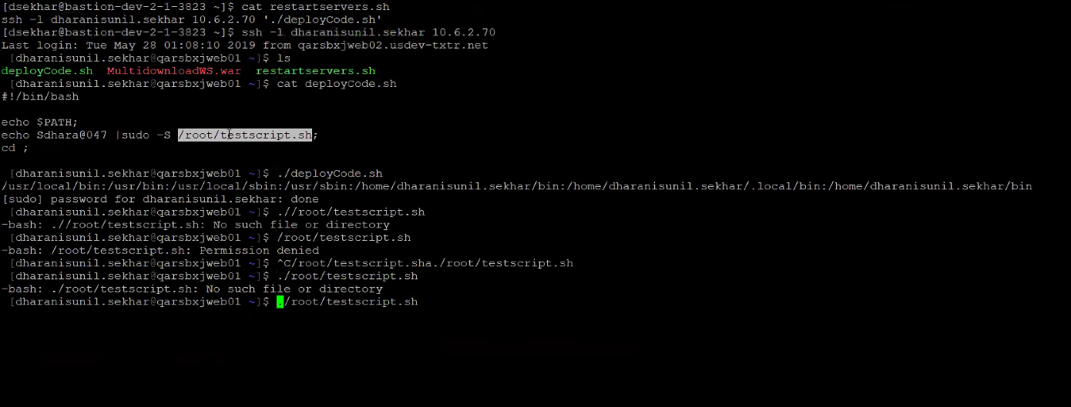

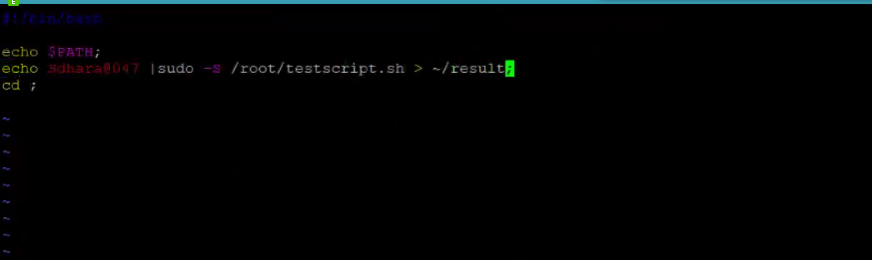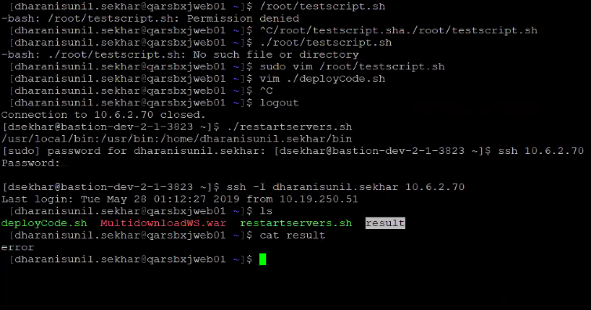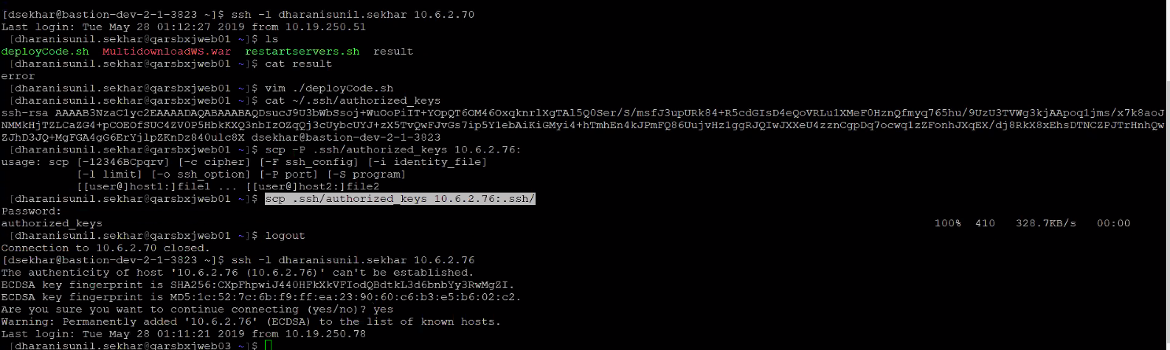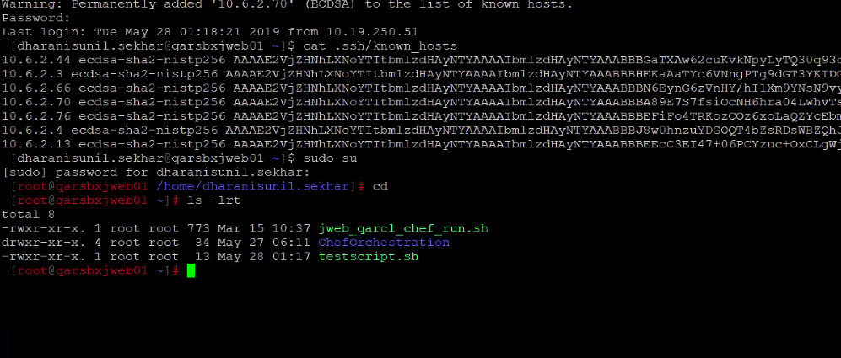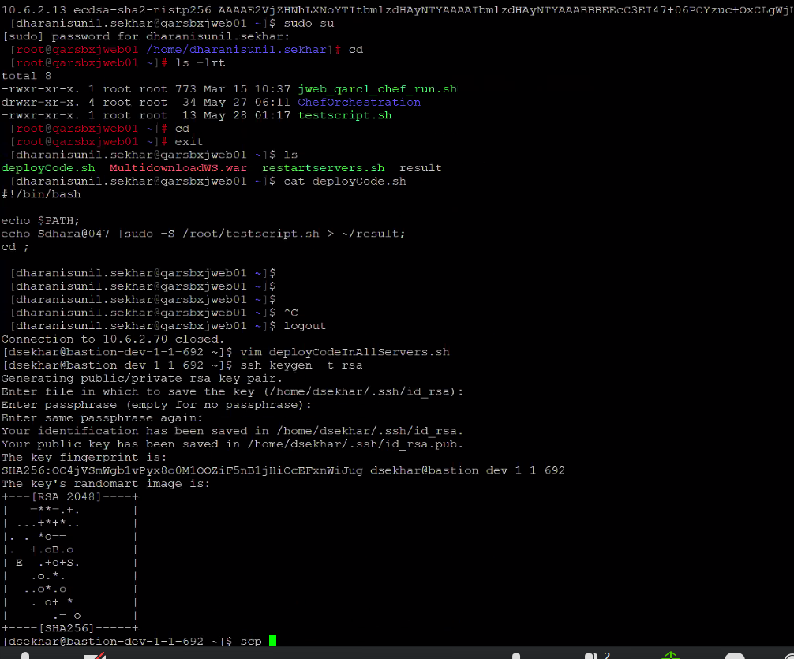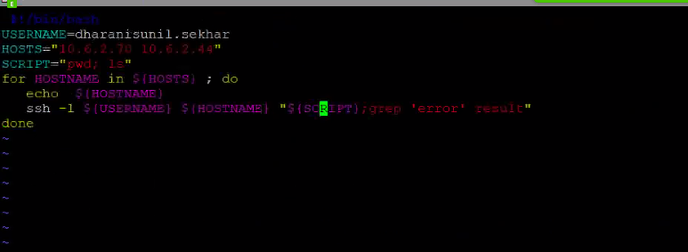

QAR Deployment Process;

1)Login to Dev Bastion Host

2)Login to Fileserver through Bastion host

3)Execute below commands to get rid of password to login into other submittal exchange servers

a)ssh-keygen -t rsa

1)Press Enter

2)Give a strong passphrase. You will be using this Passphrase to login into servers (you type it only once while executing commands)

3)Enter the passphrase again

b)cat .ssh/id_rsa.pub | ssh IP 'cat >> .ssh/authorized_keys'

4)create a script "deployCode.sh" with below content in every server.For copying to all servers see step:6

#!/bin/bash

echo $MYPASSWD |sudo -S /root/testscript.sh;

5)chmod +x deployCode.sh

6)scp deployCode.sh IP:

7)Create a script "deployCodeinAllServers.sh" with below content

cmd='export MYPASSWD='$1';./deployCode.sh';

ssh IP $cmd;

8)chmod +x deployCodeinAllServers.sh

9)Run below commands

a)eval $(ssh-agent -s)

b)ssh-add

9)Execute script with below command

./deployCodeinAllServers.sh yourpassword (not passphrase here)

10)At the end run below command

ps -aef |grep "ssh-agent" | head -n 1 |cut -d' ' -f 3 |xargs -I{} kill {}

Next Steps:

We need to Work on the scripts(deployCode.sh,deployCodeinAllServers.sh) to do proper deployment in all servers and get proper status of deployment