Number Plate Detection And Management

Project Guide: Project Report By:

Tanuja Pattanshetti Madhusudan Jadhav 111703020
Rohit Sabbanwad 111703051

Table of Contents
Table of Contents
1 Abstract
2 Introduction
2.1 List Of features
2.2 Feasibility Analysis
3 Motivation
4 Proposed System
4.1 Input Image
4.2 Localization
4.3 Segmentation
4.4 Recognition
5 Proposed Architecture
6 Hardware & Software Requirements
6.1 Hardwares
6.2 Softwares
7 Selected Process Model
8 Gnatt Chart
9 Software Requirements Specification(SRS)

1 Abstract:-
In this Project, We are planning to make a software which will be detecting number plate from the captured images continuously.
It will basically capture images from CCTV or any camera sources like webcam or video footage and then will do analysis on that and will recognize the number plate form the captured image. Then after that, We will convert that recognized portion (Number Plate) into actual characters(digital form), which will be added into the database.

2 Introduction:-
Vehicle Number Plate Identification is a part of digital image processing which is generally used in vehicle transportation system to categorize the vehicle. Number plate detection systems are having varieties of application such as traffic maintenances, tracing stolen cars, automatic electronic Toll collection system etc.
But the main aim is to automatically detect number plate of vehicle and store it’s number in database with in time and out time. In India, the number plate containing white background with black foreground color is used for private cars and for the commercial vehicles yellow is used as background and black as foreground
color. The number plate starts with two digit letter “state code” followed by two digit numeral, followed by single letter after those four following digits as the below figure.
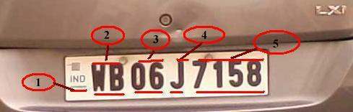

In above figure , 1 indicates the Country code, 2 indicates the state code, and 3 indicates the district code, 4 indicates the type of vehicle and 5 indicates the actual registration number. Locating the number plate is very Stimulating work in the field of image processing. The whole system mainly consists of two stages. First to identify the position of the number plate from the particular vehicle and second segmentation of all the numbers and letters of the number plate.

2.1 List Of Features:-
The following are the features that we are going to implement.
- Detection of number plate.
- Add Entry time of vehicle in the database
- Add Exit time of vehicle in the database.
- Owner’s information with respect to number plate.(own database).
- Notifications for black listed vehicles.
- Detection of new user which is not in the database.

2.2 Feasibilty Analysis:-

- In Society where watchman maintains notebook register for vehicles management.
- In College campus, at the gate through which all the vehicles pass.
- In Parking places.
- In RTO offices.
- On city roads where government has fixed cameras.

3.Motivation:-
Daily we walk through the gate of college, their we observe that security guard of gate update vehicle numbers of guests with in and out time manually in register. We are living in the 21st century which is era of automation technology, So we think about that it’s totally unfair if we are working manually where we learn new technology itself. So, here we thought can’t we make a software which can detect number plate of vehicles and manage it using database!

4.Proposed System:-
4.1. Input Image:
The image that is provided as input to the system has to satisfy following conditions
- License Plate must be clearly visible
- The image must itself be clear enough for the system to recognize.
- Image of the vehicle should be straight of the front end or straight of the backend.

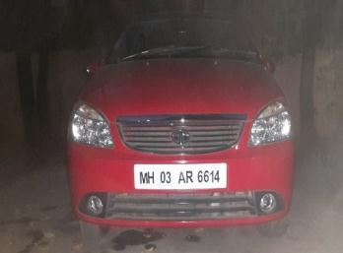

4.2. Localization:
Localization of image is done using the histogram. Once the image is taken as input it is converted into gray scale image. Dilation and Erosion operations are performed on the images to remove the noise. From this noise, free image edges are plotted horizontally and vertically. This horizontal histogram needs to be smoothened using low pass filter. Later on, the horizontal histogram values are filtered out by applying a dynamic threshold. The Same procedure is done for edges vertically. Once the system analyses the horizontal and vertical histograms the probable candidates for a license plate in the image are identified. This candidate is the region of interest which is extracted. On further processing, the most probable region of interest in identified which is isolated and thus, the localization of license plate take place. This localized license plate is then passed on to the next phase for segmentation.
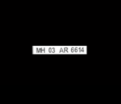

4.3. segmentation:
The localized license plate goes as an input for segmentation. The gray scale image is converted into a binary image and all the image containing less than 30px are removed. This removes the noise from the image. Properties are measured in this noise free image and thus, a bounding box is a plot. Finally, extracted characters individually displayed.

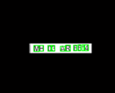
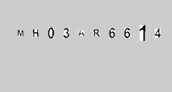

4.4. Recognition:
Recognition part is implemented using Artificial Neural Network.

5. Proposed Architecture:
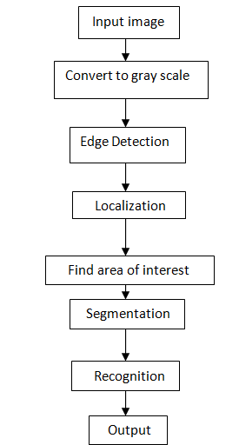

(fig.)Architectural Diagram

6.Hardware & Software Requirements:-
6.1 Hardwares-:

- Processor: any Intel processor above or equal 5 th generation.
- RAM: equal to 4GB or above.
- Hard disk: equal or above 100 GB.
- Monitor: Any LCD monitor.
- Keyboard
- Mouse: Mouse compatible to machine.
- Camera : Webcam or cctv(we’ll use webcam)

6.2 Softwares-:

- Python
- OpenCV
- Computation Neural Network (CNN)
- Database Management
- Numpy
- Tesseract
- Matplotlib
- Tensorflow
- Mysql

7. Selected Process Model:
For this Project, we are going to use waterfall model.

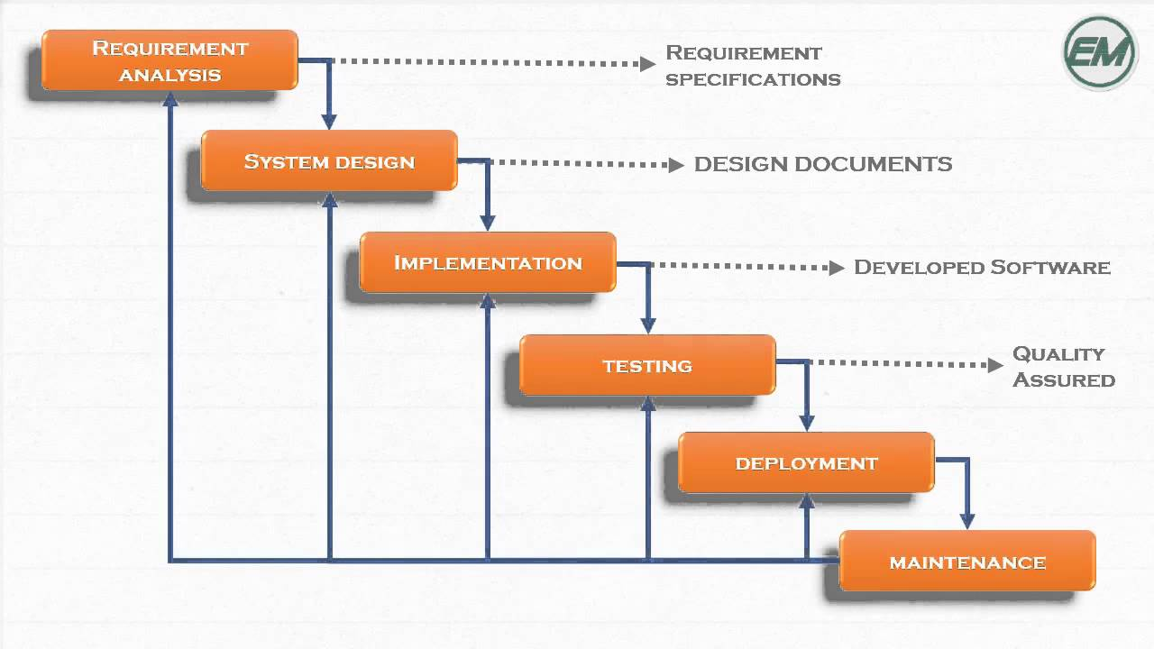

8. Gantt Chart:-
Sr.no | Process | 11th Feb – 26th Feb | 27th Feb – 1st March | 2nd March - 10th March | 11th March – 20th March | 21st March - 31st March | 1st April-  5th April | 6th April - 10th April | 11th April- 25th April
1. | Requirements Gathering
2. | Uk Design
3. | Design development
4. | Content Creation
5. | Coding
6. | QA
7. | Bug Fixing
8. | Final Testing
9. | Release

Software Requirements Specification(SRS)
for
Number Plate Detection And Management
Prepared by
Madhusudan Jadhav: 111703020
Rohit Sabbanwad: 111703051
COEP
11th Feb 2020
Table of Contents(SRS)
Table of Contents
Revision History
1. Introduction
1.1 Purpose
1.2 Document Conventions
1.3 Intended Audience and Reading Suggestions
1.4 Product Scope
1.5 References
2. Overall Description
2.1 Product Perspective
2.2 Product Functions
2.3 User Classes and Characteristics
2.4 Operating Environment
2.5 Design and Implementation Constraints
2.6 User Documentation
2.7 Assumptions and Dependencies
3. External Interface Requirements
3.1 User Interfaces
3.2 Hardware Interfaces
3.3 Software Interfaces
3.4 Communications Interfaces
4. System Features
4.1 Desciption and priority
4.2 Stimulates and responses
5. Other Nonfunctional Requirements
5.1 Performance Requirements
5.2 Safety Requirements
5.3 Security Requirements
5.4 Software Quality Attributes
6. Other Requirements
Appendix A: Analysis Models
Appendix B: To Be Determined List

Introduction

Purpose
Due to exponential increase of vehicles in the recent years- the need of management is mandatory and essential.The application of number plate detection and management is valuable in domains like colleges, residential areas, signals, parking places because it helps save time and improves the management by making it simpler and easy.

Document Conventions
This document uses the following conventions
DB database
DDB Distrubuted Database
ER Entity Relationship
NPD Number plate detectin

Intended Audience and Reading Suggestions
This project is a prototype for the vehicle management system and it is intended for the societies where a watchman maintains a notebook for keeping track of incoming and outgoing vehicles. It is also intended for the colleges and any parking places where keeping tracks of vehicles is unreliable.

Product Scope
The purpose of this project is to provide easy and better traffic management in crowded areas. This project will be mainly focusing on college campus , but later we can extend this to city level as well.

References
https://towardsdatascience.com/number-plate-detection-with-supervisely-and-tensorflow-part-1-e84c74d4382c

https://en.wikipedia.org/wiki/Automatic_number-plate_recognition

https://ieeexplore.ieee.org/document/6992954/

Overall Description

Product Perspective
Number plate detection and management is self-contained project. It stores the following information.
Number plate:number plate of vehicles in the database.
Entry time: entry time of vehicles in the campus.
Exit time: exit time of vehicles in the campus.

Product Functions
1.Detection of number plate of vehicles.
2.Add entry time in the database.
3.Add exit time in the database.
4.Owner’s information with respective number plate.(i.e own databases).
5.Notifications for black listed vehicles.
6.Detection of new user which is not in the databases.

User Classes and Characteristics
Users of the system should have vehicles with proper and well maintained number plate.
He/she will be able to see his/her own catalog where he/she can see entry time, exit time and how frequently he/she uses vehicle.

Operating Environment
Operating environment for the airline management system is as listed below.
1.Operating System: Linux
2.Database: mysql
3.platform: python
4.Distributed databases

Design and Implementation Constraints
1.The global database, owner databases
2.Mysql queries for above queries/applications
3.According to response by camera , black listed vehicles database.

User Documentation
https://ieeexplore.ieee.org/document/6992954/

Assumptions and Dependencies
In this project , It is assumed that vehicles have clean and clear number plate.
It depends on the number plate to maintain the databases properly otherwise it wont work properly.

External Interface Requirements

User Interfaces
User will be passing through the CCTV which will be moduled by us in the campus.
CCTV will capture the image and will be given to the software so at front end input is image of vehicle
At back end it will be using standard libraries and sql to perform operations.

Hardware Interfaces
It will be using CCTV for its operation.

Software Interfaces
Following are the software used for the number plate detection and management.

Software Used Description

Operating System We have chosen linux Operating system for the best
Support and user-friendliness.

Database To save the records of the user’s data

Mysql to ask the queries from the database

Communications Interfaces
This project if for all types of vehicles which have number plate on it.

System Features
4.1 Description and Priority
The number plate detection and Management maintains the database for the incoming and outgoing vehicles as well as owner’s information w.r.t. number plate’s number. This project has high priority as maintaining registers manually is difficult task for human.
4.2 Stimulus/Response Sequences
1.Search for own database
2.Display entry time, exit time for particular vehicle.
3.generate an alarm for black listed vehicles.

Other Nonfunctional Requirements

Performance Requirements
1.CCTV will be capturing the image of vehicles continuosly.
2.Image will be fed for preprocessing.
3.Then Number plate will be detected by the system.
4.Then later character segementation and recognition will be done.
5.Then output of the characters will be added into the respective databases.

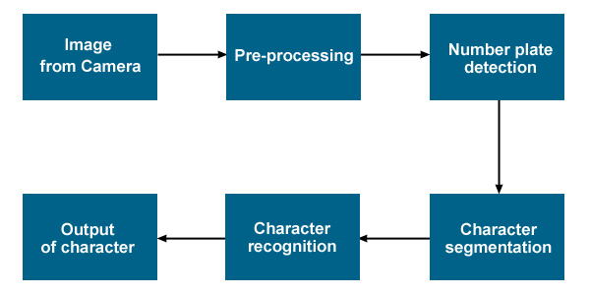

Safety Requirements
If there is extensive damage to a wide portion of the database due to catastrophic failure, such as disk crash the recovery method restores past copy of the databases that was backed up to archival storage (typically tape).

Security Requirements
Security systems need database storage just like many other applications.

Software Quality Attributes
- CORRECTNESS: The result of the number plate detection should correct. I.e high level extraction process should be applied.
- MAINTAINABILITY: The databases should be maintained properly.
- USABILITY: The project should be usable at any place having CCTV.
Appendix A: Analysis Models
We will be using waterflow model here as the we cant go forward if the previous task is incomplete.

Appendix B: To Be Determined List
1.determine the size of the number plate in India.
2.determine the font style used in the number plate.

