Methods for deriving OLCI lake features
Feature definitions and computational methods
The observational unit is a scene–lake pair. Local features are derived from native OLCI observations assigned to HydroLAKES polygons. Counts and index summaries are computed after removing duplicates with the same Hylak_id and latitude/longitude rounded to six decimal places. NASA features are derived independently from mapped daily data.

Scene and lake identification
scene_id Provider-assigned product UUID copied from the Copernicus Data Space OData catalogue Id field. The workflow validates its UUID format and preserves it as the scene key; it does not compute a new identifier.
scene_name Copied from the Copernicus Data Space catalogue Name field after removing a trailing .SEN3 suffix. The remaining product name is preserved; no new scene name is constructed.
acquisition_start Copied from ContentDate.Start in the Copernicus Data Space catalogue and retained as the sensing start time in UTC. It is not calculated from processing time or file creation time.
Hylak_id Copied from the HydroLAKES Hylak_id attribute. Native geolocated points are assigned to the polygon that strictly contains them; the identifier links observations to lake attributes.
Lake_name Retrieved from the HydroLAKES shapefile Lake_name attribute by matching Hylak_id. No reverse geocoding or name inference is applied; unavailable names remain blank.
Lake_area_km2 HydroLAKES Lake_area attribute in km², matched by Hylak_id; not calculated from the scene pixel count.
state_name Generated by intersecting the HydroLAKES pour point with first-level administrative polygons in EPSG:4326, then copying shapeName for a unique match. Unmatched or ambiguous assignments remain blank.
state_id Copied from shapeID of the uniquely matched first-level administrative polygon using the same spatial join as state_name. It is an administrative-dataset identifier.
latitude HydroLAKES Pour_lat in decimal degrees: the lake pour-point latitude, not a lake centroid or mean pixel latitude.
longitude HydroLAKES Pour_long in decimal degrees: the lake pour-point longitude, not a lake centroid or mean pixel longitude.

How the counts relate
ci_cyano_detection_pixels ≤ ci_candidate_pixels ≤ ci_input_valid_pixels ≤ primary_retained_pixels ≤ native_lake_pixels.
ci_candidate_pixels = CI_valid_pixels; ci_cyano_detection_pixels = CI_cyano_valid_pixels. Each pair counts the same population but names either the selection stage or the statistic sample size.
Equal counts do not imply equal formulas: ci_input_valid_pixels, NDCI_valid_pixels, MPH_valid_pixels and FAI_valid_pixels may equal primary_retained_pixels when their required inputs are valid, but each tests different bands.
Without optional screens, primary_retained_pixels = generic_flag_exclusion_sensitivity_pixels + bloom_rescued_pixels. Land-adjacency screening can invalidate this equality because it does not update the saved rescue mask.

Pixel retention and detection features
native_lake_pixels Count the geolocated observations with valid flag records assigned to the lake, then retain the first record for each deduplication key. Observations rejected by primary QA remain in this population.
primary_retained_pixels Count with valid_water_mask = 1: eligible non-land observations without HISATZEN or NAVFAIL, with CLDICE absent or successfully rescued, after any optional screens.
generic_flag_exclusion_sensitivity_pixels Retained count under blanket LAND, CLDICE, HISATZEN and NAVFAIL exclusion, with optional screens. Despite “exclusion” in its name, this counts survivors; it is not NASA-equivalent QA.
bloom_rescued_pixels CLDICE observations satisfying the full bloom-rescue condition below. Counts the saved bloom_rescue_mask, rather than all observations with positive FAI.
CLDICE_pixels Number of stored lake observations carrying the L2Gen cloud-or-ice flag, including any that also carry another flag.
cloud_excluded_pixels Count observations satisfying the non-land base mask AND CLDICE AND NOT bloom rescue. This is CLDICE_pixels − bloom_rescued_pixels when all counted CLDICE observations satisfy the base mask and rescue is unchanged by later screens.
bloom_rescue_fraction_of_CLDICE bloom_rescued_pixels ÷ CLDICE_pixels; a fraction from 0 to 1, not a percentage. Missing when CLDICE_pixels = 0.
ci_input_valid_pixels Primary-retained observations with finite rhos620, rhos665, rhos681 and rhos709. No spectral-shape or CI magnitude gate has yet been applied.
ci_candidate_pixels CI-input-valid observations with SS(681) < 0. CI = −SS(681) is retained here; SS(665) > 0 is not required.
ci_cyano_detection_pixels Count CI candidates satisfying SS(665) > 0 and CI > τ, where τ is the configured CI detection limit. These observations form the CI_cyano statistical population.
NASA_CI_Cyano_detectable_cells Count unique daily NASA CyAN GeoTIFF cells with centres inside the lake and DN 1–253. Overlapping tile cells are deduplicated; DN 0 (non-detectable), 254 (land) and 255 (no valid data) are excluded.

Bloom rescue algorithm
Define the base mask as lake membership AND finite geolocation AND valid flag records AND NOT LAND. Rescue requires base AND CLDICE AND NOT HISATZEN AND NOT NAVFAIL AND CI-cyano detection AND finite FAI > α AND finite rhos754 > finite rhos490. Set α = 0 for the positive-FAI rule; compute FAI before applying the final retention mask.
LAND = land classification; HISATZEN = high sensor zenith angle; NAVFAIL = navigation/geolocation failure; CLDICE = cloud or ice classification.
Cloud-count qualification: the code restricts cloud exclusion to non-land observations and forms that mask before optional screens. Land flagged as CLDICE, or later brightness screening of rescued pixels, can break the simple subtraction identity.

Index formulas and eligibility
rhosλ denotes dimensionless Rayleigh-corrected reflectance near wavelength λ in nm. The formulas below use nominal band labels; the code uses the wavelengths of the selected L2Gen products. Finite means neither missing nor infinite.

CI and CI cyano
$SS(681) = rhos681 − [rhos665 + (rhos709 − rhos665) × (681 − 665)/(709 − 665)]$
$SS(665) = rhos665 − [rhos620 + (rhos681 − rhos620) × (665 − 620)/(681 − 620)]$
$CI = −SS(681)$
CI is saved for primary-retained observations with all four CI inputs finite and SS(681) < 0. CI_cyano equals CI only where SS(665) > 0 and CI exceeds the detection limit; elsewhere it is missing, not zero.
τ denotes the chosen CI detection limit and must be reported with the processing configuration. The candidate stage does not apply τ or the SS(665) gate. The standard shape gates are SS(681) < 0 and SS(665) > 0.

NDCI
$NDCI = (rhos709 − rhos665)/(rhos709 + rhos665)$
Requires primary retention, finite 665 and 709 nm inputs, and |rhos709 + rhos665| > 10⁻⁸. Negative values are allowed.

MPH
$H(λ) = rhosλ − [rhos665 + (rhos884 − rhos665) × (λ − 665)/(884 − 665)]$
$MPH = maximum of valid H(681), H(709), H(754)$
Requires primary retention, finite baseline endpoints and at least one finite peak band. The nominal 885 nm endpoint maps to L2Gen rhos_884; actual selected wavelengths enter the calculation. Negative MPH values are allowed.

FAI
$FAI = rhos754 − [rhos665 + (rhos865 − rhos665) × (754 − 665)/(865 − 665)]$
Requires primary retention and finite 665, 754 and 865 nm inputs. This is the OLCI-adapted FAI/AFAI form, not the original SWIR-based FAI. Statistics include negative values; only bloom rescue applies the FAI > α condition.

Statistical interpretation
CI_cyano is a spectrally selected subset of CI, not a separately scaled index. NDCI, MPH and FAI use their own band-validity rules. Their summary values are dimensionless index statistics, not direct cell concentrations or bloom areas.
Local statistics use equally weighted native observations; NASA counts use mapped cells. Differences between these populations cannot be interpreted directly as differences in bloom abundance. Missing index values are excluded rather than replaced by zero.

Index summary feature definitions
Each statistic uses finite eligible values from this lake and scene, with equal weight per native observation. No valid values gives valid_pixels = 0 and missing mean, median, percentiles and maximum.
Column | Meaning
CI_valid_pixels | Number of finite values among CI candidates.
CI_mean | Arithmetic average of eligible CI values.
CI_median | 50th percentile of eligible CI values.
CI_p10 | 10th percentile of eligible CI values.
CI_p90 | 90th percentile of eligible CI values.
CI_max | Largest eligible CI value.
CI_cyano_valid_pixels | Number of finite values among CI-cyano detections.
CI_cyano_mean | Arithmetic average of eligible CI_cyano values.
CI_cyano_median | 50th percentile of eligible CI_cyano values.
CI_cyano_p10 | 10th percentile of eligible CI_cyano values.
CI_cyano_p90 | 90th percentile of eligible CI_cyano values.
CI_cyano_max | Largest eligible CI_cyano value.
NDCI_valid_pixels | Number of finite values among primary-retained observations with valid NDCI.
NDCI_mean | Arithmetic average of eligible NDCI values.
NDCI_median | 50th percentile of eligible NDCI values.
NDCI_p10 | 10th percentile of eligible NDCI values.
NDCI_p90 | 90th percentile of eligible NDCI values.
NDCI_max | Largest eligible NDCI value.
MPH_valid_pixels | Number of finite values among primary-retained observations with valid MPH.
MPH_mean | Arithmetic average of eligible MPH values.
MPH_median | 50th percentile of eligible MPH values.
MPH_p10 | 10th percentile of eligible MPH values.
MPH_p90 | 90th percentile of eligible MPH values.
MPH_max | Largest eligible MPH value.
FAI_valid_pixels | Number of finite values among primary-retained observations with valid FAI.
FAI_mean | Arithmetic average of eligible FAI values.
FAI_median | 50th percentile of eligible FAI values.
FAI_p10 | 10th percentile of eligible FAI values.
FAI_p90 | 90th percentile of eligible FAI values.
FAI_max | Largest eligible FAI value.

Processing flowchart
Masks are evaluated on native observations. Deduplication is applied before the final per-lake counts and statistics.
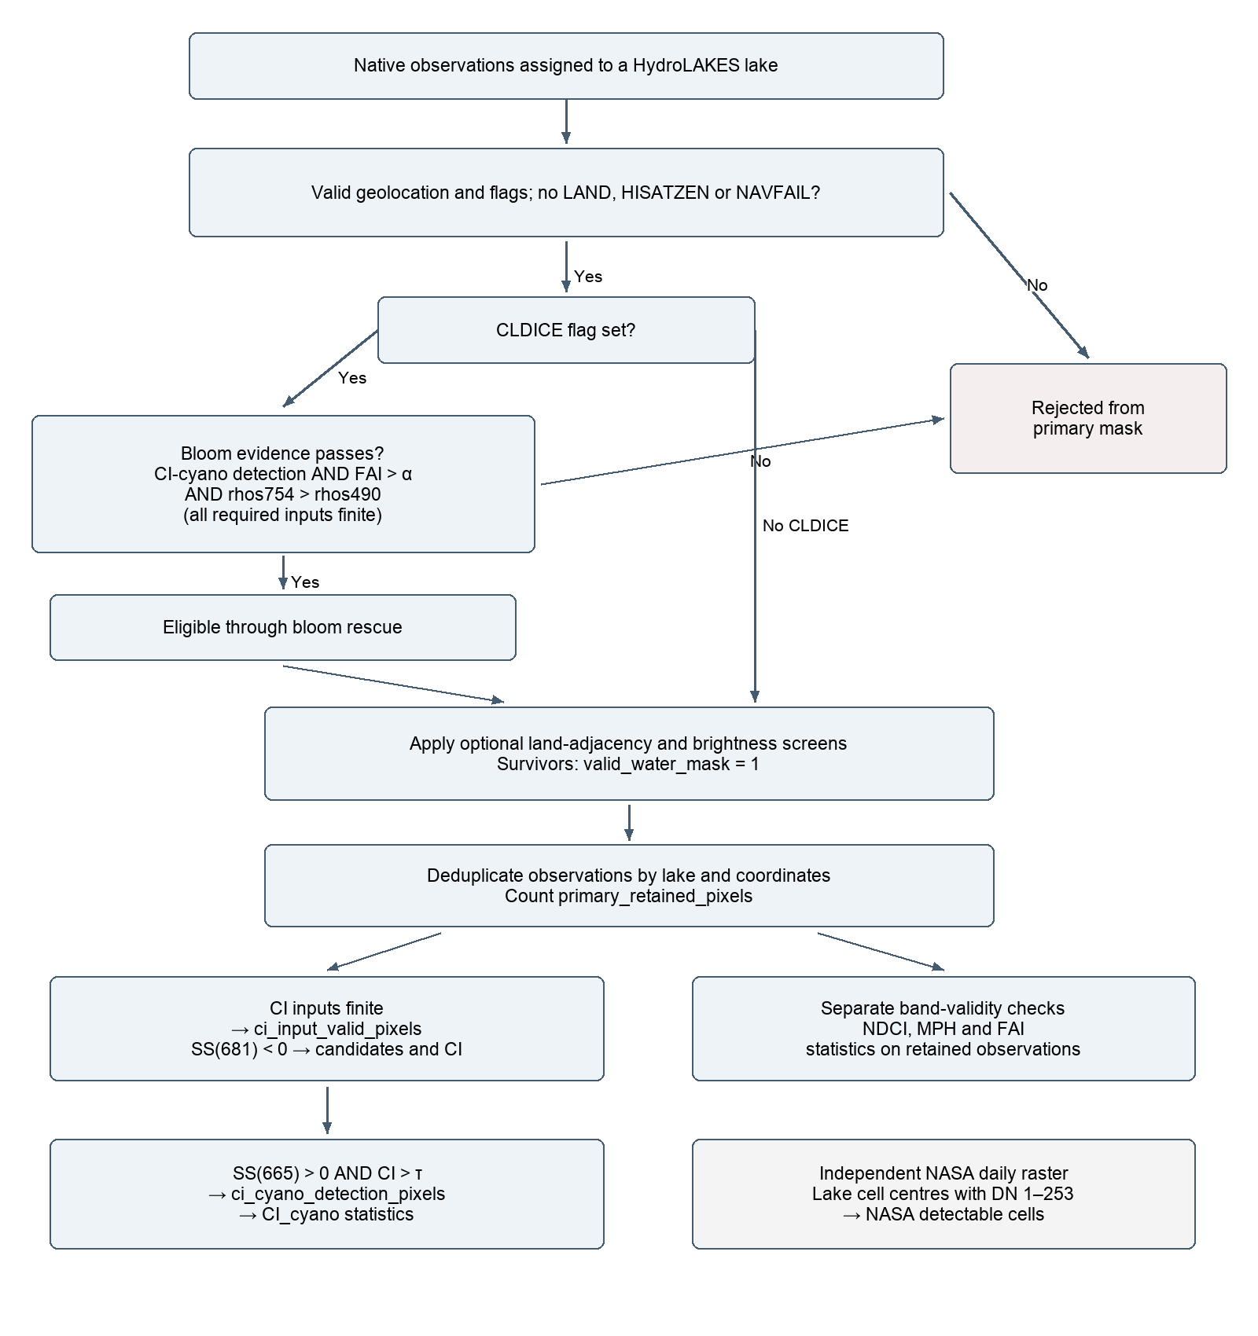
CI candidates and detections also receive their respective count, mean, median, p10, p90 and maximum. NASA raster cells remain a separate population.

