OLCI feature definitions
Sources, calculations and selection conditions
The features below describe how the processing workflow obtains each field. Local pixel features use native OLCI observations assigned to a lake; the NASA field uses a separate mapped product.

Scene and lake attributes
scene_id Copied directly from the Copernicus Data Space catalogue Id field and retained as the source-product identifier. The workflow does not generate a scene identifier.
Ex : 9a74ef88-f14d-43d8-9ce8-b4c792bf555b
scene_name Copied from the catalogue Name field, with a trailing .SEN3 suffix removed. The remaining product name is preserved.
Example:S3B_OL_1_EFR____20260628T153304_20260628T153604_20260629T164336_0179_121_339_2340_ESA_O_NT_004

acquisition_start Copied from the catalogue ContentDate.Start field. It represents the acquisition start time in UTC.
Hylak_id Taken from the HydroLAKES shapefile. A native observation receives this identifier when its geolocation lies strictly inside the corresponding lake polygon.
Lake_name Taken directly from the HydroLAKES Lake_name attribute, matched using Hylak_id. The workflow does not infer or generate lake names.
Lake_area_km2 Taken directly from the HydroLAKES Lake_area attribute, expressed in km² and matched using Hylak_id.
state_name Obtained by intersecting the HydroLAKES pour point with geoBoundaries ADM1 polygons and copying shapeName from a unique match. Unmatched or ambiguous assignments remain blank.
state_id Copied from the geoBoundaries shapeID attribute of the same unique ADM1 polygon used for state_name.
latitude Copied directly from HydroLAKES Pour_lat in decimal degrees. This is the lake pour-point latitude.
longitude Copied directly from HydroLAKES Pour_long in decimal degrees. This is the lake pour-point longitude.

Common counting rules
Native observations are stored only when lake membership, finite latitude/longitude and a valid L2 flag record are available. Before lake summaries are calculated, duplicates sharing Hylak_id and coordinates rounded to six decimal places are removed, keeping the first observation.
A mask is a true/false selection rule; its pixel count is the number of true values. “Finite” means a numerical value that is neither missing nor infinite. Quality flags are read from L2Gen l2_flags using the flag names and bit masks in the file metadata.
LAND denotes land classification; CLDICE denotes cloud or ice; HISATZEN denotes high sensor zenith angle; NAVFAIL denotes navigation failure.

Pixel selection features
The base mask selects stored lake observations that are not flagged LAND.
native_lake_pixels Count of stored observations assigned to the lake after coordinate deduplication. Observations rejected by the primary quality mask remain included in this count i.e
Its geolocation lies inside an analysis lake polygon.
Its latitude and longitude are finite.
Its L2 quality-flag record is available—not missing.
An available flag record can still contain exclusion flags. For example, the record may indicate LAND or CLDICE; the observation can still be stored.
primary_retained_pixels Count of valid_water_mask = 1: non-land observations without HISATZEN or NAVFAIL, with CLDICE absent or successfully rescued, after optional exclusion screens.
primary_retained_pixels = generic_flag_exclusion_sensitivity_pixels + bloom_rescued_pixels
generic_flag_exclusion_sensitivity_pixels Count surviving exclusion of LAND, CLDICE, HISATZEN and NAVFAIL, followed by optional screens. This is a retained-pixel count under blanket cloud exclusion.
bloom_rescued_pixels Count of the saved bloom_rescue_mask. The full condition is given below; if brightness screening is enabled, bright rescued observations are removed from this mask.
CLDICE_pixels Count of stored lake observations with the CLDICE flag set, including observations that may also carry other flags.
cloud_excluded_pixels Count satisfying the non-land base mask AND CLDICE AND NOT bloom rescue. This mask is formed before optional land-adjacency and brightness screening.
cloud_excluded_pixels = CLDICE_pixels - bloom_rescued_pixels
bloom_rescue_fraction_of_CLDICE bloom_rescued_pixels divided by CLDICE_pixels. The result is a fraction, and is missing when CLDICE_pixels is zero.
ci_input_valid_pixels Count of primary-retained observations with finite rhos620, rhos665, rhos681 and rhos709. No CI spectral-shape selection is applied at this stage.
ci_candidate_pixels Count of CI-input-valid observations with SS(681) < 0. These form the population for CI summaries.
ci_cyano_detection_pixels Count of CI candidates also satisfying SS(665) > 0 and CI > Threshold, where Threshold is the configured detection limit which is 0.0. These form the population for CI_cyano summaries.
NASA_CI_Cyano_detectable_cells Count of unique NASA daily CyAN raster cells with centres strictly inside the full lake polygon and encoded DN from 1 through 253, for the UTC acquisition date.

Bloom rescue condition
Rescue requires lake membership, valid geolocation and flags, NOT LAND, CLDICE, NOT HISATZEN, NOT NAVFAIL, CI-cyano spectral detection, finite FAI > 0, and finite rhos754 > finite rhos490. FAI and the spectral tests are calculated before the final retention mask. The positive-FAI cutoff is the current code default.

Additional selection rules
Optional land-adjacency screening excludes neighbours of flagged land; optional brightness screening excludes finite rhos865 above its configured cutoff. Both are disabled by default. The adjacency screen updates the retained masks but not the saved rescue mask.
NASA cells at overlapping grid addresses are counted once. DN 0, 254 and 255 are excluded. The NASA count is missing if a valid whole-lake comparison cannot be completed; it is not replaced by zero.

Reflectance formulas
rhosλ denotes Rayleigh-corrected reflectance at wavelength λ in nm. These equations show the band labels used in the workflow; spectral interpolation uses the wavelengths of the selected L2Gen products. The active NDCI source is also rhos.

CI and CI cyano
$$SS(681) = {rhos}_{681} - [{rhos}_{665} + ({rhos}_{709} - {rhos}_{665}) × (681 - 665)/(709 - 665)]$$
$$SS(665) = {rhos}_{665} - [{rhos}_{620} + ({rhos}_{681} - {rhos}_{620}) × (665 - 620)/(681 - 620)]$$
$$CI = -SS(681)$$
CI is retained only for primary-retained observations with all four CI inputs finite and SS(681) < 0. CI_cyano equals CI where SS(665) > 0 and CI > T; elsewhere CI_cyano is missing. The current code defaults are T = 0 and zero for both spectral-shape cutoffs.

NDCI
$$NDCI = ({rhos}_{709} - {rhos}_{665})/({rhos}_{709} + {rhos}_{665})$$
The normalized difference chlorophyll index requires primary retention, finite inputs at 665 and 709 nm, and |rhos709 + rhos665| > 10⁻⁸.

MPH
$$H(λ) = {rhos}_{λ} - [{rhos}_{665} + ({rhos}_{884} - {rhos}_{665}) × (λ - 665)/(884 - 665)]$$
$$MPH = max[H(681), H(709), H(754)]$$
Maximum peak height uses a common 665–884 nm baseline. It requires primary retention, finite baseline endpoints and at least one finite peak band. The nominal 885 nm band is supplied by L2Gen rhos_884; unavailable peak heights are ignored.

FAI
$$FAI = {rhos}_{754} - [{rhos}_{665} + ({rhos}_{865} - {rhos}_{665}) × (754 - 665)/(865 - 665)]$$
The OLCI-adapted floating-algae index is the 754 nm reflectance height above the 665–865 nm baseline. It requires primary retention and finite inputs at these three bands. It is the adapted FAI/AFAI form implemented here, rather than a SWIR-based FAI.

Eligibility for index summaries
CI summaries use candidates; CI_cyano summaries use detections. NDCI, MPH and FAI summaries use primary-retained observations with a finite value for the respective index. Negative NDCI, MPH and FAI values are retained; the positive-FAI requirement applies to bloom rescue only.

Index summary feature definitions
For each index, eligible finite values receive equal weight. The mean is their sum divided by their count. Median and percentiles follow numerical ordering; percentiles use NumPy’s default linear interpolation. An empty population gives a count of zero and missing summary values.
Feature | Definition
CI_valid_pixels | Number of finite values among CI candidates.
CI_mean | Arithmetic mean of eligible CI values.
CI_median | Median of eligible CI values.
CI_p10 | 10th percentile of eligible CI values.
CI_p90 | 90th percentile of eligible CI values.
CI_max | Largest eligible CI value.
CI_cyano_valid_pixels | Number of finite values among CI-cyano detections.
CI_cyano_mean | Arithmetic mean of eligible CI_cyano values.
CI_cyano_median | Median of eligible CI_cyano values.
CI_cyano_p10 | 10th percentile of eligible CI_cyano values.
CI_cyano_p90 | 90th percentile of eligible CI_cyano values.
CI_cyano_max | Largest eligible CI_cyano value.
NDCI_valid_pixels | Number of finite values among retained observations with finite NDCI.
NDCI_mean | Arithmetic mean of eligible NDCI values.
NDCI_median | Median of eligible NDCI values.
NDCI_p10 | 10th percentile of eligible NDCI values.
NDCI_p90 | 90th percentile of eligible NDCI values.
NDCI_max | Largest eligible NDCI value.
MPH_valid_pixels | Number of finite values among retained observations with finite MPH.
MPH_mean | Arithmetic mean of eligible MPH values.
MPH_median | Median of eligible MPH values.
MPH_p10 | 10th percentile of eligible MPH values.
MPH_p90 | 90th percentile of eligible MPH values.
MPH_max | Largest eligible MPH value.
FAI_valid_pixels | Number of finite values among retained observations with finite FAI.
FAI_mean | Arithmetic mean of eligible FAI values.
FAI_median | Median of eligible FAI values.
FAI_p10 | 10th percentile of eligible FAI values.
FAI_p90 | 90th percentile of eligible FAI values.
FAI_max | Largest eligible FAI value.

Relationships between features

ci_candidate_pixels equals CI_valid_pixels
Both describe the CI-candidate population: the first counts the candidate mask, while the second counts finite CI values selected by that mask.

ci_cyano_detection_pixels equals CI_cyano_valid_pixels
Both describe the detection population: the first counts the detection mask, while the second counts finite CI_cyano values selected by that mask.

primary_retained_pixels and index valid counts
ci_input_valid_pixels may equal primary_retained_pixels when all four CI inputs are finite. NDCI, MPH and FAI valid counts may also equal it, but each has its own band-validity rule.

primary_retained_pixels and rescued pixels
With optional screens disabled, primary_retained_pixels equals generic_flag_exclusion_sensitivity_pixels + bloom_rescued_pixels. The two contributing masks are disjoint because only rescued observations carry CLDICE.

cloud_excluded_pixels and CLDICE_pixels
cloud_excluded_pixels equals CLDICE_pixels − bloom_rescued_pixels only when the counted CLDICE observations satisfy the non-land base mask and subsequent screens have not changed rescue membership.

NASA and local detection counts
NASA_CI_Cyano_detectable_cells counts mapped daily raster cells; ci_cyano_detection_pixels counts selected native observations. The two fields do not represent the same pixel population.

Nested populations
CI-cyano detections are a subset of CI candidates, which are a subset of CI-input-valid observations. These lie within primary-retained observations, which lie within the stored native lake observations.

Optional screen qualification
Land-adjacency screening removes observations from primary retention without changing the saved rescue mask. Brightness screening changes both retention and rescue, but cloud_excluded_mask is not recomputed afterward. Consequently, these optional screens can change the count relationships above.

Feature derivation flowchart
Native masks are evaluated before lake-level aggregation. Deduplication precedes the final counts and index summaries.
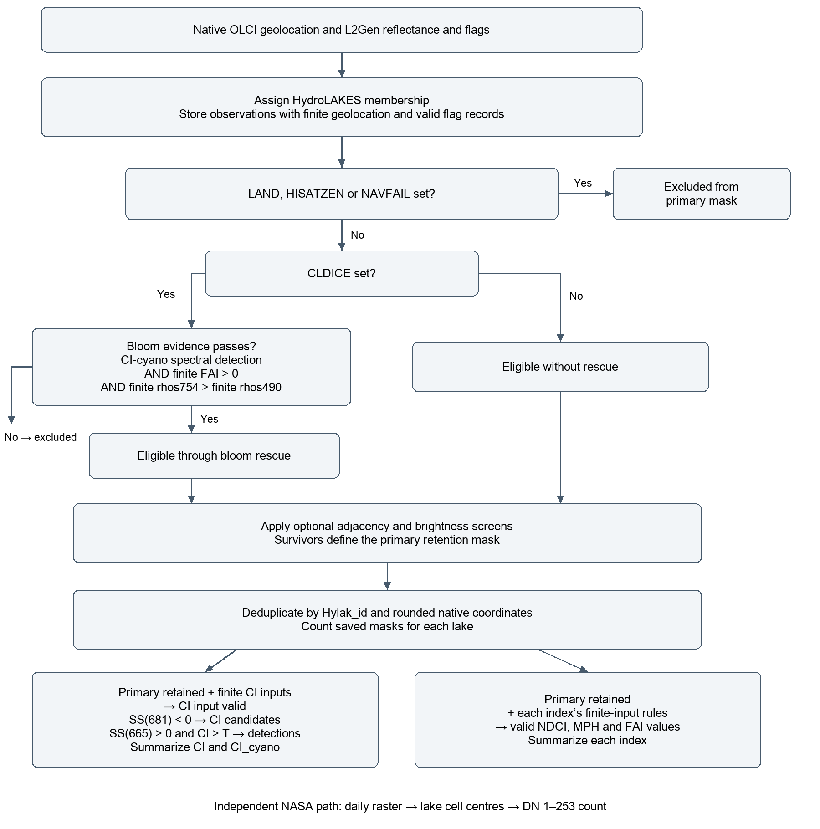
T is the configured CI detection limit. Optional screens and their effects on saved masks are described in the feature relationships.

