*******************************README*******************************
Name: Madhusudhan Sankaran.
This program was developed in the Eclipse Juno IDE in Microsoft Windows 7 Operating System.

There are three java files included. They are:
-Matrices.java
-PossibleStates.java
-QLearning.java
Instructions for compiling the program:
-Compile the source codes using the javac command in the following order:
-javac Matrices.java
-javac PossibleStates.java
-javac QLearning.java
-This should produce the .class files and the program should be ready for execution.
Instructions for running the program:
-To run the program, run the following command:
-java QLearning
-This should run the algorithm and the results should be produced.
How this algorithm was implemented:
In the grid world shown below, the agent can move in the four compass directions starting from S. The goal state is G.

The reward on reaching the goal is 100 and γ=0.9. Q-learning was used to learn the optimal policy. For learning, the sequences were generated randomly.

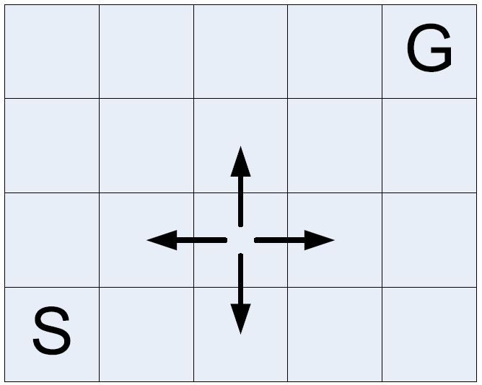

I numbered the 20 states as 0 through 19 as shown below:

15 | 16 | 17 | 18 | 19
10 | 11 | 12 | 13 | 14
5 | 6 | 7 | 8 | 9
0 | 1 | 2 | 3 | 4

The source is 0 and the goal is 19. I first generated the R-Matrix based on the above specifications of the world. Then I used the Q-Learning algorithm as shown below:

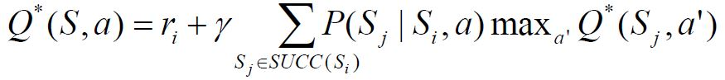

Based on this, I found the optimal path of shortest length and printed it, as well as the final Q-Matrix. In my instance, I got the optimal path of length 7 to be:

0-5-10-15-16-17-18-19

