Integrating RunScope With Teamchat

RunScope Integration:
The Runscope API uses OAuth 2.0 for authentication. OAuth2 is a protocol that lets applications ask for authorization to a Runscope account without getting their password. Access tokens can be limited to specific types of data, and can be revoked by the user at any time.

To use the API, you must first create an Application.

Applications must have a name, website URL, and callback URL. Once you create an application you'll be given a Client ID and a Client Secret to use in the authorization flow.

When you create the application, we automatically authorize your own account for it and generate an access_token for your own use. This makes it easy to start using the API for personal use without building a web flow.

Every new user can be login in RunScope then following details is to be required.
You have to pass this Client ID and Client Secret Id in Authorization.java and RunScope.java file.

Step 1: Authorization

To begin the OAuth flow, redirect a user to the Authorize URL.

Url:
https://www.runscope.com/signin/oauth/authorize

Authorize URL Parameters:
client_id : required The Client ID of your application
redirect_uri : required The Callback URL of your application. After authorizing your application a redirect will be made to this URL with an authorization code.
response_type : requiredThe desired grant type, as per the OAuth 2.0 spec. The only current valid value is response_type=code
scope : A space separated list of scopes. Valid scopes are listed below.
state : An unguessable random string. This state will be sent back to your application's Callback URL. It should be used to protect against cross-site request forgery attacks on your application.

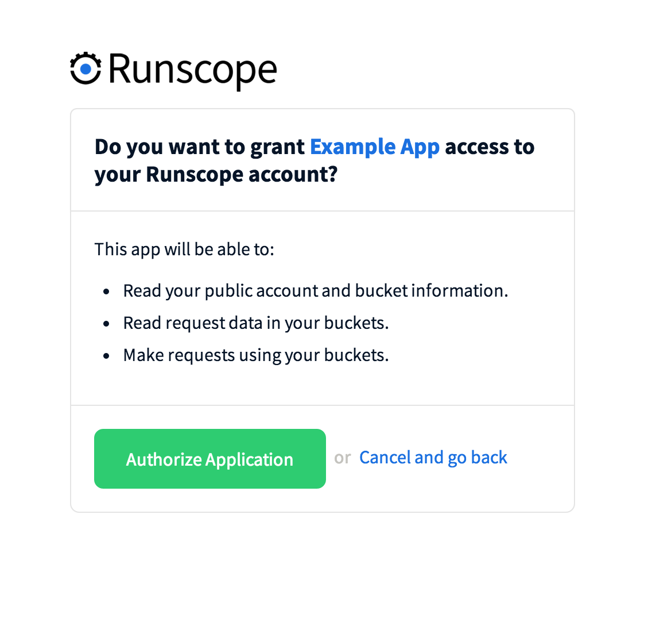
Step 2: Request Callback URL

Once the app has been authorized, Runscope will redirect the user back to your Callback URL with an authorizaton code included in a code URL parameter. If the user declines to authorize your app, a redirect to your Callback URL will be issued with a error=access_denied URL parameter.

Sample Callback URL Request (Authorization Granted)

Url:
https://example.com/oauth_callback?code=38a6c89f-7c15-4c95-ab48-8b733849958b

Authorization Codes are only valid for a short time, you must exhange the code for an access token with 60 seconds or you will have to send the user through the authorization flow again.

Step 3: Exchange Code for Access Token

You may now use this code to retrieve an Access Token from the Access Token URL.

Url:
https://www.runscope.com/signin/oauth/access_token

Parameters

client_id : required The Client ID of the application.
client_secret : required The Client Secret of the application.
code: required The code you received in your Callback URL.
grant_type : required The only valid value is authorization_code.
redirect_uri : The Callback URL specified for this application.
Respons :We will return a response with an access_token. This access token may be stored and used until the user revokes access to your application.

Step 4: API Test Result

Creating a Shareable API Test Result
You can share any test result URL by viewing a test result and changing the Private/Shareable toggle to Shareable. Once the test result has been set to Shareable, you can copy the URL and send it to people outside of your team, as well as people not signed in to Runscope. The test result is able to be viewed in detail, but the test is not editable or capable of being re-run by people outside of your team.

How to share a Runscope test result URL

Note: The shareable test result URL is virtually impossible to guess. However, because it can be shared with people outside of your team and your bucket key is a part of the URL, be sure to only share it with people you trust.

Unsharing an API Test Result
An API test result can be made private at any time by signing in to your team, going to the shared test result URL, and changing the toggle from Shareable to Private. Team members will still be able to view and share the test result URL, but it will not be available to anyone else. You can only change the Private/Shareable status of test results that are owned by your team.

API Test Result Retention
Currently, only the last 100 Passed tests and 100 Failed tests are retained in history. Because of this, test results older than the latest 100 Passed or Failed will not show the full test step Request/Response/Connection details.

Step 5: API Monitoring & Testing: Test Steps

HTTP Request Steps:
Click Add Request to add an empty request template to the end of your test. Replace the placeholder data with the method, URL, headers and parameters your test needs to call.

Adding tests manually can be tedious and lead to inconsistencies between the actual requests made from your app and those made from your tests. For this reason, we recommend capturing requests with Runscope URLs and using those as the basis for your tests.

Pause Steps:
Pauses are a type of test step that allow you to introduce short delays between steps in the test plan. You can add as many pauses as you need, but tests require at least one request to execute. If your test is on a schedule, take care that the total amount of execution time is less than your test's schedule interval.

On Keyword : help

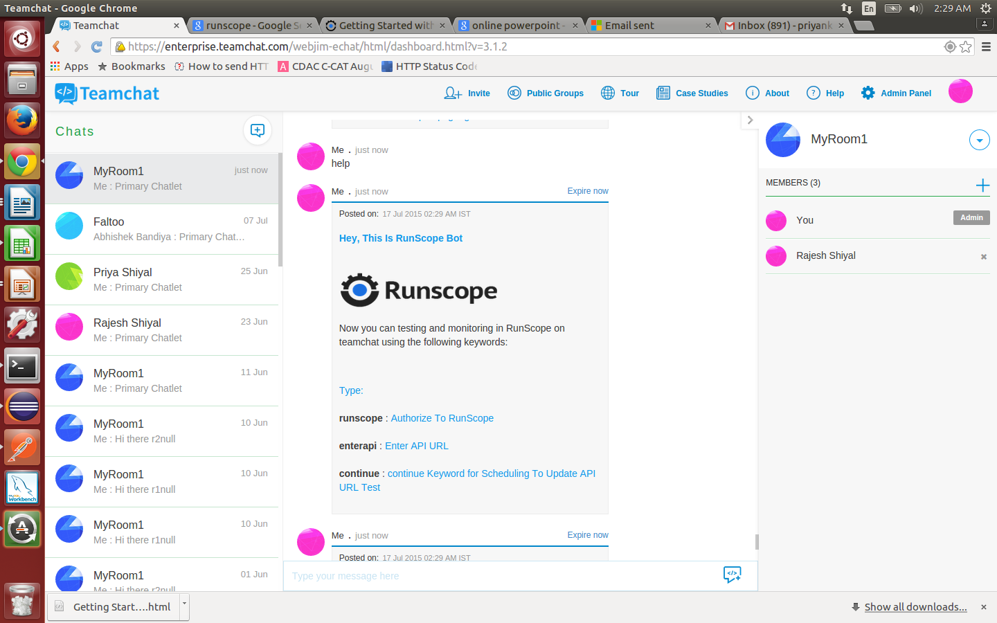

On Keyword: runscope

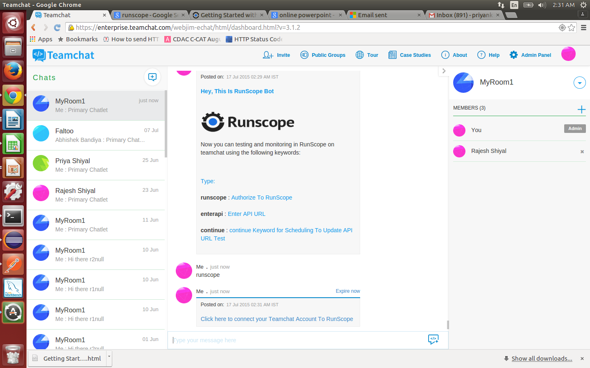

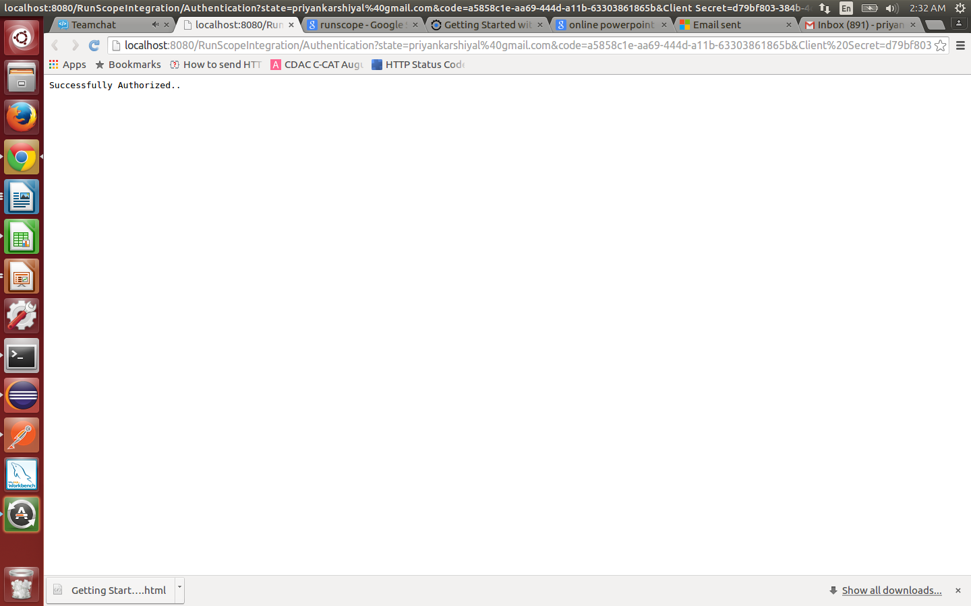

On Keyword: enterapi

