Step 1: Log in to https://console.developers.google.com and click on Credentials

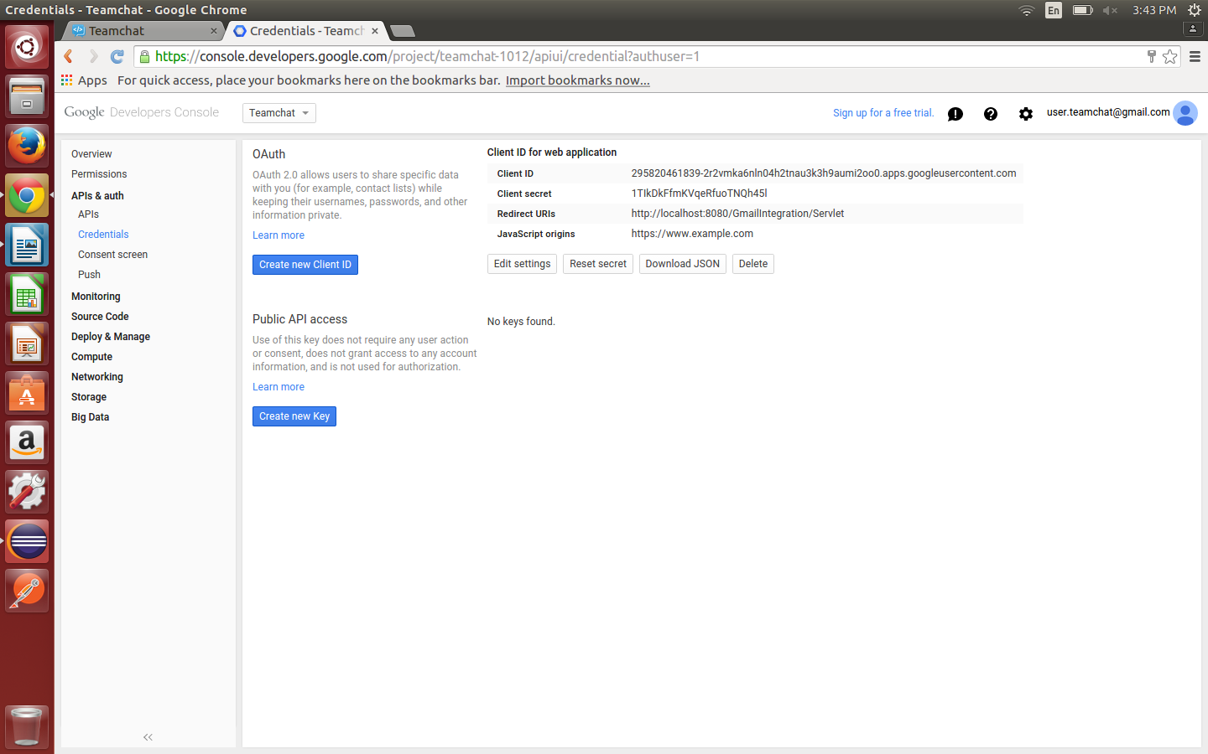
Step 2: Click on Create new Client Id->Web Application->Create Client ID

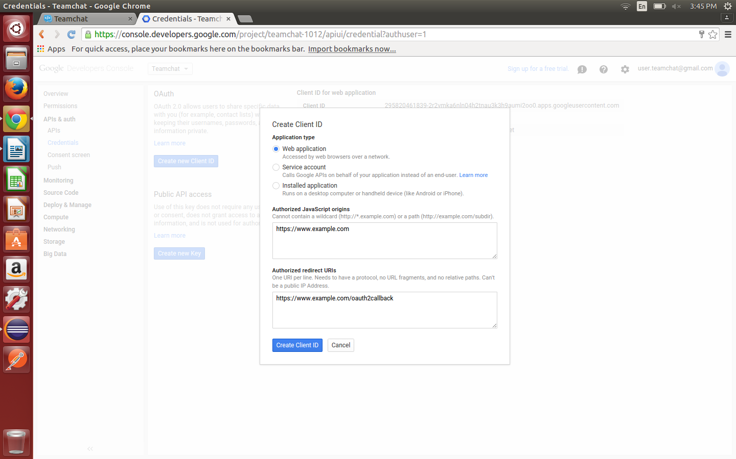

Step 3: The client id, client secret and redirect uri are used in the code as public static variables. If you have to change the developer's account change the client id & client secret varibles in GmailBot .java.

Step 4: If moving on to a new server, change the redirct uri in the google credentials settings and also in GmailBot.java

