HIPCHAT IMPLEMENTATION

Steps to implement hipchat are-

A.)How to use from teamchat-

1.)There is no oAuth or any authentication in hipchat.So what you need to do is get access token of your account from your hipchat and paste in teamchat to get authenticated.

2.)Type help in teamchat and then type start.

3.)Enter your hipchat email address of your hipchat account.

4.)Type hipchat.If your email address of your hipchat account has already been logged on before then it wil not ask for tokens orelse a chatlet will ask for 2 tokens.
One for accessing information and the other for getting notified from hipchat on teamchat.

5.)Go to Admin panel of your hipchat account and click on API .It will ask for your password.Then under create new token select Type as admin and create a new token.Paste that token in teamchat as your access token.

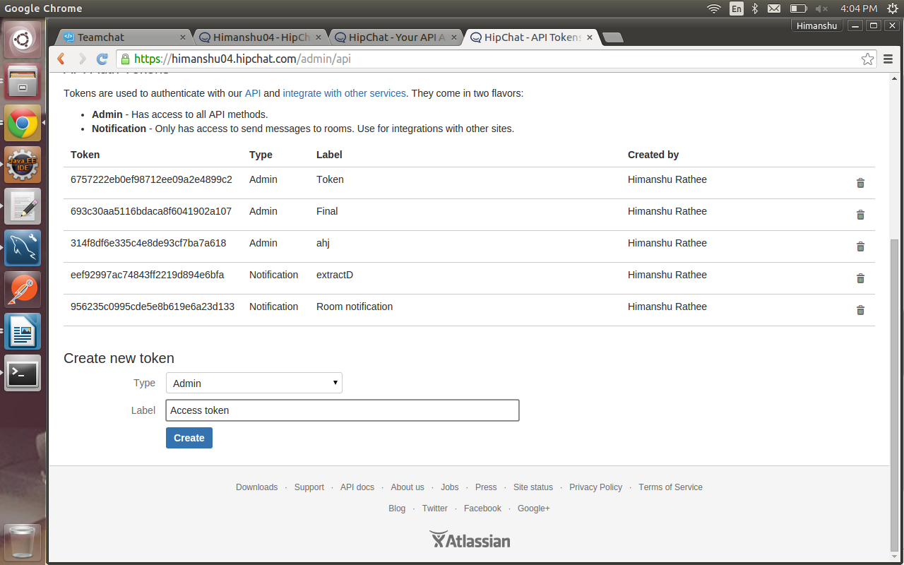

6.)Also go to account settings.Click on API access.It will ask for your password.Then under create new token select all the scopes and generate a new token.Paste that token in teamchat as your notification token.

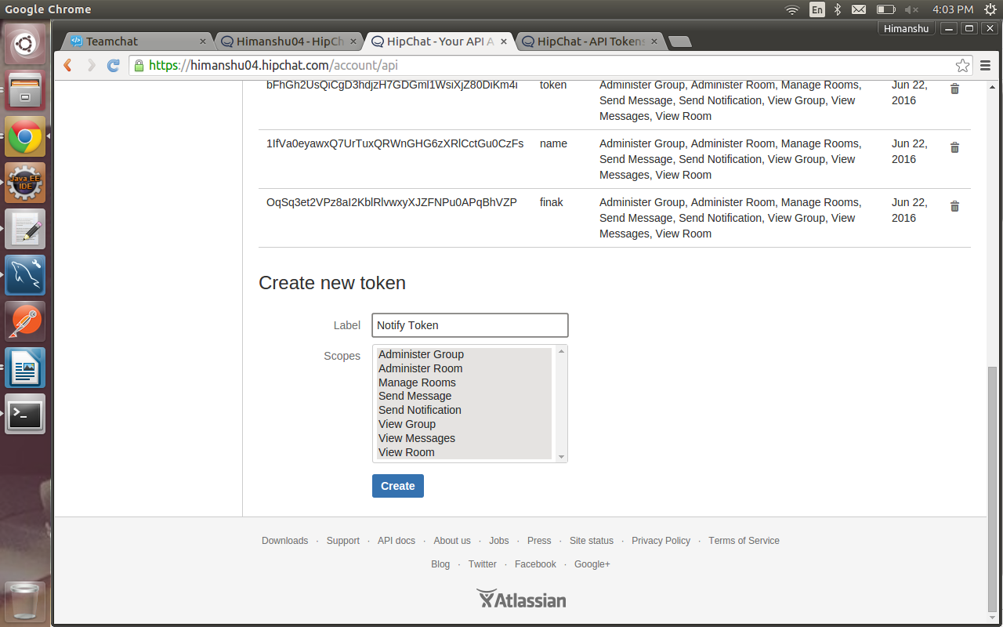

7.)Once you paste your tokens ,you are now authorized to access your hipchat account from teamchat and you'll get notifications as well.

8.)The next time you want to access your hipchat account you'll not have to fetch the tokens unless you have typed logout in teamchat.

9.)Also if you type logout and it again asks for tokens.Then the same tokens generated in Steps-5,6 can be used any number of times.

B.)Change to be made in code

1.)There a config.properties file in package-com.integration.You can change your sql_dbname,sql_username,sql_password,dbtablename and redirect_url in this file and the code will work fine.

2.)Redirect_url will be the url of the server on which you are running the code,as a webhook needs to be registered for getting back notifications from hipchat.

