Integrating Glassdoor with Teamchat

Step-1: Access and API key
The Glassdoor API is not open to the public. API key and the partner ID used in the project:

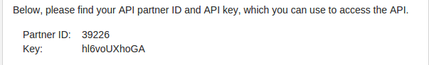

This API key and partner ID is required for all endpoints. This given API key has been hardcoded into the project.

Note:- In this project API key and this partner ID of my account is used and is in working condition so you dont have to change it in the project unless you want to do the integration with a API key of your account.

If incase this API key is not working or you want to use your new account's API key , then you have to perform certain steps:

- Go to this link : http://www.glassdoor.com/api/register_input.htm and submit a request for the API key and the partner ID
- Within a week your email ID (through which you have submitted the request) will receive partner ID and the API key
- Then you just have to change the partner ID and API key inside the the project.
- You just have to make changes in the “glassdoorintegrator.java” file given in the package “com.teamchat.integration.glassdoor.bot”
- Open the “glassdoorintegrator.java” file then
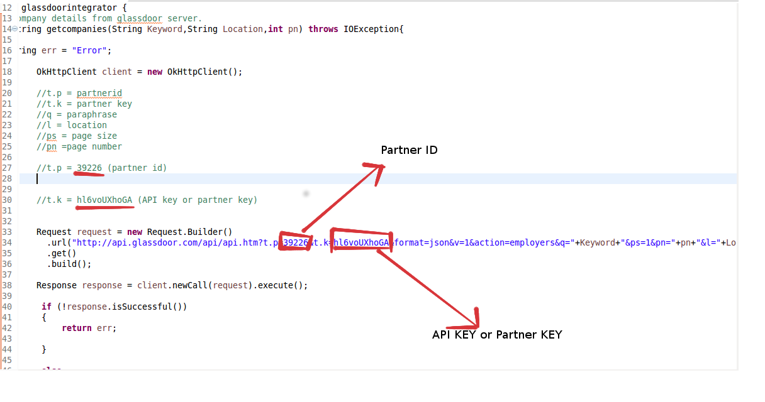
replace the API key and partner ID present inside the red boxes with your new API key and partner ID and you are ready to go.
Step-2: USING API-KEY AND PARTNER-ID TO CALL FUNCTIONS

Providing Parameters: GET requests should provide their parameters as a query string, part of the URL. API key and partner ID should also be provided with other parameters as a part of the URL.

JSON Responses: All responses are sent JSON-encoded.

METHOD: GET COMPANY SEARCH:
A company search request must specify "employers" for the action parameter in addition to the other required parameters.
URL: http://api.glassdoor.com/api/api.htm
Method : GET

Parameters : paramName=“t.p”, value=”partner ID”
paramName=“t.k”, value=”API key”
paramName=“q”, value=”search query or paraphrase”
paramName=“l”, value=”location”
paramName=“ps”, value=”page size”
paramName=“pn”, value=”page number”

Output:
{
"success": true,
"status": "OK",
"response": {
"currentPageNumber": 1,
"totalNumberOfPages": 151,
"totalRecordCount": 1510,
"employers": [
{
"id": 354,
"name": "IBM",
"website": "www.ibm.com",
"isEEP": false,
"exactMatch": false,
"industry": "",
"numberOfRatings": 0,
"squareLogo": "http://media.glassdoor.com/sqll/354/ibm-squarelogo.png",
"overallRating": 0,
"ratingDescription": "Not Applicable",
"cultureAndValuesRating": "3.6",
"seniorLeadershipRating": "2.9",
"compensationAndBenefitsRating": "2.6",
"careerOpportunitiesRating": "2.9",
"workLifeBalanceRating": "3.5",
"featuredReview": {
"id": 3855871,
"currentJob": false,
"reviewDateTime": "2014-03-12 04:56:58.41",
"jobTitle": "Employee",
"location": "",
"headline": "an extremly good compagny with very high benefits and perfectly committed to its employees with a great compagny culture",
"pros": "an extremly good compagny with very high benefits and perfectly committed to its employees with a great compagny culture",
"cons": "opportunities to travel to conference have been reduced"
},
"ceo": {
"name": "Virginia Rometty",
"title": "CEO",
"image": {
"src": "http://media.glassdoor.com/people/ceo/354/ibm-virginia-rometty.png",
"height": 50,
"width": 40
},
"numberOfRatings": 0,
"pctApprove": 0,
"pctDisapprove": 0
}
}
]
}
}

Code:
The following code gives a JSON Output which contains information about Searched keyword.

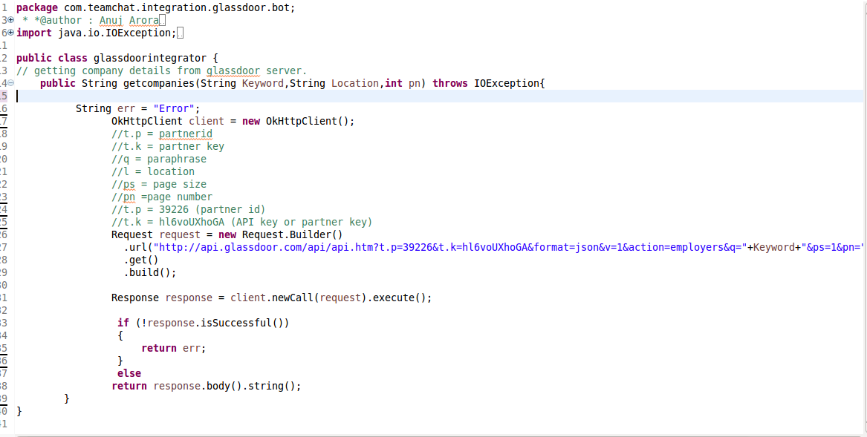
Step-3: Exporting the WAR file
Step-4: Deploying the WAR file
Step-5: Ready to use
Step-6: Follow the commands given below to use Glassdoor:

Commands | Work
help | It will tell user about the commands he/she should know before using glassdoor
search | Type this command to search any company
next | Type this command to check the next result page for your searched keyword

Note:-
- Getters and Setters classes are used for extracting the data from json object. These classes are in the package “com.teamchat.integration.glassdoor.classes”.
- Ceo
- Glassdoormain (main class for calling functions of other classes)
- Employer
- FeaturedReview
- Image
- LashedLocation
- Response

2. Libraries used:-
- gson 2.3.1 (for parsing json object)
- okhttp 2.4.0 (for authentication)
- okio 1.4.0 (prerequisite for okhttp)
- Teamchat Client SDK 1.5

3. What changes should be done before running this project on any server?
- Changes should be made in “web.xml” file , i.e your bot-email, bot-password, db-host, db-name, db-user and db-password as per your requirement
- No database or table used during the integration
- You only need to deploy the project's WAR file on the server

