Step 1: Create a desk account and login to desk.

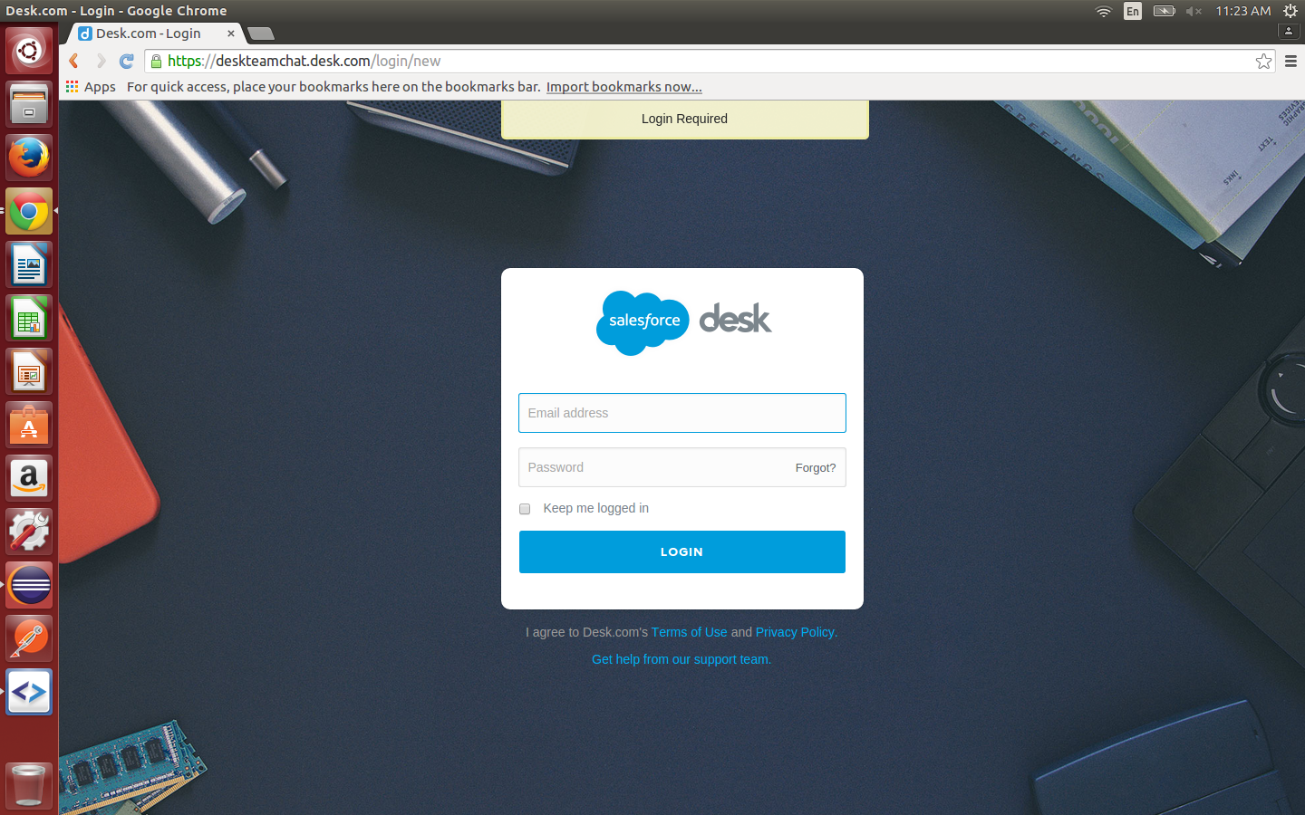
Step 2: Switch from the Classic agent view to admin view.

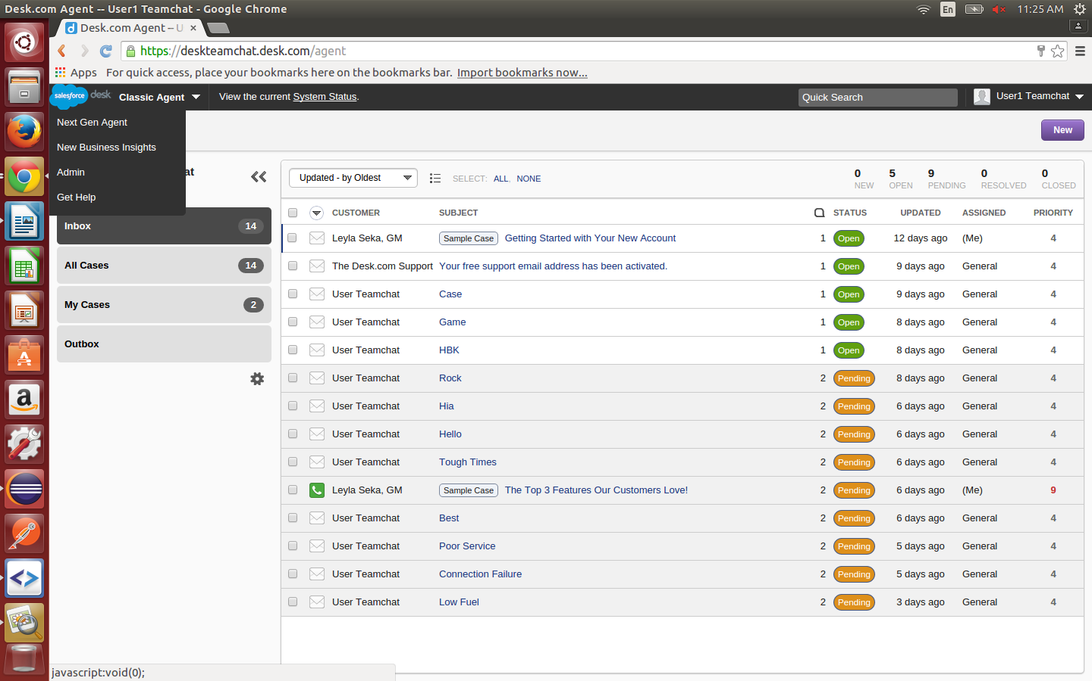

Step 3: Click on Apps tab and install the webhook (known as custom action).

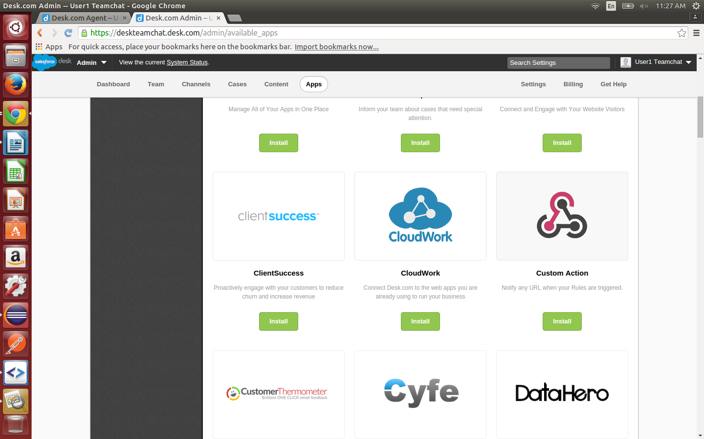
Step 4: Once Custom Action has been installed, click on Add Action. This is where you enter the webhook URL for your desk account.

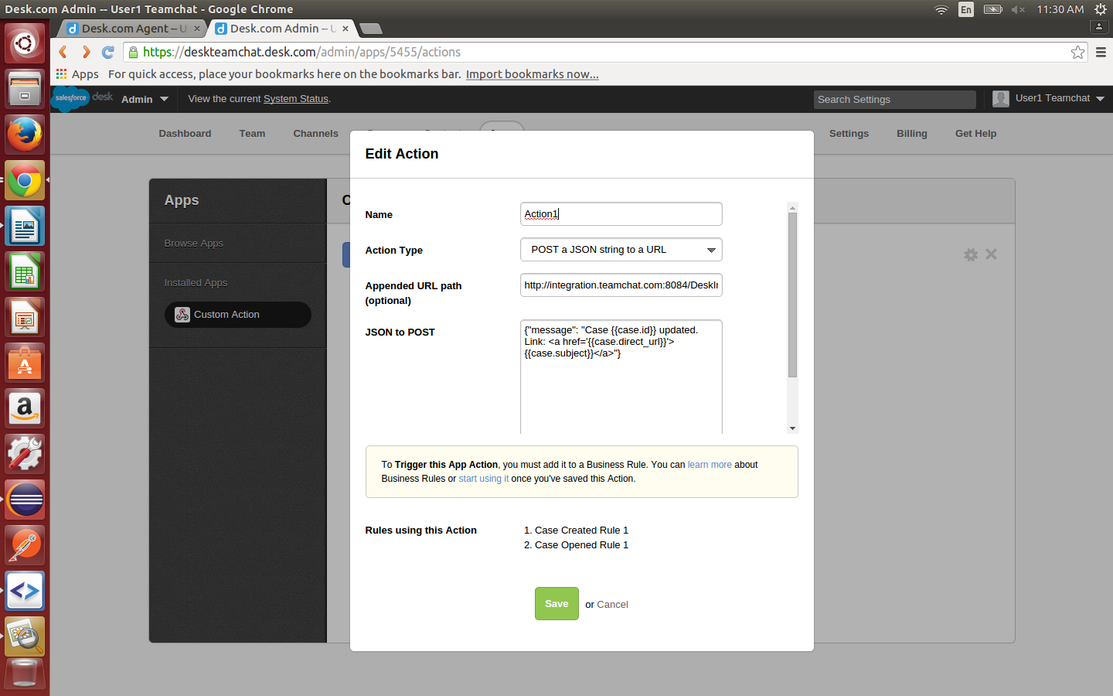

Step 5: On the admin page, click on Cases tab. Click on Rules. Create a rule for case created (& case updated, if required). In rule actions, select “trigger an app action” and select the custom action you just created.

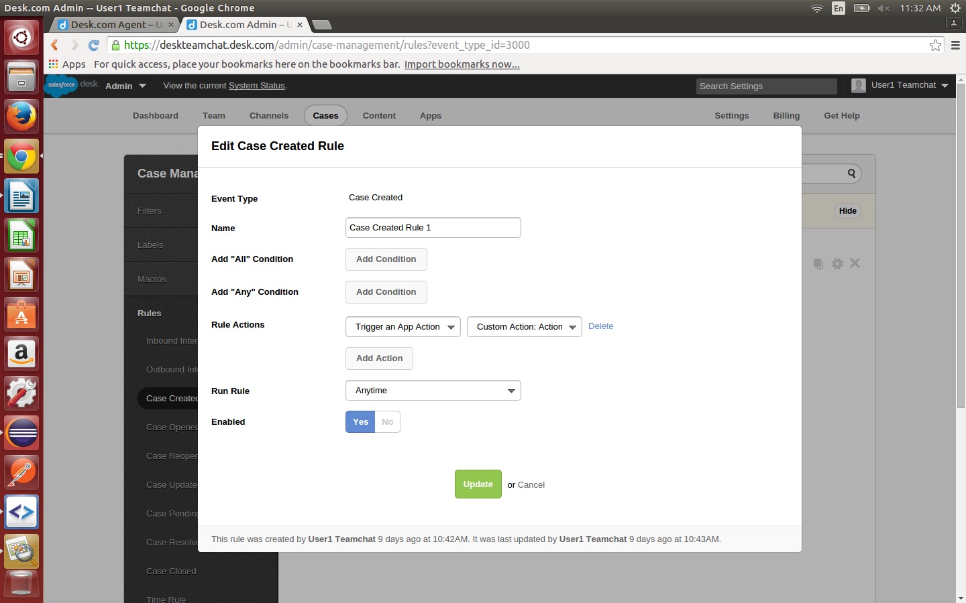
Step 6: You are good to go now. If you move the bot to any other server, you will have to edit the webhook url that the bot asks the user to enter as his webhook url. No other client id or client Secret is required.

