Step 1: Go to https://apps.twitter.com/ and create a new app

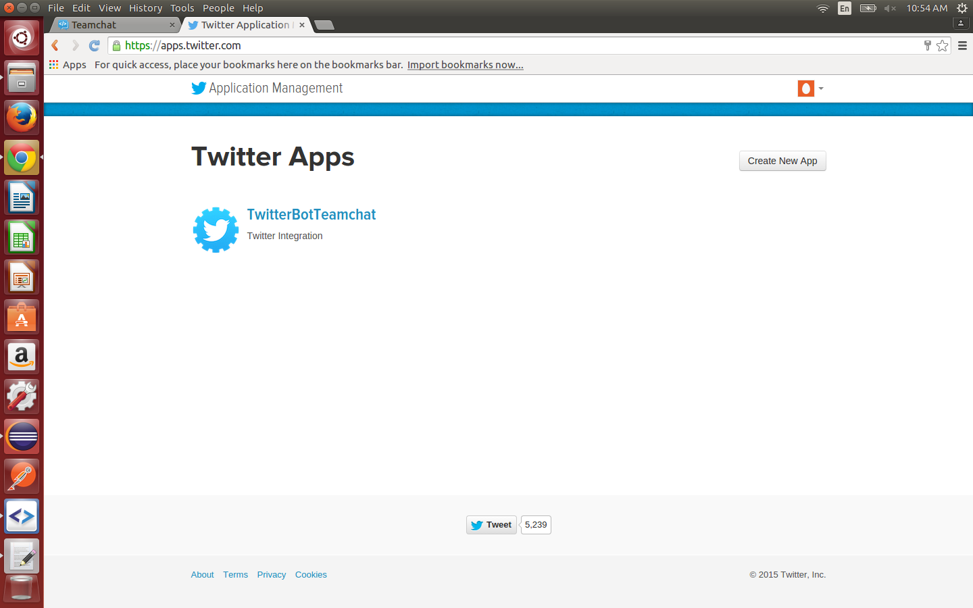
Step 2: Obtain the API keys

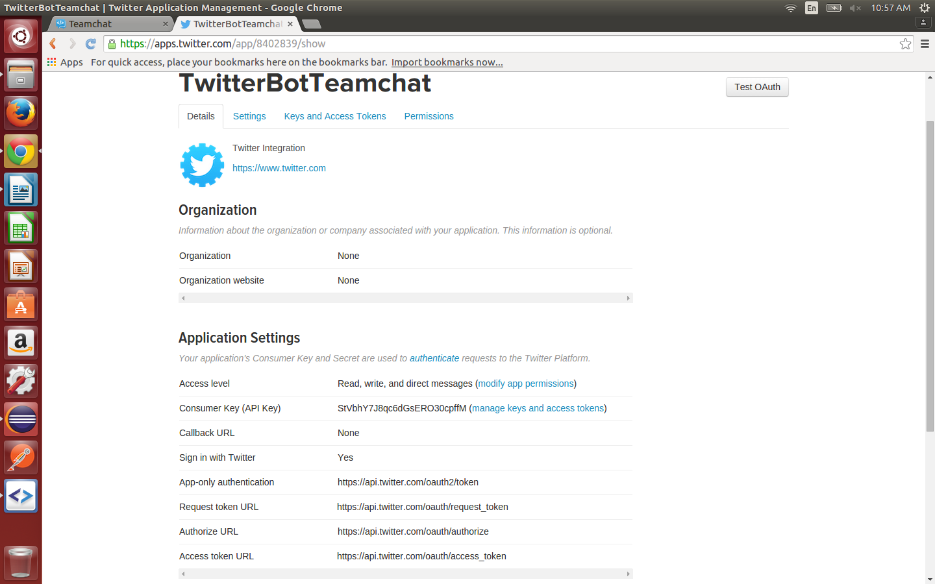
Step 3: The consumer key and consumer secret are used in the code as static variables

Step 4: No other changes required

