IMPLEMENTATION

STEP1: Retrieve and Use OAuth 2.0 Credentials
To find project's client ID and client secret, do the following:

1. Go to the Google Developers Console.
2. Select a project, or create a new one.
3. In the sidebar on the left, expand APIs & auth.
Next, click APIs. Select the Enabled APIs link in the API section to see a
list of all your enabled APIs.
4. Make sure that the Drive API is on the list of enabled APIs.If you have not
enabled it, select the API from the list of APIs, then
select the Enable API button for the API.
5. In the sidebar on the left, select Credentials.If you haven't done so already, create your project's OAuth 2.0 credentials by clicking Create new Client ID,
and providing the information needed to create the credentials.
6. Look for the Client ID and Client secret in the table associated with each of your credentials.

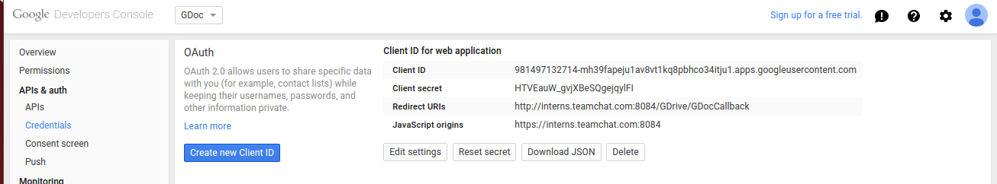
A property file name gdrive.properties is created in the src where the credentals are set. Any changes that need to be done in relate to client_id, client_secret, database name and password etc, all such changes has to be done in the property file. Nothing is hardcoded in the code.

STEP2: Use OAuth 2.0 credentials
Once OAuth 2.0 credentials have been retrieved as documented, they can be used to authorize a Drive service object and send requests to the API.

Created a class named “GDocBotServlet” to fetch the Authorization URL.

After user authorizes, it'll be re-directed to callback url which should be same as you specified in credential.

From the call back URL authorization_code is extracted and forwarded to Class named
“GDocConnect” where method to get access_token is written.

STEP3: Instantiate a service object
static Drive buildService(GoogleCredential credentials)
{
HttpTransport httpTransport = new NetHttpTransport();
JacksonFactory jsonFactory = new JacksonFactory();
return new Drive.Builder(httpTransport, jsonFactory, credentials).build();
}
STEP4: Create Database
Create a table called GDriveTable with fields email, access_token and expire_in with email as primary key. Users credentials will be save in the table and is further used to retrive files in the drive.

STEP5: Function getFiles() gets the list of files in the drive.

STEP6: Function downloadFile() downloads the file present in the file list.

