OneNote IMPLEMENTATION:-

STEPS ARE-

TO AUTHENTICATE A USER TO HIS ONENOTE ACCOUNT

A.)You need to have a client id and specify a redirect url.Steps to get a client id by creating an app are given below:-

Step1.) Go to URL-https://msdn.microsoft.com/en-us/library/hh826541.aspx#livesite

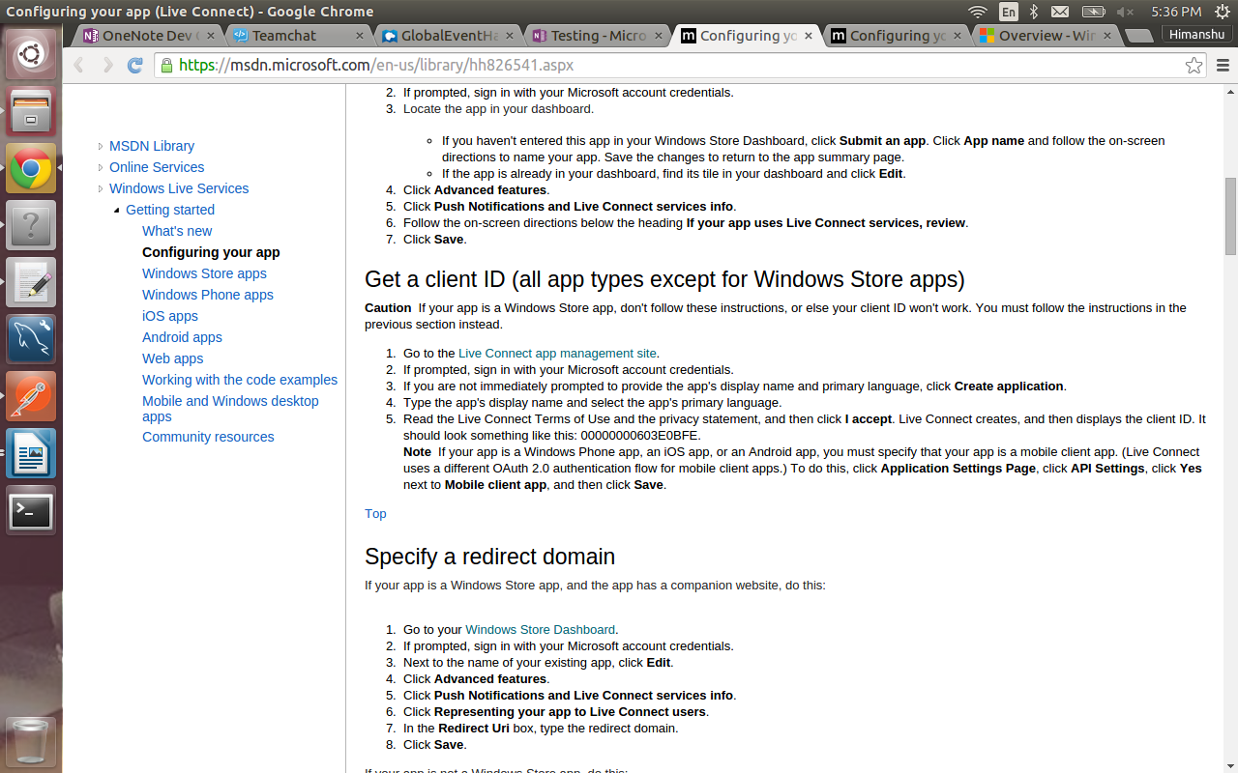

Step2.)Under get a client id(for all types except for windows Store apps) ,Go to Live Connect app management site.

Step3.)You will be redirected to app creation page.OR you can start from here and directly create an app from this url.-https://account.live.com/developers/applications/index
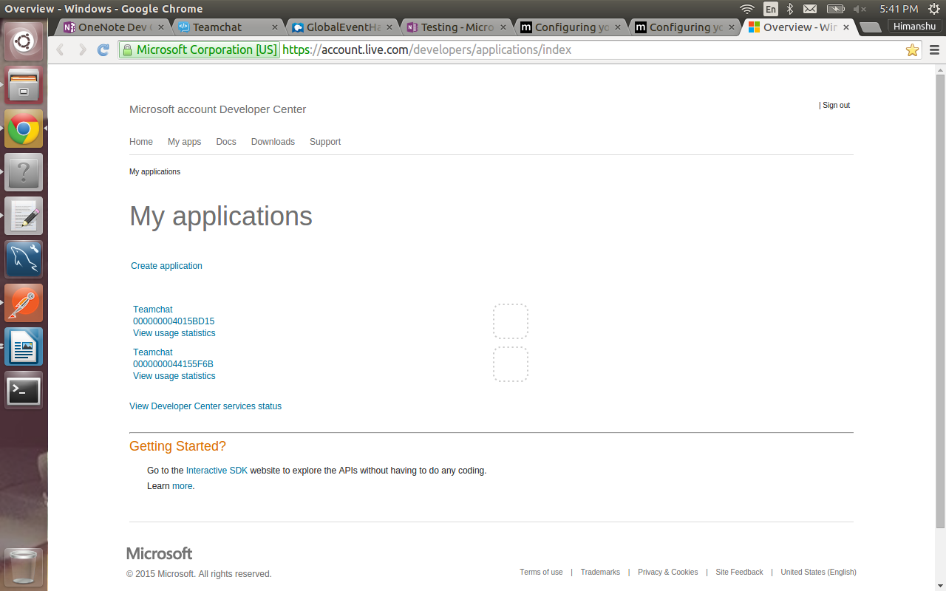

Step4.)Create a new application.It will ask for application name,redirect url,etc.Fill all the details.

Step5.)You will now recieve a client id and client secret.

B.)There are many ways to authenticate the user for his onenote account.I have used in which we recieve a access token and it requires only a client id to authenticate.

CHANGES TO BE MADE IN CODE

A.)A onenote-config.properties file is present in the src directory in the package com.integration.teamchat.main.onenote

B.)Change the client id and redirect url in the onenote-config.properties file.

C.)Change the bot-email and bot-password in the web.xml file which is present in lib folder of WEB-INF.

D.)The configuration page on which the user will be redirected once he is authenticated is present in WEB-INF.If by any chance it happens that you change the servlet.Go to success.html file.In that file find the windows.onload function and change the servlet name in var x.

