Integrating Mailchimp with Teamchat

Step 1: In order to intergrate Mailchimp in Teamchat you need to create a developer account and
after creating account you need to integrate your APP.

1.1 First click your Mailchimp Account name ...

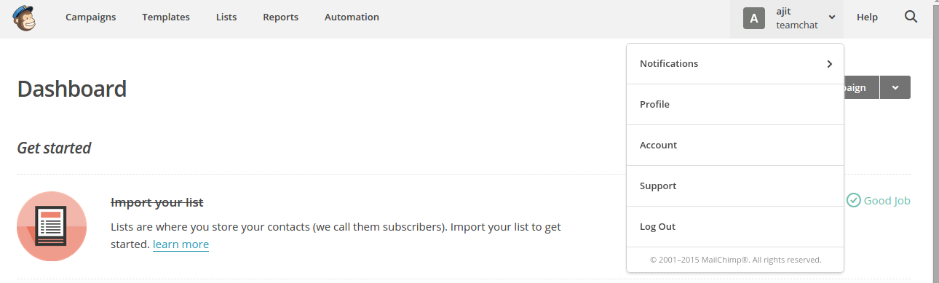
1.2Select the Account

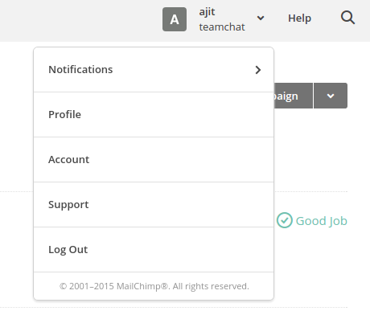

1.3 Click on Extras and Select Registered App

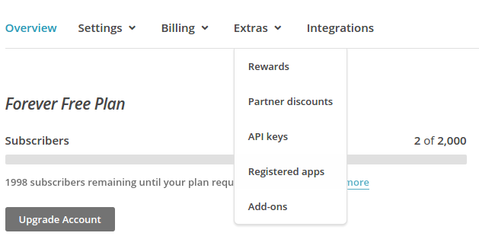

1.4Click On Register An App and fill the details .

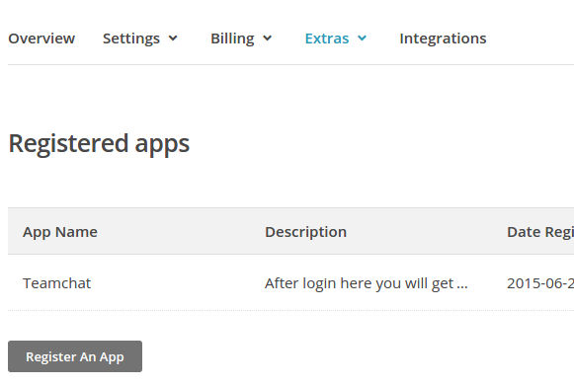

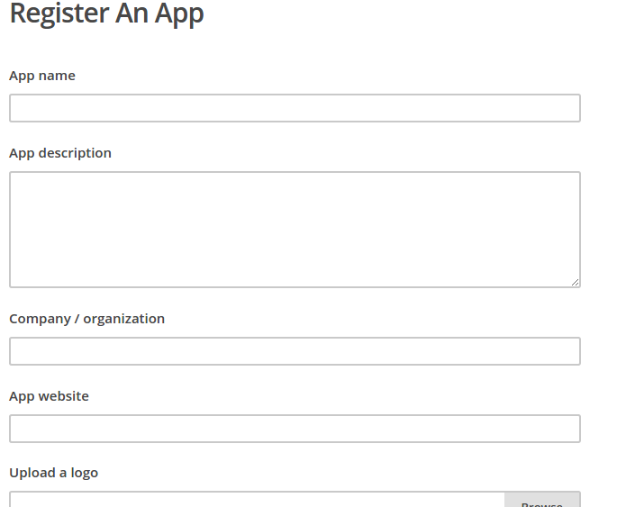

Here you will get client id and client secret.

Step2: For Oauth2 See The documentation at this link

https://apidocs.mailchimp.com/oauth2/

or

http://kb.mailchimp.com/api/article/about-oauth2

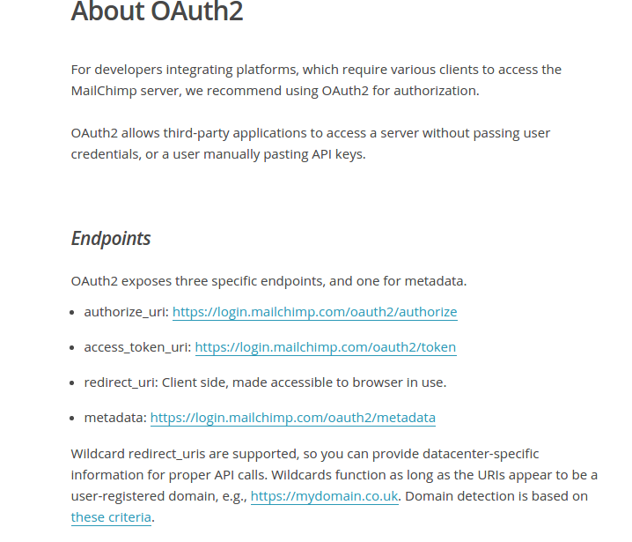

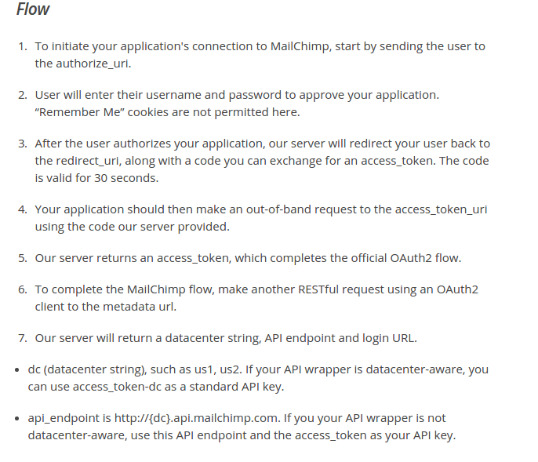

Step 3: keywords

3.1 login
on login keyword we need to pass cilent_id and redierct_url in this link

authorize_uri = https://login.mailchimp.com/oauth2/authorize?response_type=code&client_id=your clientidredirect_uri=your redirect servlet

The user will be prompted to enter their username and password to approve your app. Remember Me cookies are not in use here.

- there is nothing to show here. This is the MailChimp login page. We will be redirecting back to your redirect_uri as a GET with the "code" parameter

3.1.2 Access Token

Your application must make an out-of-band request to the access_token_uri using the "code" returned

- This is a POST request
- as you can see, grant_type, client_id, client_secret, code, and redirect_uri

access_token_uri: https://login.mailchimp.com/oauth2/token

Content-Type: application/json

{"access_token":"5c6ccc561059aa386da9d112215bae55","expires_in":0,"scope":null}

3.1.3 Metadata Url

Now you need to make a RESTful request using an OAuth2 client to the metadata url.

- Since no parameters are required, this is essentially an empty GET request
- The Authorization header is the magic here - that's your access_token
- Again, json encoded response

https://login.mailchimp.com/oauth2/metadata

Authorization: OAuth 5c6ccc561059aa386da9d112215bae55

Content-Type: application/json

{"dc":"us1","login_url":"https:\/\/login.mailchimp.com","api_endpoint":"https:\/\/us1.api.mailchimp.com"}

see the documentation https://apidocs.mailchimp.com/api/2.0/
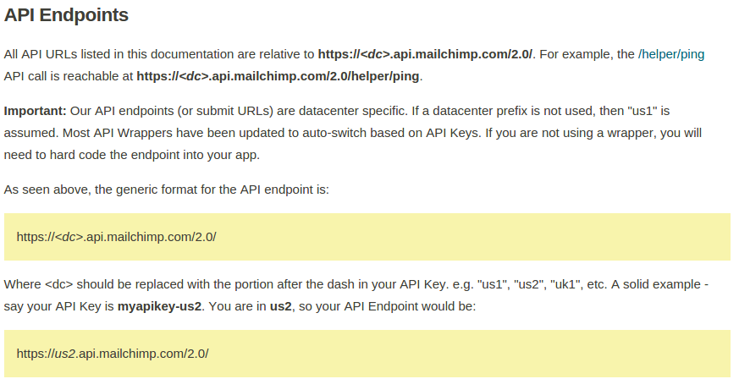

3.2 list

for geting list report you need to pass tha datacenter and accesstoken as
apikey....

https://yourdacenter.api.mailchimp.com/2.0/lists/list/?apikey= youraccesstoken"

In the code ( us) is your datacenter and (at) is your aceestoken

the response you will get in json format:

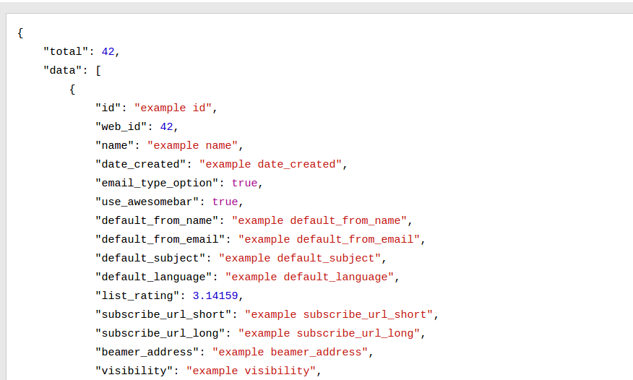

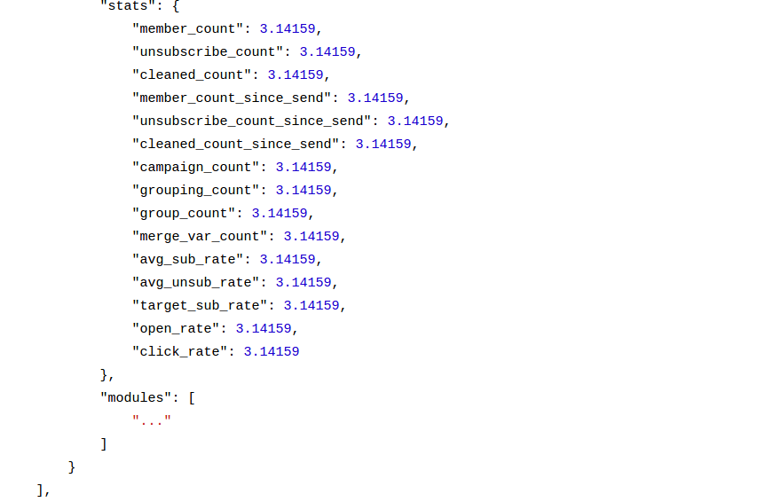

3.3 campaign

for geting campaign report you need to pass tha datacenter and accesstoken as
apikey....

https://Yourdatacenter.api.mailchimp.com/2.0/campaigns/list/?apikey=youraccesstoken

In the code ( us) is your datacenter and (at) is your aceestoken

Response in json format

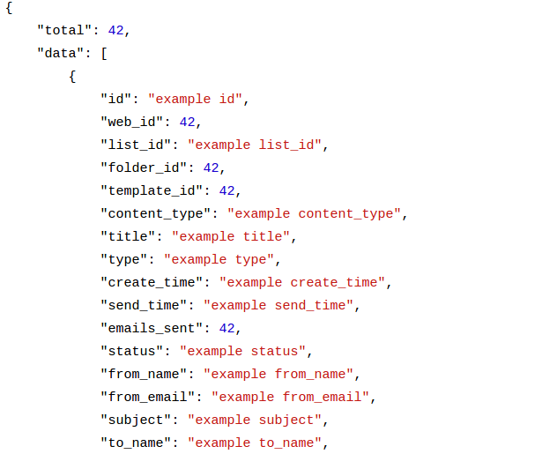

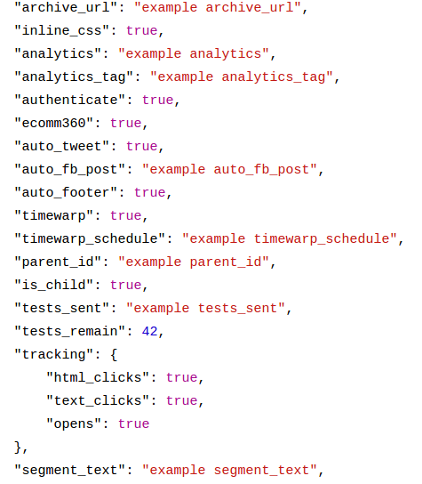

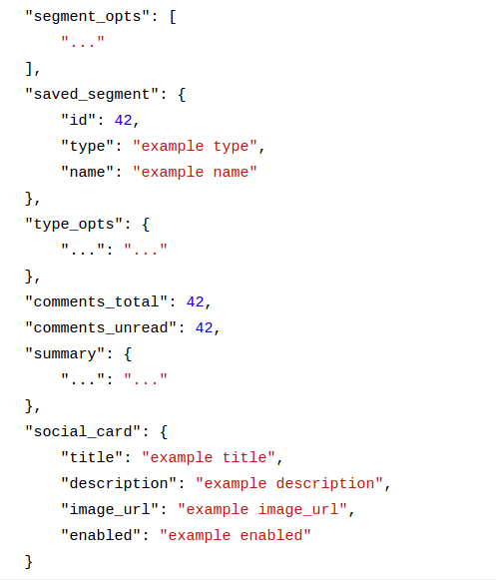

for geting specifics campaign reports you need to pass campaign id also in this
url

"https://yourdatacenter.api.mailchimp.com/1.3/?method=campaignStats&apikey=Youraccesstoken &cid=campaignid

3.4 notify
here we need to do the webhook ,intial the user select the list,

- that list is added in user webhook list.
- For adding list in webhook you need to pass listid and accesstoken and valid servlet url or webhook url.

"https://Yourdatacenter.api.mailchimp.com/2.0/lists/webhook-add/?apikey=youraccesstoken&id=yourlistid&url=webhook_url

Response in json format
here you will get webhook id for that list.

