Step 1: Log in to https://bugsnag.com/user/sign_in

Step 2: Under Installing the Java detection library click on jar
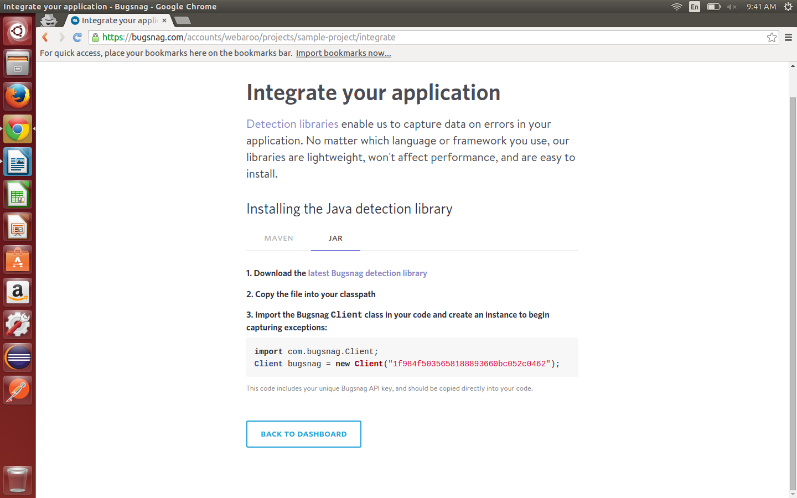
Step 3: Download the busgnag jar file and include it in your lib folder.

Step 4: Include import com.bugsnag.Client;
Client bugsnag = new Client("your-api-key-goes-here");
in your program code or simply replace the Client ID with your Client ID

Step 5: Bugsnag for Java depends only on the org.json library, download it from http://repo1.maven.org/maven2/org/json/json/20090211/json-20090211.jar

Step 6: If you would like to send non-fatal exceptions to Bugsnag, you can pass any Throwableobject to the notify method:
bugsnag.notify(new RuntimeException("Non-fatal"));

Step 7: Go to https://bugsnag.com/docs/notifiers/java for any other queries regarding bugsnag.

Step 8: To send any custom exceptions, you can use this piece of code:
public static void main(String args[]) throws RuntimeException {
Client bugsnag = new Client("1f984f5035658188893660bc052c0462");
bugsnag.notify(Method());
}

public static Error Method() {
int i=5/0;
System.out.println(i);
return null;
}

