Integrating Gosquared with Teamchat

Step 1:
Aa there is no authentication method like OAUTH so there is need of the API key and the SITE Token of the respective site and make the user create and enter the Api key and the site token and store the value in the database.

Step 2:
Exploring the api available to the developers through Gosquared
they are available at :
https://www.gosquared.com/developer/api/now/v3/

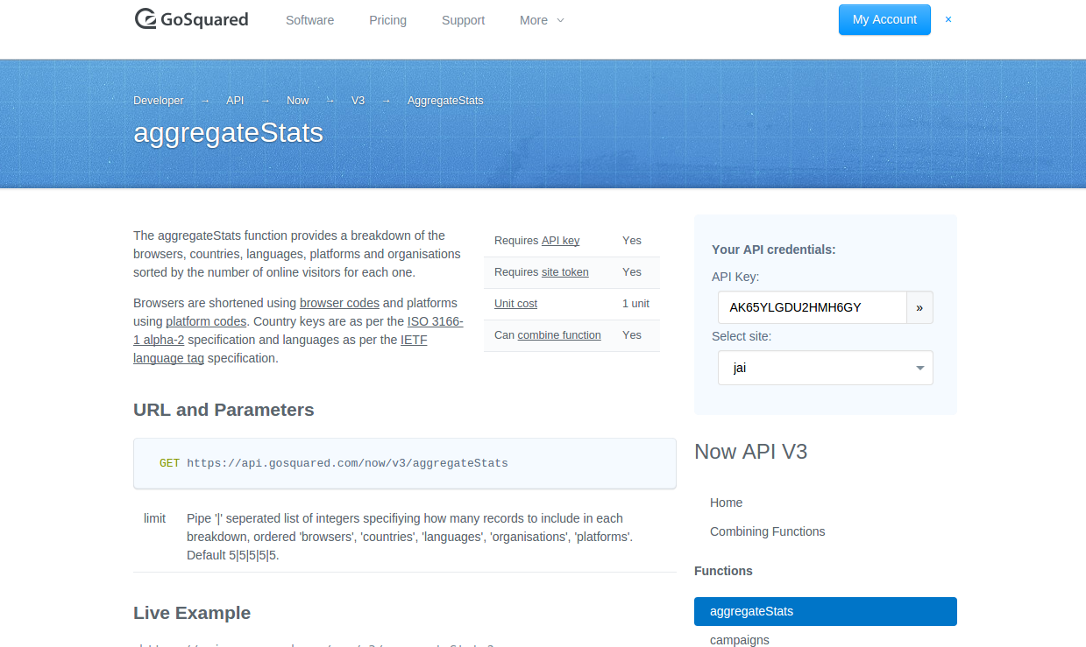

To get the basic details of the now going vistiors there browser and the total number visistors on the site use this url

https://api.gosquared.com/now/v3/aggregateStats along with this the parameters that need to be passed are the apikey and the site token of the respesctive site

This will return the JSON format :

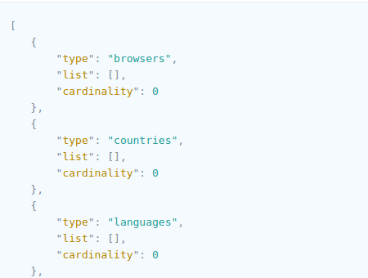

Step 3:
To get the trends basically the whole trend of a particular day or week you can get it through the trend api.

https://www.gosquared.com/developer/api/trends/v2/

Using this url
https://api.gosquared.com/trends/v2/aggregate

we can find the all bounces, visitors and new visitors on the particular site whose api key and site token is passed along with it.
The actual url is :

https://api.gosquared.com/trends/v2/aggregate?api_key={api key}&site_token={site token}

You can compare the values of the browser in charts ,like pie charts we can pass the values directly from the JSON to the charts url to compare the values.

This url can be used to attached the image file in the this url is normal in the <img> tag so it can be directly added to the chatlet.
"<div style=\"overflow:scroll;overflow-y:scroll;overflow-x:scroll;\"> <img style=\"-webkit-user-select: none\" src=\"http://chart.apis.google.com/chart?cht=p3&amp;chs=450x200&amp;chd=t:"+val+"&amp;chco=80C65A,224499,FF0000&amp;chl="+val1+"\"></div>
here the val is the values of the browser and the val1 is the values of which browser

This will also return an json along with the date that could be parsed and matched with the current date to return the trends .

And display it on the teamchat.

The json format is in this manner

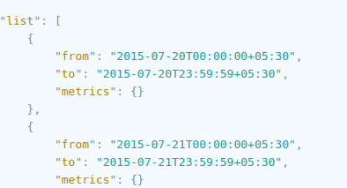

Webhook:

To setup the webhook notification the servlet url need to be given to the in the gosquared app by the user againest the notification tab (in the app right corner ) the user would copy the given url to the webhook in his app and when ever the corresponding trigger is reached it will hit the given servlet

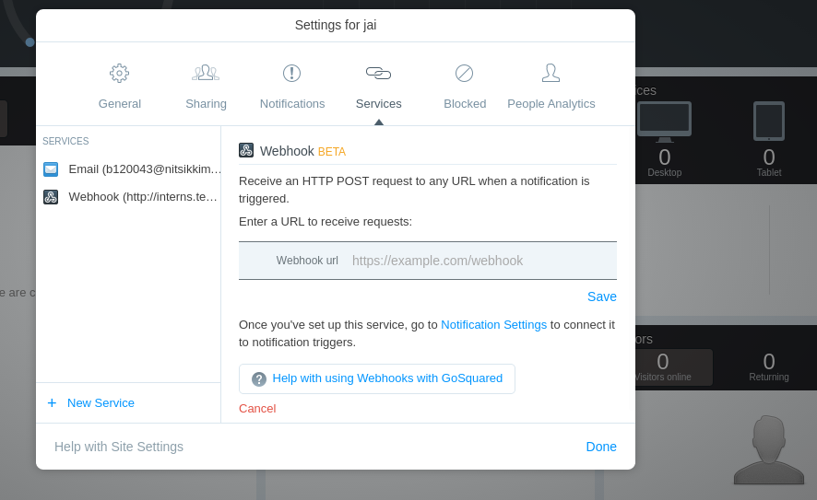

After the servlet is hit :
1)
Inorder to identify the user on the servlet we pass the email along with the servlet url and later after the servlet is hit the corresponding email is taken by using 'getparameter'
2)
the servlet will recevie the JSON format whenever it is hit ,so we need to parser the JSON to get the values that we need to show it on teamchat
3)
Normally as Gosquared is an analytics site so the normal trigger set are like traffic dip,traffic spike. So we get the 'concurrents' from the JSON to display it on the teamchat
4) These all things need to be written in the servlet's do post method.

5) later on we create a room and post the data in teamchat

