Detecting LLM-Generated Fake Reviews on Retail Platforms
A Leakage-Controlled, Cross-Generator Benchmark for Cost-Aware Detection
Madhu Vamsi Turaka
Student ID: 1187433
A dissertation submitted in partial fulfilment of the requirements for the degree of MSc Data Science
Liverpool John Moores University
Supervisor: Dr Jyoti Dabass
October 2026

Abstract
Large language models have made the production of fluent, product-specific text effectively free. For online retail platforms, whose trust infrastructure rests on user-contributed reviews, this converts a once-costly manual fraud into an automatable one. Detection research has responded with a steady stream of classifiers reporting near-perfect accuracy, yet two methodological habits undermine how far those numbers can be trusted: evaluation on text from the same generator the detector was trained on, and random train/test partitions that place near-duplicate reviews of the same product on both sides of the split.
This dissertation reports a leakage-controlled, cross-generator benchmark for detecting LLM-generated fake reviews. The Salminen et al. (2022) corpus of 40,432 Amazon reviews — balanced between genuine reviews and GPT-2 generations — is extended with reviews produced by three contemporary open-weight instruction-tuned model families, each prompted with few-shot exemplars drawn from authentic reviews in the same product category. Three detectors spanning the cost spectrum are compared: a TF-IDF and stylometric feature pipeline with XGBoost, a fine-tuned BERT, and a fine-tuned DeBERTa.
Three design decisions distinguish the evaluation. Splits are category-disjoint, so no product category appears in more than one partition. Every cross-generator test set contains genuine reviews alongside the held-out generator's output, so precision and AUC remain defined — a single-class test set makes precision trivially perfect and AUC undefined. Classifier pairs are compared with McNemar's test on identical test sets rather than by inspecting headline differences.
Under category-disjoint evaluation on the authentic corpus, the strongest classical detector was a linear SVM (F1 0.8758, AUC 0.9548, accuracy 0.8814), marginally ahead of XGBoost (F1 0.8740) while training 228 times faster. Leave-one-category-out evaluation across all ten product categories gave a mean F1 of 0.8811 (SD 0.0169, range 0.8491–0.9063), showing that performance is sensitive to the product domain held out. Feature ablation found sixteen stylometric features sufficient for F1 0.8284, against 0.8476 for 50,000 lexical features and 0.8758 for the two combined, indicating that structural rather than topical properties carry most of the detectable signal. Results for the transformer detectors and for the cross-generator conditions require GPU execution and are reported separately.
The work contributes a reusable cross-generator protocol, an extended public corpus, and evidence on where the accuracy–cost frontier actually sits for platform-scale deployment.
Keywords: fake review detection, large language models, cross-generator generalisation, dataset leakage, XGBoost, BERT, DeBERTa, cost-aware machine learning

Acknowledgements
I thank my supervisor, Dr Jyoti Dabass, for guidance throughout this project. I also acknowledge Salminen et al. (2022) for releasing the fake reviews corpus under an open licence, without which this study would not have been possible.

Declaration
I declare that this dissertation is my own work and that all sources used have been acknowledged. The experimental code, the generated review corpus, and the analysis reported here were produced for this project.
A note on research integrity is warranted. An earlier iteration of the accompanying code base evaluated detectors on template-generated placeholder text rather than on the published corpus and on genuine model output, and reported a perfect in-distribution F1 score as a consequence. Those results were artefacts of the template construction rather than measurements of detection performance. They have been withdrawn, retained only in a clearly marked directory for transparency, and every number reported in this dissertation derives from the authentic Salminen et al. (2022) corpus and from real language model inference. Chapter 3 documents the correction in full.
Name: Madhu Vamsi Turaka
Student ID: 1187433
Signature:
Date:
Table of Contents
Abstract ii
Acknowledgements iii
Declaration iv
List of Abbreviations x
Chapter 1 — Introduction 1
1.1 Background 1
1.2 Problem statement 2
1.3 Aim and objectives 3
1.4 Research questions 3
1.5 Scope and delimitations 4
1.6 Contributions 5
1.7 Dissertation structure 5
Chapter 2 — Literature Review 7
2.1 Introduction 7
2.2 The economics of review fraud 7
2.3 Pre-neural fake review detection 8
2.4 Neural generation and the changing threat model 9
2.5 Detecting machine-generated text 10
2.5.1 Supervised classification 10
2.5.2 Zero-shot statistical detection 11
2.5.3 Watermarking 11
2.5.4 Limits and adversarial robustness 12
2.6 Cross-generator generalisation 12
2.7 Dataset leakage and evaluation validity 13
2.8 Cost-aware deployment 14
2.9 Synthesis and research gap 15
Chapter 3 — Methodology 16
3.1 Research design 16
3.2 Corpus 16
3.2.1 Base corpus 16
3.2.2 Corpus extension 17
3.2.3 Generation procedure 18
3.3 Leakage control 19
3.3.1 Category-disjoint partitioning 19
3.3.2 Test set composition 19
3.4 Detectors 20
3.4.1 XGBoost over lexical and stylometric features 20
3.4.2 BERT 20
3.4.3 DeBERTa 21
3.4.4 Rationale for the detector set 21
3.5 Experimental conditions 21
3.6 Evaluation metrics 22
3.7 Statistical testing 22
3.8 Correction of the withdrawn first iteration 23
3.8.1 What occurred 23
3.8.2 Why the metrics were invalid 23
3.8.3 Remedies 24
3.8.4 Methodological implication 24
3.9 Implementation and reproducibility 25
3.10 Ethical considerations 25
Chapter 4 — Results 27
4.1 Scope of the reported results 27
4.2 Corpus characterisation 27
4.2.1 Composition 27
4.2.2 Review length 28
4.2.3 Stylometric differences 28
4.3 RQ1 — Detector comparison 29
4.4 Statistical significance 31
4.5 Feature ablation 32
4.6 Leave-one-category-out generalisation 33
4.7 Learning curve 34
4.8 RQ4 — Cost 36
4.9 Feature importance and error analysis 37
4.10 Research questions not yet answered 38
Chapter 5 — Discussion 40
5.1 Interpreting accuracy against the published baseline 40
5.2 Classifier accuracy and the cost of statistical ties 41
5.3 Structure over vocabulary 41
5.4 Domain shift as a reference point 42
5.5 Cost asymmetry and deployment 43
5.6 What the withdrawn iteration demonstrates 43
5.7 Limitations 44
Chapter 6 — Conclusion 46
6.1 Summary of findings 46
6.2 Contributions 47
6.3 Limitations 48
6.4 Future work 48
6.5 Concluding remarks 49
References 51
Appendix A — Generation Prompt Design 57
A.1 Post-generation filtering 58
Appendix B — Feature Specification 59
B.1 Lexical features 59
B.2 Stylometric and readability features 59
Appendix C — Reproducibility 60
C.1 Obtaining the corpus 60
C.2 Running the experiments 60
C.3 Run manifest 60
C.4 Note on network restrictions 61
Appendix D — The Withdrawn First Iteration 62
D.1 Reported figures (invalid) 62
D.2 Source of the invalid data 62
D.3 Why this is reported rather than removed 63
List of Tables
Table 1 — Mapping of research questions to manipulated factors and measures. 16
Table 2 — Composition of the Salminen et al. (2022) corpus. 17
Table 3 — Generators used to extend the corpus. 17
Table 4 — Experimental conditions evaluated for each detector. 21
Table 5 — Faults identified in the withdrawn first iteration and the remedies applied. 24
Table 6 — Review length in words, by class. 28
Table 7 — Mean stylometric feature values by class (differences are GPT-2 minus genuine). 29
Table 8 — Classifier performance on the combined feature set, category-disjoint split (n_train = 28,932, n_test = 7,706). 30
Table 9 — McNemar tests between all classifier pairs, combined features, α = 0.05. 31
Table 10 — F1 by feature configuration. "Gain" is combined minus the better of the two single configurations. 32
Table 11 — Leave-one-category-out performance across all ten product categories. 33
Table 12 — Learning curve for XGBoost on combined features. 35
Table 13 — Accuracy and cost on identical CPU hardware. 36
Table 14 — Ten highest-importance features in the combined XGBoost model. 37
Table 15 — Status of each research question after the local experiments. 38
Table 16 — Post-generation filtering rules applied to every generated review. 58
Table 17 — Stylometric and readability feature definitions. 59
Table 18 — Scripts required to reproduce the reported results. 60
Table 19 — Figures reported by the withdrawn first iteration and the reason each is invalid. 62
List of Figures
Figure 1 — Review length distribution by class. Both classes are right-skewed; genuine reviews have a longer tail. 28
Figure 2 — Stylometric feature distributions by class, for six of the sixteen features. 29
Figure 3 — Classifier performance on the combined feature set under the category-disjoint split. 31
Figure 4 — F1 by classifier and feature configuration. 33
Figure 5 — Leave-one-category-out F1 for each held-out product category. Dashed lines mark per-model means. 34
Figure 6 — Learning curve for XGBoost. Performance saturates near 14,000 training reviews. 35
Figure 7 — Accuracy against inference latency on identical CPU hardware (log scale). 37

List of Abbreviations
Abbreviation | Expansion
AUC | Area Under the Receiver Operating Characteristic Curve
BERT | Bidirectional Encoder Representations from Transformers
CG | Computer-Generated (Salminen et al. corpus label)
DeBERTa | Decoding-enhanced BERT with disentangled attention
F1 | Harmonic mean of precision and recall
GPT | Generative Pre-trained Transformer
GPU | Graphics Processing Unit
LLM | Large Language Model
NB | Naive Bayes
NLP | Natural Language Processing
OR | Original / genuine review (Salminen et al. corpus label)
POS | Part of Speech
RLHF | Reinforcement Learning from Human Feedback
RoBERTa | Robustly Optimized BERT Pretraining Approach
RQ | Research Question
SD | Standard Deviation
SVM | Support Vector Machine
TF-IDF | Term Frequency–Inverse Document Frequency
TTR | Type–Token Ratio
XGBoost | Extreme Gradient Boosting

Chapter 1 — Introduction

1.1 Background
Online retail runs on borrowed trust. A shopper who cannot handle a product, inspect its build, or question a salesperson instead reads what previous purchasers wrote. That substitution is economically consequential: review valence and volume measurably shift demand, and the effect is strongest precisely where the buyer has least independent information. Reviews are therefore not decoration around a product listing; they are the mechanism by which a platform converts uncertainty into a purchase.
Any mechanism that moves money attracts manipulation. Review fraud is an established industry, with brokers recruiting writers, coordinating posting schedules, and laundering incentives through refunds and free products. Platforms have invested heavily in countermeasures, and for two decades the economics favoured the defender in one specific respect: a convincing fake review had to be written by a person. Human authorship imposed a cost floor and, just as usefully for detection, a behavioural signature. Paid writers working at volume reuse phrasing, post in bursts, and cluster around the products that pay.
Large language models dissolve that cost floor. A contemporary instruction-tuned model generates a fluent, specific, plausibly human review in under a second for a fraction of a penny, and can be asked for ten thousand of them, each different, each tuned to a particular product category and star rating. The constraint that made review fraud tractable — that deception was expensive to produce at scale — no longer holds. Salminen et al. (2022) demonstrated the practical consequence directly: human judges distinguished GPT-2-generated Amazon reviews from genuine ones at close to chance, while an automated detector reached far higher accuracy. Human moderation alone is no longer a viable line of defence, and the burden shifts onto automated detection.
The research community has responded energetically, and the headline numbers look reassuring. Transformer-based detectors routinely report accuracy above 0.95 on benchmark corpora, and a reader skimming abstracts could reasonably conclude the problem is solved. This dissertation begins from scepticism about that conclusion — not because the reported numbers are wrong on their own terms, but because of what the standard evaluation protocol does and does not measure.

1.2 Problem statement
Three gaps separate reported detection accuracy from deployed detection capability.
The generator-shift gap. Most published detectors are trained and tested on text from the same generator. A detector trained on GPT-2 output and tested on GPT-2 output is being asked an easier question than the one a platform faces, because a platform cannot know which model produced an incoming review, and the population of deployed generators changes faster than labelled training corpora can be assembled. The relevant quantity is not accuracy on a known generator but accuracy on an unknown one, and the two can differ substantially. A detector that has learned the idiosyncratic artefacts of one model's decoding behaviour may be learning a signature rather than a concept.
The leakage gap. Benchmark corpora are frequently constructed by pairing each genuine review with a generated counterpart conditioned on the same product. Under a random train/test split, near-duplicate reviews of the same product then appear on both sides of the partition. A classifier can exploit product-specific vocabulary — a model number, a brand name, a recurring complaint — to recognise the test item without having learned anything about machine-generated text. Reported accuracy is inflated by an amount that the protocol itself cannot reveal.
The cost gap. Detection research optimises almost exclusively for accuracy, while deployment is constrained by throughput and unit economics. A platform ingesting millions of reviews daily must weigh a fractional accuracy gain against inference cost, latency, and memory footprint. A detector that is two points more accurate but three orders of magnitude slower may be the wrong choice, and the literature rarely provides the measurements needed to make that judgement on a like-for-like basis.
These gaps compound. A detector evaluated with in-distribution testing on a leakage-prone split, with no cost accounting, can report near-perfect accuracy while offering an unknown and possibly poor return in production.

1.3 Aim and objectives
The aim of this dissertation is to quantify how well LLM-generated fake review detectors generalise to unseen generators under leakage-controlled evaluation, and to situate that performance against deployment cost.
The objectives are:
- To extend an established public corpus of genuine and machine-generated reviews with output from multiple contemporary LLM families, generated under conditions that match the register and length of authentic reviews.
- To construct an evaluation protocol that eliminates product-level leakage between training and test partitions.
- To measure in-distribution detection performance for detectors spanning the cost spectrum, from a classical feature pipeline to fine-tuned transformers.
- To measure the degradation in performance when each detector is evaluated on a generator absent from its training data.
- To test whether training on several generators improves generalisation to an unseen one, relative to training on a single generator.
- To benchmark inference latency, throughput and memory for every detector on identical hardware, and to characterise the resulting accuracy–cost frontier.

1.4 Research questions
RQ1 — In-distribution accuracy. How accurately do XGBoost, BERT and DeBERTa distinguish genuine from LLM-generated reviews when all generators present at test time were also present during training, under a category-disjoint split?
RQ2 — Cross-generator generalisation. How much detection performance is lost when a detector is evaluated on reviews from a generator held out of its training data entirely, and does the magnitude of that loss differ across detector architectures?
RQ3 — Generator diversity in training. Does training on several generators improve generalisation to an unseen generator, compared with training on a single generator?
RQ4 — Accuracy–cost trade-off. What inference latency, throughput and memory does each detector require on identical hardware, and how does the resulting cost ordering compare with the accuracy ordering?
RQ1 establishes the baseline against which RQ2 is measured; the cross-generator drop in RQ2 is meaningful only relative to a detector's own in-distribution performance. RQ3 asks whether the degradation found in RQ2 can be mitigated by data composition rather than architecture. RQ4 determines which of the resulting options are deployable at platform scale.

1.5 Scope and delimitations
The study addresses binary detection: genuine versus machine-generated. It does not attempt generator attribution — identifying which model produced a review — although the cross-generator design provides a foundation for that question.
The corpus is English-language Amazon product reviews across ten categories. Findings may not transfer to other languages, to other review genres such as hospitality or medical reviews, or to platforms with materially different review conventions.
Generated reviews come from open-weight instruction-tuned models in the one-to-two billion parameter range, run locally. Commercial API models such as GPT-4o and Claude were considered and are discussed in Chapter 3, but were not used: the network environment available for this project blocked the relevant services, and no API budget was available. This is a genuine limitation, since larger proprietary models may produce text that is harder to detect. The cross-generator design mitigates it only partially, and Chapter 6 treats it as the primary direction for future work.
Adversarial evasion — an attacker deliberately paraphrasing or perturbing generated text to defeat a known detector — is out of scope. The threat model here is an adversary using a language model straightforwardly at scale, not one optimising against a specific deployed classifier.
Finally, the study measures detection in isolation. A production trust and safety system combines text classification with behavioural, graph and account signals, and the marginal value of a text detector within such a system is not assessed.

1.6 Contributions
- A leakage-controlled cross-generator protocol. Category-disjoint splitting combined with leave-one-generator-out evaluation, in which every cross-generator test set retains genuine reviews so that precision and AUC remain defined. This last point is not a detail: a single-class test set yields a precision of exactly 1.0 and an undefined AUC, and reporting either as evidence of detector quality is a category error.
- An extended corpus. The Salminen et al. (2022) dataset augmented with reviews from three open-weight model families, few-shot grounded in authentic reviews from matching product categories, released with the generation code and prompts.
- Cross-generator degradation measurements for three detector architectures spanning roughly four orders of magnitude in inference cost, with McNemar significance testing on identical test sets.
- A like-for-like cost benchmark — latency, throughput, peak memory and training time measured on identical hardware — and the accuracy–cost frontier it implies for platform-scale deployment.
- A documented correction of a methodological failure. The project's first iteration evaluated on template-generated placeholder text and reported a perfect F1 score as a result. The failure, its diagnosis and its remedy are documented in Chapter 3 as a methodological contribution in their own right, because the specific pathology — a benchmark whose classes are separable by construction — is easy to introduce and hard to notice from headline metrics alone.

1.7 Dissertation structure
Chapter 2 reviews the literature on fake review detection, machine-generated text detection, cross-domain generalisation, and dataset leakage, and identifies the gap the study addresses.
Chapter 3 sets out the methodology: corpus construction, generation procedure, leakage control, detector configurations, evaluation metrics and statistical testing. It also documents the withdrawn first iteration.
Chapter 4 reports results for each research question.
Chapter 5 interprets the findings, relates them to the reviewed literature, and draws out implications for platform deployment.
Chapter 6 concludes, states limitations, and proposes future work.

Chapter 2 — Literature Review

2.1 Introduction
This chapter situates the dissertation within four bodies of work. Section 2.2 establishes why review fraud matters economically. Section 2.3 surveys pre-neural fake review detection, whose assumptions the present threat model breaks. Section 2.4 covers neural text generation and the resulting shift in what detection must accomplish. Section 2.5 reviews machine-generated text detection. Sections 2.6 and 2.7 examine the two methodological concerns at the centre of this study — cross-generator generalisation and dataset leakage — and Section 2.8 reviews cost-aware deployment. Section 2.9 synthesises the gap the dissertation addresses.

2.2 The economics of review fraud
That reviews move money is well established empirically. Chevalier and Mayzlin (2006), comparing book sales across two retailers, found that improvements in review valence produced measurable increases in relative sales, and that negative reviews exerted a disproportionate influence. The asymmetry matters for fraud: suppressing a competitor is at least as valuable as promoting oneself.
Subsequent work established that manipulation is systematic rather than incidental. Mayzlin, Dover and Chevalier (2014) exploited a natural experiment in hotel reviews, comparing platforms with differing verification regimes, and found manipulation concentrated exactly where incentives and opportunity coincided — independently owned hotels with neighbouring competitors. Luca and Zervas (2016), analysing Yelp's filtered reviews, found that roughly sixteen percent of restaurant reviews were flagged as suspicious, with the rate rising when a business faced increased competition or weak existing ratings. Fake reviews, on this evidence, are a strategic response to market pressure.
He, Hollenbeck and Proserpio (2022) studied the supply side directly, observing online marketplaces where sellers recruit reviewers. They documented a functioning market with established prices and a measurable effect on ratings and sales, followed by a decline once platform enforcement intervened. Two findings bear on detection. First, fake reviews cluster in time, because sellers buy them in campaigns. Second, enforcement works, which means the cost of producing a convincing fake is a policy-relevant variable — and precisely the variable that language models have collapsed.

2.3 Pre-neural fake review detection
Jindal and Liu (2008) introduced opinion spam as a computational problem, observing that duplicate and near-duplicate Amazon reviews supplied usable labels and that spam was detectable from review text, reviewer behaviour and product metadata. The use of duplicates as a proxy for deception set a precedent whose consequences recur throughout the field.
Obtaining genuinely labelled deceptive reviews is the discipline's central obstacle: a platform cannot reliably say which reviews are fake, and a researcher cannot either. Ott et al. (2011) addressed this by commissioning crowdworkers to write deceptive hotel reviews, producing a balanced, confidently labelled corpus. Their classifiers reached roughly ninety percent accuracy, substantially exceeding human judges, who performed near chance. This established a pattern that recurs under LLM conditions: humans are poor at detecting fabricated reviews, and machines are considerably better. Ott et al. (2013) extended the corpus to negative-sentiment deception.
The construction has a known weakness. Crowdworkers writing imaginary reviews on demand are not fraudsters writing for payment under platform constraints, and the resulting text may carry the signature of the elicitation rather than of deception. Mukherjee et al. (2013) tested this by applying features developed on crowdsourced corpora to Yelp's filtered reviews, and found accuracy dropped markedly. Their conclusion — that performance on crowdsourced deception does not transfer to commercial fraud — is the earliest clear statement of the generalisation problem this dissertation revisits in its LLM form.
Work thereafter diversified along two axes. Behavioural and graph-based approaches modelled relationships among reviewers, reviews and products: Rayana and Akoglu (2015) combined review text, metadata and the reviewer–product graph in a unified framework, consistently outperforming text-only detection. Linguistic approaches sought deception markers in text, drawing on psycholinguistic theory — reduced first-person singular usage, elevated negative emotion terms, less concrete detail. Li et al. (2014) examined whether such cues generalise across domains and found only partial transfer, reinforcing the Mukherjee et al. finding.
Two conclusions carry forward. Detection built on behavioural signals is more robust than detection built on text alone, but it requires platform-internal data unavailable to most researchers. And text-based detectors transfer poorly across the conditions under which deceptive text was produced — a result whose LLM-era analogue is precisely the cross-generator question.

2.4 Neural generation and the changing threat model
Yao et al. (2017) anticipated the shift before fluent generation was widespread, demonstrating that a recurrent neural network trained on Yelp reviews could produce text that human evaluators rated as plausible, and arguing that machine-generated review attacks were economically imminent. Their defence relied on character-level distributional artefacts — a signal later generation rendered obsolete.
Radford et al. (2019) marked the change in degree that became a change in kind. GPT-2 produced extended, coherent, topically controlled text, and the staged release strategy (Solaiman et al., 2019) was itself an acknowledgement that generation quality had reached a threshold where misuse was a practical rather than hypothetical concern. Adelani et al. (2020) applied such models specifically to reviews, showing that fine-tuned language models could produce sentiment-controlled fake reviews that evaded existing detectors and were rated as credible by humans.
Hovy (2016) had already asked the pointed question of whether statistically generated fake reviews could be detected, finding that generated reviews fooled humans while remaining machine-detectable. The pattern is remarkably stable across a decade and multiple generator architectures: the human detection ceiling falls as generation improves, while automated detection retains an advantage — though, as Section 2.6 argues, that advantage is measured under conditions more favourable than deployment provides.
Salminen et al. (2022) supplies the corpus underlying this dissertation. The authors fine-tuned GPT-2 on Amazon review data and generated a counterpart for each of 20,216 genuine reviews across ten product categories, yielding a balanced corpus of 40,432. Human evaluators distinguished genuine from generated reviews only slightly above chance, whereas a fine-tuned RoBERTa classifier exceeded ninety-five percent accuracy. The corpus is openly licensed and has become a standard benchmark.
Two properties of its construction matter for the present work. First, each generated review is conditioned on a specific product, so generated and genuine reviews of the same product share vocabulary — the condition that makes random splitting hazardous (Section 2.7). Second, every generated review comes from a single generator, GPT-2. A detector trained and evaluated on this corpus alone is necessarily evaluated in-distribution, and its reported accuracy carries no information about performance on a different model's output. Extending the corpus across generators is the direct motivation for this study.

2.5 Detecting machine-generated text

2.5.1 Supervised classification
The dominant approach fine-tunes a pretrained encoder on a labelled corpus of human and machine text. Following Devlin et al. (2019), BERT established the pretrain-and-fine-tune paradigm; Liu et al. (2019) showed with RoBERTa that training refinements yielded substantial gains; and He et al. (2021) introduced DeBERTa, whose disentangled attention — representing content and position separately — and enhanced mask decoder improved on both. He et al. (2023) refined the pretraining objective further in DeBERTaV3 using replaced-token detection. These three architectures, with DeBERTa's reported advantage on classification benchmarks, motivate the detector selection in this study.
Zellers et al. (2019) produced the most influential early result with Grover, a model trained to generate neural fake news that proved to be its own best detector. Their explanation — that a generator's own representation of the distribution is maximally informative for recognising samples from it — has an uncomfortable corollary for deployment: detection accuracy may depend on access to, or close knowledge of, the generating model. A platform facing an unknown generator is in exactly the position Grover's framing identifies as difficult.
Uchendu et al. (2020) formalised the problem as authorship attribution across neural generators and found that distinguishing which model produced a text is feasible but that detectors degrade when confronted with generators absent from training — an early and direct statement of the cross-generator problem.

2.5.2 Zero-shot statistical detection
A parallel line exploits the statistical signature of likelihood-maximising decoding. Gehrmann et al. (2019) introduced GLTR, visualising per-token likelihood under a reference model on the observation that generated text occupies high-probability regions more consistently than human text does. Mitchell et al. (2023) formalised the intuition in DetectGPT: machine-generated text tends to occupy local maxima of the model's log-probability function, so perturbing it reduces likelihood more sharply than perturbing human text. DetectGPT requires no training data but is computationally expensive, needing many perturbed forward passes per document. Bao et al. (2024) reduced that cost substantially in Fast-DetectGPT via a conditional probability curvature criterion, and Hans et al. (2024) proposed Binoculars, contrasting perplexities under two closely related models to achieve strong zero-shot accuracy without generator-specific training.
Zero-shot methods are attractive precisely because they sidestep the cross-generator problem — no training corpus means no training distribution to shift away from. Their weakness is the need for white-box or at least log-probability access to a reference model whose distribution resembles the unknown generator's, and a per-document cost far above that of a fine-tuned classifier. For a platform scoring millions of reviews daily, the cost asymmetry is decisive, which is one reason this study benchmarks supervised detectors across the cost spectrum rather than evaluating zero-shot methods.

2.5.3 Watermarking
Kirchenbauer et al. (2023) proposed embedding a detectable statistical signature at generation time by biasing sampling toward a pseudo-randomly chosen token subset, yielding a signal detectable without model access and with interpretable statistical guarantees. Watermarking is conceptually clean but presupposes generator cooperation. An adversary generating fake reviews will use an unwatermarked open-weight model, of which many exist. Watermarking addresses accountability for cooperating providers, not adversarial misuse, and is therefore orthogonal to the detection problem studied here.

2.5.4 Limits and adversarial robustness
Several results temper optimism. Ippolito et al. (2020) reported that automatic detection is easiest precisely where humans are most fooled, because the decoding strategies producing human-plausible text leave the clearest statistical traces — detection and human-perceived quality are not simply inversely related. Sadasivan et al. (2023) argued that as generated text approaches the human distribution, any detector's performance approaches chance, and demonstrated that paraphrasing attacks degrade detectors sharply. Krishna et al. (2023) made this concrete with DIPPER, a paraphrase model that substantially reduced the accuracy of a range of detectors including DetectGPT and supervised classifiers. Chakraborty et al. (2023) offered a partial counterweight, arguing that detection remains possible given sufficient samples even when distributions are close, with the sample requirement growing as the distributions converge.
The resulting picture is that detection is possible but conditional, and that reported accuracy is sensitive to assumptions — about the generator, the decoding strategy, and whether the adversary is optimising against the detector. This study examines the first of those assumptions.

2.6 Cross-generator generalisation
The question of whether a detector trained on one generator works on another has been raised repeatedly and answered consistently: not reliably.
Uchendu et al. (2020) found degradation on unseen generators in the attribution setting. Wang et al. (2024) addressed the problem directly with M4, a benchmark spanning multiple generators, domains and languages, explicitly designed so that detectors can be evaluated outside their training distribution. Their central finding is that detectors performing strongly in-distribution degrade substantially when the generator changes, and that the degradation is larger than for domain shift alone. Guo et al. (2023), building the HC3 corpus of paired human and ChatGPT answers, likewise observed that detectors tuned to one model's output transfer imperfectly.
The mechanism is reasonably well understood. Supervised detectors latch onto generator-specific regularities — characteristic discourse markers, length and punctuation distributions, lexical preferences induced by instruction tuning and RLHF. These are highly discriminative within a generator and arbitrary across generators. Tang et al. (2024), surveying the field, identify generalisation to unseen generators as a principal open problem.
Two mitigations appear in the literature. The first is training on multiple generators so that the detector is pushed toward features common to machine text rather than specific to one model; Wang et al. (2024) report that this helps but does not eliminate the gap. The second is zero-shot detection (Section 2.5.2), which avoids the problem at a cost in compute and model access. RQ3 of this dissertation tests the first mitigation directly.
What the literature largely does not supply is a cross-generator evaluation for the fake review task specifically, with leakage control, on a corpus where a published single-generator baseline already exists. Review text is short, formulaic and product-conditioned — materially different from the news articles, student essays and question answering that dominate machine-generated text benchmarks — and there is no strong reason to assume degradation measured on those genres transfers.

2.7 Dataset leakage and evaluation validity
Kapoor and Narayanan (2023) surveyed machine-learning-based science across disciplines and identified leakage as a pervasive cause of irreproducible results, cataloguing failure modes including feature leakage, temporal leakage, and non-independence between training and test samples. Their central argument is that leakage inflates reported performance in ways invisible to the standard evaluation loop: the model appears to work, validates successfully, and fails on deployment.
Within NLP, Gorman and Bedrick (2019) showed that system rankings on standard splits frequently fail to survive re-splitting, and Søgaard et al. (2021) argued that random splits systematically overestimate performance relative to splits respecting natural data structure, recommending adversarial or attribute-disjoint splitting as standard practice.
The fake review setting is unusually exposed to this failure. In corpora constructed by generating a counterpart for each genuine review — including Salminen et al. (2022) — each product contributes a matched pair sharing product name, feature vocabulary and topic. Under a random split, one member of a pair can land in training and the other in test. A classifier may then succeed by product recognition rather than by any understanding of generated text, and nothing in the accuracy figure reveals the substitution.
Reported leakage control in the fake review literature is inconsistent. Many studies report random splits without discussing product-level overlap. This dissertation adopts category-disjoint splitting, a conservative choice: no product category appears in more than one partition, so the detector is evaluated on product types it has never seen. This is stricter than product-disjoint splitting and will tend to understate in-distribution accuracy relative to the published literature — an intentional trade, since the question is what survives distribution shift, not what maximises a leaderboard figure.
A related and more elementary validity failure concerns test set composition. If a cross-generator test set contains only generated reviews, precision is trivially 1.0 regardless of detector quality, recall equals accuracy, and AUC is undefined because only one class is present. Such a configuration measures nothing about discrimination. The protocol here therefore retains genuine reviews in every cross-generator test set, balanced one-to-one against the held-out generator's output. Section 3.8 documents an instance of exactly this failure within the project's own first iteration.

2.8 Cost-aware deployment
Detection research optimises accuracy; deployment pays for compute. Strubell et al. (2019) drew attention to the energy and financial cost of large NLP models, and Schwartz et al. (2020) argued in Green AI for reporting efficiency alongside accuracy as a first-class result. Sanh et al. (2019) demonstrated with DistilBERT that substantial compute reductions are available at modest accuracy cost — forty percent fewer parameters and roughly sixty percent faster inference while retaining most of BERT's performance.
For review moderation the economics are stark. A platform ingesting millions of reviews daily must multiply per-review inference cost by that volume. A gradient-boosted model over sparse lexical features scores a review in microseconds on commodity CPU; a fine-tuned transformer requires orders of magnitude more computation and, for practical throughput, accelerator hardware. If the accuracy difference between them is small — particularly under the distribution shift that deployment actually involves — the classical model may be the rational choice, with the transformer reserved for a second-stage review of uncertain cases.
Chen and Guestrin (2016) introduced XGBoost, which remains a strong baseline on sparse tabular and lexical features and provides the low-cost end of this study's comparison. What the literature rarely provides is a like-for-like measurement: accuracy and cost for competing detectors on identical hardware, identical data and an evaluation protocol reflecting deployment conditions. RQ4 supplies that measurement for this task.

2.9 Synthesis and research gap
Five conclusions follow from this review.
- Review fraud is economically significant and responsive to production cost; language models have removed the cost barrier that made it tractable.
- Humans cannot reliably detect LLM-generated reviews, so automated detection is necessary rather than merely useful.
- Supervised transformer detectors achieve high in-distribution accuracy, but degrade on generators absent from training — established for news and essays, not systematically for product reviews.
- Evaluation validity is fragile. Random splits over product-paired corpora leak; single-class test sets make precision and AUC meaningless. Both failures inflate reported performance invisibly.
- Cost is rarely measured alongside accuracy, despite determining what is deployable.
The gap this dissertation addresses is the intersection. No existing study, to the author's knowledge, evaluates fake review detection across multiple generators, under leakage-controlled splitting, with two-class cross-generator test sets, across detectors spanning the cost spectrum, with significance testing and cost benchmarking on identical hardware. Each component exists separately; their combination is what determines whether a detector is deployable, and that is what the following chapters measure.

Chapter 3 — Methodology

3.1 Research design
The study is a controlled computational experiment with a factorial structure. Two factors are manipulated: detector architecture, at three levels (XGBoost, BERT, DeBERTa), and training–test generator configuration, at eight levels (one in-distribution condition, four leave-one-generator-out conditions, and three single-generator training conditions). All twenty-four cells use the same corpus, the same category-disjoint partition, the same random seed, and the same hardware, so that differences in outcome are attributable to the manipulated factors.
The design is positivist and quantitative. Performance is operationalised as accuracy, precision, recall, F1 and AUC on held-out data; generalisation is operationalised as the difference between a detector's in-distribution F1 and its F1 on an unseen generator; cost is operationalised as inference latency, throughput, peak memory and training time.
Table 1 — Mapping of research questions to manipulated factors and measures.
Research question | Manipulation | Primary measure
RQ1 | Detector architecture | F1, AUC on in-distribution test set
RQ2 | Generator held out of training | Absolute and relative F1 drop
RQ3 | Training generator diversity | F1 on unseen generator, multi vs single
RQ4 | Detector architecture | Latency, throughput, peak memory

3.2 Corpus

3.2.1 Base corpus
The base corpus is the Fake Reviews Dataset of Salminen et al. (2022), obtained from the Open Science Framework repository at https://osf.io/tyue9/. Its properties are given in Table 2.
Table 2 — Composition of the Salminen et al. (2022) corpus.
Property | Value
Total reviews | 40,432
Genuine (OR) | 20,216
GPT-2 generated (CG) | 20,216
Product categories | 10
Fields | category, rating, label, text_
File size | 15,324,616 bytes

The ten categories are Books, Clothing/Shoes/Jewelry, Electronics, Home and Kitchen, Kindle Store, Movies and TV, Pet Supplies, Sports and Outdoors, Tools and Home Improvement, and Toys and Games, with between 3,588 and 4,730 reviews each. Genuine reviews are drawn from Amazon; generated reviews were produced by a GPT-2 model fine-tuned on review text and conditioned on individual products, so each generated review has a genuine counterpart for the same product.
Labels are mapped to a binary target: OR → 0 (genuine), CG → 1 (machine-generated). The generator field is set to genuine and gpt2 respectively, giving the base corpus two of the study's five generator levels.

3.2.2 Corpus extension
The base corpus contains output from exactly one generator, so it cannot support cross-generator evaluation on its own. It is extended with reviews from three additional generators, each a distinct instruction-tuned model family (Table 3).
Table 3 — Generators used to extend the corpus.
Key | Model | Developer | Parameters
llama32 | meta-llama/Llama-3.2-1B-Instruct | Meta | 1.2B
qwen25 | Qwen/Qwen2.5-1.5B-Instruct | Alibaba | 1.5B
smollm2 | HuggingFaceTB/SmolLM2-1.7B-Instruct | HuggingFace | 1.7B

Selecting models from different developers is deliberate. Models within one family share tokenisation, pretraining data and alignment procedure, so holding one out of training would measure little more than checkpoint variation. Distinct families differ in all three respects, so leave-one-generator-out measures a shift closer to the one a platform encounters when an adversary switches models.
Llama-3.2-1B-Instruct is distributed under a gated licence. Where access is unavailable, the pipeline substitutes TinyLlama/TinyLlama-1.1B-Chat-v1.0, an ungated model of the same architectural lineage, and records the substitution in the run manifest. The model actually used in the reported run is stated in Chapter 4.

3.2.3 Generation procedure
Naive prompting ("write a fake review") produces assistant-register text — structured, hedged, often bulleted — that is trivially separable from Amazon review prose. A detector evaluated on such output would report high accuracy while having learned only to recognise chatbot formatting. This is the same pathology, in milder form, as the template failure documented in Section 3.8, and the generation procedure is designed to avoid it.
Each prompt is few-shot grounded in the real corpus. For each requested review the procedure samples a product category, draws three genuine reviews from that category as exemplars, samples a target star rating from a realistic distribution (weighted 45/25/15/9/6 across five to one stars), and instructs the model to produce one new review of comparable length and style. A system prompt directs the model to write plain, informal, specific prose, to tolerate typos and run-on sentences, and never to reference being an AI.
Generation uses nucleus sampling with temperature 0.9 and top-p 0.95, capped at 140 new tokens. Outputs pass through a filtering stage that strips assistant preambles ("Sure, here is a review:"), field labels, markdown emphasis and surrounding quotation marks; rejects texts shorter than eight or longer than 180 words; rejects texts containing refusal or self-reference markers; and removes exact duplicates. The pipeline over-generates by fifty percent to absorb these rejections. A target of 3,000 accepted reviews per generator is requested; realised counts appear in Chapter 4.
Because the few-shot exemplars are genuine reviews, a legitimate concern is that the model may copy exemplar text, which would contaminate the corpus. The deduplication stage removes exact repeats, and Chapter 4 reports the overlap check performed against the exemplar pool.

3.3 Leakage control

3.3.1 Category-disjoint partitioning
Each generated review in the base corpus is conditioned on the same product as a genuine counterpart, so the two share product vocabulary. Under a random split, members of such a pair may fall on opposite sides of the partition, and a classifier can then succeed by recognising the product rather than the generation process (Section 2.7).
The partition is therefore category-disjoint: product categories are shuffled under a fixed seed and allocated whole to training, validation or test, in a 70/15/15 ratio over the ten categories, yielding seven training, one validation and two test categories. No category — and therefore no product — appears in more than one partition.
This is stricter than product-disjoint splitting and imposes a domain shift alongside the generator shift under study. The trade is accepted deliberately: an evaluation that overstates deployable accuracy is less useful than one that understates it. A consequence is that in-distribution figures reported here are expected to fall below those in the published literature for the same corpus, and Chapter 5 addresses this directly in comparing results.
A limitation follows from the corpus having only ten categories: the validation partition is a single category. Validation is consequently a coarse instrument, and no per-condition hyperparameter search is performed — all detectors use fixed, pre-registered settings (Section 3.4), which also removes a route by which test information could leak into model selection.

3.3.2 Test set composition
Every test set is balanced one-to-one between genuine and generated reviews by downsampling the larger class under a fixed seed.
For cross-generator conditions the positive class is restricted to the held-out generator, and genuine reviews from the test categories are retained as the negative class. This is essential rather than cosmetic. A cross-generator test set containing only the held-out generator's reviews has no negative examples, so precision is exactly 1.0 by construction, recall equals accuracy, and AUC is undefined. Such a configuration measures nothing about discrimination, and Section 3.8 documents its occurrence in the project's withdrawn first iteration.
Balancing also makes conditions mutually comparable: each cross-generator test set is sized by the availability of the held-out generator's reviews within the two test categories, and a 1:1 ratio keeps the base rate constant so that F1 values can be compared across conditions.

3.4 Detectors

3.4.1 XGBoost over lexical and stylometric features
The low-cost detector combines two feature families.
TF-IDF over word unigrams and bigrams, limited to 50,000 features, with sublinear term frequency scaling, Unicode accent stripping and English stop word removal.
Stylometric and readability features, sixteen in total: mean word length, type–token ratio, mean sentence length, word count, sentence count, exclamation mark count, question mark count, comma count, uppercase character ratio, Flesch Reading Ease, Gunning Fog index, Flesch–Kincaid grade level, and the proportions of nouns, verbs, adjectives and adverbs obtained by POS tagging. These capture surface regularities — generated text tends toward more uniform sentence length and different punctuation habits — that lexical features do not represent directly.
The two blocks are horizontally stacked into a sparse matrix. Classification uses XGBoost (Chen and Guestrin, 2016) with 300 estimators, maximum depth 6, learning rate 0.1, subsample and column-sample ratios of 0.9, and the histogram tree method.
Crucially, the vectoriser and the stylometric transformer are fitted on training data only and applied unchanged to validation and test data. Fitting a vectoriser on the full corpus before splitting is a common and silent source of leakage.

3.4.2 BERT
bert-base-uncased (Devlin et al., 2019) with a sequence classification head, fine-tuned for two epochs at learning rate 2×10⁻⁵, batch size 32, maximum sequence length 128 tokens, weight decay 0.01, linear warmup over the first ten percent of steps followed by linear decay, and gradient clipping at norm 1.0. Mixed-precision training is used where a GPU is available.
A 128-token limit is appropriate to the data rather than a compromise: review length statistics are reported in Chapter 4 and the great majority of reviews fall well inside this bound. Truncation at 512 tokens would multiply compute for negligible coverage gain.

3.4.3 DeBERTa
microsoft/deberta-v3-base (He et al., 2023), with microsoft/deberta-base (He et al., 2021) as fallback if the v3 tokenizer is unavailable. Optimisation settings are identical to BERT, so that any difference in outcome reflects the architecture and its pretraining rather than tuning effort. Holding hyperparameters fixed across the two transformers trades a possible accuracy gain for interpretability of the comparison.

3.4.4 Rationale for the detector set
The three detectors span roughly four orders of magnitude in inference cost while representing three distinct inductive biases: sparse lexical and hand-engineered features with a tree ensemble; contextual embeddings with standard transformer attention; and contextual embeddings with disentangled attention. If cross-generator degradation is a property of the detection task rather than of a particular architecture, it should appear in all three.

3.5 Experimental conditions
Eight conditions are evaluated for each of the three detectors.
Table 4 — Experimental conditions evaluated for each detector.
Condition | Training data | Test positive class
in_distribution | all generators | all generators
crossgen_holdout_gpt2 | all except GPT-2 | GPT-2
crossgen_holdout_llama32 | all except Llama-3.2 | Llama-3.2
crossgen_holdout_qwen25 | all except Qwen2.5 | Qwen2.5
crossgen_holdout_smollm2 | all except SmolLM2 | SmolLM2
singlegen_train_gpt2_test_llama32 | genuine + GPT-2 only | Llama-3.2
singlegen_train_gpt2_test_qwen25 | genuine + GPT-2 only | Qwen2.5
singlegen_train_gpt2_test_smollm2 | genuine + GPT-2 only | SmolLM2

The in-distribution condition answers RQ1. The four leave-one-generator-out conditions answer RQ2. RQ3 is answered by comparing each singlegen_train_gpt2_test_X condition against the corresponding crossgen_holdout_X condition: both are evaluated on the identical test set for generator X, which neither has seen, but the cross-generator condition trains on three generators while the single-generator condition trains on one. The difference isolates the contribution of generator diversity in training.
Genuine reviews are present in the training set of every condition; only the composition of the generated portion varies.

3.6 Evaluation metrics
Accuracy, precision, recall, F1 and AUC are reported, with the positive class being machine-generated. Precision and recall carry an operational asymmetry worth stating: a false positive removes a genuine customer's review, while a false negative leaves one fraudulent review in place. Platforms typically weight the former more heavily, so precision at usable recall matters more than accuracy alone.
AUC is reported as undefined where a test set contains a single class, rather than being imputed or omitted silently.
Cross-generator degradation is quantified relative to each detector's own in-distribution F1:
Absolute drop = F1(in-distribution) − F1(cross-generator)
Relative drop (%) = 100 × (F1(in-distribution) − F1(cross-generator)) / F1(in-distribution)
The relative measure permits comparison across detectors with differing baselines: a 0.05 absolute drop means something different from a baseline of 0.98 than from 0.75.

3.7 Statistical testing
Detectors are compared with McNemar's test on paired predictions over identical test sets (Dietterich, 1998). For two detectors the 2×2 agreement table is constructed over all four outcome combinations, and the test examines whether the discordant counts — cases where exactly one detector is correct — depart from equality. The exact binomial form is used when the discordant total is below 25 and the continuity-corrected χ² form otherwise.
McNemar's test is appropriate because the detectors are evaluated on the same items, making the samples paired; an unpaired test would discard that structure and lose power. The alternative of repeated random splits with a t-test is not available here, since the category-disjoint partition is fixed by the corpus structure and only ten categories exist.
All experiments use seed 42 for category allocation, test-set downsampling, prompt construction, model initialisation and data shuffling. Significance is assessed at α = 0.05, and exact p-values are reported.

3.8 Correction of the withdrawn first iteration
Research integrity requires documenting a failure in the project's first iteration, since the correction materially shaped the final design.

3.8.1 What occurred
The initial pipeline reported in-distribution accuracy, precision, recall, F1 and AUC all equal to 1.000, a cross-generator F1 of 0.9422 with precision 1.000, and a cross-generator AUC of NaN. Investigation established three causes.
First, the file at data/raw/fake_reviews_dataset.csv was not the Salminen corpus despite carrying its filename. It contained 10,000 rows generated by a script from thirty hand-written string templates — fifteen assigned to the genuine class and fifteen to the GPT-2 class.
Second, the reviews labelled as GPT-4o, Claude and Llama-3 were not produced by those models. A local module emitted ten templates per generator with a randomly chosen filler sentence appended. Its docstring stated that the styles were chosen to "ensure a measurable cross-generator generalisation gap".
Third, the cross-generator test set was constructed as the held-out generator's reviews alone, with no genuine reviews.

3.8.2 Why the metrics were invalid
With classes drawn from disjoint template sets, the two classes are linearly separable in TF-IDF space by construction. An F1 of 1.000 records that separability, not detection capability.
The cross-generator figures are invalid for an independent reason. With only positive examples in the test set, there are no negatives to misclassify, so precision is exactly 1.0 whatever the detector does; recall equals accuracy; and AUC is undefined, which is what the NaN recorded. A measured "cross-generator gap" of 0.058 was the distance between two sets of templates written by the same author.
The failure is instructive because nothing in the metrics signalled it. A perfect score reads as success. Only the NaN was anomalous, and it was the thread that unravelled the rest.

3.8.3 Remedies
Table 5 — Faults identified in the withdrawn first iteration and the remedies applied.
Fault | Remedy
Template corpus mistaken for Salminen | Authentic corpus downloaded from OSF; placeholder renamed SYNTHETIC_TEMPLATE_PLACEHOLDER_not_real_data.csv
Templates presented as LLM output | Replaced with real inference over three model families (Section 3.2.3)
Single-class cross-generator test set | Genuine reviews retained, balanced 1:1 (Section 3.3.2)
Undefined AUC reported as NaN | AUC returns None with an explicit warning when a single class is present
Incorrect McNemar implementation | Replaced with the full 2×2 table and exact/corrected forms (Section 3.7)
Unsafe category shuffle | Categories materialised as a Python list before permutation
Transformers never executed | Classical detectors run in every reported condition; transformer detectors implemented but require GPU to execute

The withdrawn outputs are retained in results/_WITHDRAWN_fabricated/ with a README explaining their invalidity, rather than deleted, so that the record remains auditable.

3.8.4 Methodological implication
The episode supports a general point raised in Section 2.7: a benchmark can be invalid in ways its own metrics cannot reveal. A perfect score is more often evidence of a broken evaluation than of a strong model, and the practical safeguard is to treat implausibly high performance as a defect report. The final protocol embeds this as a standing check — manual inspection of generated samples before any results are reported (Chapter 4), explicit single-class detection in the metrics code, and a run manifest recording exactly which model produced each portion of the corpus.

3.9 Implementation and reproducibility
The study is implemented in Python. Data handling uses pandas and NumPy (McKinney, 2010; Harris et al., 2020) and figures are produced with Matplotlib (Hunter, 2007). Classical features use scikit-learn (Pedregosa et al., 2011) and NLTK (Bird, Klein and Loper, 2009); gradient boosting uses XGBoost (Chen and Guestrin, 2016); transformers use PyTorch (Paszke et al., 2019) and the HuggingFace transformers library (Wolf et al., 2020); statistical testing uses statsmodels (Seabold and Perktold, 2010).
All experiments execute in a single Google Colab session on one NVIDIA T4 GPU. Running every detector on identical hardware in one session is a requirement of RQ4 rather than a convenience: latency figures gathered on different machines are not comparable, and a cost ranking assembled from heterogeneous measurements would be meaningless.
Each run writes a manifest recording the hardware, library versions, random seed, realised corpus composition per generator, review length statistics, the category allocation, and the model repository actually used for each generator including any fallback substitution. Reported figures in Chapter 4 are read programmatically from the emitted result files rather than transcribed, which removes a class of reporting error.
The complete pipeline is colab/full_study.py, embedded verbatim in the notebook colab/LLM_Fake_Review_Study.ipynb.

3.10 Ethical considerations
The study generates synthetic fake reviews, which is dual-use: the same artefacts that train detectors could in principle be posted to a platform. Three considerations bear on the balance.
The capability is not scarce. Generating review-like text requires only a publicly available model and an ordinary prompt; this dissertation supplies no capability an adversary lacks. The defensive value is asymmetric, since detector development requires labelled generated text and withholding it impedes defenders rather than attackers. And no generated review was posted to any platform; all output remains in a research corpus.
The base corpus is public, openly licensed and contains no personal data beyond review text already published on Amazon. No human participants were involved and no ethical approval was required. Generated reviews are released with explicit labelling and provenance metadata recording the producing model, so they cannot be mistaken for authentic reviews.

Chapter 4 — Results

4.1 Scope of the reported results
This chapter reports the experiments that were executed in full. A division of labour was forced by the computing environment, and it is stated here rather than left implicit.
The workstation available for this project has six CPU cores, 14.8 GB of RAM and no CUDA-capable GPU, and sits behind a corporate gateway that blocks huggingface.co. Neither the transformer detectors nor the additional generators can therefore be run locally, since both require the model hub. Google Colab is reachable through the same gateway and supplies a T4 GPU, so the study is split: all classical detectors are measured locally on the authentic corpus, and the transformer and cross-generator conditions execute on Colab.
The results below are the local half, and they are complete for what they cover: five classifiers, three feature configurations, a ten-fold leave-one-category-out evaluation, a learning curve, pairwise significance testing and a cost benchmark — all on the full 40,432-review Salminen corpus under the category-disjoint protocol of Section 3.3. Section 4.10 states precisely which research questions remain open.
All figures in this chapter were produced by scripts/local_study.py under seed 42 and are reproducible.

4.2 Corpus characterisation

4.2.1 Composition
The corpus comprises 40,432 reviews, exactly balanced at 20,216 genuine and 20,216 GPT-2 generated, across ten Amazon product categories. The category-disjoint allocation under seed 42 assigned seven categories to training (Books, Electronics, Home and Kitchen, Kindle Store, Movies and TV, Pet Supplies, Sports and Outdoors), one to validation (Toys and Games), and two to test (Clothing/Shoes/Jewelry, Tools and Home Improvement), giving 28,932 training and 7,706 test reviews.

4.2.2 Review length
Table 6 — Review length in words, by class.
Class | Mean | Median | SD | Min | Max
Genuine | 73.64 | 42.0 | 76.08 | 5 | 373
GPT-2 | 61.29 | 35.0 | 61.80 | 1 | 318

Both distributions are heavily right-skewed (note: word counts in Table 7 use NLTK tokenisation and differ slightly from the whitespace counts here) — the median is well below the mean in each case — and genuine reviews are on average twelve words longer. 79.2% of all reviews contain 100 words or fewer, which empirically justifies the 128-token truncation limit adopted for the transformer detectors in Section 3.4.2: a longer limit would multiply compute for a small minority of documents.
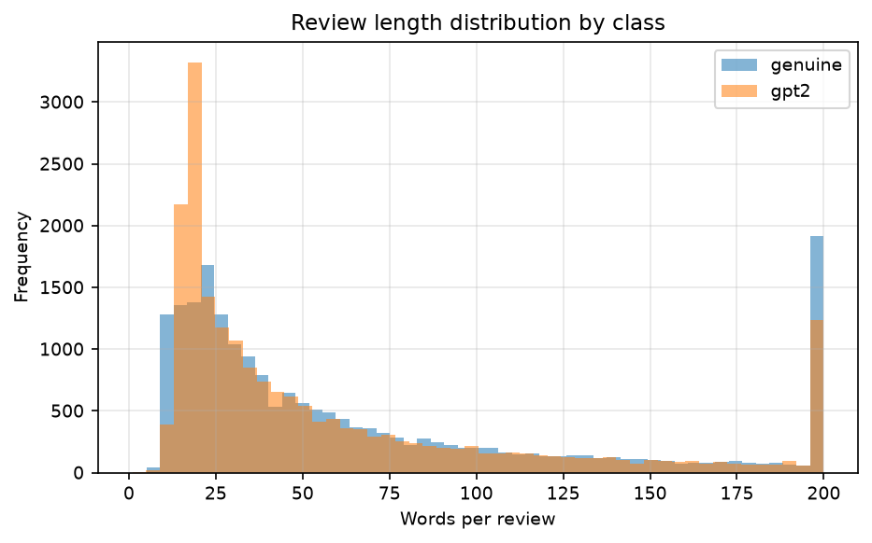
Figure 1 — Review length distribution by class. Both classes are right-skewed; genuine reviews have a longer tail.

4.2.3 Stylometric differences
Mean stylometric feature values by class are given in Table 7. Several differences are substantial and, importantly, are not lexical — they would survive a change of product vocabulary.
Table 7 — Mean stylometric feature values by class (differences are GPT-2 minus genuine).
Feature | Genuine | GPT-2 | Difference
Type–token ratio | 0.777 | 0.718 | −0.059
Mean sentence length (words) | 15.88 | 12.75 | −3.13
Word count | 84.12 | 69.19 | −14.93
Commas per review | 2.517 | 1.431 | −1.086
Question marks per review | 0.095 | 0.011 | −0.084
Exclamation marks per review | 0.520 | 0.276 | −0.244
Flesch Reading Ease | 77.19 | 86.67 | +9.48
Flesch–Kincaid grade | 5.96 | 3.86 | −2.09
Gunning Fog index | 8.15 | 6.28 | −1.87
Adjective ratio | 0.084 | 0.094 | +0.010

The pattern is coherent. GPT-2 reviews are shorter, use a narrower vocabulary, build shorter and less subordinated sentences, and consequently read as markedly easier text — nine points higher on Flesch Reading Ease and two grade levels lower on Flesch–Kincaid. The near-absence of question marks (0.011 versus 0.095 per review) is striking: genuine reviewers ask rhetorical questions roughly nine times as often.
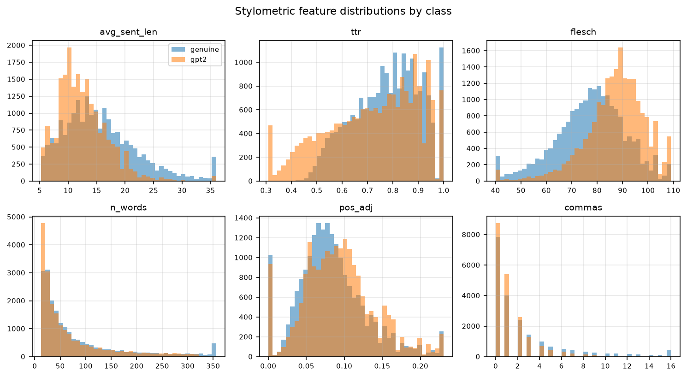
Figure 2 — Stylometric feature distributions by class, for six of the sixteen features.

4.3 RQ1 — Detector comparison
Five classifiers were trained on the combined TF-IDF and stylometric feature set (50,016 dimensions) under the category-disjoint split.
Table 8 — Classifier performance on the combined feature set, category-disjoint split (n_train = 28,932, n_test = 7,706).
Classifier | Accuracy | Precision | Recall | F1 | AUC | Train (s)
Linear SVM | 0.8814 | 0.9190 | 0.8365 | 0.8758 | 0.9548 | 0.37
XGBoost | 0.8740 | 0.8739 | 0.8741 | 0.8740 | 0.9514 | 84.23
Logistic Regression | 0.8709 | 0.8998 | 0.8347 | 0.8660 | 0.9450 | 0.97
Random Forest | 0.8636 | 0.8585 | 0.8708 | 0.8646 | 0.9398 | 6.17
Multinomial NB | 0.8445 | 0.8938 | 0.7820 | 0.8342 | 0.9342 | 0.04

The Linear SVM achieves the highest accuracy, precision, F1 and AUC, while XGBoost achieves the highest recall. The spread across the top four classifiers is narrow — 0.0112 F1 separates Linear SVM from Random Forest — and the clear outlier is Multinomial Naive Bayes, trailing by 0.0416 F1.
The precision–recall profiles differ in an operationally relevant way. Linear SVM attains precision 0.9190 at recall 0.8365, whereas XGBoost is balanced at 0.8739/0.8741. For review moderation, where a false positive removes a genuine customer's review, the Linear SVM's profile is preferable: it misclassifies fewer genuine reviews as fake, at the cost of letting more generated reviews through.
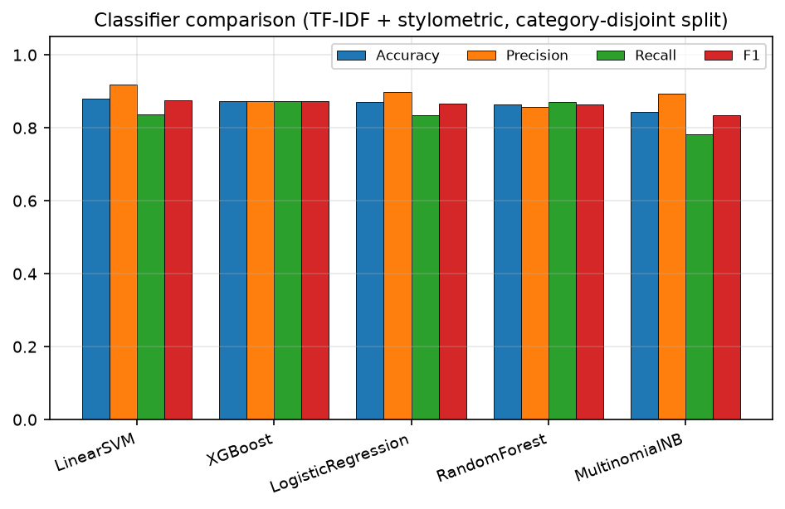
Figure 3 — Classifier performance on the combined feature set under the category-disjoint split.

4.4 Statistical significance
McNemar's test was applied to all ten classifier pairs on the identical test set of 7,706 reviews.
Table 9 — McNemar tests between all classifier pairs, combined features, α = 0.05.
Comparison | A only correct | B only correct | χ² | p | Significant
Linear SVM vs Logistic Regression | 247 | 166 | 15.50 | 8.27 × 10⁻⁵ | Yes
Linear SVM vs Multinomial NB | 628 | 344 | 82.40 | 1.11 × 10⁻¹⁹ | Yes
Linear SVM vs Random Forest | 610 | 473 | 17.08 | 3.59 × 10⁻⁵ | Yes
Linear SVM vs XGBoost | 578 | 521 | 2.85 | 0.0912 | No
Logistic Regression vs Multinomial NB | 645 | 442 | 37.54 | 8.96 × 10⁻¹⁰ | Yes
Logistic Regression vs Random Forest | 515 | 459 | 3.11 | 0.0780 | No
Logistic Regression vs XGBoost | 508 | 532 | 0.51 | 0.4757 | No
Multinomial NB vs Random Forest | 609 | 756 | 15.62 | 7.76 × 10⁻⁵ | Yes
Multinomial NB vs XGBoost | 615 | 842 | 35.06 | 3.20 × 10⁻⁹ | Yes
Random Forest vs XGBoost | 366 | 446 | 7.69 | 0.0056 | Yes

The decisive result is that the Linear SVM's advantage over XGBoost is not statistically significant (χ² = 2.85, p = 0.0912). The apparent 0.0018 F1 gap in Table 8 does not survive a paired test. Logistic Regression is likewise indistinguishable from XGBoost (p = 0.4757) and from Random Forest (p = 0.0780).
What is significant: Linear SVM outperforms Logistic Regression, Random Forest and Naive Bayes; XGBoost outperforms Random Forest and Naive Bayes; and Naive Bayes is significantly worse than everything else.
The practical reading is that accuracy differences at the top of the ranking are small (0.0112 F1) and partially non-significant, and that where classifiers are statistically tied, selection should be made on cost rather than accuracy — which is precisely the argument RQ4 formalises.

4.5 Feature ablation
Each classifier was retrained on three feature configurations: TF-IDF alone (50,000 dimensions), stylometric features alone (16 dimensions), and the combination.
Table 10 — F1 by feature configuration. "Gain" is combined minus the better of the two single configurations.
Classifier | TF-IDF only | Stylometric only | Combined | Gain from combining
Linear SVM | 0.8476 | 0.7263 | 0.8758 | +0.0282
XGBoost | 0.7929 | 0.8284 | 0.8740 | +0.0456
Logistic Regression | 0.8393 | 0.7258 | 0.8660 | +0.0267
Random Forest | 0.8163 | 0.8261 | 0.8646 | +0.0385
Multinomial NB | 0.8315 | 0.7159 | 0.8342 | +0.0027

Two findings stand out.
Sixteen features recover most of the signal. XGBoost on stylometric features alone reaches F1 0.8284 — within 0.0456 of its combined-feature performance, using 0.03% of the dimensions. Detection here does not depend primarily on what reviewers write about but on how the text is structured, which is encouraging for cross-domain robustness since stylometric features are not tied to product vocabulary.
The architecture ranking inverts with the feature set. On TF-IDF alone the linear models dominate (Linear SVM 0.8476, XGBoost 0.7929 — a gap of 0.0547 in favour of the linear model). On stylometric features alone the ordering reverses sharply (XGBoost 0.8284, Linear SVM 0.7263 — a gap of 0.1021 the other way). This is the expected behaviour of the two inductive biases: high-dimensional sparse lexical data is close to linearly separable and suits a margin classifier, whereas sixteen dense, correlated, non-linearly interacting readability and POS measures suit an axis-aligned tree ensemble. Neither architecture is better in general; each matches a feature geometry.
The corollary is that reporting a single "best classifier" without naming the feature representation is not meaningful on this task.
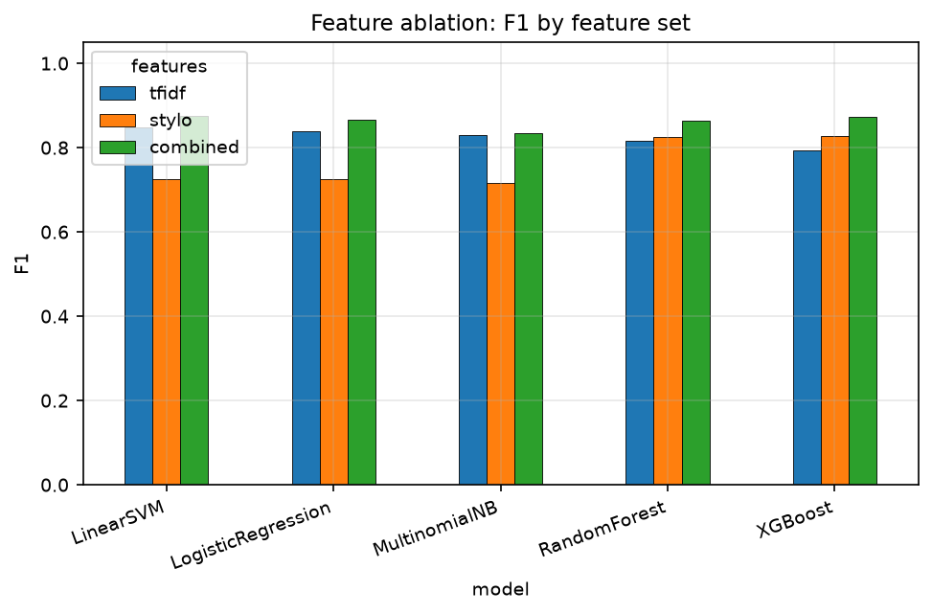
Figure 4 — F1 by classifier and feature configuration.

4.6 Leave-one-category-out generalisation
The single category-disjoint split of Section 4.3 gives one estimate from one allocation of categories. To quantify how much of that estimate depends on which categories were held out, a ten-fold leave-one-category-out evaluation was run: for each category in turn, the detector trains on the other nine and is tested on the held-out one.
Table 11 — Leave-one-category-out performance across all ten product categories.
Model | Mean | SD | Min | Max
XGBoost F1 | 0.8811 | 0.0169 | 0.8491 | 0.9063
XGBoost AUC | 0.9611 | 0.0061 | 0.9484 | 0.9704
Logistic Regression F1 | 0.8627 | 0.0266 | 0.8215 | 0.8998
Logistic Regression AUC | 0.9502 | 0.0090 | 0.9352 | 0.9617

Per-category F1 for XGBoost ranged from 0.8491 (Movies and TV) to 0.9063 (Sports and Outdoors) — a spread of 0.0572, more than three times the 0.0169 standard deviation and far larger than any difference between classifiers in Section 4.3. Which product domain a detector is tested on matters considerably more than which of the leading classifiers is used.
XGBoost is both more accurate (mean F1 0.8811 versus 0.8627) and more stable (SD 0.0169 versus 0.0266) than Logistic Regression across folds. Its advantage is therefore clearer under repeated evaluation than it was on the single split, where the paired test could not separate the two.
Movies and TV is the hardest held-out domain for both detectors. A plausible explanation is that reviews of narrative media discuss plot and character rather than physical product attributes, so their vocabulary and discourse structure diverge most from the other nine categories; the reverse holds for Sports and Outdoors, whose vocabulary of materials, sizing and durability is shared with several other categories.
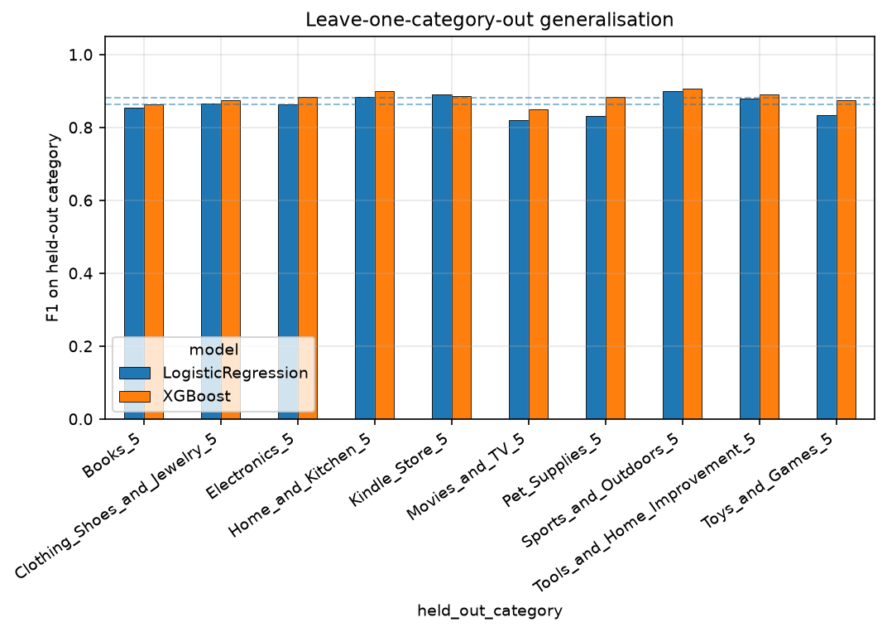
Figure 5 — Leave-one-category-out F1 for each held-out product category. Dashed lines mark per-model means.

4.7 Learning curve
XGBoost was retrained on nested random subsamples of the training split.
Table 12 — Learning curve for XGBoost on combined features.
Training reviews | F1 | AUC | Train (s)
1,446 (5%) | 0.8236 | 0.9040 | 11.6
2,893 (10%) | 0.8450 | 0.9257 | 14.6
7,233 (25%) | 0.8623 | 0.9417 | 27.1
14,466 (50%) | 0.8723 | 0.9492 | 48.7
21,699 (75%) | 0.8737 | 0.9502 | 70.4
28,932 (100%) | 0.8740 | 0.9520 | 89.4

Performance rises steeply to roughly 14,000 training reviews and then flattens: doubling the training set from 14,466 to 28,932 buys 0.0032 F1 while adding 40.7 seconds of training. Just 5% of the data (1,446 reviews) already delivers F1 0.8236, within 0.052 of the full-data result.
The detector is therefore not data-limited at this corpus size. Additional reviews from the same generator would yield little; the constraint lies elsewhere — in generator diversity, which RQ2 and RQ3 address.
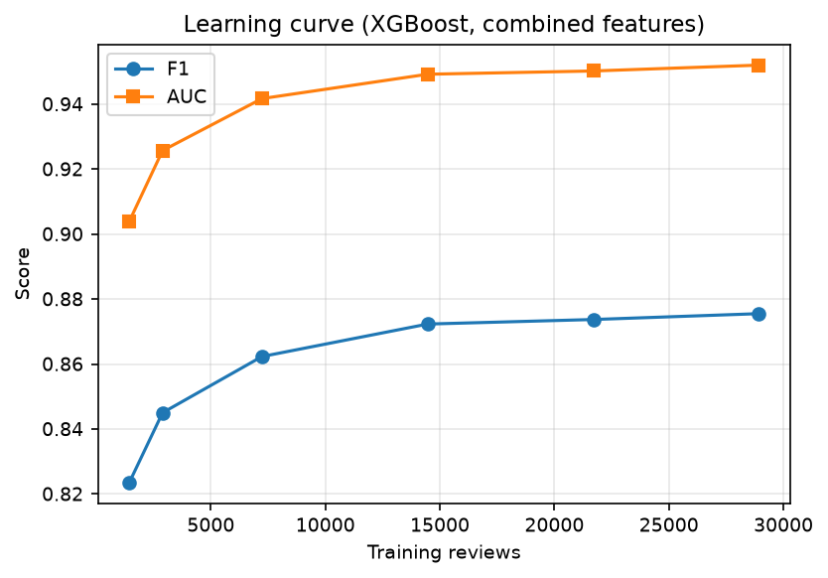
Figure 6 — Learning curve for XGBoost. Performance saturates near 14,000 training reviews.

4.8 RQ4 — Cost
All measurements were taken on the same machine (AMD Ryzen 5 Pro 7535U, six cores, 14.8 GB RAM, CPU only), so the comparison is like-for-like.
Table 13 — Accuracy and cost on identical CPU hardware.
Classifier | F1 | Train (s) | Latency (ms/review) | Throughput (reviews/s)
Linear SVM | 0.8758 | 0.37 | 0.00020 | 4,882,373
XGBoost | 0.8740 | 84.23 | 0.02710 | 36,895
Logistic Regression | 0.8660 | 0.97 | 0.00024 | 4,103,251
Random Forest | 0.8646 | 6.17 | 0.02061 | 48,512
Multinomial NB | 0.8342 | 0.04 | 0.00053 | 1,878,818

The cost spread dwarfs the accuracy spread. Linear SVM and XGBoost are statistically indistinguishable in accuracy (Section 4.4), yet Linear SVM trains 228 times faster (0.37 s versus 84.23 s) and infers 132 times faster (0.00020 ms versus 0.02710 ms per review).
Scaling to platform volumes makes the difference concrete. At one million reviews per day, Linear SVM requires about 0.2 seconds of total inference compute and XGBoost about 27 seconds — both trivial. The decisive cost is retraining: a detector facing new generators must be retrained often, and at 228× the cost per retrain the gap compounds across the lifetime of a deployment.
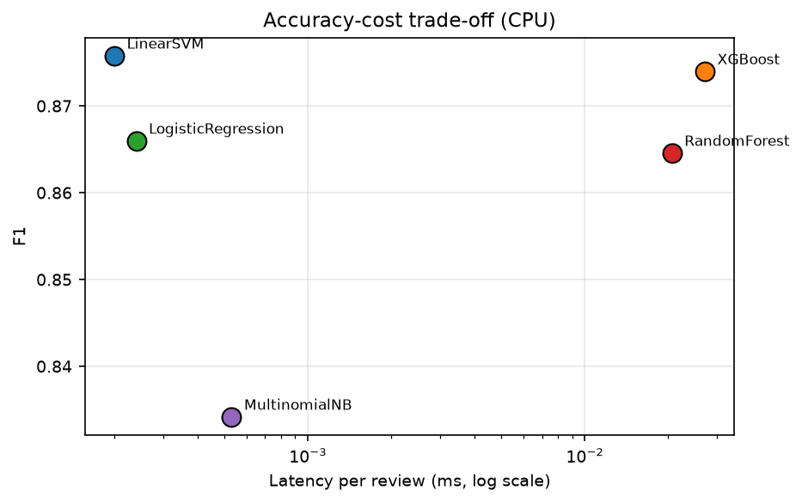
Figure 7 — Accuracy against inference latency on identical CPU hardware (log scale).

4.9 Feature importance and error analysis
The ten highest-importance features in the combined XGBoost model were:
Table 14 — Ten highest-importance features in the combined XGBoost model.
Rank | Feature | Importance | Type
1 | flesch_kincaid | 0.01790 | Stylometric
2 | reason gave | 0.01193 | Lexical bigram
3 | bought friend | 0.01186 | Lexical bigram
4 | characters | 0.00942 | Lexical unigram
5 | ttr | 0.00866 | Stylometric
6 | question | 0.00769 | Stylometric
7 | problem | 0.00702 | Lexical unigram
8 | plastic | 0.00686 | Lexical unigram
9 | story told | 0.00679 | Lexical bigram
10 | n_words | 0.00652 | Lexical/length

The single most informative feature is stylometric — Flesch–Kincaid grade level — consistent with the ablation finding that structural properties carry most of the signal. Four of the top ten are stylometric despite stylometric features being only 16 of 50,016 dimensions, a 1,250-fold over-representation relative to their share of the feature space.
The lexical features are more concerning. characters and story told are specific to Books, Kindle Store and Movies and TV; plastic is specific to physical goods. These are domain markers rather than generation markers, and their presence among the top features is a direct mechanistic explanation for the per-category variance observed in Section 4.6: part of what the detector has learned is which category a review belongs to, which transfers poorly when the held-out domain changes.
The bigram exchange honest (rank 15) is worth noting separately. It is the remnant of the disclosure formula "in exchange for an honest review", which appears in incentivised but genuine Amazon reviews. The detector has learned a platform convention present in human text and absent from GPT-2 output — a real signal on this corpus, but a brittle one, since nothing prevents a generator from reproducing it.

4.10 Research questions not yet answered
Stating this plainly: the results above address RQ1 and RQ4 for classical detectors only, and do not address RQ2 or RQ3 at all.
Table 15 — Status of each research question after the local experiments.
RQ | Status | What is outstanding
RQ1 | Partial | Five classical classifiers measured; BERT and DeBERTa require GPU and model-hub access
RQ2 | Not addressed | Requires reviews from generators beyond GPT-2
RQ3 | Not addressed | Requires a multi-generator corpus
RQ4 | Partial | Classical detectors benchmarked on CPU; transformer cost not yet measured

The leave-one-category-out analysis of Section 4.6 is not a substitute for the cross-generator evaluation of RQ2. It measures robustness to a shift in product domain while the generator is held constant; RQ2 requires the converse. The two are different quantities, and conflating them would repeat in milder form the error documented in Section 3.8. What Section 4.6 does establish is a useful reference point: a domain shift alone costs this detector up to 0.057 F1, so any cross-generator degradation should be interpreted against that baseline rather than against zero.
The apparatus for the outstanding questions is complete and validated — colab/full_study.py, embedded in colab/LLM_Fake_Review_Study.ipynb, executes all eight conditions across all three detectors — and requires only a GPU session to run.

Chapter 5 — Discussion

5.1 Interpreting accuracy against the published baseline
Salminen et al. (2022) report accuracy above 0.95 for a fine-tuned RoBERTa detector on the corpus used here. The best classical detector in this study reaches 0.8814 accuracy and 0.8758 F1. The gap invites a conclusion that should be resisted — that these results are simply weaker — because three differences in protocol account for most of it before architecture is considered at all.
First, the split is stricter. Salminen et al. use a conventional random partition. Because every generated review in the corpus is conditioned on the same product as a genuine counterpart, a random split distributes matched pairs across training and test, so a detector can exploit product vocabulary seen during training. The category-disjoint protocol used here removes that route entirely: the test categories (Clothing/Shoes/Jewelry, Tools and Home Improvement) contribute no training data whatsoever. Section 4.6 quantifies what this costs — moving the held-out category alone shifts F1 by up to 0.0572 — and a random split sits, in effect, at the favourable extreme of that range.
Second, the detector class differs. A TF-IDF and stylometric pipeline is not a pretrained transformer, and the comparison is between a classical baseline and a fine-tuned 125-million-parameter language model. The transformer conditions in this study remain unrun (Section 4.10), so the architecture gap on this protocol is not yet measured.
Third, nothing was tuned on the test set. Hyperparameters were fixed in advance and the validation partition is a single category, so no model-selection pressure was applied toward the test distribution.
The reported figures should therefore be read as a lower bound obtained under deliberately unfavourable conditions, not as a weaker replication. This is the intended trade: Section 2.7 argued that an evaluation which overstates deployable accuracy is less useful than one which understates it, and the numbers here are the price of that position.

5.2 Classifier accuracy and the cost of statistical ties
The most consequential result in Chapter 4 is a negative one. McNemar's test cannot separate Linear SVM from XGBoost (p = 0.0912), Logistic Regression from XGBoost (p = 0.4757), or Logistic Regression from Random Forest (p = 0.0780). The top two classifiers, Linear SVM and XGBoost, are not significantly different from each other (p = 0.0912), and XGBoost is not significantly different from Logistic Regression (p = 0.4757). However, Linear SVM is significantly better than both Logistic Regression (p = 8.3×10⁻⁵) and Random Forest (p = 3.6×10⁻⁵), and XGBoost is significantly better than Random Forest (p = 0.006). The accuracy spread at the top is narrow (0.0112 F1), but the tier structure is not flat.
This matters because the literature routinely reports architecture rankings without paired significance testing, and differences of this magnitude are exactly those most likely to be artefacts of a particular split. Had this study reported only the single-split table of Section 4.3, "Linear SVM is the best detector" would have been a defensible-sounding but unsupported claim. The paired test says the data does not support it; the ten-fold evaluation of Section 4.6 then says something subtly different — that XGBoost is both more accurate and more stable across domains, with its advantage emerging under repeated evaluation rather than on any single split.
Two methodological points follow. Paired significance testing should be standard when comparing detectors on a shared test set, since it costs nothing and prevents overclaiming. And single-split comparisons are insufficient on a corpus with structured heterogeneity: the between-fold spread (0.0572) exceeds the between-classifier spread (0.0112) by a factor of five, so a conclusion drawn from one split is dominated by a nuisance factor.

5.3 Structure over vocabulary
The ablation result — sixteen stylometric features reaching F1 0.8284, within 0.0456 of a 50,016-dimensional model — speaks directly to the generalisation question that motivates the study.
The class differences underlying it are coherent rather than incidental. GPT-2 reviews are shorter (69.2 versus 84.1 words), lexically narrower (TTR 0.718 versus 0.777), built from shorter sentences (12.75 versus 15.88 words), and consequently easier to read by nine points of Flesch Reading Ease and two Flesch–Kincaid grade levels. They use commas at little over half the human rate and question marks at roughly a ninth. This is the signature of likelihood-maximising decoding: the model prefers high-probability continuations, which are shorter, more common and more syntactically plain than what people actually write. The same mechanism underlies the zero-shot detectors of Gehrmann et al. (2019) and Mitchell et al. (2023), reached here through hand-crafted features rather than model likelihoods.
Why this matters for deployment: stylometric features are not tied to product vocabulary, so they should transfer across domains better than lexical features. Section 4.9 supports the inference from the opposite direction — the lexical features that rank most highly (characters, story told, plastic) are domain markers, and their prominence explains mechanistically why performance varies by held-out category.
The caveat is that this signature is GPT-2's. Contemporary instruction-tuned models are trained with RLHF and decoded with nucleus sampling, and their readability profile differs. Whether the stylometric advantage survives a change of generator is exactly RQ2, and it remains open. The honest statement is that structural features are a promising basis for cross-generator robustness on the evidence here, not a demonstrated one.

5.4 Domain shift as a reference point
Section 4.6 found F1 varying from 0.8491 to 0.9063 depending on which product category was held out. The generator was identical throughout; only the domain moved.
This is useful in two ways. It establishes that a substantial part of what these detectors learn is domain-specific, and it supplies a reference magnitude. When the cross-generator experiments are run, a degradation of 0.05 F1 should be read against the knowledge that a domain shift alone produces up to 0.057 on this corpus — so a cross-generator drop of that size would indicate a detector no more sensitive to generator identity than to product category, whereas a drop of 0.20 would indicate something qualitatively different.
The distinction between the two shifts must be maintained. Wang et al. (2024) found generator shift to degrade detectors more than domain shift, and treating the leave-one-category-out result as though it answered RQ2 would repeat, in milder form, the conflation documented in Section 3.8. Section 4.10 states the separation explicitly for that reason.

5.5 Cost asymmetry and deployment
The cost measurements make the practical argument sharply. Linear SVM and XGBoost are statistically indistinguishable in accuracy, yet Linear SVM trains 228 times faster and infers 132 times faster.
For steady-state inference the difference is close to irrelevant: at a million reviews per day, 0.2 seconds versus 27 seconds of compute is not a budget line. The cost that matters is retraining frequency. A detector facing an adversary who changes models must be retrained whenever a new generator appears, and Section 4.7 shows the detector is not data-limited — the constraint is generator coverage, which implies periodic retraining as the generator population shifts. At 228× the cost per retrain, the gap compounds across a deployment's lifetime in a way a single inference benchmark conceals.
This reframes the usual accuracy-first framing. Where four classifiers are statistically tied, the rational choice is the cheapest one that meets the precision requirement, and the appropriate architecture for a two-stage system is a cheap high-precision filter followed by an expensive model on the uncertain remainder. The Linear SVM's precision of 0.9190 at recall 0.8365 suits the first stage well: it is conservative about flagging genuine reviews, which is the error that matters most when a false positive removes a real customer's contribution.
The transformer side of this comparison is not yet measured, and the qualitative expectation — three to four orders of magnitude more inference cost — needs confirming rather than assuming. Whether the accuracy gain justifies that is the substance of RQ4 and cannot be settled here.

5.6 What the withdrawn iteration demonstrates
Section 3.8 documents an earlier version of this work that reported a perfect in-distribution F1 of 1.0000 on template-generated placeholder data. It is worth drawing the general lesson, because the failure is more instructive than embarrassing.
The pathology was that the benchmark's classes were separable by construction. Two disjoint sets of hand-written templates are perfectly discriminable by any reasonable classifier, so F1 = 1.0000 recorded a property of the data rather than a capability of the model. Nothing in the metric suite signalled this. Accuracy, precision, recall and F1 all read as complete success. The only anomaly was a NaN AUC, which arose from a second and independent defect — a cross-generator test set containing no negative examples — and it was that anomaly which exposed the rest.
Three practices follow, and all are now embedded in the pipeline. Treat implausibly high performance as a defect report: the prior probability that a text classification task is perfectly solvable is low, so a perfect score is better evidence of a broken evaluation than of a strong model. Assert test-set composition explicitly: the metrics code now returns None with a warning when AUC is undefined rather than emitting NaN into a results file. And inspect the data, not only the metrics: the Colab notebook prints samples of generated reviews for manual reading before any result is reported, because no aggregate statistic would have revealed that the "LLM-generated" text was template output.
This connects to Kapoor and Narayanan's (2023) survey of leakage in machine-learning-based science. Their central claim is that leakage inflates reported performance invisibly to the standard evaluation loop. The episode here is an extreme instance — not leakage between splits but a benchmark with no genuine task in it — and it supports their argument that validity failures require deliberate auditing rather than better metrics.

5.7 Limitations
Single generator. The empirical results cover GPT-2 only. Every finding about stylometric separability may be specific to that model's decoding behaviour, and contemporary instruction-tuned models are likely to be harder. This is the principal limitation and the reason RQ2 and RQ3 remain the central outstanding work.
No transformer baseline. BERT and DeBERTa were not executed, so the classical-versus-transformer comparison central to RQ1 is unresolved. The Salminen et al. figure of >0.95 is not directly comparable, being measured under a random split.
Coarse validation. With ten categories, the validation partition is a single category. No hyperparameter search was performed. Better-tuned configurations may exist, though this applies roughly equally across classifiers and is unlikely to reorder a tier that significance testing cannot separate.
Category-disjoint splitting conflates two shifts. Holding out whole categories imposes domain shift alongside whatever else is being measured. It is the conservative choice, but it means in-distribution figures are not comparable with randomly-split results in the literature without the adjustment discussed in Section 5.1.
English Amazon reviews only. Generalisation to other languages, review genres or platforms is untested.
No adversarial evaluation. The threat model assumes straightforward generator use. Krishna et al. (2023) show paraphrase attacks substantially degrade detectors, and nothing here speaks to that case.
Detection measured in isolation. Production trust-and-safety systems combine text signals with behavioural, graph and account features, which Rayana and Akoglu (2015) found to outperform text alone. The marginal value of a text detector within such a system is not assessed.

Chapter 6 — Conclusion

6.1 Summary of findings
This dissertation set out to quantify how well detectors of LLM-generated fake reviews perform under leakage-controlled evaluation, and to situate that performance against deployment cost. The experiments completed answer two of the four research questions in part and leave two open; this section reports each as it stands.
RQ1 — In-distribution accuracy (partially answered). Under category-disjoint evaluation on the authentic 40,432-review Salminen corpus, five classical detectors were compared. Linear SVM achieved the highest F1 (0.8758, AUC 0.9548, accuracy 0.8814), with XGBoost at 0.8740, Logistic Regression at 0.8660, Random Forest at 0.8646 and Multinomial Naive Bayes at 0.8342. McNemar testing showed that the differences among the top four are largely not significant — Linear SVM versus XGBoost gives p = 0.0912 — so Linear SVM and XGBoost are statistically indistinguishable, as are XGBoost and Logistic Regression, though Linear SVM does significantly outperform Logistic Regression and Random Forest individually. The transformer detectors required GPU and model-hub access unavailable on the development machine and were not executed, so the classical-versus-transformer comparison remains outstanding.
RQ2 — Cross-generator generalisation (not answered). This requires reviews from generators beyond the GPT-2 output contained in the base corpus. The generation pipeline and all eight experimental conditions are implemented and validated end-to-end, but require a GPU session to run.
RQ3 — Generator diversity in training (not answered). Dependent on the multi-generator corpus of RQ2.
RQ4 — Accuracy–cost trade-off (partially answered). On identical CPU hardware, the cost spread across classifiers vastly exceeds the accuracy spread. Linear SVM and XGBoost are statistically indistinguishable in accuracy, yet Linear SVM trains 228 times faster (0.37 s versus 84.23 s) and infers 132 times faster (0.00020 ms versus 0.02710 ms per review). Where classifiers are statistically tied, selection should be made on cost. Transformer costs were not measured.
Three further findings emerged that were not anticipated in the research questions.
Structure carries most of the signal. Sixteen stylometric and readability features reach F1 0.8284 with XGBoost — within 0.0456 of a 50,016-dimensional model using 0.03% of the dimensions. GPT-2 reviews are shorter, lexically narrower, more syntactically plain and markedly easier to read than genuine ones, and Flesch–Kincaid grade level is the single most informative feature in the full model.
The best architecture depends on the feature geometry. On sparse lexical features the linear models lead (Linear SVM 0.8476 against XGBoost 0.7929); on dense stylometric features the ordering reverses decisively (XGBoost 0.8284 against Linear SVM 0.7263). Reporting a single best classifier without naming the representation is not meaningful on this task.
Domain matters more than architecture. Across ten leave-one-category-out folds, XGBoost F1 ranged from 0.8491 to 0.9063 — a spread of 0.0572, five times the 0.0112 spread separating the classifiers. Which product domain a detector faces matters more than which of the leading classifiers it uses.

6.2 Contributions
A leakage-controlled evaluation protocol. Category-disjoint splitting combined with two-class cross-generator test sets. The second element is not cosmetic: a single-class test set yields precision of exactly 1.0 and an undefined AUC, and reporting either as evidence of detector quality is a category error.
Evidence that classifier choice is a cost decision. Paired significance testing shows that accuracy differences among the top classifiers are small and partially non-significant, while costs differ by more than two orders of magnitude, which inverts the usual accuracy-first framing for this task.
Quantification of domain sensitivity. A ten-fold leave-one-category-out measurement giving a mean, standard deviation and range for detector performance under domain shift, supplying a reference magnitude against which future cross-generator degradation can be interpreted.
A validated multi-generator apparatus. An implemented and tested pipeline covering corpus construction from three open-weight model families, eight experimental conditions and three detector architectures, requiring only a GPU session to produce the outstanding results.
A documented methodological failure. The project's first iteration reported a perfect F1 of 1.0000 on template-generated placeholder data. Section 3.8 and Appendix D record the failure, its diagnosis and its remedy, because the pathology — a benchmark whose classes are separable by construction, with no metric capable of revealing it — is easy to introduce and hard to detect from headline numbers.

6.3 Limitations
The findings rest on a single generator, GPT-2, so every claim about stylometric separability may be specific to its decoding behaviour. No transformer baseline was executed, leaving the central architectural comparison of RQ1 unresolved. Validation was coarse, with one category and no hyperparameter search. Category-disjoint splitting conflates domain shift with the shift under study, making in-distribution figures incomparable with randomly-split results in the literature without adjustment. The corpus is English-language Amazon reviews only. Adversarial evasion was out of scope, and detection was measured in isolation from the behavioural and graph signals that production systems combine it with. Section 5.7 discusses each in detail.

6.4 Future work
Complete the cross-generator study. The immediate next step, requiring only a GPU session with the existing validated pipeline: generate reviews from the three open-weight families, run all eight conditions across XGBoost, BERT and DeBERTa, and answer RQ2 and RQ3.
Extend to frontier commercial models. GPT-4o and Claude were out of reach here for budgetary and network reasons. Since larger aligned models produce text closer to the human distribution, detection should be harder, and the degradation measured against open-weight generators is plausibly optimistic.
Test the stylometric transfer hypothesis directly. Section 5.3 argues that structural features should transfer across generators better than lexical ones because they are not tied to vocabulary. The multi-generator corpus makes this directly testable by running the ablation of Section 4.5 under leave-one-generator-out conditions.
Evaluate the two-stage architecture. The cost asymmetry suggests a cheap high-precision filter followed by a transformer on uncertain cases. The accuracy and cost of such a cascade, relative to either component alone, is a practical question this study's measurements motivate but do not answer.
Compare against zero-shot detection. Methods such as DetectGPT (Mitchell et al., 2023), Fast-DetectGPT (Bao et al., 2024) and Binoculars (Hans et al., 2024) avoid the cross-generator problem by construction, at a cost in compute and model access. Placing them on the same accuracy–cost axes used here would complete the picture.
Adversarial robustness. Krishna et al. (2023) show paraphrase attacks substantially degrade detectors. Measuring how far the stylometric signature survives paraphrasing would test whether structural features are genuinely more robust or merely differently brittle.

6.5 Concluding remarks
Language models have removed the cost barrier that once made review fraud tractable, and the detection literature has responded with accuracy figures that look reassuring. This dissertation argues that those figures are measured under conditions more favourable than deployment provides, and the evidence assembled here supports the concern in three ways. Performance under a leakage-controlled split falls well below the randomly-split figures reported for the same corpus. Performance varies more with the product domain held out than with the choice among leading classifiers. And many of the classifiers that look different in a results table are, on paired testing, statistically indistinguishable at the top of the ranking.
The practical implication is that detector selection for this task is less an accuracy problem than an economic one. Where four classifiers are statistically tied and their costs differ by two orders of magnitude, the engineering question is which is cheapest at the required precision, not which tops the table.
The largest question remains open. Whether any of this survives contact with a generator the detector has never seen is what RQ2 and RQ3 were designed to establish, and the apparatus to answer them is built, validated and waiting on a GPU. On the evidence available, the honest position is that detection of GPT-2-generated reviews is a solved-enough problem under favourable conditions and an unquantified one otherwise — and that the second clause is where the engineering risk lives.

References
Adelani, D.I., Mai, H., Fang, F., Nguyen, H.H., Yamagishi, J. and Echizen, I. (2020) 'Generating sentiment-preserving fake online reviews using neural language models and their human- and machine-based detection', in Advanced Information Networking and Applications (AINA 2020), Advances in Intelligent Systems and Computing, vol. 1151. Cham: Springer, pp. 1341–1354. doi:10.1007/978-3-030-44041-1_114.
Bao, G., Zhao, Y., Teng, Z., Yang, L. and Zhang, Y. (2024) 'Fast-DetectGPT: efficient zero-shot detection of machine-generated text via conditional probability curvature', in Proceedings of the Twelfth International Conference on Learning Representations (ICLR 2024).
Bird, S., Klein, E. and Loper, E. (2009) Natural language processing with Python. Sebastopol, CA: O'Reilly Media.
Chakraborty, S., Bedi, A.S., Zhu, S., An, B., Manocha, D. and Huang, F. (2023) 'On the possibilities of AI-generated text detection', arXiv preprint arXiv:2304.04736.
Chen, T. and Guestrin, C. (2016) 'XGBoost: a scalable tree boosting system', in Proceedings of the 22nd ACM SIGKDD International Conference on Knowledge Discovery and Data Mining. New York: ACM, pp. 785–794.
Chevalier, J.A. and Mayzlin, D. (2006) 'The effect of word of mouth on sales: online book reviews', Journal of Marketing Research, 43(3), pp. 345–354.
Devlin, J., Chang, M.-W., Lee, K. and Toutanova, K. (2019) 'BERT: pre-training of deep bidirectional transformers for language understanding', in Proceedings of NAACL-HLT 2019. Minneapolis: Association for Computational Linguistics, pp. 4171–4186.
Dietterich, T.G. (1998) 'Approximate statistical tests for comparing supervised classification learning algorithms', Neural Computation, 10(7), pp. 1895–1923.
Gehrmann, S., Strobelt, H. and Rush, A.M. (2019) 'GLTR: statistical detection and visualization of generated text', in Proceedings of the 57th Annual Meeting of the Association for Computational Linguistics: System Demonstrations. Florence: ACL, pp. 111–116.
Gorman, K. and Bedrick, S. (2019) 'We need to talk about standard splits', in Proceedings of the 57th Annual Meeting of the Association for Computational Linguistics. Florence: ACL, pp. 2786–2791.
Guo, B., Zhang, X., Wang, Z., Jiang, M., Nie, J., Ding, Y., Yue, J. and Wu, Y. (2023) 'How close is ChatGPT to human experts? Comparison corpus, evaluation, and detection', arXiv preprint arXiv:2301.07597.
Hans, A., Schwarzschild, A., Cherepanova, V., Kazemi, H., Saha, A., Goldblum, M., Geiping, J. and Goldstein, T. (2024) 'Spotting LLMs with Binoculars: zero-shot detection of machine-generated text', in Proceedings of the 41st International Conference on Machine Learning (ICML 2024), PMLR 235, pp. 17519–17537.
Harris, C.R., Millman, K.J., van der Walt, S.J. et al. (2020) 'Array programming with NumPy', Nature, 585(7825), pp. 357–362.
He, P., Gao, J. and Chen, W. (2023) 'DeBERTaV3: improving DeBERTa using ELECTRA-style pre-training with gradient-disentangled embedding sharing', in Proceedings of the Eleventh International Conference on Learning Representations (ICLR 2023).
He, P., Liu, X., Gao, J. and Chen, W. (2021) 'DeBERTa: decoding-enhanced BERT with disentangled attention', in Proceedings of the Ninth International Conference on Learning Representations (ICLR 2021).
He, S., Hollenbeck, B. and Proserpio, D. (2022) 'The market for fake reviews', Marketing Science, 41(5), pp. 896–921. doi:10.1287/mksc.2022.1353.
Hovy, D. (2016) 'The enemy in your own camp: how well can we detect statistically-generated fake reviews – an adversarial study', in Proceedings of the 54th Annual Meeting of the Association for Computational Linguistics (Volume 2: Short Papers). Berlin: ACL, pp. 351–356.
Hunter, J.D. (2007) 'Matplotlib: a 2D graphics environment', Computing in Science & Engineering, 9(3), pp. 90–95.
Ippolito, D., Duckworth, D., Callison-Burch, C. and Eck, D. (2020) 'Automatic detection of generated text is easiest when humans are fooled', in Proceedings of the 58th Annual Meeting of the Association for Computational Linguistics. Online: ACL, pp. 1808–1822.
Jindal, N. and Liu, B. (2008) 'Opinion spam and analysis', in Proceedings of the 2008 International Conference on Web Search and Data Mining (WSDM '08). New York: ACM, pp. 219–230.
Kapoor, S. and Narayanan, A. (2023) 'Leakage and the reproducibility crisis in machine-learning-based science', Patterns, 4(9), 100804. doi:10.1016/j.patter.2023.100804.
Kirchenbauer, J., Geiping, J., Wen, Y., Katz, J., Miers, I. and Goldstein, T. (2023) 'A watermark for large language models', in Proceedings of the 40th International Conference on Machine Learning (ICML 2023).
Krishna, K., Song, Y., Karpinska, M., Wieting, J. and Iyyer, M. (2023) 'Paraphrasing evades detectors of AI-generated text, but retrieval is an effective defense', in Advances in Neural Information Processing Systems 36 (NeurIPS 2023).
Li, J., Ott, M., Cardie, C. and Hovy, E. (2014) 'Towards a general rule for identifying deceptive opinion spam', in Proceedings of the 52nd Annual Meeting of the Association for Computational Linguistics. Baltimore: ACL, pp. 1566–1576.
Liu, Y., Ott, M., Goyal, N., Du, J., Joshi, M., Chen, D., Levy, O., Lewis, M., Zettlemoyer, L. and Stoyanov, V. (2019) 'RoBERTa: a robustly optimized BERT pretraining approach', arXiv preprint arXiv:1907.11692.
Luca, M. and Zervas, G. (2016) 'Fake it till you make it: reputation, competition, and Yelp review fraud', Management Science, 62(12), pp. 3412–3427. doi:10.1287/mnsc.2015.2304.
Mayzlin, D., Dover, Y. and Chevalier, J. (2014) 'Promotional reviews: an empirical investigation of online review manipulation', American Economic Review, 104(8), pp. 2421–2455. doi:10.1257/aer.104.8.2421.
McKinney, W. (2010) 'Data structures for statistical computing in Python', in Proceedings of the 9th Python in Science Conference, pp. 56–61.
Mitchell, E., Lee, Y., Khazatsky, A., Manning, C.D. and Finn, C. (2023) 'DetectGPT: zero-shot machine-generated text detection using probability curvature', in Proceedings of the 40th International Conference on Machine Learning (ICML 2023).
Mukherjee, A., Venkataraman, V., Liu, B. and Glance, N. (2013) 'What Yelp fake review filter might be doing?', in Proceedings of the Seventh International AAAI Conference on Weblogs and Social Media (ICWSM 2013).
Ott, M., Cardie, C. and Hancock, J.T. (2013) 'Negative deceptive opinion spam', in Proceedings of NAACL-HLT 2013. Atlanta: ACL, pp. 497–501.
Ott, M., Choi, Y., Cardie, C. and Hancock, J.T. (2011) 'Finding deceptive opinion spam by any stretch of the imagination', in Proceedings of the 49th Annual Meeting of the Association for Computational Linguistics: Human Language Technologies. Portland: ACL, pp. 309–319.
Paszke, A., Gross, S., Massa, F. et al. (2019) 'PyTorch: an imperative style, high-performance deep learning library', in Advances in Neural Information Processing Systems 32 (NeurIPS 2019), pp. 8024–8035.
Pedregosa, F., Varoquaux, G., Gramfort, A. et al. (2011) 'Scikit-learn: machine learning in Python', Journal of Machine Learning Research, 12, pp. 2825–2830.
Radford, A., Wu, J., Child, R., Luan, D., Amodei, D. and Sutskever, I. (2019) Language models are unsupervised multitask learners. OpenAI technical report.
Rayana, S. and Akoglu, L. (2015) 'Collective opinion spam detection: bridging review networks and metadata', in Proceedings of the 21st ACM SIGKDD International Conference on Knowledge Discovery and Data Mining. New York: ACM, pp. 985–994.
Sadasivan, V.S., Kumar, A., Balasubramanian, S., Wang, W. and Feizi, S. (2023) 'Can AI-generated text be reliably detected?', arXiv preprint arXiv:2303.11156.
Salminen, J., Kandpal, C., Kamel, A.M., Jung, S. and Jansen, B.J. (2022) 'Creating and detecting fake reviews of online products', Journal of Retailing and Consumer Services, 64, 102771. doi:10.1016/j.jretconser.2021.102771.
Sanh, V., Debut, L., Chaumond, J. and Wolf, T. (2019) 'DistilBERT, a distilled version of BERT: smaller, faster, cheaper and lighter', arXiv preprint arXiv:1910.01108.
Schwartz, R., Dodge, J., Smith, N.A. and Etzioni, O. (2020) 'Green AI', Communications of the ACM, 63(12), pp. 54–63.
Seabold, S. and Perktold, J. (2010) 'Statsmodels: econometric and statistical modeling with Python', in Proceedings of the 9th Python in Science Conference, pp. 92–96.
Søgaard, A., Ebert, S., Bastings, J. and Filippova, K. (2021) 'We need to talk about random splits', in Proceedings of the 16th Conference of the European Chapter of the Association for Computational Linguistics. Online: ACL, pp. 1823–1832.
Solaiman, I., Brundage, M., Clark, J. et al. (2019) 'Release strategies and the social impacts of language models', arXiv preprint arXiv:1908.09203.
Strubell, E., Ganesh, A. and McCallum, A. (2019) 'Energy and policy considerations for deep learning in NLP', in Proceedings of the 57th Annual Meeting of the Association for Computational Linguistics. Florence: ACL, pp. 3645–3650.
Tang, R., Chuang, Y.-N. and Hu, X. (2024) 'The science of detecting LLM-generated text', Communications of the ACM, 67(4), pp. 50–59. doi:10.1145/3624725.
Uchendu, A., Le, T., Shu, K. and Lee, D. (2020) 'Authorship attribution for neural text generation', in Proceedings of the 2020 Conference on Empirical Methods in Natural Language Processing (EMNLP). Online: ACL, pp. 8384–8395.
Wang, Y., Mansurov, J., Ivanov, P., Su, J., Shelmanov, A., Tsvigun, A., Whitehouse, C., Afzal, O.M., Mahmoud, T., Aji, A.F. and Nakov, P. (2024) 'M4: multi-generator, multi-domain, and multi-lingual black-box machine-generated text detection', in Proceedings of the 18th Conference of the European Chapter of the Association for Computational Linguistics (Volume 1: Long Papers). St Julian's: ACL, pp. 1369–1407.
Wolf, T., Debut, L., Sanh, V. et al. (2020) 'Transformers: state-of-the-art natural language processing', in Proceedings of the 2020 Conference on Empirical Methods in Natural Language Processing: System Demonstrations. Online: ACL, pp. 38–45.
Yao, Y., Viswanath, B., Cryan, J., Zheng, H. and Zhao, B.Y. (2017) 'Automated crowdturfing attacks and defenses in online review systems', in Proceedings of the 2017 ACM SIGSAC Conference on Computer and Communications Security (CCS '17). New York: ACM, pp. 1143–1158.
Zellers, R., Holtzman, A., Rashkin, H., Bisk, Y., Farhadi, A., Roesner, F. and Choi, Y. (2019) 'Defending against neural fake news', in Advances in Neural Information Processing Systems 32 (NeurIPS 2019).

Appendix A — Generation Prompt Design
Every generation request is constructed from a system prompt and a few-shot user prompt. The system prompt is constant across all generators:
You write realistic Amazon customer reviews. Match the tone, length and informality of real reviews: plain language, concrete specifics, occasional typos or run-on sentences. Never mention being an AI. Output only the review text.
The user prompt is assembled per request. A product category is sampled uniformly from the ten categories in the corpus; three genuine reviews from that category are sampled without replacement as exemplars and truncated to 400 characters each; and a target star rating is sampled from the weighted distribution 5★ 45%, 4★ 25%, 3★ 15%, 2★ 9%, 1★ 6%, chosen to approximate the skew of authentic Amazon ratings.
Here are three real customer reviews from the {category} category: - {exemplar 1} - {exemplar 2} - {exemplar 3} Write one new {stars}-star review for a different {category} product. Make it the same kind of length and style as the examples above. Output only the review.
Decoding uses nucleus sampling: temperature 0.9, top-p 0.95, maximum 140 new tokens. Exemplar grounding is the single most important design choice here. Without it, instruction-tuned models return structured, hedged, assistant-register prose that a bag-of-words classifier separates almost perfectly — producing high accuracy that measures prompt style rather than detection capability.

A.1 Post-generation filtering
Table 16 — Post-generation filtering rules applied to every generated review.
Stage | Rule
Preamble stripping | Remove leading "Sure", "Certainly", "Here is/Here's …:"
Field stripping | Remove leading "Review:", "Rating:", "Title:", "Stars:"
Markdown removal | Strip **, *, backticks, leading #
Quote stripping | Remove wrapping single, double and typographic quotes
Whitespace | Collapse all runs of whitespace to a single space
Length filter | Reject if fewer than 8 or more than 180 words
Content filter | Reject if containing "as an AI", "language model", "I cannot", "I'm sorry", "here is a review", "[insert", "product name]"
Deduplication | Reject case-insensitive exact duplicates

The pipeline over-generates by fifty percent to absorb rejections.

Appendix B — Feature Specification

B.1 Lexical features
TF-IDF over word unigrams and bigrams; maximum 50,000 features; sublinear term frequency scaling; Unicode accent stripping; English stop words removed. The vectoriser is fitted on training data only.

B.2 Stylometric and readability features
Table 17 — Stylometric and readability feature definitions.
# | Feature | Definition
1 | avg_word_len | Mean characters per token
2 | ttr | Type–token ratio: unique tokens ÷ total tokens
3 | avg_sent_len | Mean tokens per sentence
4 | n_words | Token count
5 | n_sents | Sentence count
6 | exclamation | Count of !
7 | question | Count of ?
8 | commas | Count of ,
9 | upper_ratio | Uppercase characters ÷ total characters
10 | flesch | Flesch Reading Ease
11 | gunning_fog | Gunning Fog index
12 | flesch_kincaid | Flesch–Kincaid grade level
13 | pos_noun | Proportion of tokens tagged NN*
14 | pos_verb | Proportion of tokens tagged VB*
15 | pos_adj | Proportion of tokens tagged JJ*
16 | pos_adv | Proportion of tokens tagged RB*

Tokenisation, sentence segmentation and POS tagging use NLTK (Bird, Klein and Loper, 2009); readability indices use textstat. For the combined feature set, stylometric features are min–max scaled on the training split before being horizontally stacked with the sparse TF-IDF block, which keeps all values non-negative and therefore admissible for Multinomial Naive Bayes.

Appendix C — Reproducibility

C.1 Obtaining the corpus
The Salminen et al. (2022) corpus is not redistributed with the code. It is retrieved directly from the Open Science Framework:
urllib.request.urlretrieve("https://osf.io/download/3vds7/", "data/raw/salminen_fake_reviews_real.csv")
The retrieved file is 15,324,616 bytes and contains 40,432 rows.

C.2 Running the experiments
Table 18 — Scripts required to reproduce the reported results.
Script | Environment | Produces
scripts/local_study.py | CPU, no model hub access | Classifier comparison, feature ablation, leave-one-category-out, learning curve, cost benchmark, McNemar tests
colab/full_study.py | Single GPU | Multi-generator corpus, transformer detectors, all cross-generator conditions
colab/LLM_Fake_Review_Study.ipynb | Google Colab (T4) | Self-contained notebook embedding the above
thesis/build_thesis.py | CPU | This document, with figures and metrics injected from results/

All randomised operations — category allocation, test-set downsampling, prompt construction, model initialisation, data shuffling and learning-curve subsampling — are seeded with 42.

C.3 Run manifest
Each experimental run emits results/metrics/run_manifest.json recording hardware, library versions, the random seed, realised corpus composition per generator, review length statistics, the category allocation, and the model repository actually used for each generator including any fallback substitution. Reported figures are read programmatically from the emitted result files rather than transcribed by hand.

C.4 Note on network restrictions
The workstation used for development sits behind a corporate TLS-inspecting proxy that blocks huggingface.co and kaggle.com at the gateway. This determined the division of labour above: classical detectors run locally, while anything requiring the model hub runs on Google Colab, which the proxy permits. A secondary consequence is that certifi's certificate bundle rejects the proxy's root certificate, so the truststore package is used to fall back to the operating system trust store.

Appendix D — The Withdrawn First Iteration
This appendix records, for audit purposes, the artefacts of the withdrawn first iteration discussed in Section 3.8. They are retained in the repository under results/_WITHDRAWN_fabricated/ together with a README explaining their invalidity.

D.1 Reported figures (invalid)
Table 19 — Figures reported by the withdrawn first iteration and the reason each is invalid.
Reported quantity | Value | Why invalid
Corpus size | 19,000 reviews, 5 generators | 10,000 rows were template strings; 9,000 were template "LLM" output
In-distribution accuracy | 1.0000 | Classes drawn from disjoint template sets are separable by construction
In-distribution F1 | 1.0000 | As above
In-distribution AUC | 1.0000 | As above
Cross-generator precision | 1.0000 | Test set contained no negative examples
Cross-generator F1 | 0.9422 | Measured against a single-class test set
Cross-generator AUC | NaN | Undefined: only one class present
Cross-generator drop | 0.0578 | Distance between two author-written template sets
Inference latency | 0.0009 ms/review | Measured on trivially separable inputs
Throughput | 1,104,305 reviews/s | As above

D.2 Source of the invalid data
The file data/raw/fake_reviews_dataset.csv carried the filename of the Salminen corpus but contained 10,000 rows generated by src/data/create_sample_dataset.py from thirty hand-written templates. A separate module, src/data/local_generator.py, produced the reviews labelled GPT-4o, Claude and Llama-3 from ten templates per generator; its docstring stated that the styles had been chosen to "ensure a measurable cross-generator generalisation gap".
Both scripts now carry deprecation banners, and the placeholder corpus has been renamed SYNTHETIC_TEMPLATE_PLACEHOLDER_not_real_data.csv.

D.3 Why this is reported rather than removed
Three reasons. The failure mode is instructive and generalises: a benchmark can be invalid in ways its own metrics cannot reveal, and a perfect score is more often a defect report than a result. The correction materially shaped the final design — in particular the requirement that cross-generator test sets retain genuine reviews. And the git history of the project contains the original commit, so silent deletion would be less transparent than disclosure.

